Leader in Me Process  Beginning in 2016, PS 56K has adopted the Leader in Me process developed by author and teacher, Stephen R. Covey. The Leader in Me is an “innovative, school wide model that increases teacher effectiveness, student engagement, and academic achievement, while preparing students to be leaders in the 21st century.” Through this effort, our school will develop leadership qualities within all members of our school community, students, teachers, support staff, parents, and community members. This will be accomplished through direct instruction of the 7 Habits of Highly Effective People, developing rituals and routines around leadership, team building, goal setting, community action, and yearlong celebrations and events. The Seven Habits of Highly Effective People 1 .BE PROACTIVE 2. BEGIN WITH THE END IN MIND 3. PUT FIRST THINGS FIRST 4. THINK WIN-WIN 5. SEEK FIRST TO UNDERSTAND, THEN BE UNDERSTOOD 6. SYNERGIZE 7. SHARPEN THE SAW |  |  | Who We Are  At PS 56K, our goal is to educate the whole child, with an engaging, challenging, and rigorous curriculum, an emphasis on healthy and happy living, and artistic endeavors on a daily basis. Through a collaborative effort, our entire school community, teachers, parents, support staff, and students work together to create a positive and productive school environment.  PS 56  170 Gates Ave.  Brooklyn, NY 11238  Contact Us  Phone: 718-857-3149  Fax: 718-783-3149  Web: www.ps56k.org  School Hours  8:20am-2:40 pm (Early Dropoff Program)  Parent Communication Time-  Every Tuesday 2:20pm-3:50pm |  |  | PS 56K- The Lewis H. Latimer School  World Language Spanish Program  “A Community of Learners, A Community of Leaders.”  Eric Grande, Principal  Marvin Williams, Parent Coordinator  Tina Fleming, PTA President

Welcome to PS 56- The Lewis H. Latimer School  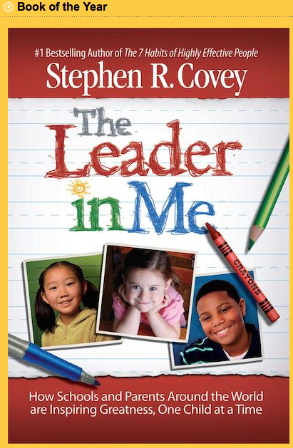  At PS 56k, our academic program is aligned to Common Core Expectations, where students are provided with rigorous tasks and learning activities that foster creative thinkers, problems solvers, and well-rounded individuals. In literacy, we follow the Teacher’s College Units of Study, with students reading and writing in multiple genres and areas of focus, such as informational texts, persuasive writing, and historical fiction, among others. All instruction focuses on students moving towards greater levels of independence in reading and writing, with targeted support for all students. In mathematics, our students learn multiple methods of problem solving, and are taught to explain their thinking verbally and in writing. We utilize such programs as Number Talks, Go Math, and Quick Drills. Our online programs include iReady, MyOn, Reading A-Z.  Professional Development  Our philosophy for professional development is we are all learners and we can all be facilitators of other teachers’ development. Our approach is a multi-faceted strategy, where teacher teams meet regularly, share best practices, attend workshops, turnkey their learning to their colleagues and apply practices in the classroom. Additionally, we utilize a “Lab Site” model, where teachers plan together, teach together with a group of children, and then reflect afterwards and plan instruction based on their learning. |  |  | World Language Spanish Program  Beginning in the Fall of 2017, PS 56k will initiate a “World Language Spanish” program. Through this academic approach, our students will be exposed to the general education curriculum, while simultaneously obtaining foundational Spanish language instruction with the ultimate goal of Spanish language proficiency. Research has shown, that language instruction, especially at the early childhood grades benefits student brain development and educational outcomes for years to come in all academic areas.  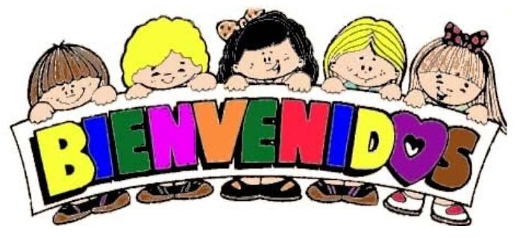  Within the initial stages of the program, our students will be receiving the majority of their instruction in English, especially in the core areas, such as reading, writing and mathematics. However, the instructors will be teaching basic Spanish vocabulary, numbers, colors, and songs over the course of the primary grades. As students’ progress through the grades of our program, we will increase the percentage of instruction taking place in Spanish to encourage greater command of the language and to develop full bilingual students with command of both English and Spanish by the time they leave PS 56. They will develop conversation and writing skills in the 2nd language, listen to instruction in Spanish, and respond to the teacher and their peers in their new language. |  |  | Extracurricular Activities/School Programs  Performance- School Wide Dance Program, Ballroom Dancing, Chorus  Arts- Little Orchestra Society, Studio in a School Art Program, Suzi Shelton Music, Kindermusic  Afterschool- Kids Orbit, Academic Intervention, Chess Club, Dance  Athletics- School Wide Physical Education Program, Mighty Milers, Wellness Coach  Health and Wellness- Cookshop for Classrooms, Cookshop for Parents, Wellness Chef, Alternative Healthy Lunch Menu, Breakfast in the Classroom, School Garden, Wellness Labs  Special Programming- World Language Spanish (Starting Fall of 2017 in Kindergarten, expanding up the grades each year), Gifted and Talented (K-3)  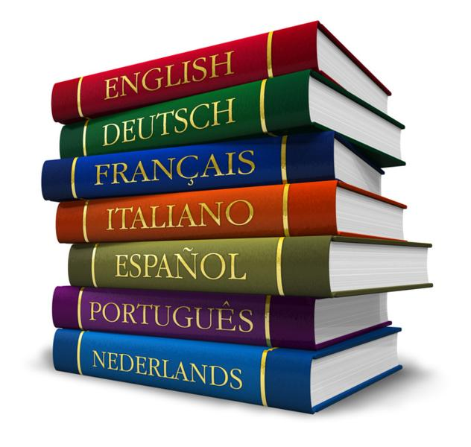  PS 56k- “A Community of Learners, A Community of Leaders”

