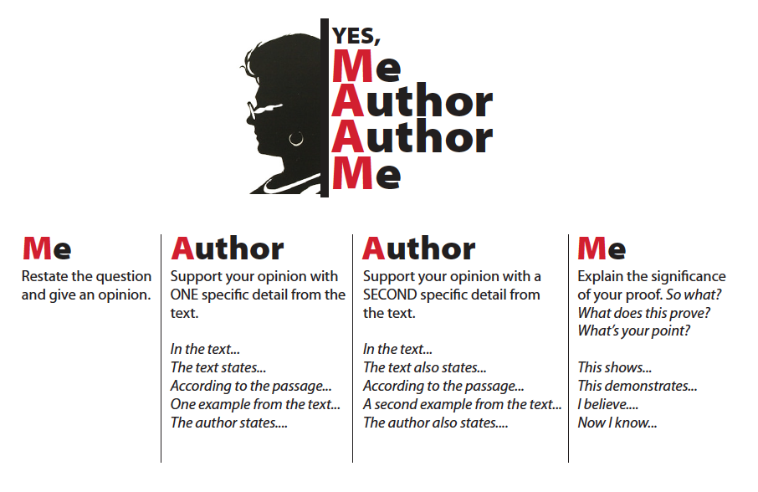
Use this strategy to provide practice for writing constructed responses.

Question: Did Cinderella’s stepmother feel empathy for Cinderella?
Response: I don’t think that Cinderella’s stepmother felt empathy for Cinderella. For example, when her stepsisters ordered Cinderella around or made fun of her, the stepmother never defended Cinderella. Another example is when Cinderella pleaded with her stepmother to allow her to go to the ball, her stepmother said no. This shows that her stepmother did not feel any empathy for Cinderella.

