IMPORTANT CONCEPTS YOUR STUDENT SHOULD KNOW AND ACTIVITIES TO DO AT HOME
Unit 5 Two Dimensional Shapes & Unit 7 Geometry and Coordinate Plane
Important Concepts Addressed in this Unit
MGSE5.G.3 Understand that attributes belonging to a category of two-dimensional figures also belong to all subcategories of that category. For example, all rectangles have four right angles and squares are rectangles, so all squares have four right angles.  MGSE5.G.4 Classify two-dimensional figures in a hierarchy based on properties (polygons, triangles and quadrilaterals).  Student should be able to reason about the attributes of shapes by examining questions like the following. • What are ways to classify triangles? • Why can’t trapezoids and kites be classified as parallelograms? • Which quadrilaterals have opposite angles congruent and why is this true of certain quadrilaterals? How many lines of symmetry does a regular polygon have?  - polygons – a closed plane figure formed from line segments that meet only at their endpoints  - quadrilaterals - a four-sided polygon  - rectangles - a quadrilateral with two pairs of congruent parallel sides and four right angles  - rhombi – a parallelogram with all four sides equal in length  - square – a parallelogram with four congruent sides and four right angles.  - parallelogram – a quadrilateral with two pairs of parallel and congruent sides.  - trapezoid-a quadrilateral with at least one pair of parallel sides | MGSE5.G.1 Use a pair of perpendicular number lines, called axes, to define a coordinate system, with the intersection of the lines (the origin) arranged to coincide with the 0 on each line and a given point in the plane located by using an ordered pair of numbers, called its coordinates. Understand that the first number indicates how far to travel from the origin in the direction of one axis and the second number indicates how far to travel in the direction of the second axis, with the convention that the names of the two axes and the coordinates correspond (e.g., x-axis and x-coordinate, y-axis and y-coordinate.  MGSE5.G.2 Represent real world and mathematical problems by graphing points in the first quadrant of the coordinate plane, and interpret coordinate values of points in the context of the situation.  MGSE.5.OA.3 Generate two numerical patterns using a given rule. Identify apparent relationships between corresponding terms by completing a function table or input/output table. Using the terms created, form and graph ordered pairs on a coordinate plane.
Sample Problems | How You Can Help Your Student
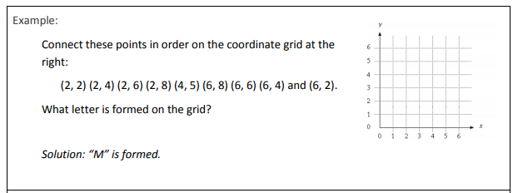  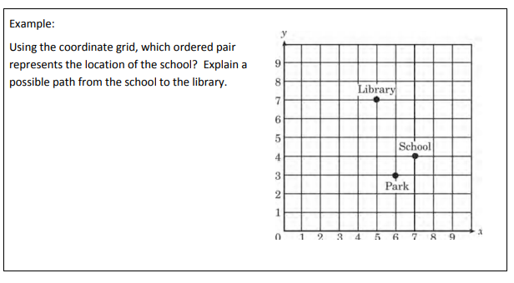 | Interactive Learning Games: Playing games is a wonderful way to practice skills at home in a fun environment.  Create a hierarchy diagram using the key words for types of quadrilaterals.  Websites:  https://www.mathsisfun.com/geometry/quadrilaterals-interactive.html  https://www.math10.com/en/math-games/games/geometry/games-cali-coordinate-system.html  https://www.khanacademy.org/math/cc-fifth-grade-math/cc-5th-geometry-topic  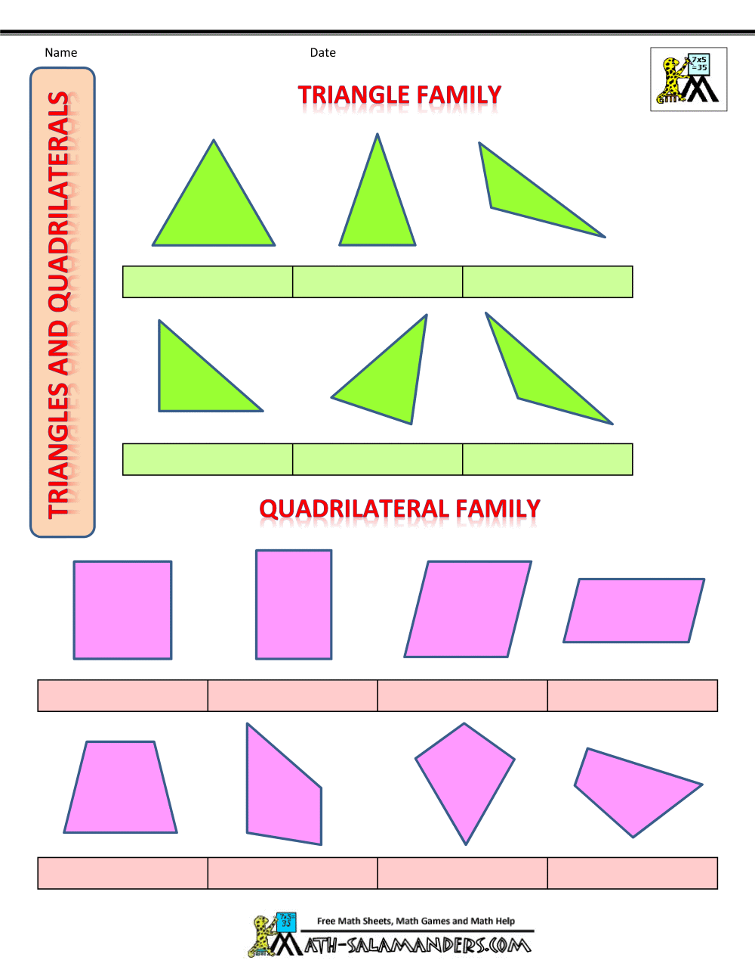

Sample Problems

