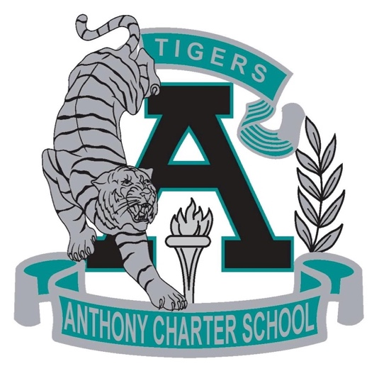

Public Notice
(Notificamiento Publico)

Anthony Charter School
Governing Council
(Junta del Cuerpo Escolar)
Monday, April 03th, 2017
(Lunes, Abril 03, 2017)
TIME: 6:00 pm
Location:
780 Landers
Anthony NM 88021

