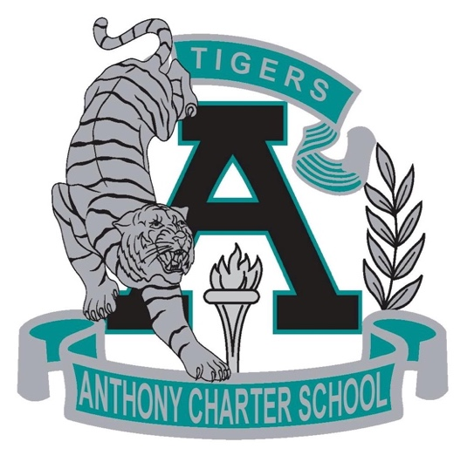

Public Notice
(Notificamiento Publico)

Anthony Charter School
Governing Council Special Meeting
(Junta del Cuerpo Escolar)
Saturday January 14th, 2017
(Saturday, Enero 14, 2017)
TIME: 10:00 am
Location:
780 Landers
Anthony NM 88021

