november newsletter
Spell, write, and identify too,
your name is so special because it belongs to you.
Pumpkins, apples, and colored leaves too;
Autumn is here, there is so much to do.
Counting, matching, and number names,
we will do by playing different math games.
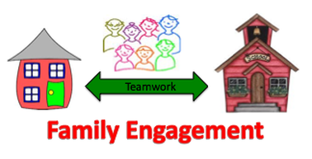
If you have a special family fall activity (apple or pumpkin picking, creating a fall wreath using leaves or pinecones, dressing up for Halloween, etc.) you can send a picture or create a craft for your child to share with the class. If you send a picture or create a craft it will be displayed in our classroom and returned to you in December.

November 1: School Spirit Day. Please wear your koala school shirt or a blue shirt.
November 3: Picture Day. Please place your child's picture money in their folder on this day. It will not be collected before the date.
November 7: Election Day: No School for students
November 9: Students will be dismissed at 11:00 a.m. for Parent Teacher Conferences.
Parent Teacher Conferences will be held during the following times:
Afternoon session 12:20 p.m. - 2:20 p.m.
Evening session: 4:00 p.m. - 7:30 p.m.
Please contact your child's teacher on ClassDojo if:
you would like to schedule an appointment
you are unable to make the appointment time
you need an alternate appointment
November 13: World Kindness Day. Students can wear a shirt that states a positive word or
message.
November 14: Please join your child in their classroom at 1:20 p.m. for a Family Engagement
Activity.
November 21: PTA meeting: a notice will be sent with the link.
November 23-24: Thanksgiving: School will be closed.

Visit https://www.schools.nyc.gov/schools/k212 Click on “Reports” to view our CEP and additional information.

