Resizing Images for your Website
It has been brought to our attention that the website images are too large. Because of this, they are taking a significant amount of time to load and using a large amount of bandwidth. It has also become an accessibility issue. All photos need to be reduced in size. Please use the following directions to help with this process.
Appropriate pixel size for Images
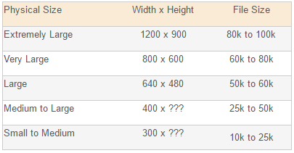
*NOTE: Please use the smallest possible size for your purposes.
Changing Image Size
- Open up Windows Explorer using the icon at the bottom of your screen.
- I would recommend creating 1 folder to put all pictures for your website. Move all your pictures to the folder.
- Right click on the first image you want to open.
- Scroll down the menu and choose Open With. Then choose Paint.
- The picture will open in Paint. At the top of the menu you will see the below on the top right:
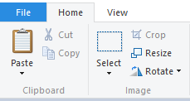
- Choose Resize and a Menu will pop up.
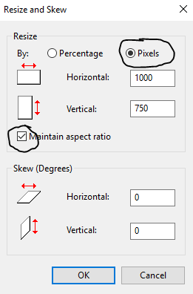
- Make sure that pixels is chosen and that you have Maintain Aspect Ratio box checked.
- Change the top number to the smallest size you can for your purposes (See Table Above). Click Ok.
- Then Save your image as a JPEG with a new name.
- Complete this for all pictures and then re-upload the images to your eChalk Site.

