Community Schools at PS/MS 123 Mahalia Jackson Go Green
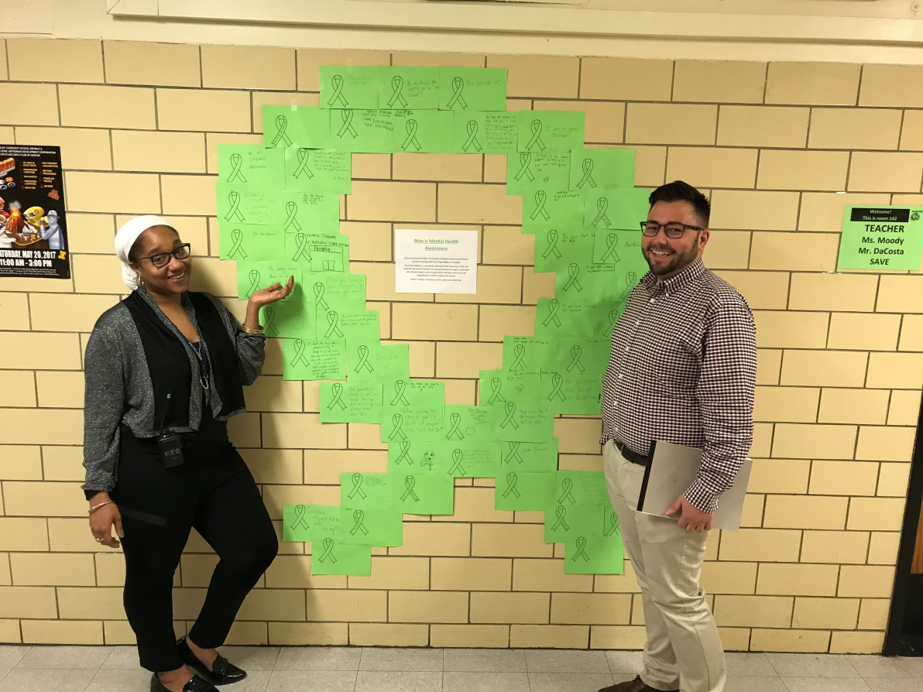

In commemoration of Mental Health Awareness Month, the Graham Wellness Center at PS 123 Mahalia Jackson hosted a Green Ribbon Campaign during the week of May 15th. Wellness Clinician Raymond Blanchard (Mr. Ray) and Mrs. Renisse Baiden tabled during the students lunch periods and collaborated with students, teachers and other school and community based organization faculty to write positive messages that will be placed on green ribbon sheets, which were placed around the school
“The goal is to spread awareness and break the stigma of Mental Health.” said Raymond Blanchard.
PS 123 Mahalia Jackson currently has 26 students serviced through their school based mental health clinic and plan to increase to 35 students and families during the next school year.

Green Light for Literacy
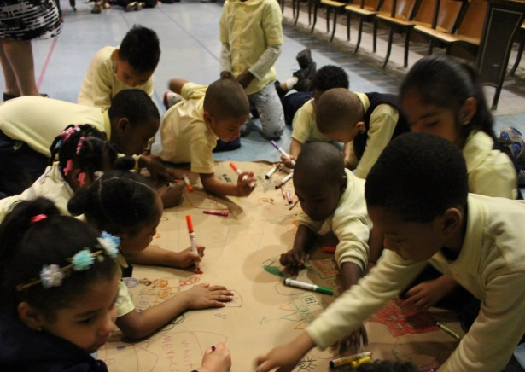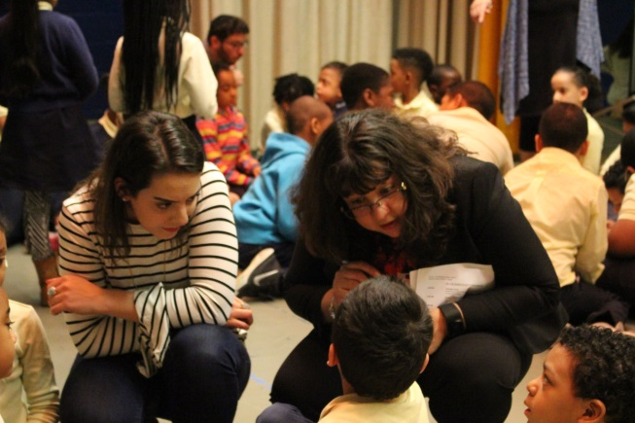

PS/MS 123 Mahalia Jackson is the place everyone wants to go. On Friday May 12, 2017, K- 3rd grade students celebrated literacy with top selling publishing company, Penguin Random House. An ongoing partnership developed by Graham Windham, students, teachers, administrators and other faculty and staff went through a 3 month series of having Penguin House volunteers host book readings during elementary classrooms at PS 123M. Students were engaged in activities that tied to theme of the book and were also gifted free books throughout the year to take home.
“Literacy and art is paramount in our school. The more we encourage and support our students to read, the more confident and fluent they become.” said Tina Hernandez, Principal.
Families are always invited to the school’s literacy events and are often provided with free books to link literacy with school-home connections. The students were thankful for t
“I love my journal. I am going to write in it every day.” said a 2nd grade student.
“All the Place You Will Go” by Dr. Seuss was the culminating event theme. The school often encourages students to find themselves through literacy and the art as well as to dream big to achieve their goals.

