|  |  |
| --- | --- |
| **Subject: Geometry Unit: Two** | |
| **Unit Topic and Length:**  **PROPERTIES OF TRIANGLES – CONGRUENCE, SIMILARITY & TRIGONOMETRY (3 weeks)** | |
| **Common Core Learning Standards:**  **G-CO.10** Prove theorems about triangles. *Theorems include: measures of interior angles of a triangle sum to 180°; base angles of isosceles triangles are congruent; the segment joining midpoints of two sides of a triangle is parallel to the third side and half the length; the medians of a triangle meet at a point.*  **G-SRT.4** Prove35 theorems about triangles. *Theorems include: a line parallel to one side of a triangle divides the other two proportionally, and conversely; the Pythagorean Theorem proved using triangle similarity*.  **G-SRT.5** Use congruence and similarity criteria for triangles to solve problems and to prove relationships in geometric figures.  **G-C.3** Construct the inscribed and circumscribed circles of a triangle, and prove properties of angles for a quadrilateral inscribed in a circle.  **G-CO.7**  Use the definition of congruence in terms of rigid motions to show that two triangles are  congruent if and only if corresponding pairs of sides and corresponding pairs of angles are  congruent.  **G-CO.8** Explain how the criteria for triangle congruence (ASA, SAS, and SSS)follow from the definition of congruence in terms of rigid motions  **G-CO.9** Prove34 theorems about lines and angles. *Theorems include: vertical angles are congruent; when a transversal crosses parallel lines, alternate interior angles are congruent and corresponding angles are congruent; points on a perpendicular bisector of a line segment are exactly those equidistant from the segment’s endpoints.*  **G-SRT.6** Understand that by similarity, side ratios in right triangles are properties of the angles in the triangle, leading to definitions of trigonometric ratios for acute angles.  **G-SRT.7** Explain and use the relationship between the sine and cosine of complementary angles.  **G.SRT.8**  Use trigonometric ratios and the Pythagorean Theorem to solve right triangles in applied  problems.  **G.SRT.9**  Derive the formula A = 1/2 ab sin(C) for the area of a triangle by drawing an auxiliary line from a vertex perpendicular to the opposite side.  **G.SRT.10**  Prove the Laws of Sines and Cosines and use them to solve problems.  **G.SRT.11**  Understand and apply the Law of Sines and the Law of Cosines to find unknown  measurements in right and non-right triangles | |
| **Big Ideas/Enduring Understandings:**   |  | | --- | | Comparing the corresponding parts of two figures can show whether the figures are congruent. |  |  | | --- | | Two triangles can be proven to be congruent without have to show that all corresponding parts are congruent. |  |  | | --- | | If two triangles are congruent, then every pair of their corresponding parts is also congruent. |  |  | | --- | | The midsegment of a triangle can be used to uncover relationships within a triangle. |  |  | | --- | | Geometric figures such as angle bisectors and perpendicular bisectors can be used to cut the measure of an angle or segment in half.  Proving identities requires the use of the rules of arithmetic and algebra to produce equivalent expressions.  Evaluating trigonometric functions requires the use of arithmetic and algebraic rules and geometric analysis to understand degree and radian measure.  Relationships between trigonometric quantities can be represented symbolically, numerically, graphically and verbally in the exploration of real world situations | | **Essential Questions:**   |  | | --- | | How can technology be utilized to investigate and explore geometric properties? |  |  | | --- | | Can I logically communicate my mathematical reasoning in writing as well as orally? |  |  | | --- | | How do you show that two triangles are congruent? |  |  | | --- | | How do you solve problems that involve measurements of triangles? |   When and how is trigonometry used in solving real world problems?  How do I determine trigonometric characteristics of problems that would determine how to model the situation and develop a problem solving strategy? |

|  |  |  |
| --- | --- | --- |
| **Content:**  **Congruent Triangles**  **Corresponding parts of congruent triangles**  **Isosceles and Equilateral**  **Congruence in Right Triangles**  **Midsegments of triangles**  **Perpendicular bisectors of angles and sides.**  **Define trigonometric ratios and solve problems involving right triangles** | **Skills:**  Understanding the properties of different types of triangles -- scalene, isosceles and equilateral, as well as obtuse, right and acute.  Understanding the sum of the angles of a triangle add up to 180 degrees.  Understanding the exterior angle theorem for triangles.  Understanding that corresponding parts of congruent triangles are congruent.  The midsegment theorem for triangles.  Understanding the constructions of perpendicular bisectors for sides of a triangle.  Knowing how to construct angle bisectors.  Knowing how to construct the altitudes of a triangle.  Sketch the unit circle and represent angles in standard position.  Express and apply the six trig functions as ratios of the sides of a right triangle. **A2.A55**  Sketch and use the reference angle for angles in standard position (for the unit circle). **A2.A57**  terminal side of angle θ.  Use inverse functions to find the measure of an angle, given its sine, cosine, or tangent **A2.A64**  Determine the length of an arc of a circle,  given its radius and the measure of its central angle. **A2.A60, A2.A61**  Sketch and recognize one cycle of a function of the form: y = A sin Bx or y = A cos Bx.  Use inverse functions to find the measure of an angle, given its sine, cosine, or tangent.  Solve for an unknown side or angle, using the Law of Sines or the Law of Cosines **A2.A73**  Determine the area of a triangle or a parallelogram, given the measure of two sides and the included angle  **A2.A74**  Determine the solution(s) from the SSA situation (ambiguous case) **A2.A75** | **Days:** |
| **Assessment Evidence and Activities:**  Pre and Post Tests (formative assessment and assessments for evidence of growth)  Problem Solving Tasks and Activities  Quizzes  Questioning and Observations  Do Nows and Exit Slips  Class work and Homework | | |
| **Possible Support Strategies:**  Use of manipulatives  Word Walls and Individual Glossaries  Journals  Back Tracking Technique demonstrated for solving equations | | |
| **Formative Assessment:**  The assessments listed above will be used to identify students’ strengths and weaknesses.  There will be constant adjustments and fine tuning of the curriculum delivery based on this analysis. Sharing student work, sharing best practice and planning next steps will be an integral part of common planning meetings. | | |
| **Final Performance Based Task: See Attached** | | |
| **Extension:**  Differentiated column sheets for order of operations and evaluating like terms.  Table logic for adding and subtracting integers and polynomial expressions.  Differentiated column sheets for solving equations. | | |
| **Learning Plan & Activities:**  The learning plan will incorporate work shop style lessons which will allow for student centered learning. Group work will be incorporated into various concepts with a focus on students learning collaboratively. There will be an emphasis on technique to enable students to solve skills based questions. This will be supported with problem solving exercises for all content to give students a conceptual understanding of the material. | | |
| **Resources:**  Text book : Meaningful Math Algebra I Prentice Hall Mathematics Algebra I  Graphing calculators  Geometric Manipulatives, Sketchpad  Smart Board Demonstrations  Problem solving materials created by teachers | | |

**Hopewell Native AmericanTask**

The Hopewell people were Native Americans whose culture flourished in the central Ohio Valley about 2000 years ago. The Hopewell people constructed earthworks using right triangles, including those below.

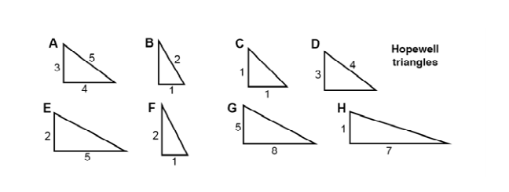

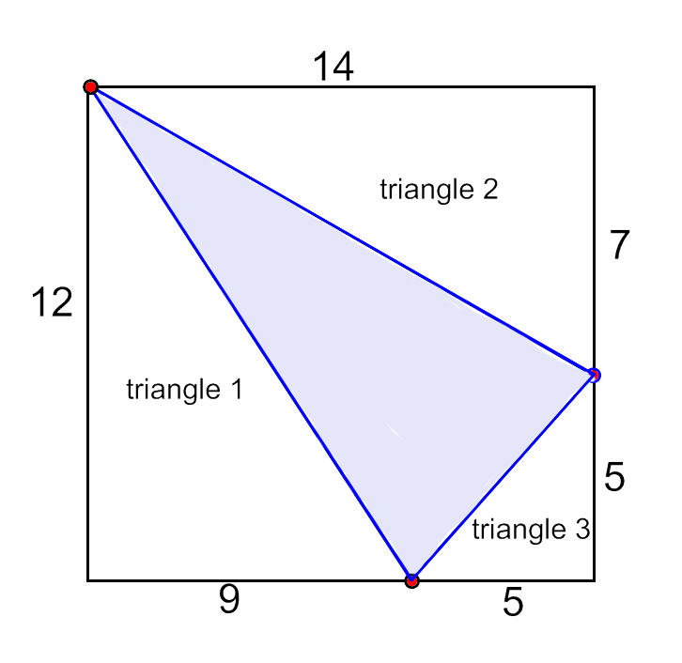

The three right triangles surrounding the shaded triangle form a rectangle measuring 12 units by 14 units.

Each of these three right triangles is similar to one of the Hopewell triangles on the previous page.

For example: Triangle 3 above is similar to Hopewell Triangle C.

Explain how you know this is true?

_____________________________________________________

_____________________________________________________

_____________________________________________________

_____________________________________________________

Which Hopewell triangle is similar to Triangle 1?

Explain how you know?

_____________________________________________________

_____________________________________________________

_____________________________________________________

_____________________________________________________

Which Hopewell triangle is similar to Triangle 2?

Explain how you know?

_____________________________________________________

_____________________________________________________

_____________________________________________________

_____________________________________________________

Is the shaded triangle a right triangle?

Explain how you know?

_____________________________________________________

_____________________________________________________

_____________________________________________________

_____________________________________________________

FLAGS AND CONGRENT TRIANGLES TASK

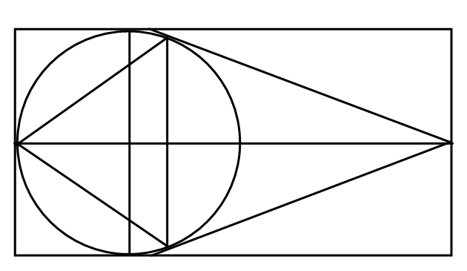

A circle with center O is inscribed in a rectangle so that it is tangent at three points at E, F and D.  and  are tangents to the circle. FCA  FBA.

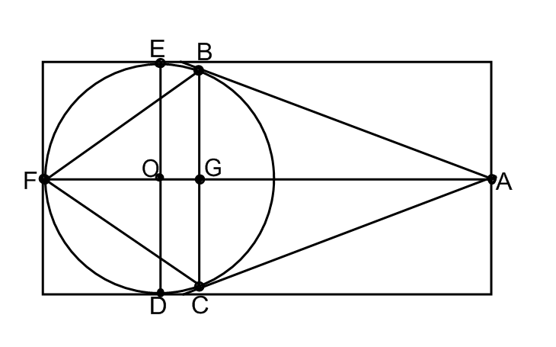

How many congruent triangles can you find? How do you know they are congruent?

**A Performance Task on Centers of Triangles**

A developer plans to build an amusement park but wants to locate it within easy access of the three largest towns in the area as shown on the map below. The developer has to decide on the best location and is working with the ABC Construction Company to minimize costs wherever possible. No matter where the amusement park is located, roads will have to be built for access directly to the towns or to the existing highways.

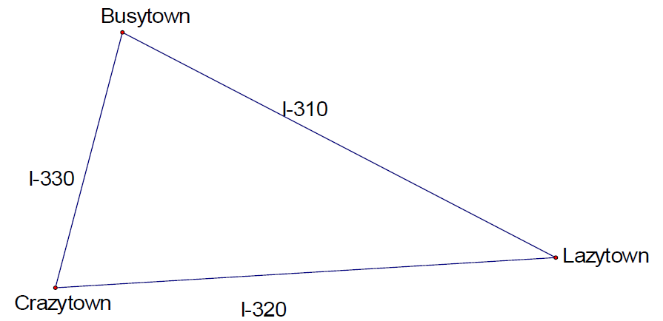

1. Just by looking at the map, choose the location that you think will be best for building the amusement park. Explain your thinking.

2. Now you will use some mathematical concepts to help you choose a location for the tower.

Investigate the problem above by constructing the following:

i. all 3 medians of the triangle

ii. all 3 altitudes of the triangle

iii. all 3 angle bisectors of the triangle

iv. all 3 perpendicular bisectors of the triangle

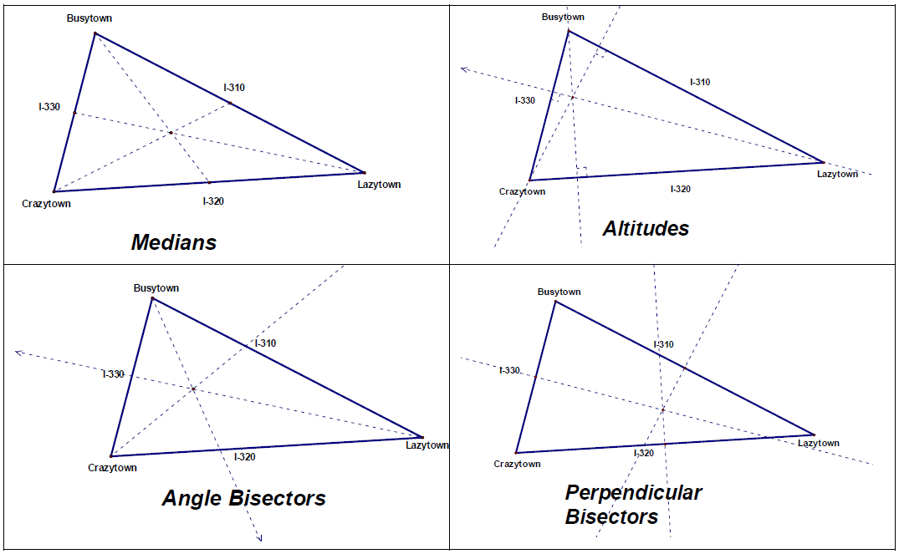

3. Choose a location for the amusement park based on the work you did in part 2. Explain why you chose this point.

***Solution***

***Answers will vary, but it is critical for students to have a mathematical justification for their decision. For example, they may choose the circumcenter because it is equidistant from all three cities. Or they may choose the incenter because it is equidistant from each of the roads. They could choose the centroid instead of the circumcenter because it is closer to two of the cities while not being that much further away from Lazytown.***

There is a variety of questions below which can be used for review or independent work where students choose their own starting point depending on their perceived needs.

Name : _________________________ Date : ____________

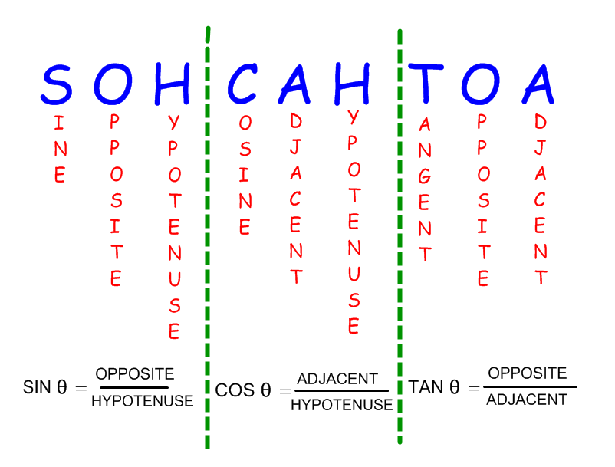

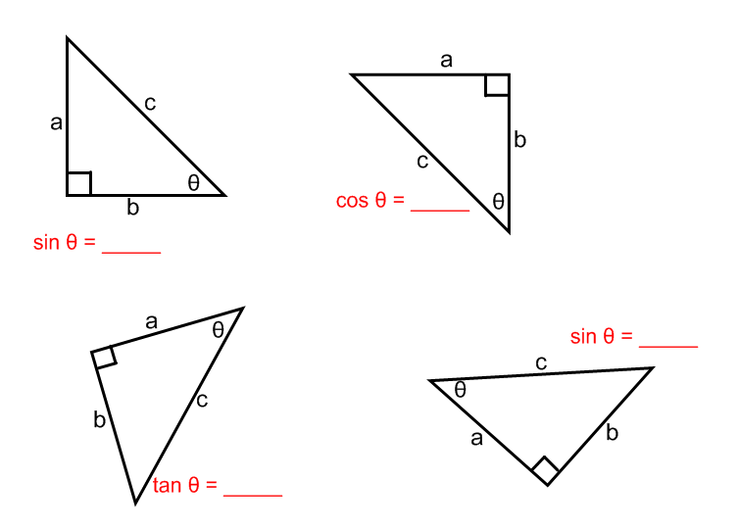

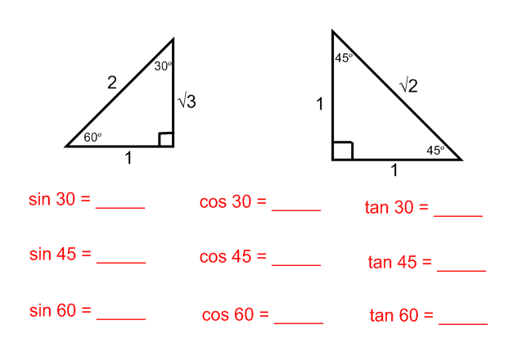

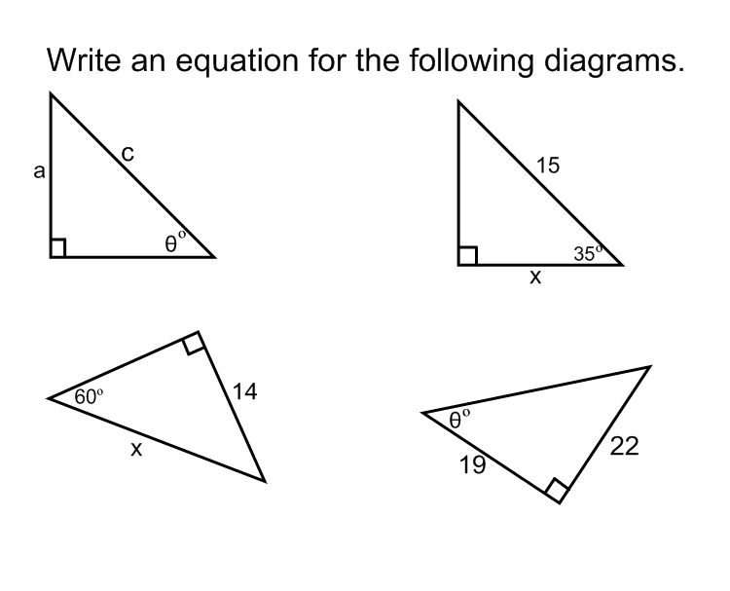

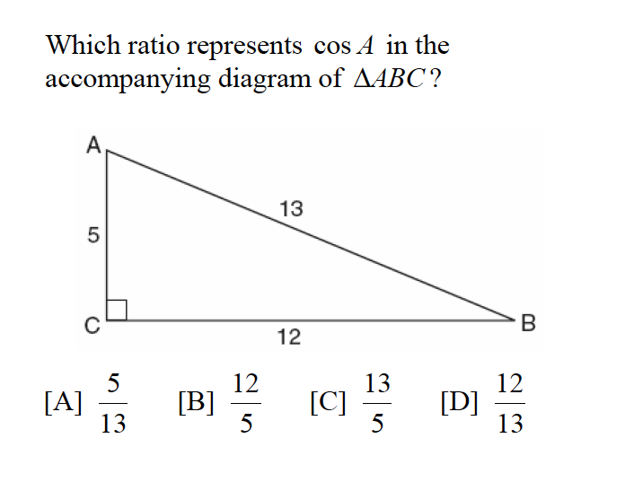

In the diagram above what trigonometric ratio could  be?

In the diagram above what trigonometric ratio could  be?

============================================================

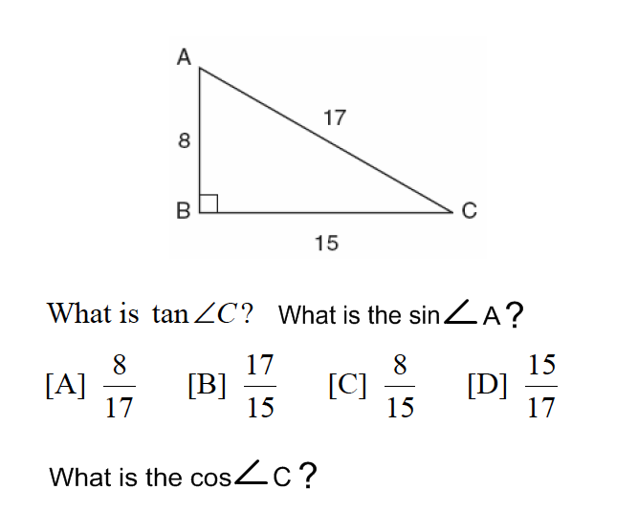

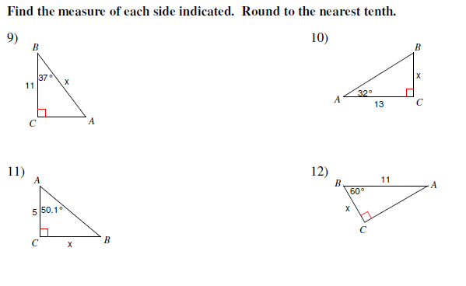

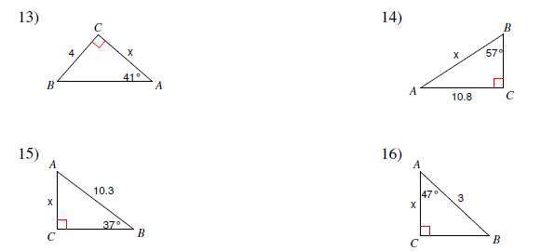

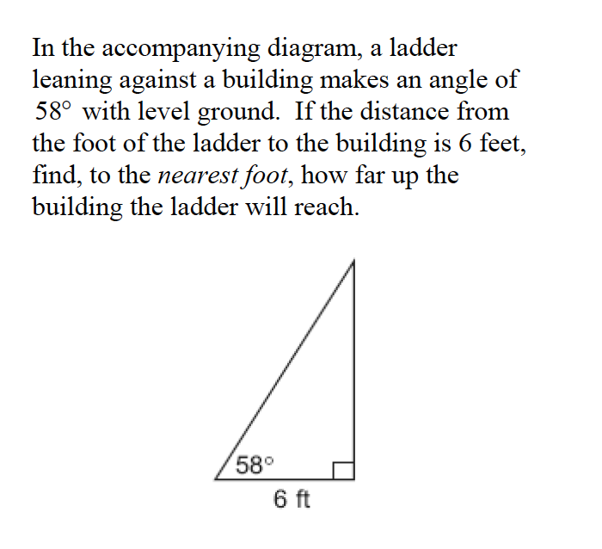

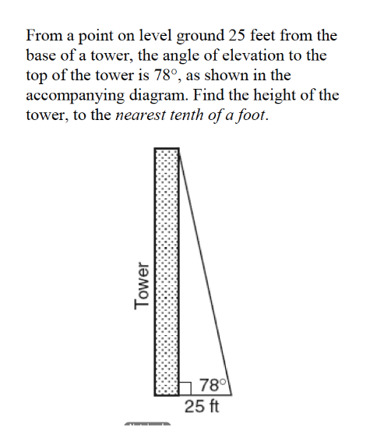

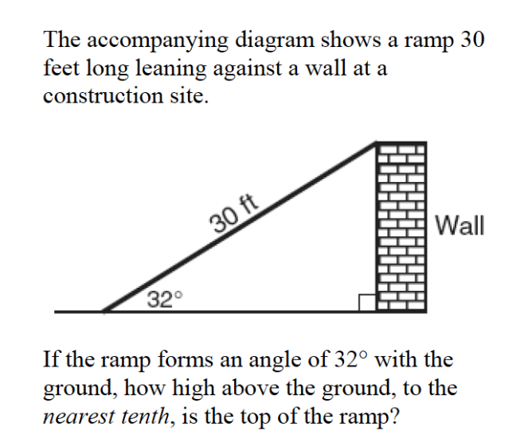

===========================================================

A tree casts a shadow that is 20 feet long. The angle of elevation from the end of the shadow to the top of the tree is 66°. Determine the height of the tree, to the *nearest foot.*

===========================================================

A ship on the ocean surface detects a sunken ship on the ocean floor at an angle of depression of 50°. The distance between the ship on the surface and the sunken ship on the ocean floor is 200 meters. If the ocean floor is level in this area, how far above the ocean floor, to the *nearest meter*, is the ship on the surface?

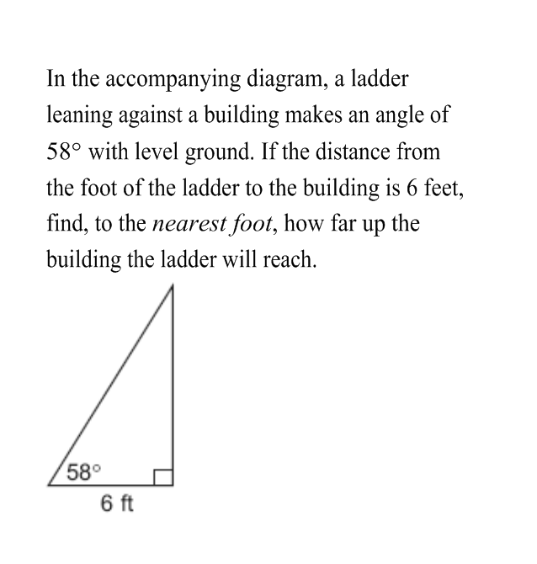

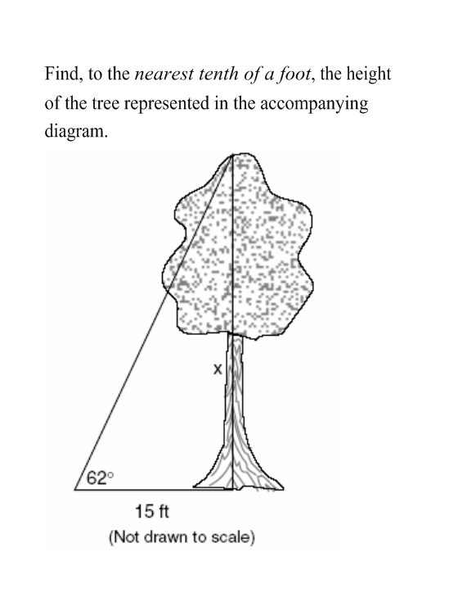

Joe is holding his kite string 3 feet above the ground, as shown in the accompanying diagram. The distance between his hand and a point directly under the kite is 95 feet. If the angle of elevation to the kite is 50°, find the height, h, of his kite, to the nearest foot.

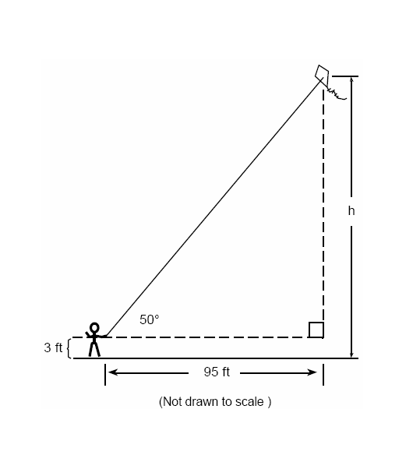

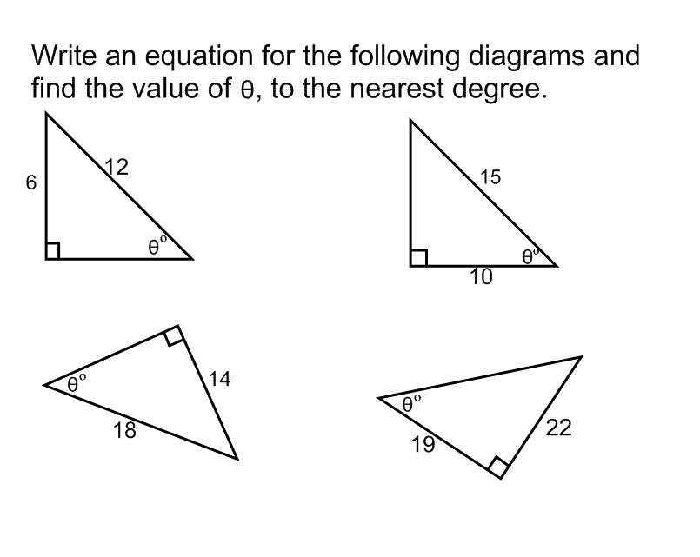

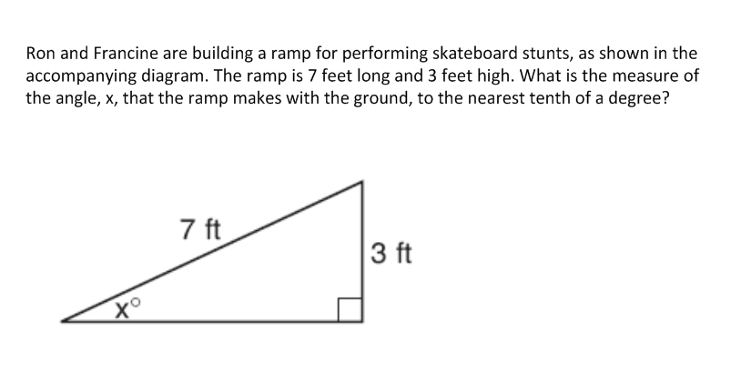

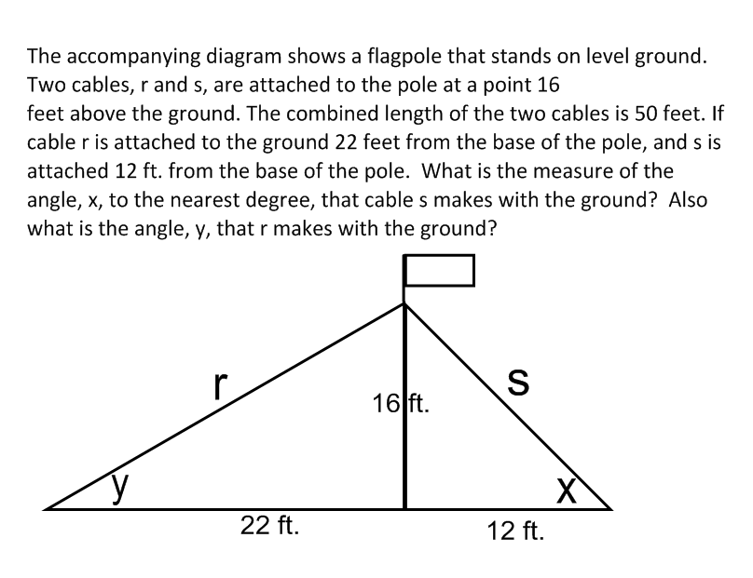

Name : __________________________ Date : ____________

**Common Core Performance Task for Trigonometry**

***Graph trigonometric functions, showing intercepts and end behavior, and showing period, midline, and amplitude.***

Mathematical Goals •

Collect data and represent with a graph

Determine if a relationship represents a function Identify characteristics of a graph.

The hands of a clock on a wall move in a predictable way. As time passes, the distance between the ceiling and the tip of the hour hand changes. We want to investigate how this distance has changed over a twelve hour period.

Let’s simulate the situation using a clock and the diagram below.

The hour hand in this case goes all the way to the rim of the clock and is 40 cm long. You need to calculate the distance between the tip of the hour hand and a line representing the ceiling every hour on the hour.

Directions: Work in pairs. You will need a ruler, graph paper, the sheet with the clock and the ceiling. Record your distances in a table and graph your results explaining what type of relationship you have found.

|  |  |  |  |  |  |  |  |  |  |  |  |  |  |
| --- | --- | --- | --- | --- | --- | --- | --- | --- | --- | --- | --- | --- | --- |
| **Time** | **12 PM** | **1** | **2** | **3** | **4** | **5** | **6** | **7** | **8** | **9** | **10** | **11** | **12** |
| **Distance from the ceiling (cm)** |  |  |  |  |  |  |  |  |  |  |  |  |  |

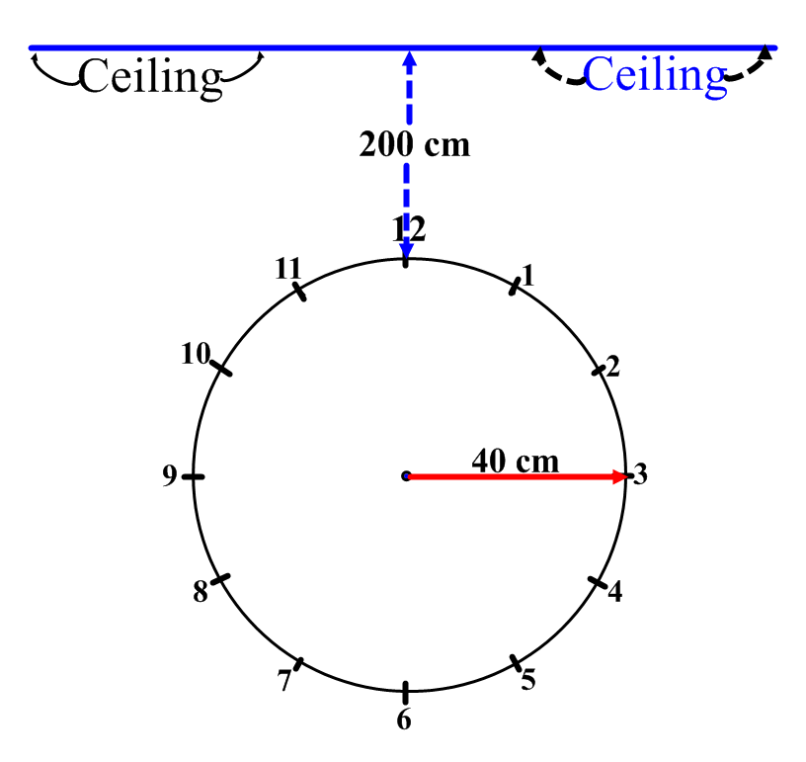

Y = (40-40cos(x)) + 200

Name: _________________________ Date : _____________

**Ferris Wheel Performance Task**

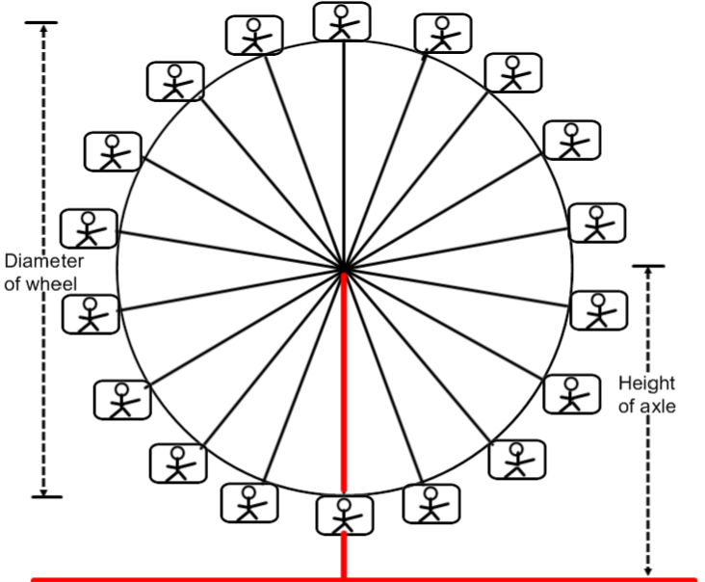

A Ferris Wheel is 70 meters in diameter and rotates once every three minutes. The center axle of the Ferris Wheel is 50 meters from the ground.

|  |  |  |  |  |  |  |  |
| --- | --- | --- | --- | --- | --- | --- | --- |
| **Time**  **(minutes - seconds)** | **0min 0sec** | **min 10sec** | **min 20sec** | **min 30sec** | **min 40sec** | **min 50sec** | **1min 60sec** |
| **Height of Passenger above ground (m)** | **15** | **17.11** | **23.19** | **32.5** | **43.92** | **56.08** | **67.5** |

|  |  |  |  |  |  |  |  |
| --- | --- | --- | --- | --- | --- | --- | --- |
| **Time**  **(minutes)** | **min 70sec** | **min 80sec** | **min 90sec** | **min 100sec** | **min 110sec** | **2min 120sec** | **min 130sec** |
| **Height of Passenger above ground (m)** | **76.81** | **82.89** | **85** | **82.89** | **76.81** | **67.5** | **56.08** |

|  |  |  |  |  |  |
| --- | --- | --- | --- | --- | --- |
| **Time**  **(minutes)** | **min 140sec** | **min 150sec** | **min 160sec** | **min 170sec** | **3min 180sec** |
| **Height of Passenger above ground (m)** | **43.92** | **32.5** | **23.19** | **17.11** | **15** |

1. Using the axes below, sketch a graph to show how the height of a

passenger will vary with time. Assume that the wheel starts rotating when the passenger is at the bottom. Because there are 18 carriages, this means that to get to each new position it will take :

(3 x 60)/18 seconds or ten seconds which equates to ****min.

Also angle A would be 360/18 or 20 degrees. Thus the height above the ground would now be (35 – 35Cos 20o) + 15.

This = (35 – 35 x .9397) + 15 = (35 – 32.8892) + 15  17.11

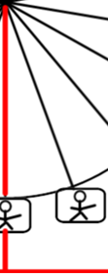

A**minmin**

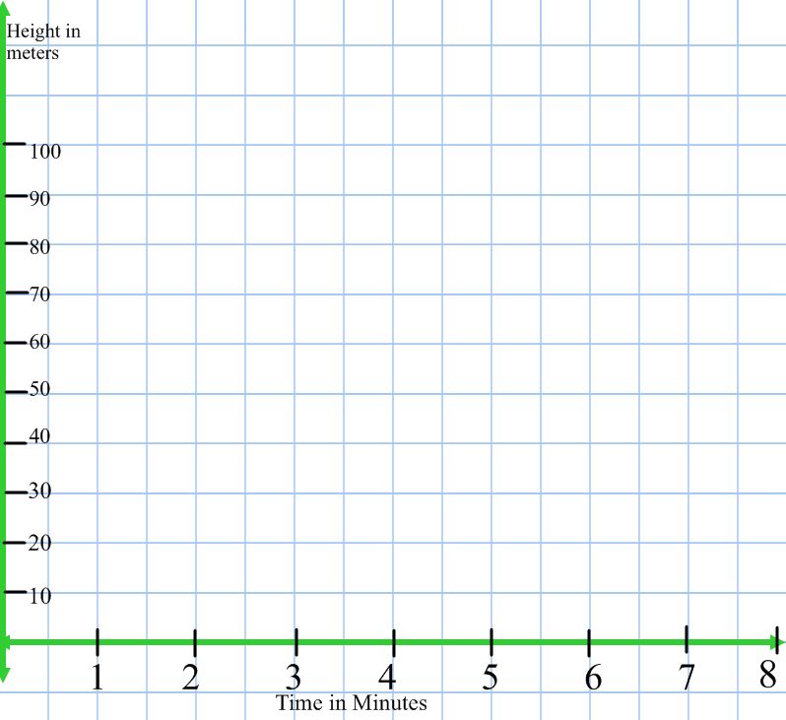

A mathematical model for this motion is given by the formula:

h = a - bcos(ct) where h = the height of the car in meters

t = the time that has elapsed in minutes

a, b, c are constants. Find values for a, b and c that will model this situation.

_____________________________________________________________

______________________________________________________________

______________________________________________________________

______________________________________________________________

______________________________________________________________

______________________________________________________________

_____________________________________________________________

______________________________________________________________

______________________________________________________________

______________________________________________________________

______________________________________________________________

______________________________________________________________

_____________________________________________________________

______________________________________________________________

______________________________________________________________

______________________________________________________________

______________________________________________________________

______________________________________________________________

Look at the cards on the next three pages and match them in to six sets of three.

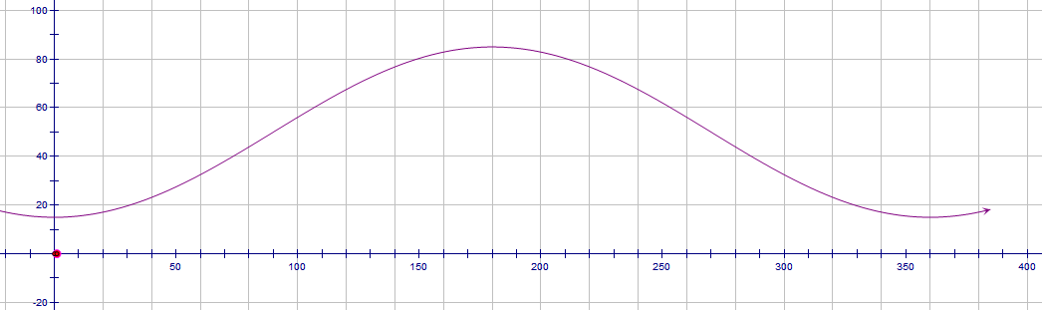

**University Neighborhood High School**

**Geometry Pre–Test SIMILAR TRIANGLES & TRIGONOMETRY**

Name : ___________________________________ Date : _____________

1.) State whether  and  are congruent.



[A] yes, by either SSS or SAS

[B] yes, by SSS only

[C] yes, by SAS only

[D] No; there is not enough information to conclude that the triangles are

congruent.

2.) Based on the given information, what can you conclude, and why?

**Given:** H  L and HJ  JL



[A] HIJLKJ by ASA [B] HIJJLK by AAS

[C] HIJJLK by SAS [D] HIJLKJ by SAS

3.) Name the theorem or postulate that lets you immediately conclude





[A] SAS [B] ASA [C] AAS [D]none of these

4.) A lamppost is 6 feet high and casts an 8-foot shadow. At the same time of day,

a flagpole directly behind the lamppost casts a 28-foot shadow.



Which proportion can be used to find the height, *H*, of the flagpole?

[A] *= * [B] * = * [C] * = * [D] * = *

5.) Two ladders are leaning against a wall at the same angle as shown. How far up the wall does the shorter ladder reach?



[A] 8 ft [B] 10 ft [C] 6 ft [D] 20 ft

6.) Use similar triangles to find *x*.



[A] 1.5 ft [B] 2.67 ft [C] 1.25 ft [D] 6 ft

7.) Use the Side-Splitter Theorem to find *x,* given that .



[A] 12 [B] 6 [C] 20 [D] 24

8.) Given , solve for *x*.The diagram is not drawn to scale.



[A]  [B]  [C]  [D] 

9.) In the figure shown, *BC* || *DE* , *AB* = 2 yards, *BC* = 9 yards, *AE* = 36 yards, and

*DE* = 36 yards. Find *BD*.



[A] 9 yd [B] 8 yd [C] 6 yd [D] 27 yd

10.) The accompanying diagram shows part of the architectural plans for a structural support of a building. *PLAN* is a rectangle and *AS* *LN*. Which equation can be used to find the length of *AS* ?



[A]** = ** [B] *=*

[C] *=*  [D] *=*

11.) Use the diagram below to solve for *a* and for *b.*



[A] ** [B] **

[C] ** [D] **

12.) Use the diagram below to solve for *a* and for *b.*



[A]  [B] 

[C]  [D] 

17) The side of a square measures 6 cm. What is the exact length of the diagonal of the square?

1. The length of the hypotenuse of a right triangle is 32 inches and the length of one of the legs is 18 inches. What is the length, to the *nearest tenth* of an inch, of the other leg of the triangle?
2. A light post, shown at the right, is set in concrete and supported with a wire while the concrete dries. The length of the wire is 10 feet and the ground stake is 4 feet from the bottom of the light post. What is the height of the light post, *x*, from the ground to the top of the light post?   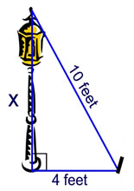
3. What is the value of *x* in the diagram at the right?

.

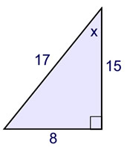

1. From a point, *G*, on the ground, the angle of elevation of an airplane is 21º. The altitude of the plane is 2200 meters. What is the distance from point *G* to the airplane, to the nearest tenth of a meter?

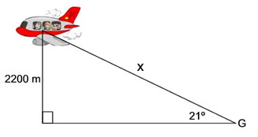

1. Find to the *nearest degree*, the number of degrees in the angle labeled Description: theta, in the diagram at the right.(*Hint: this is a two step problem. Use the small triangle on the left to help find needed information.*)

