Replacing the Toner

Turning off / reset Toner sensor light:

- Make sure that the printer is turned on. Open the front cover.
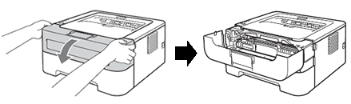

- Take out the drum unit and toner cartridge assembly

- Unpack the new toner cartridge. Hold the cartridge level with both hands and gently rock it from side to side five or six times to spread the toner evenly inside the cartridge.

- Pull off the protective cover.
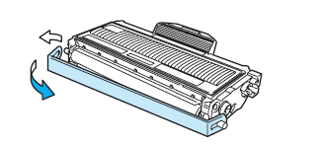

- Put the new toner cartridge firmly into the drum unit until you hear it lock into place. If you put it in properly, the lock lever will lift automatically.

- Clean the primary corona wire inside the drum unit by gently sliding the green tab from right to left and left to right several times

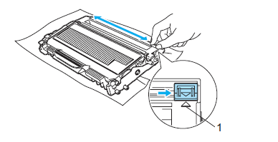

- Put the drum unit and toner cartridge assembly back in the printer. Close the front cover

Replacing the Drum Unit (2170W printers):

- Make sure that the printer is turned on and the Drum LED is blinking. Open the front cover.
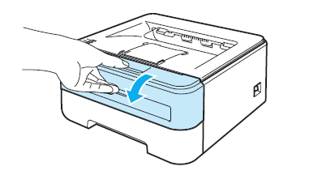
- Press and hold down the white Go button for about 4 seconds until all the LEDs light up. Once all four LEDs are lit, release the Go button.
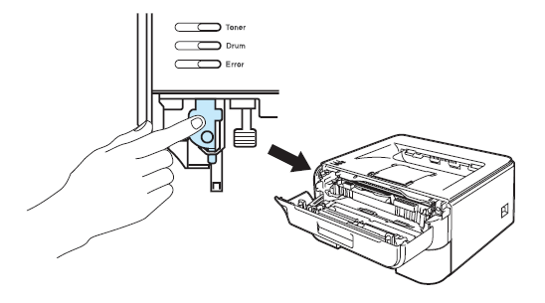
- Take out the drum unit and toner cartridge assembly.
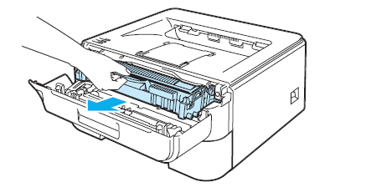
- Push down the green lock lever and take the toner cartridge out of the drum unit.
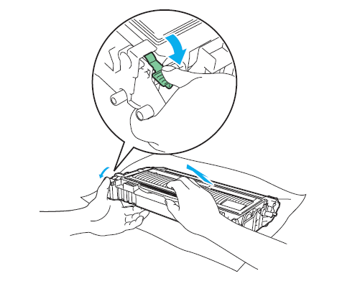
- Unpack the new drum unit.

- Put the toner cartridge firmly into the new drum unit until you hear it lock into place. If you put the cartridge in properly, the green lock lever will lift automatically.

- Put the drum unit and toner cartridge assembly back in the printer

- Close the front cover.

- Make sure that the Drum LED is now off.

You Must Now Reset the Drum Counter…

Is the Drum LED is still on or flashing after you replace the drum unit with a new one?
- Make sure that the machine is turned on.
- Open the front cover.
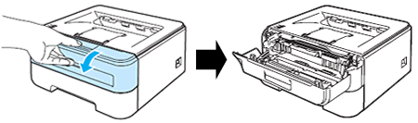
- To reset the drum counter, press and hold down Go for about 4 seconds until all the LEDs light up. Once all four LEDs are lit, release Go.
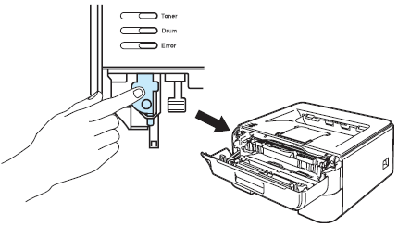

- Close the front cover.
- Make sure that the Drum LED is now off.

