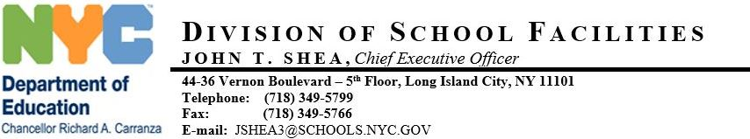

September, 18 2019
Steven Schwartz
P.S. 24 - BRONX
660 WEST 236 STREET
BRONX , NY 10463
RE: AHERA MANAGEMENT PLAN (AHERA)
In compliance with the U.S. Environmental Protection Agency (US EPA) Asbestos Hazard Emergency Response Act (AHERA), 40 CFR Part 763, Subpart E, the New York City Department of Education has performed an inspection of the asbestos containing building materials (ACBM) in your school.
This inspection was performed by accredited asbestos inspectors certified by the New York State Department of Labor and the U.S. Environmental Protection Agency. An accredited management planner, also certified by both agencies, reviewed the results of the inspection and recommended actions that should be taken to safely manage asbestos materials in the building.
The results of the inspection are contained in the AHERA Management Plan, which is available at the administrative office or custodian office for review by the public, including parents, teachers and other school personnel, and their representatives without any cost or restriction. Please share copies of this notification with the Parent Association President, UFT Chairperson and the custodian. However, you should post copies of this notification in the administrative office, custodial office, and faculty common rooms. Should there be any questions about asbestos in the building, I can be reached at (718) 610-3111. Your cooperation is greatly appreciated.

