**GEOMETRY -- UNIT PLAN**

**TRANSFORMATIONS**

**Table of Contents**

Unit Template ………………………………………….. 2

Lead Up Tasks 1 & 2 ………………………………….... 6

Review Isometry Properties …………………………….. 8

Notation of Transformations …………………………… 9

Transformation Project …………………………………. 10

Transformation Vocabulary ……………………………. 16

First Performance Task …………………………………. 17

Task Rubric ……………………………………………... 22

Second Performance Task ……………………………… 24

Pre Test ………………………………………………… 28

Bulletin Notices for Transformations …………………… 35 Post Test ………………………………………………… 40

|  |  |
| --- | --- |
| **Subject: Geometry Unit: SIX** | |
| **Unit Topic and Length:**  **Transformations -- 3 WEEKS** | |
| **Unit Summary**  The unit will focus on the family of quadrilaterals and the properties that the different types have as well proving angle measures. The unit will focus on giving students a deep conceptual understanding of the four different types of transformations. We will investigate translations, reflections, rotations and dilations. We will also work on compound transformations. There will be pre and post test assessments and a performance based assessment where students will investigate the end products of robotic assembly lines which use transformation properties to create their products. | |
| **Common Core Learning Standards:**    **G-CO.2** Represent transformations in the plane using, e.g., transparencies and geometry software; describe transformations as functions that take points in the plane as inputs and give other points as outputs. Compare transformations that preserve distance and angle to those that do not (e.g., translation versus horizontal stretch).  **G-CO.3** Given a rectangle, parallelogram, trapezoid, or regular polygon, describe the rotations and reflections that carry it onto itself.  **G-CO.4** Develop definitions of rotations, reflections, and translations in terms of angles, circles, perpendicular lines, parallel lines, and line segments.    **G-CO.5** Given a geometric figure and a rotation, reflection, or translation, draw the transformed figure using, e.g., graph paper, tracing paper, or geometry software. Specify a sequence of transformations that will carry a given figure onto another. | |
| **Big Ideas/Enduring Understandings:**  Transformations, symmetry, and spatial reasoning can be used to analyze and model mathematical situations.  The exploration of the concepts related to transformations can give insight into the design of structures. | **Essential Questions:**  Why is symmetry an important property?  Where in nature do we see symmetry?  What is the importance of transformations to the real world and to our everyday lives?  How can we apply translations of shapes and use this to help us solve problems?  What are the characteristics and applications of rotations?  How many ways can an object be reflected in the coordinate plane and what practical applications do we regularly see aligned to reflections?  How are compound transformations uses in assembly lines?  How are dilations used in the real world? What is the connection for scale drawings and dilations?  When do we call a quadrilateral a parallelogram?  What are the types of parallelograms and how do we distinguish them?  What types of polygons to we see regularly in everyday life?  What is the relationship between sides and internal angles of regular polygons?  Why is knowledge of properties of the circle important to high school students?  What is the relationship between pi and the circumference of a circle?  Where do we use our knowledge of circles to solve real world problems? |

|  |  |  |  |
| --- | --- | --- | --- |
| **ASSESSMENT TIME LINE** | | | |
| **Start of Unit** | | **Throughout the Unit** | **End of Unit** |
| A pre-test will be given to see what knowledge the students have based on their mathematics learnt in high school. This information will be used to form group work. | | Students will work on several lead ups tasks which are problem solving based and should help them prepare for the types of thinking skills they should use on their performance based assessment. | Students will do a self-reflection at the end of their common core aligned unit.  Teachers will also do a gap analysis of this work and they will address the needs of students based on the pre & post-test results. |
| **ASSESSMENT SUMMARY]** | | | |
| Students will be assessed in a variety of ways. There will observations conducted on a regular basis during independent work and guided practice. A variety of questioning techniques will be used to gather information on what students understand. Students will be assessed on the class work and home work that they complete. We will also use exit slips. There will be formal assessments in the way of a pre and post-test. Students will also be assessed on their problem solving strategies and their level of conceptual understanding. This will be done through a performance based assessment and three lead up problem solving tasks. | | | |
| **ACCOMMODATIONS FOR SPECIAL NEEDS** | | | |
| **Special Needs Students** | Students with special needs will have small group instructions for parts of the curriculum delivery. All problem solving tasks will be scaffolded to ensure there are entry points and lessons will be differentiated to target their needs. We will also make use of manipulatives. | | |
| **Nonnative Speakers** | If there are available translated versions for any of the material this resource will be utilized. Group work will be formed with their needs in mind. There will be diagrams and numeric representations for most of the material. | | |
| **Gifted/Talented Students** | The problem solving tasks will have a degree of rigor and open-endedness which will challenge these students at multiple levels. | | |

|  |  |
| --- | --- |
| **CONTENT** | **SKILLS** |
| **Experiment with**  **Transformations in the plane.**  **Understand similarity in**  **terms of transformations**  **Understand the different types of transformations and their properties.**  **Experiment with transformations**  **in the plane.**  **Apply geometric concepts in**  **Modeling situations.** | Represent transformations in the plane using, e.g., transparencies and geometry software;  Describe transformations as functions that take points in the plane as inputs and give other points as outputs.  Compare transformations that preserve distance and angle to those that do not.  Verify the properties of a dilation  Develop definitions of rotations, reflections, and translations in terms of angles, circles, perpendicular lines, parallel lines, and line segments and various geometric figures.  Examples of how transformations can be used in real world situations |

|  |  |
| --- | --- |
| **DAY** | **PACING FOR UNIT WITH LESSON CONTENT** |
| 1 | Pre Test |
| 2 | In depth look at translations. The effect of translations on point in the plane as well two dimensional figures. The properties preserved under translations. |
| 2 | In depth look at reflections. The effect of reflections on point in the plane as well two dimensional figures. The properties preserved under reflections. |
| 2 | In depth look at rotations. The effect of rotations on point in the plane as well two dimensional figures. The properties preserved under rotations. |
| 2 | In depth look at dilations. The effect of dilations on point in the plane as well two dimensional figures. The properties preserved under dilations. |
| 2 | Understand that a two-dimensional figure is similar to another if the second can be  obtained from the first by a sequence of rotations, reflections, translations, and  dilations. |
| 2 | Given two similar two- dimensional figures, describe a sequence that exhibits  the similarity between them. Examine the two figures and describe the  transformations that could have been used to map the object onto the image. |
| 2 | Performance Based Assessment on compound transformations. This component will be done collaboratively with a focus on achieving a conceptual understanding through discovery approach. |
| 2 | Performance Based Assessment on compound transformations. This component will be done collaboratively with a focus on achieving a conceptual understanding through discovery approach. |
| 1 | Post Test |

|  |
| --- |
| **Formative Assessment:**  The assessments listed above will be used to identify students’ strengths and weaknesses.  There will be constant adjustments and fine tuning of the curriculum delivery based on this analysis. Sharing student work, sharing best practice and planning next steps will be an integral part of common planning meetings. |
| **Standards of Mathematical Practices**    **1.** Make sense of problems and persevere in solving them.  **2.** Reason abstractly and quantitatively.  **3.** Construct viable arguments and critique the reasoning of others.  **4.** Model with mathematics.    **5.** Use appropriate tools strategically.  **6.** Attend to precision.  **7.** Look for and make use of structure.  **8.** Look for and express regularity in repeated reasoning. |
| **Final Performance Based Task:**  Attached Below :  Transformations – The Assembly Line |
| **Extension:**  Differentiated column sheets for order of operations and evaluating like terms.  Table logic for adding and subtracting integers and polynomial expressions.  Differentiated column sheets for solving equations. |
| **Resources:**  Text book : CMP 3 PEARSON’S Mathematics GEOMETRY  Graphing calculators Geometric Manipulatives, Sketchpad  Smart Board Demonstrations Problem solving materials created by teachers  Geo-boards Mirror Reflectors |

**Lead Up Task 1: Introduction to Reflections, Translations, and Rotations**

1. On your graph paper draw and label a square. Describe its original position and size.

Rotate it 90 degrees. Translate it so that it is in the 4th quadrant. Reflect it over a line

y="a number" so that the square is in the 1st quadrant. Write 2 distinctly different

ways that you can get the shape back in its original position.

2. On your graph paper draw and label a triangle. Describe its original position and size.

Rotate, Translate, and Reflect the triangle so that the one side is touching an original side in

such a way that it forms a parallelogram. List your steps here:

3. On your graph paper draw and label a parallelogram. Describe its original position and size. Rotate, Translate, and Reflect the parallelogram several times, listing your steps here:

Now, challenge a friend to get the parallelogram back into its original position! Are the steps

that your friend used the reverse of your steps, or are they different?

**Lead Up Task 2 :**

Antonio and his friend Brittany were at a summer math camp that had a large *coordinate plane* drawn on the gym floor. Antonio challenged Brittany to try and mirror him as he traveled around the first quadrant.

Map Antonio’s and Brittany’s movements on this coordinate plane:

Antonio began at (2, 1) and walked to (3, 5); Brittany decided to begin at (-2, 1), then tried to mirror Antonio by walking to (-3, 5). Antonio jumped to (5,5) and side-stepped to (4,3); Brittany jumped to (-5, 5) then side-stepped to (-4,3). Antonio returned to (2, 1) and Brittany returned to (-2, 1).

1. Did Brittany mirror Antonio?

• If you answered no, identify the incorrect coordinates Brittany used and find the correct coordinates. Explain your decision and identify the line of symmetry she should have used as a mirror. How did you know that this should have been the line of symmetry?

• If you answered yes, identify the line of symmetry Brittany used as a mirror. How did you know it was the line of symmetry?

2. If Brittany had instead begun at (-2,1), walked to (-4,3), side-stepped to (-5,5), jumped to (-3,5) and then returned to (-2,1), could she claim that she created a mirror image of Antonio’s path? Justify your answer.

Antonio and Brittany decided to change the game and use some lettered blocks to mark points they visited on the grid. Antonio placed blocks *A*, *B*, and *C* as indicated by the points below, then drew a chalk line between them.

3. Draw this figure on a separate sheet of graph paper. Label the coordinates Antonio used, and then construct the graph of where Brittany would place her blocks if she correctly reflected Antonio’s figure across the *x*-axis.



4. Describe how you determined where to place Brittany’s blocks.

5. Each block Brittany placed corresponds to one that Antonio placed. List each pair of coordinates that correspond.

6. What can you observe about the distances between each of Antonio’s blocks and the corresponding block Brittany placed?

7. If Antonio walked 2 feet from his block *A* toward his block *C*, and Brittany mirrored his movement by walking 2 feet from the blocks corresponding to *A* and *C*, would Brittany and Antonio be the same distance from the reflection line? How can you be certain?

8. How would you define a reflection now that you have analyzed some of the properties of reflected images using the coordinate plane?

**Review of Transformations- Isometry Status**

**Isometry** - length is preserved - the figures are congruent.  
 **Direct Isometry** - orientation is preserved - the order of the lettering in the figure

and the image are the same,

either both clockwise or both counterclockwise.  
**Opposite Isometry** - orientation is not preserved - the order of the lettering is reversed,

either clockwise becomes counterclockwise or counterclockwise becomes

clockwise.

|  |  |  |  |  |  |
| --- | --- | --- | --- | --- | --- |
| ***Choose the appropriate term from this column to fill in the spaces in the next five columns*** | **Line Reflection** | **Point reflection** | **Translations** | **Rotations** | **Dlations** |
| **Isometry**   1. Direct Isometry 2. Opposite Isometry 3. Not Isometry | **Isometry?** | **Isometry?** | **Isometry?** | **Isometry?** | **Isometry?** |
| **Properties Preserved:**   1. distance 2. Congruence 3. angle measure 4. parallelism 5. colinearity 6. midpoint | **Properties preserved** | **Properties preserved** | **Properties preserved** | **Properties preserved** | **Properties preserved** |
| **Orientation:**  a) Reverse Orientation  (letter order changed)  b) Same Orientation  (letter order the same) | **Orientation?** | **Orientation?** | **Orientation?** | **Orientation?** | **Orientation?** |
| **Notation:** | **Notation:** *List all line reflection rules* | **Notation:** | **Notation:** | **Notation:** *List all rotation rules* | **Notation:** |

CHHS ~ MG 22 Name:_________________

Review of Transformations - Notations and Formulas

|  |  |
| --- | --- |
| **Line Reflections** | A reflection is a flip.  It is an opposite isometry - the image does not change size but the lettering is reversed. |
| Reflection in the  ***x*-axis:** | When you reflect a point across the x-axis, the x-coordinate remains the same, but the y-coordinate is transformed into its opposite.  http://www.regentsprep.org/Regents/math/geometry/GT5/review66.gif    or     http://www.regentsprep.org/Regents/math/geometry/GT5/review67.gif |
| Reflection in the  ***y*-axis:** | When you reflect a point across the y-axis, the y-coordinate remains the same, but the x-coordinate is transformed into its opposite.  http://www.regentsprep.org/Regents/math/geometry/GT5/review68.gif    or     http://www.regentsprep.org/Regents/math/geometry/GT5/review69.gif |
| Reflection in  ***y* = *x*:** | When you reflect a point across the line y = x, the x-coordinate and the y-coordinate change places.   http://www.regentsprep.org/Regents/math/geometry/GT5/review70.gif      or      http://www.regentsprep.org/Regents/math/geometry/GT5/review71.gif |
| Reflection in  ***y* = *-x*:** | When you reflect a point across the line y = -x, the x-coordinate and the y-coordinate change places and are negated (the signs are changed).  http://www.regentsprep.org/Regents/math/geometry/GT5/review72.gif   or     http://www.regentsprep.org/Regents/math/geometry/GT5/review73.gif |
| **Point Reflections** | A point reflection exists when a figure is built around a single point called the center of the figure.  It is a direct isometry. |
| Reflection in the  **Origin:** | While any point in the coordinate plane may be used as a point of reflection, the most commonly used point is the origin. http://www.regentsprep.org/Regents/math/geometry/GT5/review74.gif    or    http://www.regentsprep.org/Regents/math/geometry/GT5/review75.gif |
| **Rotations** (assuming center of rotation  to be the origin) | A rotation turns a figure through an angle about a fixed point called the center.  A positive angle of rotation turns the figure counterclockwise, and a negative angle of rotation turns the figure in a clockwise direction.  It is a direct isometry. |
| Rotation of **90°:** | http://www.regentsprep.org/Regents/math/geometry/GT5/review76.gif |
| Rotation of **180°:** | http://www.regentsprep.org/Regents/math/geometry/GT5/review77.gif   (same as point reflection in origin) |
| Rotation of **270°:** | http://www.regentsprep.org/Regents/math/geometry/GT5/review78.gif |
| **Dilations** | A dilation is a transformation that produces an image that is the same shape as the original, but is a different size**.  NOT an isometry.** Forms similar figures |
| Dilation of scale factor **k**: | The center of the dilation is assumed to be the origin unless otherwise specified. http://www.regentsprep.org/Regents/math/geometry/GT5/review79.gif |
| **Translations** | A translation ***"slides***" an object a fixed distance in a given direction.  The original object and its translation have the same shape and size, and they face in the same direction.  It is a direct isometry. |
| Translation of  **h, k:** | http://www.regentsprep.org/Regents/math/geometry/GT5/review80.gif |

**Name:_______________**

**TRANSFORMATIONS PROJECT**

**Assignment:**

**Your Project must include each of the following pages**

* **Title Page** - Title, name of author, name of class, period, date, teacher
* **Vocabulary Page** - First page clearly describes the main ideas of image, preimage, isometry, direct isometry, opposite isometry, transformation. reflection, line reflection, point reflection, translation, rotation, dilation and scale factor. For each term provide an example/ drawing that shows your understanding of the definition.
* **Reflection Page** – **Translation Page** - **Rotation Page** - **Dilation Page** - **Composition of transformations Page**

Solve the problems provided to you. Clearly label the image and write the

coordinates of the pre-image and the image for each problem. You MUST use a

pencil.

* **Isometry Status Page-**

Fill in the provided chart. Choose your answers from the first column. Use yor notes to find the notations for reflection and rotation that are not provided in the chart.

* **Summary Page** (All sections)- Discuss what you liked and didn’t like about this project.

  List a few things that you learned during the course of the project.







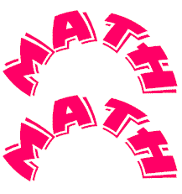



|  |
| --- |
| *Pre-image image* |
| **Write a rule to describe the transformation.**  *Pre-image image* |



|  |  |
| --- | --- |
| Reflection in the *y* – axis    *Pre-image image* | Reflection in the *x* - axis    *Pre-image image* |
| Reflection in the origin  *Pre-image image* | |
|  | |



|  |  |
| --- | --- |
| Rotation 900 around the origin    *Pre-image image* | Rotation 1800 around the origin    *Pre-image image* |
| Pre-image image Rotation 2700 around the origin | |







|  |
| --- |
| Given triangle ABC: A(1,4), B(3,7), C(5,1) Graph and label the following composition:  PracGl8  *Pre-image image 1 image 2* |
| Describe two transformations that together could have been used to create the image *A'*. |

General "Transformation" Vocabulary

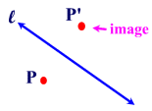**Image:** An image is the resulting point or set of points under a transformation.

**Isometry:**  An isometry is a transformation of the plane that preserves length.

For example, if the sides of an original pre-image triangle measure 3, 4, and 5, and the sides of its image after a transformation measure 3, 4, and 5, the transformation preserved length.

A **direct isometry** preserves orientation or order - the letters on the diagram go in the same clockwise or counterclockwise direction on the figure and its image

A **non-direct** or **opposite isometry** changes the order (such as clockwise changes to counterclockwise

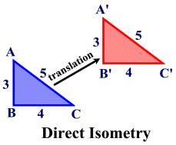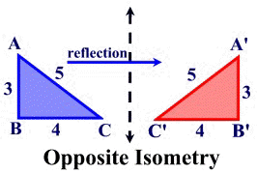

**Orientation:**  Orientation refers to the arrangement of points, relative to one another, after a transformation has occurred.

**Transformation:**  A transformation of the plane is a one-to-one mapping of points in the plane to points in the plane.

**THE LABORATORY SCHOOL OF FINANCE AND TECHNOLOGY**

Transformations Pre-Test

Name : ______________________________ Date : _________________

1.) Which graph shows a triangle and its reflection image in the y-axis?

[A] 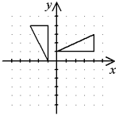 [B] 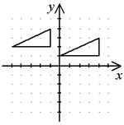

[C] 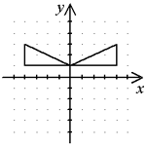 [D] 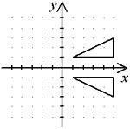

2.) Which graph shows a triangle and its rotation image about the origin?

[A] 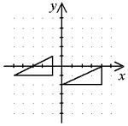 [B] 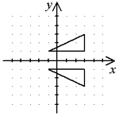

[C] 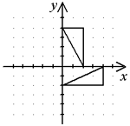 [D] 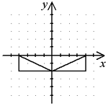

3) Which graph shows a triangle and its reflection image in the x-axis?

[A] 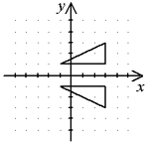 [B] 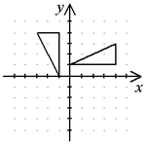

[C] 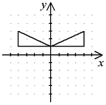 [D] 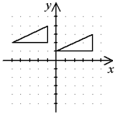

4.) Show the image of the vertex marked A, in the triangle below after a

rotation of 180 degrees about the origin.



[A] ( -4, 6 ) [B] ( 4, -6 ) [C] ( 6, 4 ) [D] ( 4, 6 )

5.) Use the same diagram from question four and imagine that the triangle is rotated 90 degrees in a clockwise direction. What would be the image of the vertex at C?

[A] ( 2, 2 ) [B] ( 2, -2 ) [C] ( -2, 2 ) [D] ( -2, -2 )

6.) Use the same diagram from question four and imagine that the triangle is rotated 90 degrees in a counter clockwise direction. What would be the image of the vertex at C?

[A] ( -4, 6 ) [B] ( 4, -6 ) [C] ( 6, 4 ) [D] ( -4, -6 )

7.) Point A (1, 4) is reflected over the y-axis. Write the coordinates of A′.

[A] (–1, 4) [B] (–1, –4) [C] (1, –4) [D] (1, 4)

8.) Point A (6, –3) is reflected over the x-axis. Write the coordinates of A′.

[A] (–6, –3) [B] (6, –3) [C] (6, 3) [D] (–6, 3)

9.) Point A (–9, –1) is reflected over the x-axis. Write the coordinates of A′.

[A] (–9, –1) [B] (9, 1) [C] (9, –1) [D] (–9, 1)

10.) Write a rule to describe the translation of ΔABC to ΔA′B′C′.

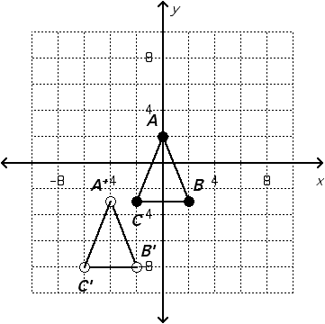

[A] four units left and three units down

[B] four units left and five units down

[C] five units right and four units up

[D] four units right and three units up

11.) Write a rule to describe the translation of ΔABC to ΔA′B′C′.  
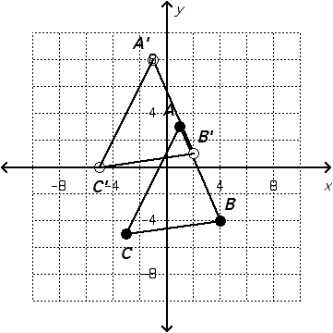

[A] four units left and ten units down

[B] two units left and five units up

[C] five units right and four units up

[D] four units right and three units up

12.) Write a rule to describe the translation of ΔABC to ΔA′B′C′.  
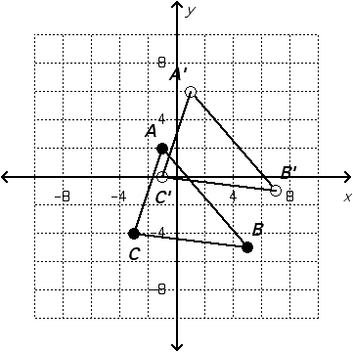

[A] four units left and two units down

[B] two units left and five units up

[C] five units right and four units up

[D] two units right and four units up

13.) The dotted triangle is a dilation image of the solid triangle. What is the scale factor?  
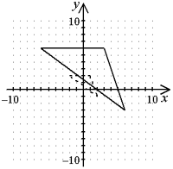

[A] 2 [B] 3 [C]  [D] 

14.) Use scalar multiplication to find the image of the quadrilateral for a dilation with center (0, 0) and scale factor 2. Graph the quadrilateral and its image.  
Graphic

[A] 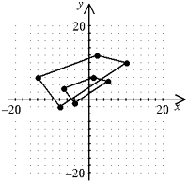 [B]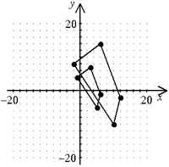

[C] 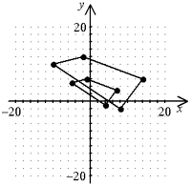 [D] 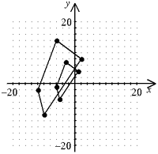

15.) Draw the image of the following triangle when it is dilated about the origin by a factor of 2. What are the coordinates of the vertices of the image?



[A] (2, 2) (6, 0) (8, 8) [B] (2, 2) (6, 6) (8, 6)

[C] (2, 2) (6, 0) (8, 6) [D] (2, 2) (6, 6) (8, 8)

16.) The only time that the following properties are NOT preserved :

Angle Measure Length of Segments Congruence

is when the transformation is a :

[A] translation [B] refelction

[C] rotation [D] dilation

**Which transformations preserve order?**

**What other words can be used for rotation, reflection, translation, and dilation?**

**What 2 transformations make up a glide reflection?**

**What happens to the coordinates when you reflect or rotate a point in the coordinate plane?**

**Transformations**

**G-CO.2**

Represent transformations in the plane using, e.g., transparencies and geometry software; describe transformations as functions that take points in the plane as inputs and give other points as outputs. Compare transformations that preserve distance and angle to those that do not (e.g., translation versus horizontal stretch).

**G-CO.3**

Given a rectangle, parallelogram, trapezoid, or regular polygon, describe the rotations and reflections that carry it onto itself.

**G-CO.4**

Develop definitions of rotations, reflections, and translations in terms of angles, circles, perpendicular lines, parallel lines, and line segments.

G-CO.5

Given a geometric figure and a rotation, reflection, or translation, draw the transformed figure using, e.g., graph paper, tracing paper, or geometry software. Specify a sequence of transformations that will carry a given figure onto another.