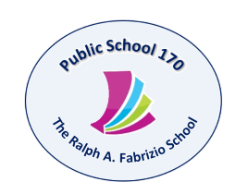

Tony Wu, Principal
Kristi Pollock, AP
Holli Sainz, AP
Maria Strongilis, AP
Therese Mulkerrins, Dean
619 72nd Street Brooklyn, NY 11209 Tel. (718) 491 8400 Fax (718) 491-8405 www.PS170.com

Dear Parents,
We would like to wish you a wonderful summer vacation and also let you know what your child will need when he/ she starts Second Grade in September 2018. This will allow you to shop at your convenience during the summer months.
- 7 hardcover notebooks (black and white marble style – not spiral)
- 2 boxes of #2 pencils (sharpened) and 1 soft pencil case
- 1 box of crayons (box of 24)
- 1 pack of washable markers
- 1 pack of Dry Erase markers
- 2 large Elmer’s glue sticks
- 1 ruler (12 inches with centimeters)
- 1 pair of safety scissors
- 1 box of colored pencils
- 1 roll of paper towels
- 2 boxes of tissues
- 1 container of baby wipes
- 1 large box of gallon-sized Ziplock bags and I box of sandwich-sized bags
- 1 pack white copy paper (W.B. Mason and Staples brands preferred)
- 4 strong folders for homework/classwork
- 2 bottles of hand sanitizer
- send in a healthy snack every day
- $6.50 for Scholastic News order
Please label all supplies with your child’s name. Thank you for your help and have a nice vacation!
Sincerely,
The Second Grade Teachers

