IMPORTANT CONCEPTS YOUR STUDENT SHOULD KNOW AND ACTIVITIES TO DO AT HOME
Fractions and Decimals
Important Concepts Addressed in this Unit
- Write a fraction with a denominator of 10 as an equivalent fraction with a denominator of 100  - Add two fractions with denominators of 10 and 100  - Use decimal grids to show equivalent fractions with denominators of 10 and 100  - Write fractions with denominators of 10 and 100 as a decimal | - Represent fractions and decimals of tenths and hundredths on a number line  - Compare two decimals to hundredths  - Justify comparisons by using a model  - Solve word problems involving fractions or decimals
Key Words To Know | How You Can Help Your Student
Fraction: A way to describe a part of a whole or a part of a group by using equal parts.  Numerator: The number written above the line in a fraction. It tells how many equal parts are in the fraction.  Denominator: The number written below the line in a fraction. It tells how many equal parts are in the whole.  Equivalent: Fractions that have the same value.  Model: Using graphs, pictures, manipulatives, etc to demonstrate  Decimal: A fraction whose denominator is a power of ten and whose numerator is expressed by figures placed to the right of a decimal point.  Tenths: The place value directly to the right of the decimal, or a fraction with the denominator of 10.  Hundredths: The place value two digits to the right of the decimal (directly to the right of the tenths place), or a fraction with the denominator of 100. | Interactive Learning Games: Playing games is a wonderful way to practice skills at home in a fun environment.  https://www.mathgames.com/skill/4.123-equal-fractions-with-denominators-of-10-100-1000  https://www.mathgames.com/skill/4.124-decompose-fractions-with-denominators-of-10-100-1000  https://www.mathgames.com/skill/4.125-add-fractions-with-denominators-of-10-100-1000  https://www.mathgames.com/skill/4.72-compare-decimal-numbers-up-to-2-places  https://www.mathgames.com/skill/4.73-put-decimal-numbers-in-order-with-numbers-up-to-5  https://www.splashmath.com/decimal-games-for-4th-graders  http://www.sheppardsoftware.com/mathgames/menus/decimals.htm  https://www.mathplayground.com/ASB_SnowSprint.htm  https://www.mathplayground.com/interactive_decimal_chart.htmll

Sample Problems
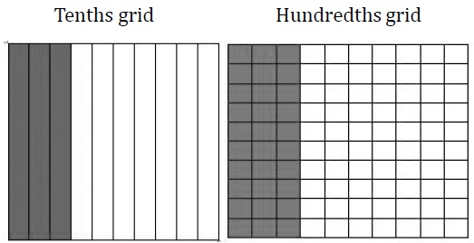Example: .3 = 3 tenths = 3/10 .30 = 30 hundredths = 30/100
Hundreds | Tens | Ones | . | Tenths | Hundredths
 |  |  | . | 3 | 2
$\frac{32}{100}$can be expanded to $\frac{3}{10}$ and $\frac{2}{100}$
Students represent these values as 0.32 or $\frac{32}{100}$on a number line. $\frac{32}{100}$ is more than $\frac{30}{100}$(or $\frac{3}{10}$) and less than $\frac{40}{100}$ (or $\frac{4}{10}$). It is closer to $\frac{30}{100}$so it would be placed on the number line near that value.

0.32
0 0.1 0.2 0.3 0.4 0.5 0.6 0.7 0.8 0.9 1.0

