IMPORTANT CONCEPTS YOUR STUDENT SHOULD KNOW AND ACTIVITIES TO DO AT HOME
Weather
Important Concepts Addressed in this Unit
- What form does water take on our earth?  - How does water change from a solid to a liquid to a gas?  - How does water change from a gas to a liquid to a solid?  - What are forms of precipitation?  - How do meteorologists use the following weather instruments: rain gauge, thermometer, anemometer, barometer, and wind vane? |  |  | - How do you distinguish between weather and climate?  - Why are weather symbols important on a weather map?  - How do we know if a weather forecast is accurate?  - What do the louds tell about the weather?
Key Words To Know |  |  | How You Can Help Your Student
Solid - has a definite shape, mass, and volume. It will always look the same and take up the same amount of space.  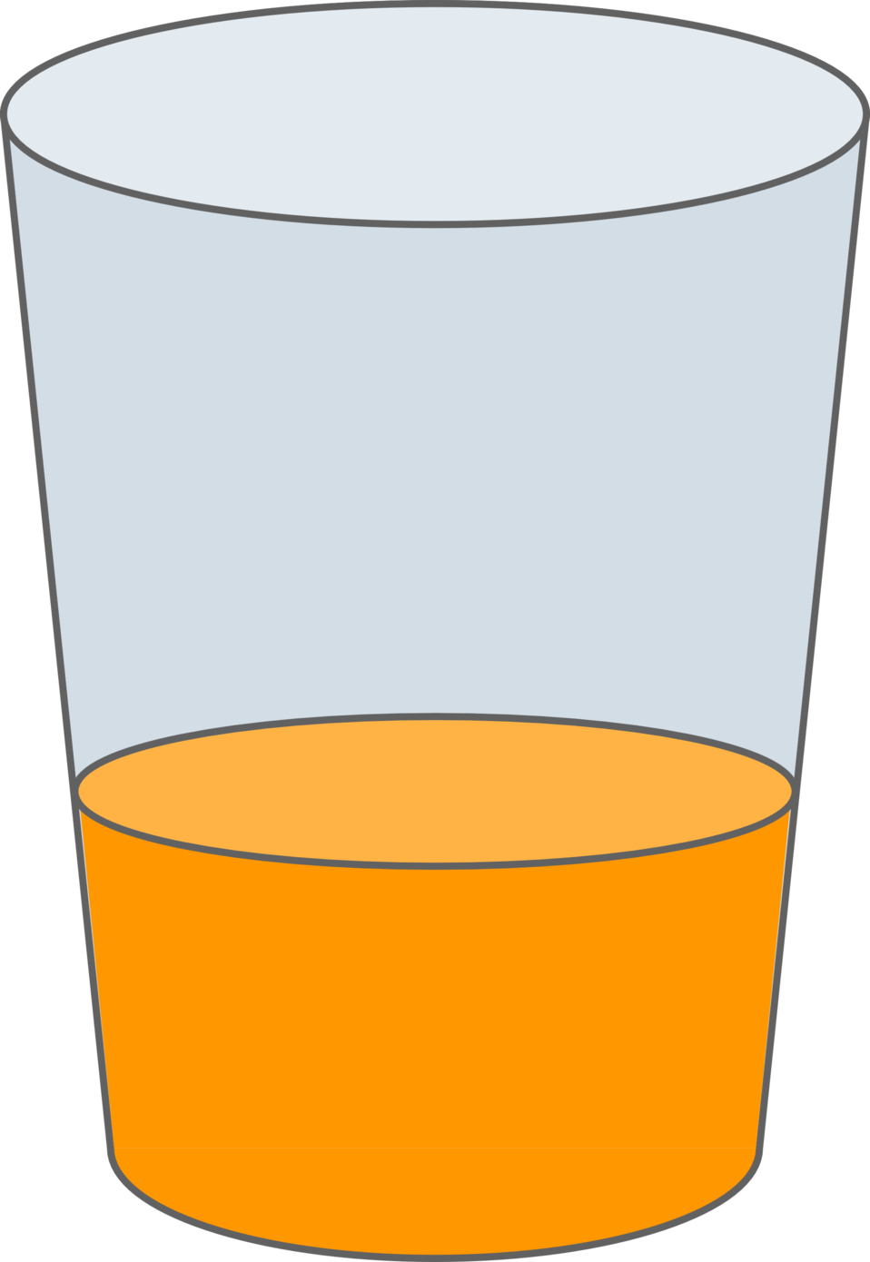  Liquid- does not have a definite shape, but does have a definite mass and volume. It will always take up the same amount of space and take the shape of its container.  Gas - does not have a definite shape, mass, or volume. It does not always weigh the same or take up the same amount of space. However, like a liquid, a gas will always take the shape of its container, no matter the size or shape of that container.  Water Vapor - water in the form of a gas  Barometer- an instrument for measuring air pressure  Thermometer- an instrument that measures temperature  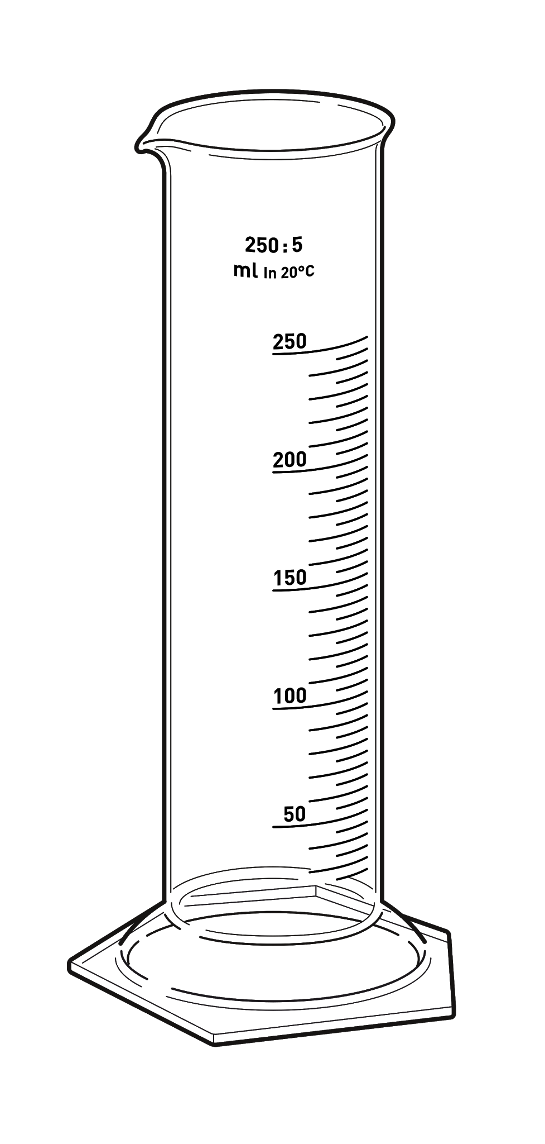  Wind vane- a moveable, arrow-shaped object that shows which way the wind is blowing  Rain gauge- an instrument used to measure the amount of rain that has fallen  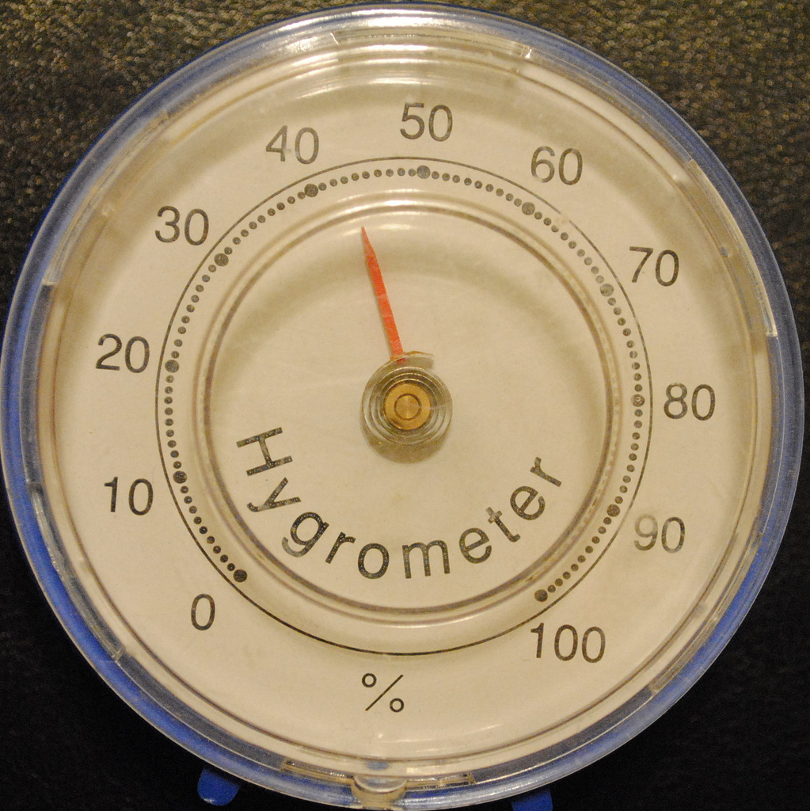  Anemometer- an instrument used to measure wind speed  Hygrometer- an instrument used to measure the amount of humidity in the air.  Warm front - the beginning of a large mass of warm air; usually bringing precipitation.  Cold front - the beginning of a large mass of cold air; usually bringing storms.  Stationary front - where two air masses come together, and neither moves any more. These fronts usually dissolve.  Temperature - a degree of hot or cold that can be measured using a thermometer.  Precipitation - the release of water from the sky, it can be liquid or solid, for example, rain, sleet, hail and snow.  Cirrus - thin, wispy clouds seen high in the sky; they are made of ice crystals instead of water droplets. A blue sky and a few cirrus clouds high in the sky, usually means it is going to be a nice day.  Stratus - look like a huge thick blanket covering the sky. These clouds are a sure sign of rain if it is warm and snow if it is cold. If stratus clouds are near the ground, they form fog.  Cumulus - puffy clouds that are usually scattered throughout the sky; they can be white or gray. White fluffy cumulus clouds means no rain, but when they form into dark or gray clouds, it is going to rain.  Weather - the condition of the atmosphere at a certain time or place.  Climate - the weather taken over a long period of time. |  |  | - Your child will have access to many links, educational videos, and games pushed out to them through Google Classroom. Your child may access his/her Google Classroom from home.  - Talking to your child about what they are learning is a great way to help your child.  - Reviewing vocabulary each night is a great way to help your student. Making vocabulary study index cards is a quick way to review. You can quickly review words this way.  - Take time to watch the weather forecast or look it up online.  - Discuss the weather maps and tools that meteorologist use to predict the weather.  - Go outside and observe the types of clouds in the sky.

Sample Problems
Your child will be asked to:
- Plan and carry out investigations to observe the flow of energy in water as it changes states from solid (ice) to liquid (water) to gas (water vapor) and changes from gas to liquid to solid.
- Develop models to illustrate multiple pathways water may take during the water cycle (evaporation, condensation, and precipitation).
- Plan and carry out investigations to observe the flow of energy in water as it changes states from solid (ice) to liquid (water) to gas (water vapor) and changes from gas to liquid to solid.
- Construct an explanation of how weather instruments (thermometer, rain gauge, barometer, wind vane, and anemometer) are used in gathering weather data and making forecasts.
- Interpret data from weather maps, including fronts (warm, cold, and stationary), temperature, pressure, and precipitation to make an informed prediction about tomorrow’s weather.
- Ask questions and use observations of cloud types (cirrus, stratus, and cumulus) and data of weather conditions to predict weather events.
- Construct an explanation based on research to communicate the difference between weather and climate.

These questions may be assessed through projects, models, and/or assessments.

