How to Use Win 10 Pro – A Quick Sheet
We have upgraded from Windows 7 Pro to Windows 10 Pro – this means your desktop is going to look different, especially the Taskbar at the bottom of the screen.
You will notice your Start Button is no longer round (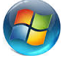) – but no fear, all will be well if you follow these simple instructions:
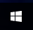
The Win 10 Pro Start Button/Menu
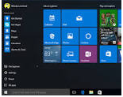
It now looks like this:

And when you click on it, it looks like this:

If you RIGHT CLICK the Start Button, you see a list of all the old Windows 7 features you are used to:
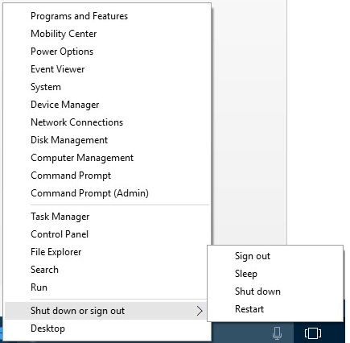

Just click on them and their window will open!

File Explorer….ahhh, there’s my stuff…
This is your new best friend - it’s the File Explorer and it sits in your Taskbar at the bottom of your screen
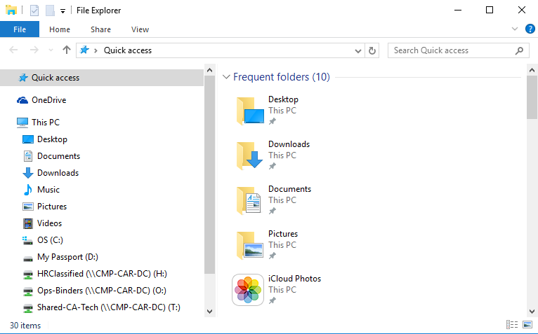
When you click on it, it looks like this:

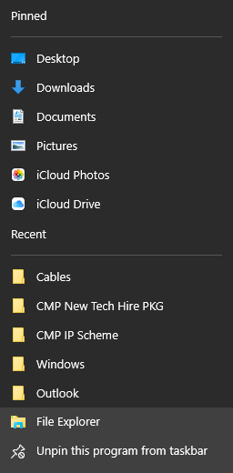
This is where you will find all your documents, pictures, network drives, downloads and music, etc.

If you right click the File Explorer icon, you can quickly get too your recently used folders, or you documents, pictures and downloads.
The Search Bar – Find anything you need…
This is your second best friend -
It is the Search Bar and it connects to your Start Button
You will use the Search Bar to locate anything in your computer. Can’t find the Control Panel?
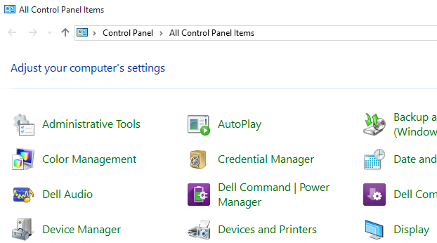
Just type ‘Control Panel’ into the Search Bar and you’ll see a link to the Control Panel and when you click it…Voila:

Wanna quickly get to a web site? Just type it into the search Bar and it will open. Not sure of the address? Type in a key word and let Win 10 find a best match.
Can’t find that document you created yesterday…you know you created it! Just type a key word relating to the document in the search bar and Win 10 will try to match it to a document and show you a list of best matches!
Looking for your printer? Type Printer into the Search bar and the Printer window will open
From the Start Menu, you can quickly get to your Calendar, Mail, favorite Websites and latest news, etc.
Wanna personalize your computer? Click on the Start Button and then click ‘Settings” then click on Personalize:
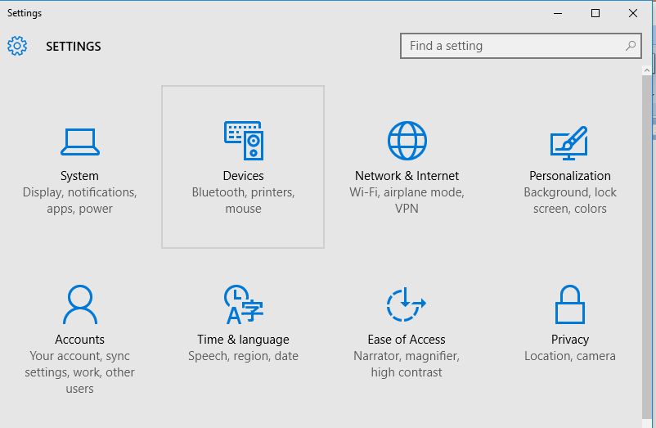

The Personalization Window will open and you can change to your heart’s desire:
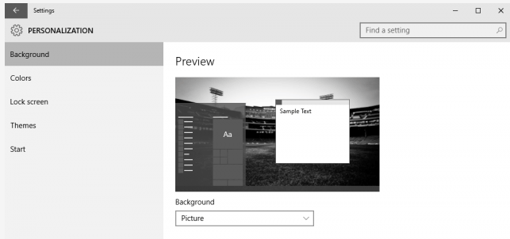

The items outlined above are the biggest differences between Windows 7 Pro and Windows 10 Pro
Enjoy your Windows 10 Pro and let your campus tech person know if you have any questions – we’re here to help.

