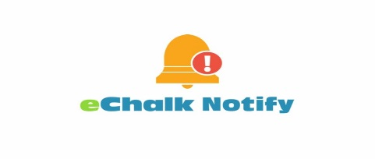
Dear Parents and Guardians,

PS 94 (15k094) has a new and simple way for you to stay updated on emergency notices, school closings, delayed openings, school and district announcements, and more! Using our new eChalk Notify App you can receive real time updates that appear as notifications immediately on your mobile devices! The eChalk Notify App can be downloaded from the Apple App Store or Google Play Store or by using the links below:
Apple App Store: https://apple.co/2mkz4wD
Google Play Store: https://bit.ly/2NjIUtV

Once downloaded, you can login to receive critical messages and alerts from your school and district by entering our school code below:
95Y9U7

You can refer to the step by step instructions below to download and install eChalk Notify on your mobile phone or tablet:

eChalk Notify Quick Start For Parents

Download the eChalk Notify App.
Anyone can download the eChalk Notify App for free from the Apple App Store or the Google Play Store. Just search for “eChalk Notify.”

You can log into the eChalk Notify App without an account by clicking “Proceed without logging in” > Settings icon > + > enter your school’s alert code > Connect. You’ll only need to enter the school’s alert code when logging in for the first time.

If you have questions, please don’t hesitate to contact your parent coordinators
Elaine Ayala, Eayala6@schools.nyc.gov
Anna Ta, Ata@schools.nyc.gov
Nellie Hernandez, NHernandez20@schools.nyc.gov .
Tel: 718-435-6034

