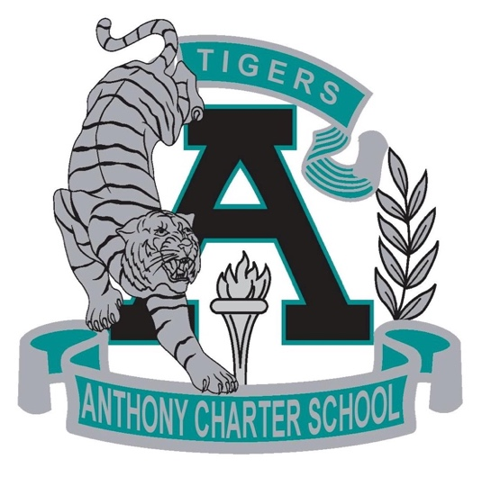

Public Notice
(Notificamiento Publico)
SPECIAL MEETING
Anthony Charter School
Governing Council
(Junta del Cuerpo Escolar)
Monday, December 18th, 2017
(Monday, Diciembre 18, 2017)
TIME: 6:15 pm
Location:
780 Landers
Anthony NM 88021

