Pre-K Supply List

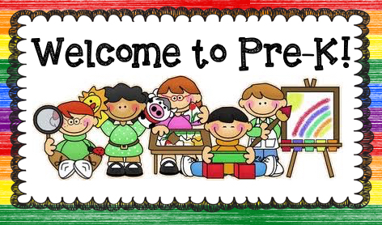
To ensure a successful school year, we made a list of those items that would be especially useful throughout the year. These include the following:

Items for our classroom:
- 1 backpack (no wheels, please, safety reasons. Please bring on the first day of school
- 1 box Dixon Ticonderoga (Beginner’s Pencils)
- 1 box of Crayola Triangular Crayons
- 1 Pack of Crayola Markers
- 1 Box of Ziplock bags 1 Gallon
- 1 Box of Ziplock bags 1-Quart
- 2 Boxes of Tissues
- 2 Bottles of UNSCENTED Hand Sanitizer
- Please provide two changes of clothing on the first day (include socks and underwear)

