THE GREENBURGH-GRAHAM UNION-FREE SCHOOL DISTRICT
1 SOUTH BROADWAY
HASTINGS-ON-HUDSON, NEW YORK 10706
(914) 478-1106, EXT. 400 FAX (914) 478-0904

Robyn Dunn
Intake Coordinator
Assistant to the Superintendent

DIRECTIONS to One South Broadway, Hastings-on-Hudson, NY 10706.
If entering into a GPS or any navigation system please enter: Greenburgh Graham Union Free School District, Hastings-on-Hudson, NY 10706.

The school buildings are to the right as you enter campus. Visitor parking is available along the side of the Ziccolella Elementary/Middle School. You will enter this building to check-in with the front desk and inform them you are here to meet with Robyn Dunn. If you have any further questions, please do not hesitate to contact me.

FROM SOUTHERN WESTCHESTER & BURROUGHS:
Take the Saw Mill Parkway North to Exit 9 for Executive Boulevard. Turn off of the exit ramp and cross the parkway. Stay on Executive Boulevard until you cannot proceed straight further and you are at the Broadway intersection. Make a right onto South Broadway and stay in the left lane. Travel approximately 200 yards and the entrance to the Graham School will be on your left.

FROM NORTHERN WESTCHESTER & ABOVE:
Take the Saw Mill River Parkway South to Exit 9 for Executive Boulevard. Stay on Executive Boulevard until you cannot proceed straight further and you are at the Broadway intersection. Make a right onto South Broadway and stay in the left lane. Travel approximately 200 yards and the entrance to the Graham School will be on your left.

Sincerely,

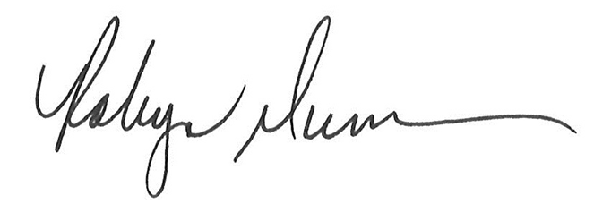
Robyn Dunn

