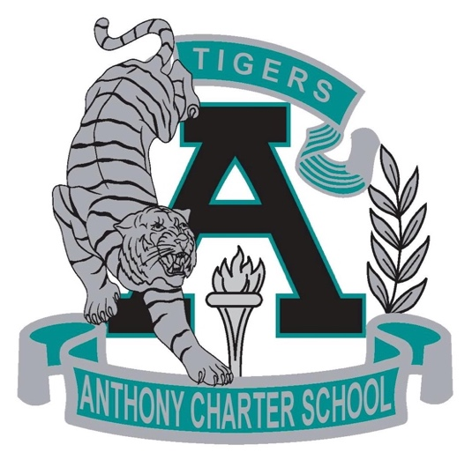

Public Notice
(Notificamiento Publico)
Regular MEETING
Anthony Charter School
Governing Council
(Junta del Cuerpo Escolar)
Thursdat, April 26rd, 2018
(Jueves, Abril 26 2018)
TIME: 4:00 pm
Location:
780 Landers
Anthony NM 88021

