Go Guardian Admin Cheat Sheet

Overview of Go Guardian Admin
This video does an excellent job of overviewing and showing how to use Go Guardian Admin

Video: Overview of Go Guardian Admin

Help Menu
The following website has a full list of resources and direction sheets for admin and teachers with access to Go Guardian Admin - Go Guardian Help Menu

Go Guardian Dashboard

Specifying the OU for your Dashboard
You can choose a specific level of the OU to get information on. In the top right hand corner of the page, you will see . Click on there and the Admin accounts can be specified to a specific campus or a specific classroom.

Timeline
At the top of your main dashboard display, you will find a usage graph showing levels of both online users (in blue) and flagged activity (in red). The timeframe of the view can be changed with the date range selector to display activity from today, last 3 days, last 7 days, last 30 days, this month (from the beginning of the month to the current day in that month), last month, or any customizable date range you would like. You can also filter this timeline view by sub-OU by selecting a different sub-OU in the drop-down menu in the top-lefthand region of the page.

Summary
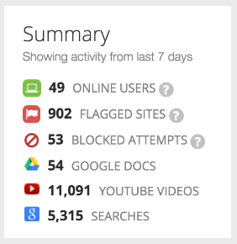
- Online Users: Total number of online users that have pinged the server in the last minute
- Flagged Sites: Total number of flagged pages in the past seven days
- Blocked Attempts: Total number of sites that students have tried to visit and been blocked for past seven days
- Google Docs: Total number of Google Docs visited for the past seven days
- YouTube Videos: Total number of YouTube videos viewed for the past seven days
- Searches: Total number of Google searches made for the past seven days

Top Sites
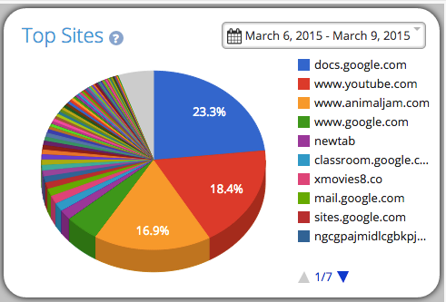
A pie chart depicting the top sites for your organization sorted by time spent on each site. The timeframe of the view can be changed with the drop down box to show information for either today, the last 3 days, or the last 7 days.

Trending Sites
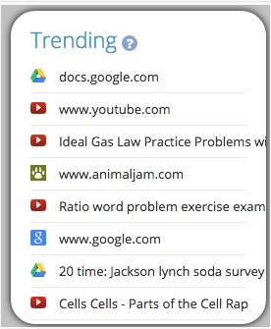
On the main dashboard, you can the see that sites that are trending for you organization. These represent sites that have become newly popular among your users.
We use a proprietary algorithm to identify the most popular content given the organization’s unique level of activity, and remove consistently popular items so that the trending items are always the freshest.

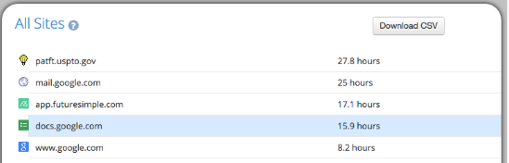
All Sites

A list of the top 100 sites visited, ordered by time spent on each site. This view can be filtered for different time ranges by changing the dropdown box in the Top Sites section directly above it. Clicking on a site will display a list of users that have gone to that site and how much time they have spent there. You can also download a CSV file of this information with the button located on the top right hand side of the All Sites box.
Note: If you are looking at this list while filtering information by a specific sub-OU from the top bar, then this will display a list of the Top Sites for this sub-OU for ALL time. You can filter this information by time range only when All Users is selected from the OU dropdown at the top.
Flagged Activity
The Flagged Activity tab provides an overview of all of the questionable activity that has occurred on the Chromebooks being monitored. The Flagged Activity Tracker will scan visible as well as hidden information about the site being visited, run a proprietary algorithm against our large list of flagged terms, and flag sites deemed as inappropriate. This category will address any questions about Flagged Activity.
- Setting Up Flagged Activity Notifications: Flagged Activity Overview/Directions
- Flagged Activity Tracking on Student Chromebooks: Flagged Activity Tracking Overview/Directions
- Setting Up and Adding Flagged Terms: Flagged Terms Overview/Directions

Filtering

Whitelist/Blacklist
- Separating whitelists/blacklists by OU: Overview/Directions
- Building a Blacklist/Whitelist: Overview/Directions
- Blacklist History: Overview/Directions
- Go Guardian Blacklist:
- Making Suggestions to the GoGuardian Blacklist: Overview/Directions
- Managing Blacklist Categories & CIPA Compliance: Overview/Directions

YouTube Filtering
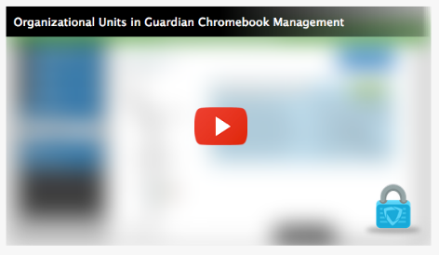
- Filtering YouTube on Chromebooks: Overview/Directions
- Filtering Embedded YouTube Videos: Overview/Directions
Embedded YouTube Videos will look like the picture to the left.

Google
This category presents a macro-view of all YouTube videos watched, all Google searches completed, all Google Docs viewed, and all Apps & Extensions that have been downloaded or blacklisted.

All Users
This section allows you to pull spreadsheets and see all activity of a specific student.

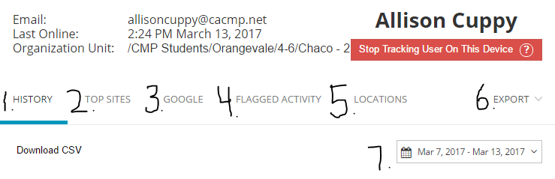
- History: See everything the student has done on their device during the specified period of time (7), including the amount of time spent on each site.
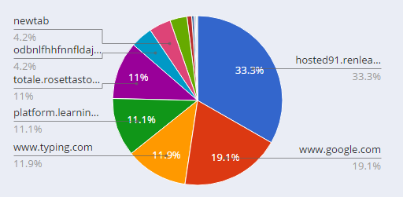
- Top Sites: Where does the student Spend Most of their time. Includes a pie chart (See the right) of the % of their time spent in each place and a list of their most popular sites.
- Google: Keeps a record of all YouTube videos, apps/extensions, Google Searches and Docs.
- Flagged Activity: Shows all of the activity that includes flagged keywords and blacklist history (Which of their searches has resulted in that site being flagged).
- Locations: See where the student was during class time and where they have logged into their device.
- Export: Export the report as a CSV or an excel document.
- Time Period: This shows the time period for the report. It can be changed to cover any amount of time.

