Kindergarten September Goals
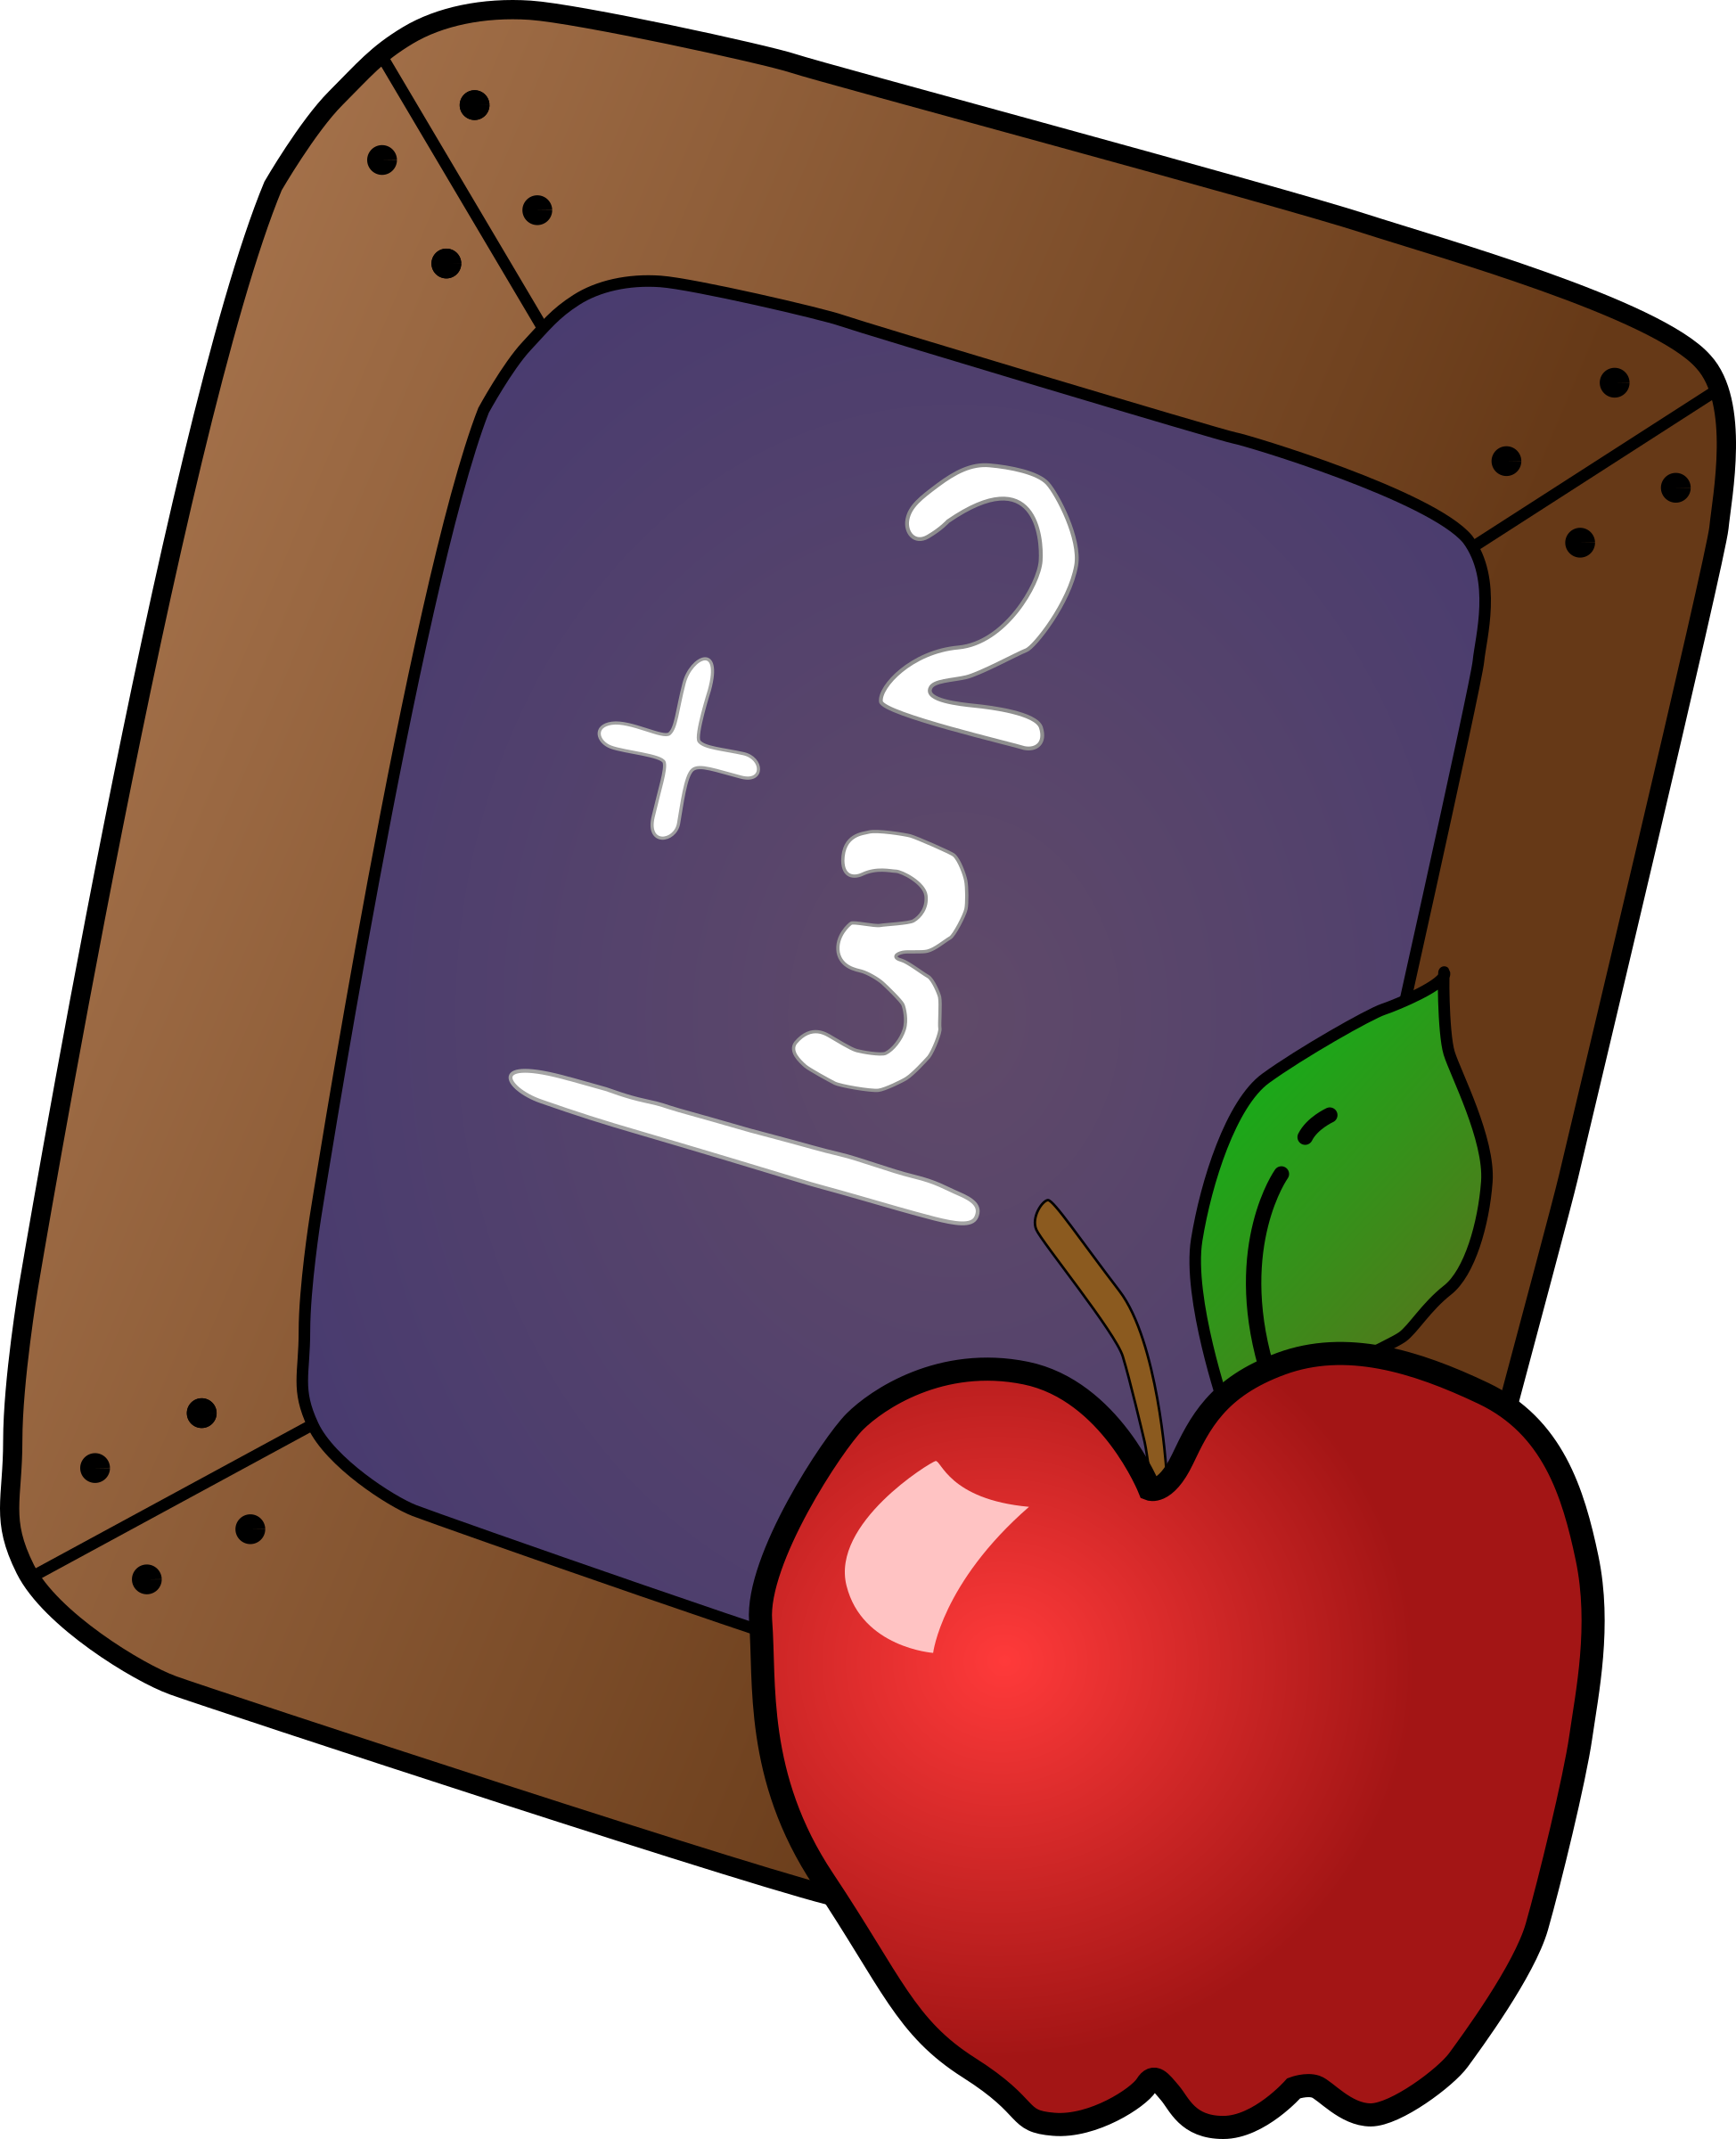
Reading: Your child will:
- Listen to books and other forms of literature being read in a group setting with purpose and understanding
- Identify concepts of print
For example: the front of the book, the back of the book, the illustrations, the text, etc.
Writing: Your child will:
- Begin to use a combination of drawing, dictating, and/or writing to tell a story
Math: Your child will:
- Identify and describe colors
- Identify and describe 2 dimensional shapes
Science: Your child will:
- Identify and describe the five senses
- Use the five senses to make observations
- Observe things by using academic language such as measuring, comparing, and sorting
- Identify science tools such as a hand lens, thermometer, measuring cup, balance, and ruler
Social Studies: Your child will:
- Learn about our school community
- Learn about rules and why they are important

