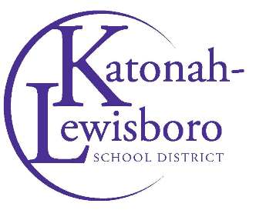
To: Parent Organizations/Community Members
From: Danelle Placella, Assistant Superintendent for Business
Kimberly Monzon, District Clerk
Date: May 2023
Re: Donations to the District
Please refer to the following guidelines regarding donations to the schools.
Monetary Donations:
Monetary donations are the preferred method of receiving donations to the district (rather than donations of items, which may or may not meet required codes for use in schools). Accepting monetary donations to purchase item(s) allows the district to purchase item(s) that meet the necessary requirement codes.
When donating, please follow these steps:
- Complete the donation form available on the district website under the “Parents/Community” tab and include as many details as possible.
- Make checks payable to the Katonah-Lewisboro UFSD.
- Send the monetary donation and form to District Treasurer, Kim Parks at 60 North Salem Road, Cross River, NY 10518.
Once the BOE acknowledges and accepts the donation, the donator will receive a letter acknowledging their donation. The Department or School, to which the donation is designated will coordinate with the Business Office to purchase the item(s).
In-Kind Donations:
There may be instances when Parent Organizations or Community Members would like to donate items that have already been purchased. In these cases, please refer to the following guidelines:
- Contact the Building Administrator/Department Administrator prior to any furniture/large supply/equipment item(s) being donated to the District.
  - The following criteria should be met:
- Confirm that the school can use the item(s).
- Ask the donator to supply pictures of the item(s) they wish to donate.
- Confirm that the item(s) are in good working order and there are no unreasonable costs associated with the acceptance of the donation.
    - If it is determined that one of the schools could use the item(s), then the donator makes arrangements for the delivery to the school.
- If the Building/Department authorizes the in-kind donation, please complete and return the donation form and pictures of the item(s) to District Clerk, Kimberly Monzon at kmonzon@klschools.org
- Once the school/department receives the item(s) and confirmed to be in good working condition, then the District Clerk will place the donation on an agenda for the Board of Education to acknowledge and accept.
- Once the Board of Education acknowledges and accepts the donation, a letter thanking the donator will be sent.

