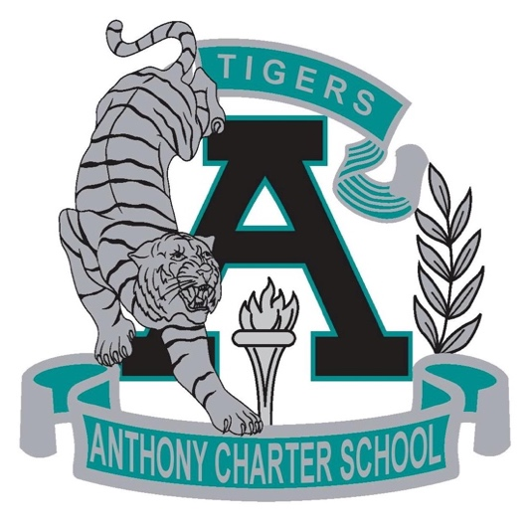

Public Notice
(Notificamiento Publico)

Anthony Charter School
Governing Council WORK SESSION
OPEN TO THE PUBLIC
(Session de Entrenamiento del Cuerpo Escolar)
Saturday January 07th, 2017
(Sabado, Enero 07, 2017)
TIME: 9:00 am to 2:00 pm
Location:
780 Landers
Anthony NM 88021

