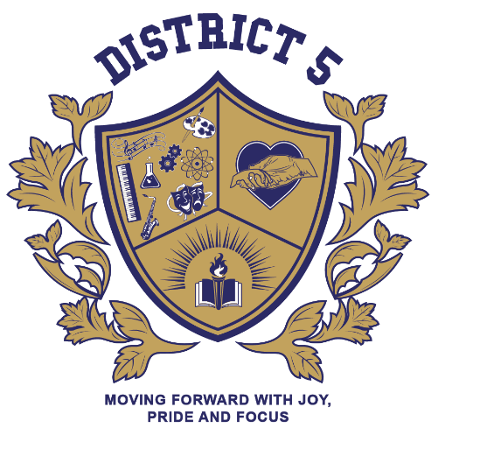

District 5 Office
Superintendent (Supt) - Mrs. Danika Rux
Principal Leadership Facilitator (PLF) – Dr. Ruby Ababio-Fernandez
Teacher Development & Effectiveness Coach (TDEC) – Mr. Major Fareed
Director of School Renewal (DSR) – Ms. Debra Spivak
Field Support Liaison (FSL) – Ms. Mary Norwood
Teacher Team Leader (TTL) – Ms. Lakethia White
Family Support Coordinator (FSC) – Ms. Carla Tenorio
Family Leadership Coordinator (FLC) - Mr. Ernest Clayton
Administrative Assistant (AA) - Ms. Nadine Edwards

123 Morningside Drive - Room 235
(212) 222-1395 X 2355
Enrollment Office
388 West 125th St.
212-342-8300

Manhattan Suspension Hearing Office
209 West 125th St. 3rd Floor
212-932-1058

Manhattan Field Support Center
333 7th Avenue
212-356-3700

