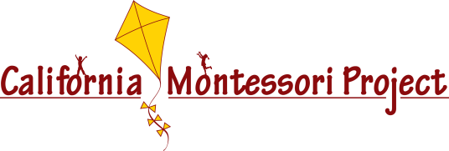

WHAT IS A CHARTER SCHOOL?

In 1992 Senate Bill 1448, authored by Gary Hart, gave birth to Charter Schools in California. Charter schools were created as a catalyst to improve the quality of traditional public education. Charter schools are bound by fewer state regulations allowing schools to offer smaller class size, a focused mission, a high degree of parental involvement, flexible scheduling, and innovative programs. Charter schools are student centered and measure outcomes based on student performance.

Charter schools are public schools, most frequently sponsored by pre-existing school districts. They are tuition free. There are currently 360 charters in the State of California serving over 200,000 students and their families. Charter schools promote education as a shared responsibility of public schools, parents, individual learners and the communities in which they reside. Over 36 states have authorized the creation of these alternatives to traditional public education.

For a copy of the California Montessori Charter document and more information on the California Montessori Project go to our website at: www.cacmp.org

Web sites for more information on charter schools:
California Department of Education (CDE) - www.cde.ca.gov

California Network of Educational Charters (CANEC) - www.cacharterschools.org

