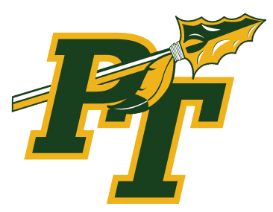
Show your Warrior spirit at Level Green Elementary’s SPIRIT WEEK!!
Spirit Week will be September 28-October 1
Get creative & have some fun showing off your best style each day. The class with the most participation will win the school’s SPIRIT AWARD flag!

Monday: CAREER day! Dress up as what you’d like to be when you grow up!
Tuesday: MIX-MATCH day! Go crazy & show us your wackiest outfit!
Wednesday: CHARACTER day! Dress as your favorite book or movie character!
Thursday: WARRIOR day! Go all out in green & gold!

We are Level Green!!

