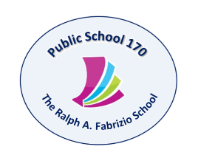

Tony Wu, Principal
Kristi Pollock, AP
Holli Sainz, AP
Maria Strongilis, AP
Therese Mulkerrins, Dean
619 72nd Street Brooklyn, NY 11209 Tel. (718) 491 8400 Fax (718) 491-8405 www.PS170.com
September 18, 2018

Dear Parents and Guardians:

As we continue to encourage everyone to participate in “First Fridays” program. Once a month a grade is selected, and we will invite our parents of that designated grade to participate in a class experience. It ends up being a wonderful experience to share with your child and other children in their class.

After participating with your child, we will offer an interesting and useful Family Engagement workshop for our parents. We may speak about many topics as Homework help, Wellness, Stress, Bully prevention, Middle School Process. Each month we promise to engage you in a short but important workshop that will benefit you and your family.

Below I have listed the scheduled dates and assigned grades for our “First Friday” It will begin promptly at 9:00 am until 9:30 am. Our parent workshop will begin at 9:35 and end at about 10:20 am.

We look forward to seeing you then.

Sincerely,

Mrs. Abigail Figueroa
Parent Coordinator
Afigueroa9@schools.nyc.gov

Schedule for 2018/2019 Grade Family Engagement:
October 5, 2018 – 4th Grade
November 2- 3rd Grade
December 7- 2nd Grade
January 4, 2019 – 5th Grade
February 1, - Dual Language Classes
March 1, - Kindergarten

