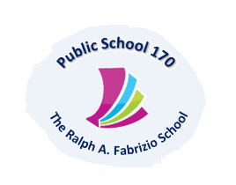
Tony Wu, Principal Maria Strongilis, AP
Holli Sainz, AP
Kristi Pollock, AP
Therese Mulkerrins, Dean
619 72nd Street Brooklyn, NY 11209 Tel. 718-748-0333 Fax 718-921-6351 www.PS170.com

PS 170K-THE RALPH FABRIZIO SCHOOL
PARENT SURVEY
To help promote the educational success of my child, I/we are interested in participating in: (Please check all that apply)
- Parent Teacher Association Membership (PTA)
- Title I Parent Advisory Council (PAC)
- School Leadership Team (SLT)
- Fundraising Committee
- Community Education Council (CEC)
- Attending Parent/Teacher Conferences

I/We are interested in learning about the following topics:
(Please check all that apply)

Informative Workshops – Title I Parent Involvement
- Promotional Policy and/or Graduation Requirements
- Understanding the New York State Common Core Learning Standards
- Understanding the English Language Arts Curriculum for Elementary Students
- Understanding the Math Curriculum for Elementary Students
- Roles/Responsibilities of School Leadership Team Members
- Understanding Special Education Placement, Services and Resources
- Other _________________________________________________________________
What are the best times for you to participate in school meetings or other activities?
Please circle one:
- Days
- Evenings
I have received and read the P.S. 170 School Parent Compact and Survey.
Parent Signature_____________________________________Phone_____________________
Student Name ______________________________________ Class ______________________

