IMPORTANT CONCEPTS YOUR STUDENT SHOULD KNOW AND ACTIVITIES TO DO AT HOME
Important Concepts Addressed in this Unit
History:  SS5H1 Describe how life changed in America at the turn of the century.  b. Describe the impact on American life of the Orville and Wilbur Wright (flight), George Washington Carver (science), Thomas Edison (electricity),  Alexander Graham Bell (communication), and Andrew Carnegie (steel mill).  Geography:  SS5G1 Locate important places in the United States.  a. Locate important man-made places: Pittsburgh, PA; Kitty Hawk, NC; Tuskegee, AL; and Menlo Park,NJ.  SS5G2 Explain the reasons for the spatial patterns of economic activities.  b. Locate primary agricultural and industrial locations since the turn of the 20th century and explain how factors such as population, transportation, and resources have influenced these areas. |  |  | Economics:  SS5E1 Use the basic economic concepts of trade, opportunity cost, specialization, productivity, and price incentives to illustrate historical events.  a. Describe opportunity costs and their relationship to decision-making across time.  c. Describe how specialization can improve standards of living and productivity.  SS5E2 Describe the functions of four major sectors in the U. S. economy.  a. Describe the household function in providing resources and consuming goods and services.  b. Describe the private business function in producing goods and services.
Key Words To Know |  |  | How You Can Help Your Student
Wright Brothers: flight, scientific, inventor, contribution, aviation  Edison: inventions, credited, filament, phonograph, motion pictures, businessman, marketer, manufacturer, genius, creation  Carver: scientist, agriculture, research, crop rotation, nutrient, depletion, replenish  Bell: telephone, device, affordable, communication, telephone operator, design  Carnegie: steel, steel mines, entrepreneur, free enterprise, corporation |  |  | *Interactive Learning Games: (Check Google Classroom) Playing games is a wonderful way to practice skills at home in a fun environment.  *Study Packets: Please review packets daily  *Flash Cards  *www.studiesweekly.com  *http://www.jonathanfeicht.com  *http://www.gallopade.com/online

Sample Questions
- For years, the main source of energy in United States was coal. By the 1920s, many Americans were beginning to use oil, natural gas, and electricity. Why was electricity so popular?
A) Coal was no longer being mined.
B) It could be generated at home.
C) Oil and natural gas were too expensive.
D) It was now available and affordable.

- Explain how the scientific discoveries of George Washington Carver changed the way people farm and live today. Support your answer with details and examples.

- How did Alexander Graham Bell's invention of the telephone change life in rural America?
A) Opportunities for jobs increased for farm workers.
B) Mail service to farming communities decreased significantly.
C) Current information became more available for farm families.
D) Transportation networks in farming communities became less necessary.

- How did Alexander Graham Bell's invention of the telephone change life in rural America?

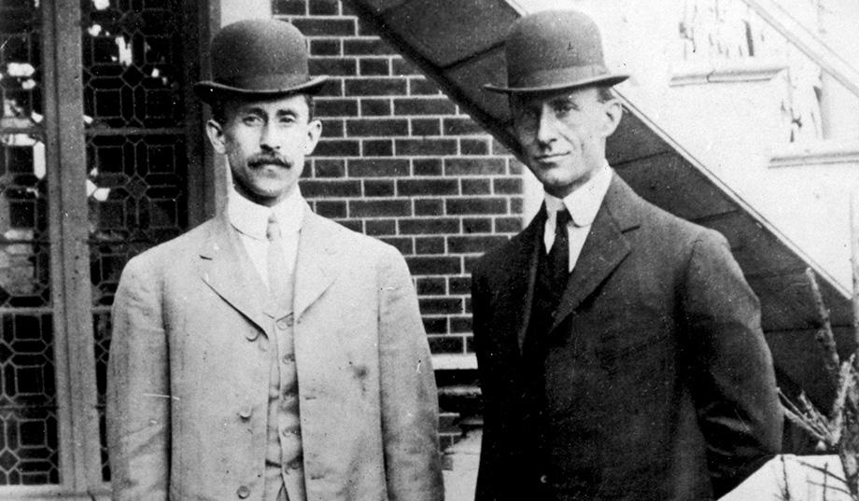

- Identify the brothers in this picture. What invention are they best known for?

- Where and when was the experiment of this invention performed? Why was this location chosen?

