**P.S. 170 Parent Handbook**

**2018 - 2019**



Tony Wu, Principal

September 5, 2018

The Ralph A. Fabrizio School

619 72nd Street, Brooklyn, NY 11209

Kristi Pollock, Assistant Principal

Holli Sainz, Assistant Principal

Maria Strongilis, Assistant Principal

Therese Mulkerrins, Dean

September 5, 2018

Dear Parents,

Welcome to the 2018-2019 school year! As I mentioned repeatedly at parent meetings or kindergarten orientations, parents are children’s first and life-long teachers.

It will make a great difference in your child’s school life and their future if you get yourself closely involved in the education of your child. Some of you may feel you cannot be of help because you are working long hours and your English is limited. I have to say, and my experience seconds it, that you do not need too much time or English to inspire your child to excel in school. It is important to let your child know that you love and care for them and you have high expectations for them. You may have short conversations with them about school and ask them to show you what they have learned. Check if they have completed their homework. When you have a little time, spend it with your children, taking them to parks, museums, libraries, or just shopping together! A lot of things can be talked about and learned during shopping! In my over 30 years of experience in education, I have witnessed that hundreds of children, whose parents were English limited and had little schooling themselves, excelled in school and were subsequently successful in their later careers. All these families shared one common characteristic: their love for their children was embodied in their involvement in their children’s education.

To help parents understand our school better, we created this parent handbook. Please note that this handbook is a living document and will be improved on each year. Therefore, we welcome comments and suggestions from parents, teachers, and students. Have a great school year!

Sincerely,

Tony Wu

Principal

**Table of Contents**

1. **Arrival, Dismissal, and Other Safety Procedures ------------ 3**
2. **Expectations for Student Behavior ----------------------------- 7**
3. **Attendance Requirements ----------------------------------------- 8**
4. **Trips -------------------------------------------------------------------- 9**
5. **School Policy for Cell Phones, Laptops, Tablets, and**

**Other Portable Electronic Devices ------------------------------- 10**

1. **School Grading Policy 2017-2018 -------------------------------- 12**
2. **Communication with Parents ------------------------------------- 19**
3. **Middle School Admissions ----------------------------------------- 19**
4. **School Year Calendar**

**English ---------------------------------------------------------------- 21**

**Chinese ---------------------------------------------------------------- 22**

**Spanish ---------------------------------------------------------------- 23**

**Arabic ----------------------------------------------------------------- 24**

1. **Important Numbers ------------------------------------------------ 25**
2. **Arrival, Dismissal, and Other Safety Procedures**

**Breakfast**

* Breakfast is served from 7:30-8:20 AM daily in the cafeteria for early arriving students. Students must enter the building through the main entrance and proceed to the cafeteria.
* Students who arrive at the regular time indicated below will be offered a grab-and-go breakfast which they will eat in their classroom.

**Arrival**

* Students should line up at the designated entrance, a designated staff member will be present at the entrance 5 minutes earlier than the arrival time indicated below. If a grades K-4 child arrives earlier than the staff member, the parent or guardian of the child must stay with the child until a staff member arrives.
  + Kindergarten – 71st Street schoolyard at 8:30 AM
  + 1st Grade – 72nd Street side door at 8:30 AM
  + 2nd Grade – 6th Avenue gate toward 72nd Street at 8:30 AM
  + 3rd Grade – 6th Avenue gate toward 71st Street at 8:35 AM
  + 4th Grade – 71st Street side door toward 6th Avenue at 8:35 AM
  + 5th Grade – 71st Street side door toward 7th Avenue at 8:35 AM
  + Bridge Classes (K12, 345) – main entrance 72nd Street at 8:30 AM
* Late students should be escorted to main office by a parent.

**Dismissal**

* Students will be escorted as a class to the designated dismissal location.
* Parents or guardians should not take their children until the class arrives at the designated dismissal spot. Confirm with the teacher before you leave that you have received your child.
* If you are unable to pick up your child because of an emergency, please call the main office and provide the name of the person who will pick up your child at dismissal. This person must be listed on the blue emergency card and have a photo identification with him/her.
* If you send someone who is not on the blue emergency card, we will not release your child unless you are able to verify the identity of this person over the phone.
* Designated locations/time for dismissal are:
  + Kindergarten – 71st Street Schoolyard at 2:50 PM
  + 1st Grade – 72nd Street Side Door at 2:50 PM
  + 2nd Grade – 6th Avenue gate toward 72nd Street at 2:50 PM
  + 3rd Grade – 6th Avenue gate toward 71st Street at 2:55 PM
  + 4th Grade – 72nd Street Side Door toward 6th Avenue at 2:55 PM
  + 5th Grade – Through the 71st Street Schoolyard toward 7th Avenue at 2:55 PM
  + Bridge Classes (K12, 345) – Main Entrance 72nd Street at 2:50 PM
* If you are late in picking up your child, your child will be sent to the late room (cafeteria) and you will need to enter the building through the main entrance. You will be asked to wait on a line to sign your child out with proper identification.

**Go-Home-Alone Policy**

* Students of all grades except grade 5 must be picked up at dismissal by a parent, guardian, or a person with photo ID and listed on the blue emergency card.
* Parents of grade 5 students may decide to give permission for their child to walk home alone by filling out and returning the school’s standard parental permission letter. Please note that fifth grade students who need to walk home alone from after school programs or events will need a different parental permission.
* In general, grade 4 students are not allowed to walk home alone. However, upon the request from parents for justifiable needs, we will consider the request on a case-by-case basis.
* By signing the go-home-alone parental permission letter, parents agree that they will be held fully liable for the child’s safety once the child leaves the school premises.

**Visitor Procedures**

* All visitors entering the school building are expected to be polite and respectful and refrain from inappropriate dress and language.
* Visitors must stop at the security desk to sign in and show photo identification.
* A visitor entering the building will be requested to provide at least one (1) item of valid photo identification. (For example, this may include a driver’s license, foreign or US passport, or consulate identification card).
* All visitors enter and exit the building **only** through the main entrance.
* The security agent on duty at the main entrance will record the date, time, visitor’s name and visitor’s destination in the Log Book, notify the main office, and direct the visitors to the main office.
* All visitors are required to sign next to the entry made by the security agent on duty.
* ***Parents who do not have acceptable photo identification shall not be denied access to the school. Where acceptable photo identification cannot otherwise be made and there is no other reason to deny access, the office must be contacted. One of the office staff will then escort the parent to the office he or she is visiting.***
* Visitors should be given a pass in the main office indicating the floor he or she is going to. The main office should notify the destination class or office about the visitor’s visit. If a visitor shows up at a class or office without notice from the main office or a pass, the visitor will be returned to the main office.
* No parents or visitors are allowed to pick up a student directly from the class. Parents must report to and notify the main office and the office will send for the child.
* Only a parent or guardian has permission to sign out a child before the end of the school day for medical or other justifiable reasons. If the parent would like to send someone else for this purpose, then a written notice must be sent in advance indicating the person’s identity and the person must carry a photo ID.
* The vestibule area of the main entrance has been designated as the Parent’s Waiting Area. This is for parents who are not going to the Main Office and just here for picking up or dropping children or when too many parents are visiting the school.
* If a fire drill takes place during a parent visit, parents/visitors must leave the building immediately and may re-enter the building when the fire drill ends.

**Emergency Contact Information**

* It is very important that you provide accurate and most recent information on the blue emergency card.
* Please print legibly all information, especially address, phone numbers, and names.
* Please provide at least 2 other names and phone numbers other than yourself so that we may contact them in case you cannot be reached.
* If your contact information changes, it is very important that you notify our office immediately. Failure to do so may have serious safety consequences.
* Only the parents or the legal guardians may change the information on the blue emergency card. When you come to the office to request for such changes, make

sure you have a photo identification with you. If you are changing the address, you need to have two proofs of the new address.

* If you have any legal documentation regarding order of protection or custody arrangements, please provide the main office with a copy.

1. **Expectations for Student Behavior**

The manner in which students conduct themselves in school is a major factor in establishing and maintaining a safe and secure teaching and learning environment. Students must know and understand the Citywide Standards of Intervention and Discipline Measures (the Discipline Code.) All school faculty and staff must affirm clear and consistent behavioral expectations that set the tone for a safe and orderly school. School faculty and staff must be firm, fair, and consistent in implementing the Discipline Code.

* The school has zero tolerance of any forms of violence, sexual harassment, child abuse, corporal punishment, race discrimination, cyber bullying, and bias-based bullying, intimidation and harassment.
* Parents should encourage their children to respect different ethnic backgrounds, cultures, religions, genders, and other individual differences. The school is committed to educate the students to have respect for all.
* If you have a concern with a child of another family, please seek the school’s assistance. We **do not** encourage you to address such concerns directly with another family.

**Discipline Code Compliance**

* Each family can access a copy of the Discipline Code at the Department of Education’s website and should review the document with their children.
* Parents should receive the Chancellor’s letter with information on the Discipline Code and the student behavior contract, which is to be reviewed, signed, and returned to the child’s teacher.
* The school is committed to the implementation of the NYC Discipline Code and takes the appropriate disciplinary actions for Level 1 to 5 infractions.

**Items that Students Must Leave at Home**

* Hats or headgear [except religious attire] are not worn in the building.
* Beads, “colors”, or symbols representing gang affiliation are not permitted in the school.
* Parents may be periodically notified of prohibited items via official school document(s) (eg. newsletter, brochure, principal’s letter, etc.)
* Gaming devices and toys should be left at home unless directed otherwise by the teacher.
* Laptop computers and tablets should be left at home since all students have access to such equipment in school.

1. **Attendance Requirements**

Attendance and punctuality are very important and students must arrive at school on time every day. Absences and/or lack of punctuality will have significant impact on student learning. Attendance records will affect report card grades. An absence is only excused when the parent submits a parent note (up to 2 days) or a doctor note (3 or more days), notice of a mandatory appointment, or a note stating religious observation. Please note that excused absences are still absences. The difference between excused and unexcused absences is that the former would not have impact on report card grades and will not incur discipline penalties or legal consequences for the parents.

To obtain credit for the school year, a student must attend at least 90% of the days that school is in session. Telephone and letter outreach will be made to parents if unexcused absence and/or lateness become excessive. If after absences are investigated and educational neglect is suspected, a call may be made to the Administration for Children’s Services. Parents should ensure that their children attend the full length of the school year. **Avoid planning vacations with your children during the school year except when the school is in recess.**

However, if your child is sick, e.g. having a fever or vomiting, you should make arrangements to have your child stay home or take your child to the doctor and follow the doctor’s advice. Please provide the school with a parent note (1 day absence) or doctor’s note (2 or more days) regarding your child’s absence.

* If your child has a physical injury (for example: broken leg) or health condition, you must provide proper medical documentation that they can attend school stating necessary accommodations and/or limitations.
* If your child has a contagious illness, you must provide proper medical documentation that they can return to school.

1. **Trips**

* All school trips are an educational extension of the curriculum and the learning environment. Parents should encourage their child to participate in all school trips.
* Parents of children who need medical support or physical assistance should contact the school before the class trip. The school will do its best to cater for such needs. If such needs cannot be met after all effort made, the parents may choose to travel with the child or leave the child in school.
* Parents will be notified in writing in advance of the planned trip, and a parental consent form is required for each school trip. If a student does not return a signed consent form, they may not leave the building unless parental permission is obtained over the phone and the grade supervisor’s permission is sought.
* At least one (1) staff member and two (2) additional adults are required for up to thirty (30) students. For each additional ten (10) students, an additional adult is required. We would appreciate your volunteering to be a chaperone. Chaperones must be 18 years of age or older. Children other than those in the class are not permitted to accompany the chaperone.
* Chaperones should assist the teacher in maintaining the safety and order of all students during the class trip.

**V. School-based Policy for the Use of Cell Phones, Laptops, Tablets,**

**and Other Portable Electronic Devices on School Property**

P.S. 170 has been investing heavily in instructional technology in the past years. As of the 2017-2018 school year, all classrooms are equipped with state-of-the-art LED Smart Boards, laptop computers, Ipads, document cameras, and printers. The building has been upgraded to Verizon Fios Internet. There is no compelling instructional need for **personal** electronic devices. We do not encourage students to bring cell phones to school except **for safety reasons.** The following are what we consider reasonable safety reasons:

* + **Fifth grade students with parent permission to walk home alone.**
  + **Fourth grade students with parent and school permission to walk home alone.**

However, all students, who wish to bring cell phones to school, are subject to the following stipulations:

* Submit a signed parental consent form, provided by the school, which will be kept on file.
* All devices must be kept in the student’s backpack upon entering the school. The devices should be on **silent mode** or **power off.**
* Devices may not be taken out of the backpack **during all school hours** without the permission of his/her teacher.
* School hours include before- and after-school programs and school trips.
* Violation of the above may result in confiscation of the cell phone and the parents will need to come to the school to retrieve the cell phone.

**Parent/Guardian Responsibility**

* Students who wish to bring cell phones must have a signed consent form from their parent or legal guardian on file.
* The school or school staff will not be responsible for the loss or damage of any personal cell phones, laptops, tablets, or any other portable electronic devices brought to school by students.
* For emergency or any other communication needs, please call the school at (718) 491-8400.

1. **School Grading Policy 2017-2018**

**Grading System**

Student academic achievement shall be based on the degree of mastery of the subject curriculum, which is aligned with the Common Core Learning Standards (CCLS) or New York City/New York State Scope and Sequence for various subjects of grades K-5.

Students’ level of mastery is assessed through assignments, tests, projects, classroom activities, and other instructional activities that are aligned with the curriculum. Although consideration is also given to attendance, classroom participation, student conduct, and homework completion, the student’s mastery level is the major factor in determining the grade of a subject.

Grading Percentages

Academic Performance Results – 75%

Classroom Participation – 10%*

Homework – 10%*

Attendance – 5%* (for overall marking period grades only)

*The major criteria for grading is a student’s mastery of the curriculum. If a student’s academic performance results indicate mastery of the curriculum, he or she should not receive a failing grade due to deficit in classroom participation, homework, or attendance.

**Grades K-2 Grading System\***

Performance Levels

4 – Excels in standards

3 – Proficient

2 – Below standards

1 – Well below standards

**Grades 3-5 Grading System\***

Percentage Grade forCore Subjects (ELA, Math, Science, and Social Studies)

92%-100% - Excels in Standards

80%-91% – Proficient

65%-79% – Below Standards

Below 65% – Well Below Standards

Performance Levels for All Other Subjects and Programs

4 – Excels in standards

3 – Proficient

2 – Below standards

1 – Well below standards

*Please note the following special grades:

**NX:**  students may be awarded a grade of incomplete (‘NX’) if a student has a documented, extreme extenuating circumstance that prevents him/her from completing the course in its established timeframe (e.g., surgery, death in the family).

**NL:** Students who are newly admitted may be awarded a grade of “NL” to indicate that the teacher does not have sufficient time to provide a fair and accurate evaluation.

**NS:** A grade of ‘NS’ is given to a student who does not participate in any of the work or tests from which a grade can be derived. ‘NS’ has a pass/fail equivalent of fail and a default numeric equivalent of 45.**5** This mark should be used in egregious situations, when students have been given reasonable chances to make up missed work and their absences are so chronic that only a failing mark is appropriate. Typically, a long-term absentee (LTA) should be discharged from the school and dropped from the schedule, rather than be given a failing grade. Similarly, students who are on home and hospital instruction should not receive ‘NS’ marks.

**Grading Guidelines**

Teachers’ grading consideration should include the following:

English Language Arts

1. Unit Test results
2. Performance-based Test results
3. Six (6) writing pieces per unit scored using school designated rubrics
4. About 5 - 10 reading quizzes on curriculum texts or with separate texts
5. Any grade-wide learning tasks or assessments determined by teachers of the grade
6. Fountas & Pinnell results for all students in grades K-2 and level 1 and 2 students in grades 3-5

* Fountas and Pinnell Reading Levels as compared to student performance levels

|  |  |  |  |  |  |  |
| --- | --- | --- | --- | --- | --- | --- |
| **Grade** | **Level with %** | **September** | **November** | **January** | **March** | **June** |
| **K** | 4 – 100% |  | B | C+ | D+ | F+ |
| 3 – 91% |  | A | B | C | D/E |
| 2 – 79% |  | Early Emergent | A | A/B | C |
| 1 – 64% |  |  | Early Emergent | Early Emergent | B Or Below |
| **1** | 4 – 100% | F+ | H+ | I+ | K+ | L+ |
| 3 – 91% | D/E | F/G | G/H | H/I/J | I/J/K |
| 2 – 79% | C | D/E | E/F | F/G | H |
| 1 – 64% | B Or Below | C Or Below | D Or Below | E Or Below | G Or Below |
| **2** | 4 – 100% | L+ | M+ | M+ | N+ |  |
| 3 – 91% | I/J/K | J/K/L | K/L | L/M |  |
| 2 – 79% | G/H | H/I | I/J | J/K |  |
| 1 – 64% | F Or Below | G Or Below | H Or Below | I Or Below | Or Below |
| **3** | 4 – 100% | N+ | O+ | P+ | P+ | Q+ |
| 3 – 91% | M | N | O | O | P |
| 2 – 79% | L | L/M | M/N | N | O |
| 1 – 64% | K Or Below | K Or Below | L Or Below | M Or Below | N Or Below |
| **4** | 4 – 100% | R+ | S+ | T+ | T+ | U+ |
| 3 – 91% | P/Q | Q/R | R/S | R/S | S/T |
| 2 – 79% | N/O | O/P | P/Q | P/Q | Q/R |
| 1 – 64% | M Or Below | N Or Below | O Or Below | O Or Below | P Or Below |
| **5** | 4 – 100% | T+ | U+ | V+ | V+ | W+ |
| 3 – 91% | S | T | U | U | V |
| 2 – 79% | Q/R | Q/R/S | R/S/T | R/S/T | S/T/U |
| 1 – 64% | P Or Below | P Or Below | Q Or Below | Q Or Below | R Or Below |

* Highlighted row indicates the expected reading level for each grade.

Mathematics

1. Go Math! Chapter Tests and Mid-Chapter Checkpoints
2. Go Math! Performance Tasks
3. Designated number of required fluency tests/quizzes

Social Studies

* One (1) project-based learning task per unit

Science/STEM

* Unit Tests
* One STEM project

Arts

* Learning tasks based on NYC Blueprint for the Arts

Physical Education

* NYS Physical Education Requirement and National Physical Education Standards

**Please note that students must make up any missing work and tests. However, late or make-up work may receive 10% less than the grade the work deserves.**

**Report Card Grades**

* There are three marking periods in a school year:

*First marking period:* September to November

*Second mark period:* December to March

*Third marking period:* April to June

* Teachers will provide report card grades for each subject and for each marking period.
* **The final annual report card grade is an average of all three marking periods.**

**Homework**

Homework is work that is assigned to be completed at home. Homework provides students with the opportunity to review, practice, and extend what they learn in the classroom.  Homework is also an effective tool in developing responsibility and good study habits. It should be purposeful, related to classroom experiences, as well as age and grade appropriate.

Below shows the suggested time for daily homework. This time excludes daily reading time. It is suggested students in grades K - 1 read for 15 - 20 minutes daily and students in grades 2 - 5 for 30 – 45 minutes daily.

* Grade K & 1: 20 - 30 min.
* Grade 2: 30 - 45 min.
* Grades 3 - 5: 45 - 60 min.

Because students work at different paces, it may take some students more or less than the suggested time to complete assignments. Homework is assigned daily. All students are expected to complete their daily homework assignments.

**Parent Responsibilities**

* To establish a specific time and quiet place for your child to complete their homework assignment
* To provide the supplies and materials necessary to complete homework
* To provide support as needed, but do not do the homework for their children
* To check homework for completion as well as quality
* To communicate with their teacher when concerns arise
* To promote **15 - 45 minutes of reading** **each night depending on the student’s grade level (Grades K & 1: 15 - 20 min.; Grades 2 - 5: 30 - 45 min.)**

**Student Responsibilities**

* To complete assigned work with quality and on time
* To communicate with the teacher when he/she does not understand the assignments
* To review teacher feedback and redo the work if needed
* To read 15-45 minutes per night

**Attendance**

Attendance and punctuality are very important, students must arrive to school on time every day. Unexcused absences and/or lack of punctuality will have significant impact on student learning. Attendance records will affect the report card grades. An absence is only excused when the parent submits a parent’s or doctor’s note, notice of a mandatory appointment, or a note stating religious observation.

* Absences and punctuality count for 5% of the report card grade for each major subject.

2% will be deducted for each unexcused day of absence in a marking period. A total of 5% will be deducted from the student’s marking period grade for over two days of unexcused absences.

1% will be deducted for each lateness. All 5% will be deducted when the number of lateness exceeds 4.

**Attendance Requirements**

To obtain credit for the year, a student must attend at least 90% of the days that school is in session, unless the absences are excused by the school.

**Parent-Teacher Conferences**

Parents will be provided any relevant information concerning their child’s grade at the Parent-Teacher Conference. Teachers at all grade levels shall inform parents when a student’s academic progress, attendance, or behavior becomes a concern.

**Attendance Weights in Report Cards**

* Absences and punctuality count for 5% of the report card grade for each major subject in a marking period.

2% will be deducted for each unexcused day of absence in a marking period. A total of 5% will be deducted from the student’s marking period grade for over two days of unexcused absences.

1% will be deducted for each lateness. The entire 5% will be deducted when the number of lateness exceeds 3 in a marking period.

1. **Communication with Parents**

* Your child’s teacher or the school may send home letters regarding your child or with important school or Department of Education announcements. Please check with your child for these letters. For children of grades K-2, you may need to check their schoolbags for such letters.
* School letters are usually translated into Arabic, Chinese, and Spanish for families who speak these languages at home.
* Important school announcements are also sent to the phone numbers you provided to school. Therefore, if you miss the phone call and your child is with you, you do not need to call school to verify.
* Important school announcements or messages are posted on the school website as well. Please visit [www.ps170.com](http://www.ps170.com) for such messages or to learn about school events on the school calendar.
* Parents will be provided with a school calendar in September. Together with the calendar in this handbook and on the school website, we believe that it is not necessary to send reminder letters about school closings throughout the school year. For emergent school closings on storm or snow days, please watch the major public TV channels or listen to the radio stations.

**VIII. Middle School Admissions**

* The Middle School admissions process takes place in the fall of 5th grade
* Middle School Placement is based on the following criteria:
  + 45% 4th grade State ELA and Math Test scores
  + 45% 4th grade final report card grades
  + 5% attendance
  + 5% punctuality
* Middle School admissions timeline:
  + September – Middle School Directories are distributed
  + September through December – Middle School Open Houses are held
  + October – Request for Mark Twain Testing due
  + November – Applications are distributed
  + December – Applications are due
  + January & February – Mark Twain testing held by appointment
  + February – New Schools Round (only if new programs are available)
  + May – Middle School notification letters are distributed
  + June – Appeals round is held

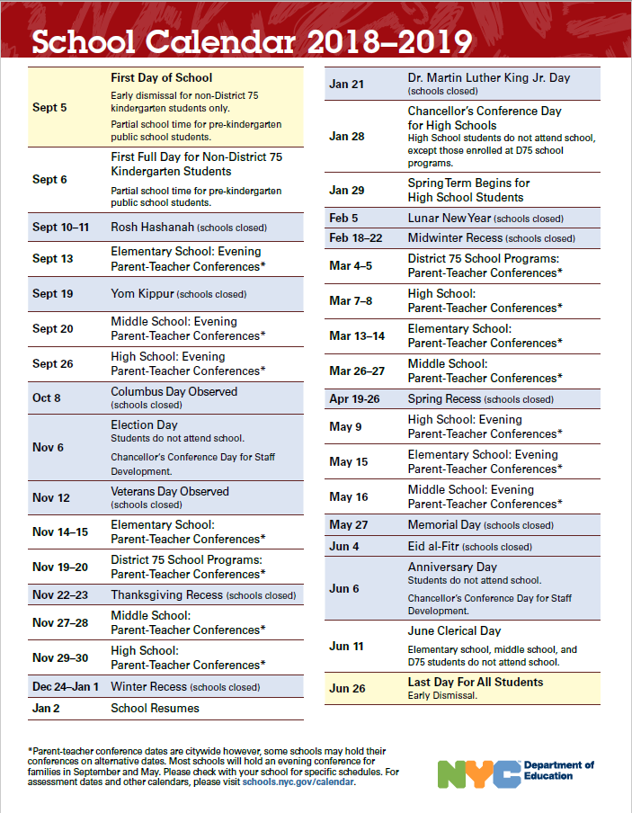

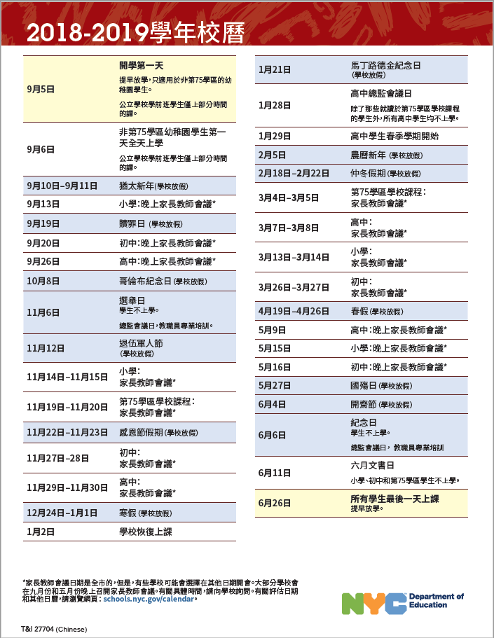

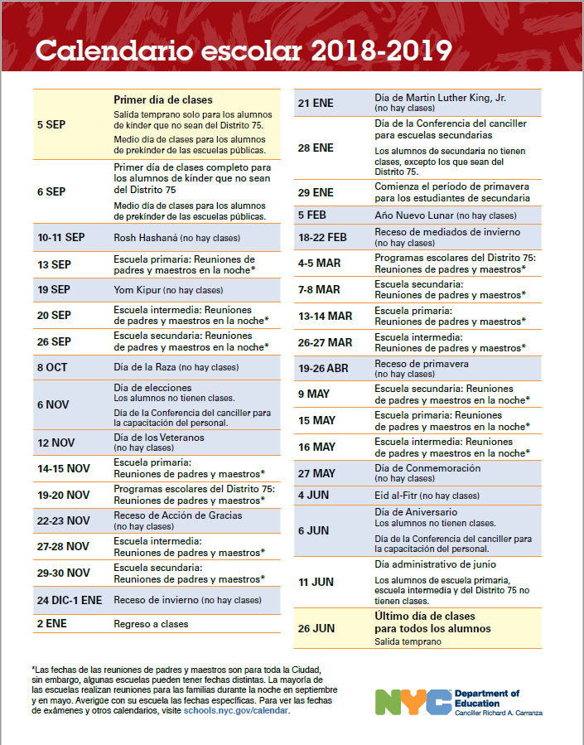

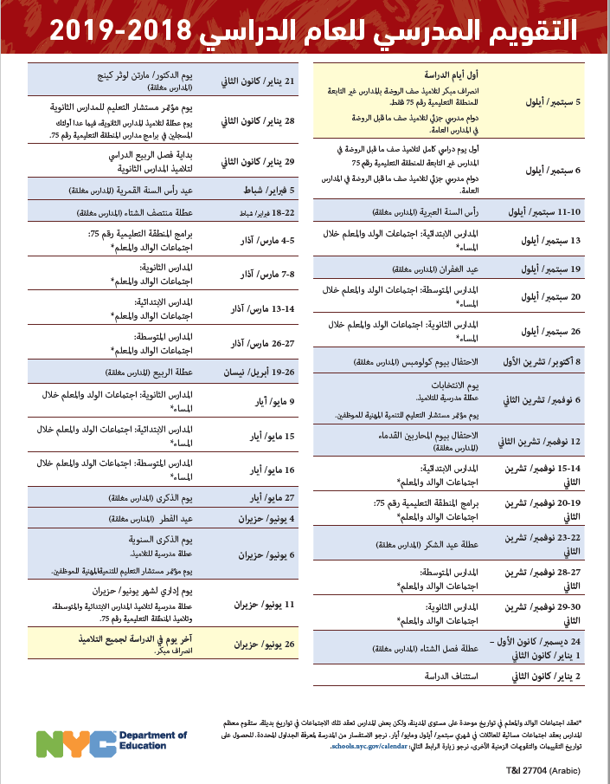

**Important Numbers**

**Main Office: (718) 491 – 8400**

**School Dean Extension: 1101**

**Guidance Counselor Extension: 1091/1092**

**School Nurse Extension: 3041**

**School Nurse Outside Line: (718) 491 - 8403**

**School Assessment Team Extension: 3001**

**Parent Coordinator Extension: 1102**

**Parent Coordinator Cell: (347) 563-4548**

**PTA Extension: 1031**

**CAMBA After School Center Extension: 1032**

**CAMBA Direct Line: 347-675-5090**

**CPC After School Center: (917) 214-8143**

**School Website:** [**www.ps170.com**](http://www.ps170.com)

**To make appointment with a teacher or administrator, please call the main office.**

**Don’t have time to take your child to the library?**

**No worry! We have purchased myOn for you. Your child can read many stories and news articles online at their own level. There are also quizzes to check their comprehension, too! Please contact your child’s teacher for user name and password.**

**Your child has no interest in or struggles with math?**



