Subject: Geometry Unit: Four
Unit Topic and Length:
QUADRILATERALS
(Three weeks)

Common Core Learning Standards:

Geometry. G-MG.1 Use geometric shapes, their measures, and their properties to describe
objects.

Theorems. G-CO.11 Prove theorems about parallelograms.

Big Ideas/Enduring Understandings:  Many quadrilaterals share the same properties.  Each type of quadrilateral has something about it which makes it unique.  All types of quadrilaterals can be seen in everyday life.  Quadrilaterals play an important role in design. | Essential Questions:  What can the diagonals tell us about a quadrilateral?  Are all rectangles parallelograms or are all parallelograms rectangles?  What do we know when diagonals bisect each other?  What do we know when diagonals are perpendicular?

Content:  Properties of a rectangle  Diagonals or a Rectangle  Diagonals of a Rhombus  What are properties of a trapezoid  How can we apply the properties of quadrilaterals in formal proofs | Skills:  Know that the opposite sides of a rectangle are congruent.  Know that the four angles of a rectangle are right angles.  Solve arithmetic and algebraic problems involving the sides of a rectangle and the angles of a rectangle.  The diagonals of a rectangle are congruent.  The diagonals of a rectangle bisect each other  State that each diagonal forms a pair of complementary angles at each vertex of the rectangle.  Solve arithmetic and algebraic problems  involving the diagonals of a rectangle.  Know the diagonals of a rhombus are perpendicular.  Know the diagonals of a rhombus bisect each other.  Know the diagonals of a rhombus bisect the angles of the rhombus.  Solve arithmetic and algebraic problems involving the diagonals of a rhombus.  Know a trapezoid is a quadrilateral with only one pair of opposite sides parallel.  Know the non-parallel sides are not necessarily congruent.  Know the sum of an upper angle and its adjacent lower angle are supplementary.  Know the sum of the four angles of a trapezoid is 360°.  Solve arithmetic and algebraic problems involving the trapezoid  Use a Venn Diagram or graphic organizer to organize the family of quadrilaterals based on their properties  Justify that a given quadrilateral is a rectangle, rhombus, rectangle, square, trapezoid or isosceles trapezoid  Apply the properties of trapezoid or isosceles trapezoid in formal proofs | Days:
Assessment Evidence and Activities:
Pre and Post Tests (formative assessment and assessments for evidence of growth)
Problem Solving Tasks and Activities
Quizzes
Questioning and Observations
Do Nows and Exit Slips
Class work and Homework
Possible Support Strategies:
Use of manipulatives
Word Walls and Individual Glossaries
Journals
Back Tracking Technique demonstrated for solving equations
Formative Assessment:
The assessments listed above will be used to identify students’ strengths and weaknesses.
There will be constant adjustments and fine tuning of the curriculum delivery based on this analysis. Sharing student work, sharing best practice and planning next steps will be an integral part of common planning meetings.
Final Performance Based Task: See Attached

Extension:
Differentiated column sheets for order of operations and evaluating like terms.
Table logic for adding and subtracting integers and polynomial expressions.
Differentiated column sheets for solving equations.
Learning Plan & Activities:
The learning plan will incorporate work shop style lessons which will allow for student centered learning. Group work will be incorporated into various concepts with a focus on students learning collaboratively. There will be an emphasis on technique to enable students to solve skills based questions. This will be supported with problem solving exercises for all content to give students a conceptual understanding of the material.
Resources:
Text book : Meaningful Math Algebra I Prentice Hall Mathematics Algebra I
Graphing calculators
Geometric Manipulatives, Sketchpad
Smart Board Demonstrations
Problem solving materials created by teachers

THE RESCUE MISSION

Ms. Jones and Ms. Smith are working at the rescue center during the summer break in Sum City. They receive an emergency call stating that a climber on Mt Pythag has fallen and is seriously injured. A medic on the scene informs Jones and Smith that they must get their helicopter here and fly the climber to Hypotenuse Hospital located at Angler’s Rest. The medic on the scene has assessed the injuries and can not stem the flow of blood. He believes that the climber must get to Hypotenuse Hospital in 5 hours or she will not survive.

Jones and Smith quickly put on their super hero costumes and jump in the helicopter. Jones tells Smith that she forgot to fill the chopper with fuel when they last were at the depot. It is obvious that they will need to fly back to the nearest depot for fuel before going to the climber. Smith is not impressed but considers the time constraints by the medic at the scene and she knows it takes 13 minutes to re-fuel and it will take 17 minutes to upload the injured climber. She tells Jones that their flying time is exactly 4 hours and thirty minutes.

From the rescue centre the depot which has the much needed fuel is located 30 miles west and 40 miles south of the rescue centre. The climber is 120 miles west and 80 miles north of the rescue center. The hospital is 40 miles east and 40 miles south of the rescue center.

Jones will have the helicopter on full throttle which means they will travel at a constant speed of 95 miles per hour. You need to determine if the climber will survive?
Use the graph paper provided. The rescue station is marked for you. Every little square grid is 5 miles by 5 miles.

STEP ONE :
Construct a triangle showing the given distances and the direct line of flight between the rescue center and fuel depot. The direction of the rescue center from the depot is North 37º East. Label this angle on your construction.

STEP TWO :
Use Pythagoras to determine the distance from the rescue center to the depot where the helicopter will re-fuel.

STEP THREE :
Construct a triangle showing the given distances and the direct line of flight between the fuel depot and the injured climber. The direction of the injured climber from the depot is North 53º West. Label this angle on your construction. Prove that the two constructed triangles are similar.
Use similar triangles to determine the distance from the depot to the climber.
STEP FOUR :
Construct a triangle showing the given distances and the direct line of flight between the injured climber and the hospital. The direction of the hospital from the injured climber is South 53º East. Label this angle on your construction. Prove that the this newly constructed triangle is similar to the first two.
Show how to find the distance from the climber to the hospital by using similar triangles.

Time = Distance / Speed (for every sector flown find the flight time.
Round off all time calculations to the nearest hundredth. Will the rescue team get injured climber to hypotenuse hospital on time?

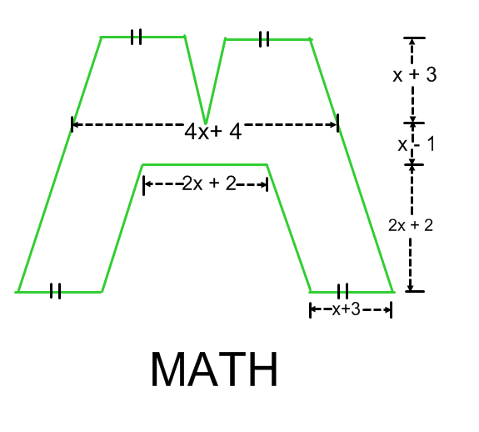
Find the area of the letter above. (hint: extend the inside legs of the to the top of the figure. This will form two very tall parallelograms. Connect the parallelograms with a horizontal line touching the bottom of the “v” in the top of the M. You should now have two equal parallelograms, two equal triangles and one trapezoid.)
________________________________________________________________________
________________________________________________________________________
________________________________________________________________________
________________________________________________________________________
________________________________________________________________________
________________________________________________________________________
________________________________________________________________________
________________________________________________________________________

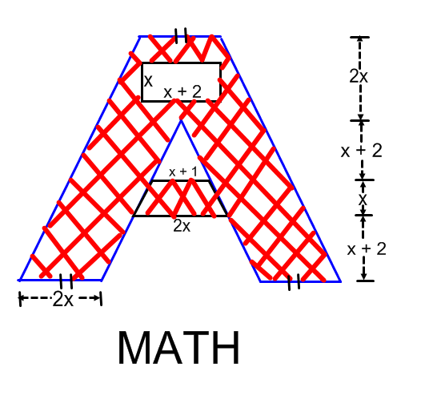
Find the area of the letter above. (hint: Draw a horizontal line in the A below the hollow rectangle touching the top of the triangle where the inside legs meet. You should now have two equal parallelograms and two different trapezoids.)
________________________________________________________________________
________________________________________________________________________
________________________________________________________________________
________________________________________________________________________
________________________________________________________________________
________________________________________________________________________
________________________________________________________________________
________________________________________________________________________
________________________________________________________________________
________________________________________________________________________
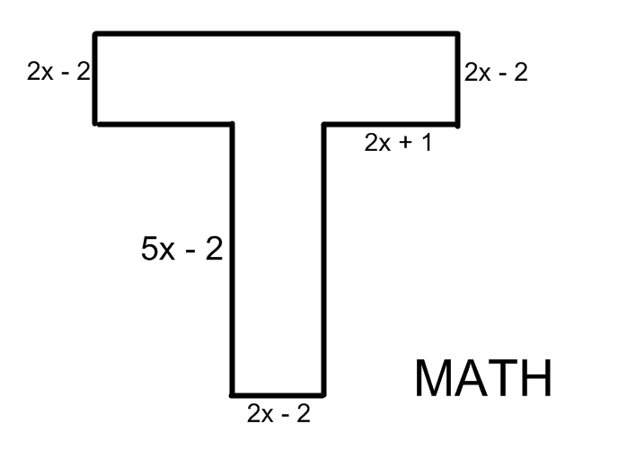

Find the area of the letter above. (hint: You don’t need one)
________________________________________________________________________
________________________________________________________________________
________________________________________________________________________
________________________________________________________________________
________________________________________________________________________
________________________________________________________________________
________________________________________________________________________
________________________________________________________________________
________________________________________________________________________
________________________________________________________________________
________________________________________________________________________
________________________________________________________________________
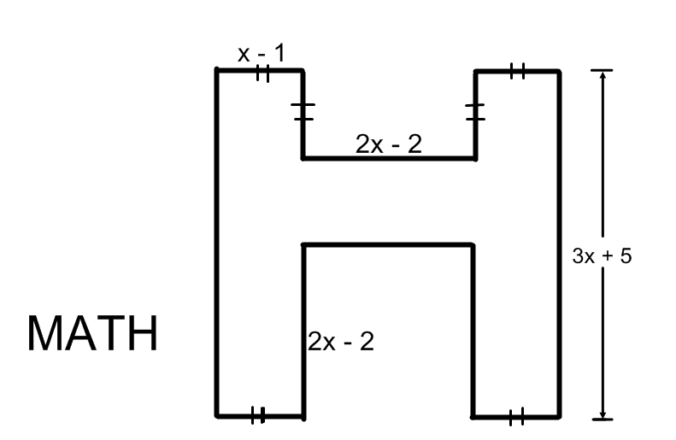

Find the area of the letter above. (hint: This is easy.)
________________________________________________________________________
________________________________________________________________________
________________________________________________________________________
________________________________________________________________________
________________________________________________________________________
________________________________________________________________________
________________________________________________________________________
________________________________________________________________________
________________________________________________________________________
________________________________________________________________________
________________________________________________________________________
________________________________________________________________________
________________________________________________________________________

