|  |  |  |  |  |
| --- | --- | --- | --- | --- |
| **Subject: Algebra II Unit: Seven** | | | | |
| **Unit Topic and Length:**  **Exponential functions – 20 days** | | | | |
| **Common Core Learning Standards Assessed:**  **F-IF.4** For a function that models a relationship between two quantities, interpret key features of graphs and tables in terms of the quantities, and sketch graphs showing key features given a verbal description of the relationship. Key features include: intercepts; intervals where the function is increasing, decreasing, positive, or negative; relative maximums and minimums; symmetries; end behavior; and periodicity.  **F-IF.7** Graph functions expressed symbolically and show key features of the graph, by hand in simple cases and using technology for more complicated cases.  e. Graph exponential and logarithmic functions, showing intercepts and end behavior, and trigonometric functions, showing period, midline, and amplitude.  **F-IF.8** Write a function defined by an expression in different but equivalent forms to reveal and explain different properties of the function. | | | | |
| **Enduring Understandings:**  Exponents are used to represent complex expressions.  Linear functions have a constant difference, whereas exponential functions have a constant ratio.  Real world situations can be represented symbolically and graphically with exponentials. | | | **Essential Questions:**  How can you simplify expressions involving exponents?  What characterizes exponential growth and decay?  What are real world models of exponential growth and decay?  How can one differentiate an exponential model from a linear model given a real world  set of data?  What is the meaning of half-life? | |
| **Content**  The concept of a function  Various representations of functions  Exponential functions and characteristics of their graphs  The solution of linear equations using algebra and graphing approaches  Familiarity with graphing technology  Use patterns to write a function to model a situation | | | **Skills : Students will be able to:**  Understand the concept of a function interpret functions that arise in applications in terms of the context analyze functions using different representations  Analyze functions using different representations Graph exponential functions  expressed symbolically and show key features of the graph  Understand the nature of exponential growth, and what makes a base of a function, write the equation of the exponential function and explore limits to exponential growth  Interpret functions that arise in applications in terms of context. Analyze functions using  different representations. Build a function that models a relationship between two quantities  Write expressions in equivalent forms Understand the concept of a function and use function notation Interpret functions that arise in applications in terms of the  Context Analyze functions using different representations Construct exponential models  and solve problems  Ability to distinguish between linear and exponential relationships given multiple representations and then create the appropriate equation/inequality using given information. | |
| **ASSESSMENT TIME LINE** | | | | |
| **Start of Unit** | | **Throughout the Unit** | | **End of Unit** |
| A pre-test will be given to see what knowledge the students have based on their mathematics learnt in high school. This information will be used to form group work. | | Students will work on several lead ups tasks which are problem solving based and should help them prepare for the types of thinking skills they should use on their performance based assessment. | | Students will do a self-reflection at the end of their common core aligned unit.  Teachers will also do a gap analysis of this work and they will address the needs of students based on the pre & post-test results. |
| **ASSESSMENT SUMMARY]** | | | | |
| Students will be assessed in a variety of ways. There will observations conducted on a regular basis during independent work and guided practice. A variety of questioning techniques will be used to gather information on what students understand. Students will be assessed on the class work and home work that they complete. We will also use exit slips. There will be formal assessments in the way of a pre and post-test. Students will also be assessed on their problem solving strategies and their level of conceptual understanding. This will be done through a performance based assessment and three lead up problem solving tasks. | | | | |
| **ACCOMMODATIONS FOR SPECIAL NEEDS** | | | | |
| **Special Needs Students** | Students with special needs will have small group instructions for parts of the curriculum delivery. All problem solving tasks will be scaffolded to ensure there are entry points and lessons will be differentiated to target their needs. We will also make use of manipulatives where appropriate. | | | |
| **Nonnative Speakers** | If there are available translated versions for any of the material this resource will be utilized. Group work will be formed with their needs in mind. There will be diagrams and numeric representations for most of the material. | | | |
| **Gifted/Talented Students** | The problem solving tasks will have a degree of rigor and open-endedness which will challenge these students at multiple levels. | | | |
|  | | | | |

|  |  |
| --- | --- |
| **DAY** | **PACING FOR UNIT WITH LESSON CONTENT** |
| 1 | Pre Test |
| 2 |  |
| 3 |  |
| 4 |  |
| 5 |  |
| 6 |  |
| 7 |  |
| 8 |  |
| 9 |  |
| 10 |  |
| 11 |  |
| 12 | Post Test |

|  |
| --- |
| **Formative Assessment:**  The assessments listed above will be used to identify students’ strengths and weaknesses.  There will be constant adjustments and fine tuning of the curriculum delivery based on this analysis. Sharing student work, sharing best practice and planning next steps will be an integral part of common planning meetings. |
| **Standards of Mathematical Practices**    **1.** Make sense of problems and persevere in solving them.  **2.** Reason abstractly and quantitatively.  **3.** Construct viable arguments and critique the reasoning of others.  **4.** Model with mathematics.  **5.** Use appropriate tools strategically.  **6.** Attend to precision.  **7.** Look for and make use of structure.  **8.** Look for and express regularity in repeated reasoning. |
| **Final Performance Based Task:**  Attached Below : |
| **Extension:**  Differentiated column sheets for order of operations and evaluating like terms.  Table logic for adding and subtracting integers and polynomial expressions.  Differentiated column sheets for solving equations. |
| **Resources:**  Text book : CMP 3 PEARSON’S Mathematics GEOMETRY  Graphing calculators  Geometric Manipulatives, Sketchpad  Smart Board Demonstrations  Problem solving materials created by teachers  Geo-boards  Mirror Reflectors |

Name : _______________________ Date : _____________

Do Now : Match the tables to their corresponding graph and to their equation. Do this by writing the letter of the graph and number of the equation next to the corresponding table.

|  |  |  |  |  |  |
| --- | --- | --- | --- | --- | --- |
| **x** | **-2** | **2** | **3** | **6** | Equation ______ |
| **y** | **6** | **6** | **11** | **38** | Graph _______ |

|  |  |  |  |  |  |
| --- | --- | --- | --- | --- | --- |
| **x** | **-2** | **2** | **3** | **6** | Equation ______ |
| **y** | **-7** | **5** | **8** | **17** | Graph _______ |

|  |  |  |  |  |  |
| --- | --- | --- | --- | --- | --- |
| **x** | **-2** | **2** | **3** | **6** | Equation ______ |
| **y** | **1 1/9** | **10** | **28** | **730** | Graph _______ |

|  |  |  |
| --- | --- | --- |
| A | 1  y = x2 + 2 | B |
| 2  Y = 3x + 1 | C | 3  y = 3x - 1 |

What strategies can I use to graph a relation or a function that I am unfamiliar with?

y = (x – 2)2 + 1

How large could y get to? In order for y to be very large what would x need to be? Can you find any key points for the graph?

_____________________________________________________

_____________________________________________________

_____________________________________________________

_____________________________________________________

How small could y be? Can y ever equal zero? What would x need to be if y was going to be very small?

_____________________________________________________

_____________________________________________________

_____________________________________________________

y = 3x + 5

How large could y get to? In order for y to be very large what would x need to be? Can you find any key points for the graph?

_____________________________________________________

_____________________________________________________

_____________________________________________________

How small could y be? Can y ever equal zero? What would x need to be if y was going to be very small?

_____________________________________________________

_____________________________________________________

_____________________________________________________

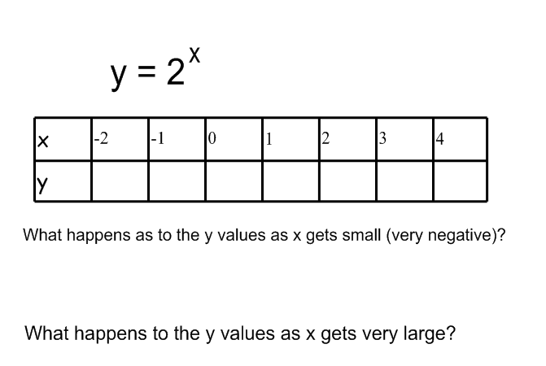

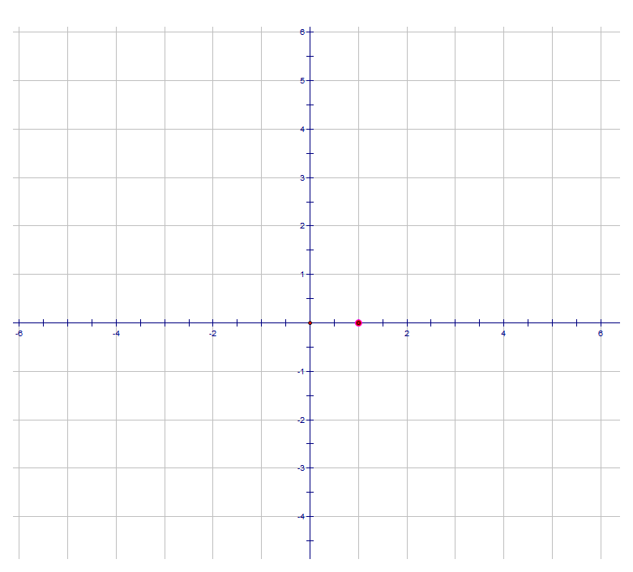

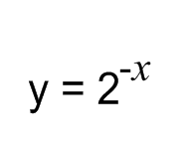

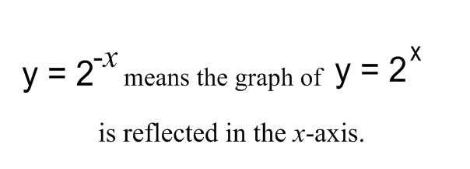

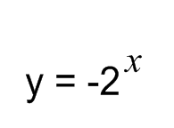



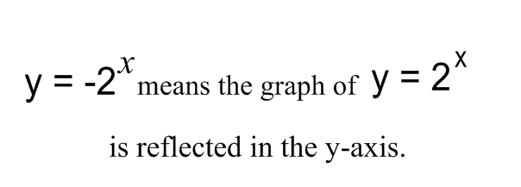

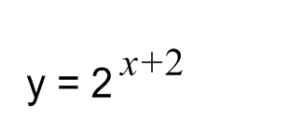 

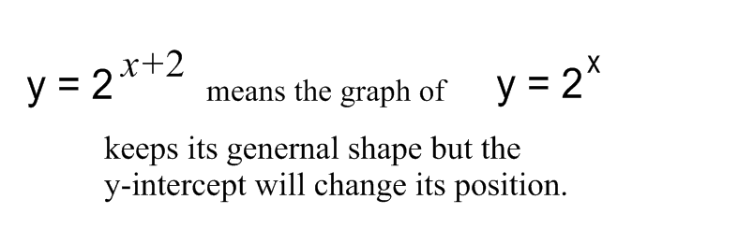

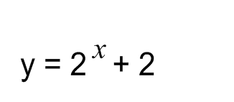



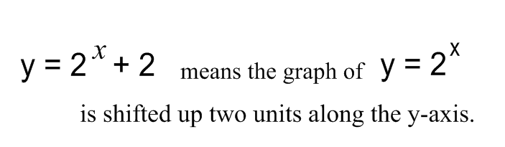

Group Problem Solving

Grandma passed away leaving a Bank Book with $16,750 that she deposited in 1973. No one has touched the money since then. She died in the year 2004 leaving everything to her three sons. After her death the sons went to the bank with the bankbook and found out that the money was invested at a fixed rate of 6.5% per year. Each of the sons wanted to but a new car which cost $40,000. Will the money that grandma left be enough to cover the cost of their cars?

If the sons decide to invest their money into a fixed deposit with the bank of their choice and leave it their until the end of 2010. The first son, Frank deposits 50% of his share at Chase Manhattan bank at 3.75% compounded annually. The second son, Jimmy deposits 65% of his share at CITI bank in a fixed deposit at 3% compounded annually. The third son, Bob decides to deposit 75% of his share at Capitol One Bank in a fixed deposit at 2.8% compounded annually. How much money does each son now have including their initial inheritance from grandma. Which son has accumulated the greatest sum of money and how much wealthier is he than each of his brothers.

Each group to share their results.

Formula: ***y = a * bx***

Problem Two

You are offered a job in retail at Lowe’s who will pay you $27 an hour and will also give you a rise of $1 an hour every six months. Home Depot also want you to work for them and they will pay $16 an hour and will give a 18% pay rise every six months. After five years which job will pay more money and how much more per hour will that job pay? When will both jobs pay very close to the same hourly wage?

Graph the two pay scales and discuss prepare your group to discuss what you have found from your graphs.

The manager of Lowe’s decides that he wants his employees to be making as much money as the employees at Home Depot at the end of five years. He still wants to increase their hourly wage by a constant amount every six months. Instead of an increase of $1 an hour every six months, how much would he need to increase their hourly wage by to achieve equal pay with Home Depot at the end of five years?

Name : ________________________________ Date: ________________________

**Performance Task: “Ponzi” Pyramid Schemes (Exponents)**

Max has received this email. It describes a scheme for making money.

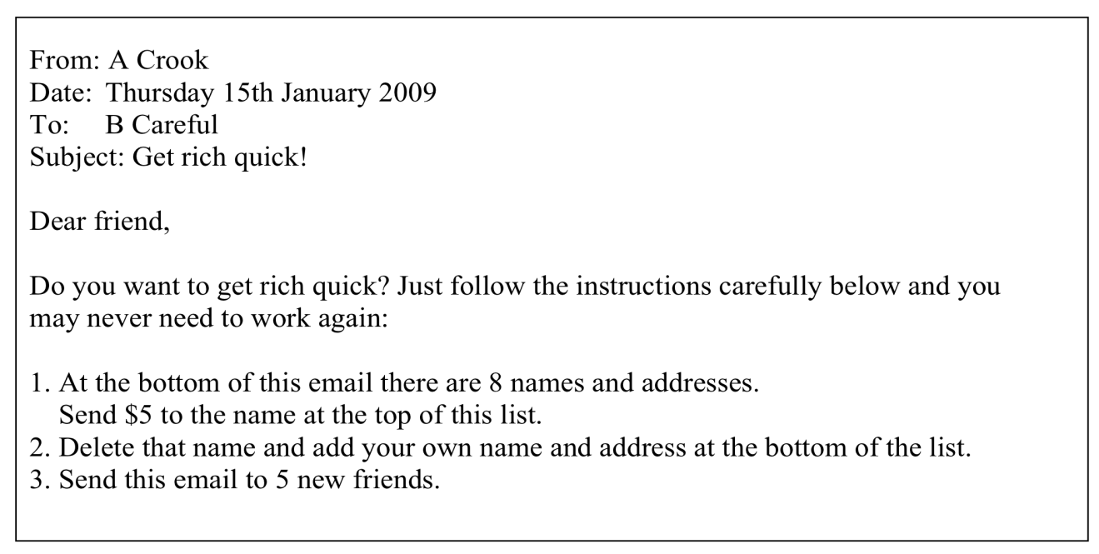

1. If that process goes as planned, how much money would be sent to Max?

Show your calculations.

__________________________________________________________________

__________________________________________________________________

__________________________________________________________________

__________________________________________________________________

__________________________________________________________________

2. What could possibly go wrong? Explain your answer clearly.

__________________________________________________________________

__________________________________________________________________

__________________________________________________________________

__________________________________________________________________

3. Why do they make Ponzi schemes like this illegal?

__________________________________________________________________

__________________________________________________________________

__________________________________________________________________

Stage One

1)_____________ 2) ______________ 3)_____________ 4) ______________

5)_____________ 6) ______________ 7)_____________ 8) _My Name_____

There are only five with my name on it at this stage.

===============================================================

Stage Two – My Name moves to number seven on the list

1)_____________ 2) ______________ 3)_____________ 4) ______________

5)_____________ 6) ______________ 7) _My Name____ 8) ­­­­­­­­­­­­______________

Now there are twenty- five with my name on it at this stage.

================================================================

Stage Three – My Name moves to number six on the list

1)_____________ 2) ______________ 3)_____________ 4) ______________

5)_____________ 6) _My Name_____ 7) _____________ 8) ­­­­­­­­­­­­______________

Now there are (5 x 5 x 5) one hundred twenty- five with my name on it at this stage.

|  |  |  |
| --- | --- | --- |
| **Stage** | **Where is my name on the list** | **How many people have my name** |
| **1** | **8** | **5** |
| **2** | **7** | **25** |
| **3** |  |  |
| **4** |  |  |
| **5** |  |  |
|  |  |  |
|  |  |  |
|  |  |  |
|  |  |  |
|  |  |  |
|  |  |  |
|  |  |  |

How many stages are there ?

When will I get my money?

How much will I receive?

**How Many Times Can You Fold a Piece of Paper?**

Take a standard 8 x 11  and fold it in half down the center. Open the paper back up and you will notice that the paper is now divided into two regions by the fold down the center of the page.

Fold the paper in half again and now fold this in half again. When you open the paper up this time how many regions do you see?

_________________

What if you fold the paper three times or if you fold it four times, can you imagine the number of regions you would see.

Compete the table below:

|  |  |
| --- | --- |
| **Number of Folds** | **Number of Regions** |
| **0** | **1** |
| **1** | **2** |
| **2** |  |
| **3** |  |
| **4** |  |
| **5** |  |
| **10** |  |
| **n** |  |



1) Describe patterns found in the table.

2) Describe how the number of regions is related to the number of folds. Translate this relationship into an algebraic rule. Use this rule to determine the number of regions given 18 folds.

3) Draw a graph of the function below.

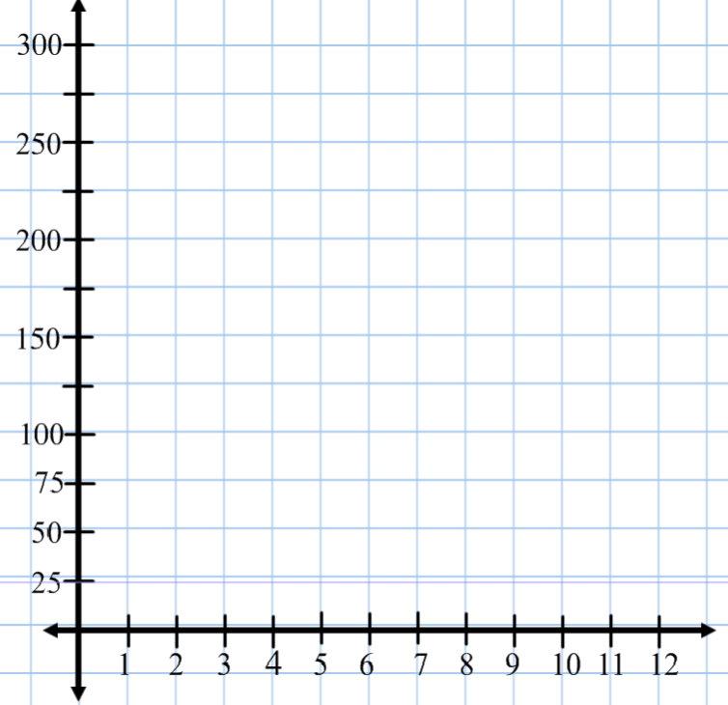

Saturday, 26 April 1986 -- The Chernobyl plant

The disaster began during a systems test on Saturday, 26 April 1986 at reactor number four of the Chernobyl plant, which is near the city of [Pripyat](http://en.wikipedia.org/wiki/Pripyat) and in proximity to the administrative border with [Belarus](http://en.wikipedia.org/wiki/Belarus) and the [Dnieper](http://en.wikipedia.org/wiki/Dnieper) river. There was a sudden and unexpected power surge, and when an emergency shutdown was attempted, an exponentially larger spike in power output occurred, which led to a reactor vessel rupture and a series of steam explosions. These events exposed the [graphite](http://en.wikipedia.org/wiki/Graphite) [moderator](http://en.wikipedia.org/wiki/Neutron_moderator) of the reactor to air, causing it to ignite. The resulting fire sent a plume of highly radioactive [fallout](http://en.wikipedia.org/wiki/Fallout) into the atmosphere and over an extensive geographical area, including Pripyat. The plume drifted over large parts of the western [Soviet Union](http://en.wikipedia.org/wiki/Soviet_Union) and Europe. From 1986 to 2000, 350,400 people were evacuated and resettled from the most severely contaminated areas of [Belarus](http://en.wikipedia.org/wiki/Belarusian_SSR), [Russia](http://en.wikipedia.org/wiki/Russian_SFSR), and [Ukraine](http://en.wikipedia.org/wiki/Ukrainian_SSR). According to official post-Soviet data, about 60% of the fallout landed in Belarus.

The accident raised concerns about the [safety](http://en.wikipedia.org/wiki/Nuclear_safety) of the Soviet nuclear power industry, as well as nuclear power in general, slowing its expansion for a number of years and forcing the Soviet government to become less secretive about its procedures. The government coverup of the Chernobyl disaster was a "catalyst" for [glasnost](http://en.wikipedia.org/wiki/Glasnost), which "paved the way for reforms leading to the Soviet collapse."

**Why is uranium dangerous?**

The reason is that every now and again, one of the atoms spontaneously (at random) 'decays'. At the instant of decay it fires off a poisonous ray (an alpha or beta particle, or a Gamma ray). If this ray hits someone, that's what does the damage.

So before firing off the ray, the atom is not hurting anyone, it is only potentially dangerous. After firing off the ray, the atom is now 'safe' and has been turned into something else, like lead, and is no longer radioactive.

It really is a random process. Scientists do not know what triggers any particular atom to decay, but they do know at the end of, say, a year, what fraction of the atoms have decayed.

Exponential Decay

Name : ____________________________ Date : _____________

Radio active substances decompose according to exponential rules.

Let us assume that we have a substance that will decay according to

the following rule.

A=A0rt

A equals the amount of substance left. A0 is the initial amount of substance,

r is the rate at which the substance decays for every period of time, t.

We will set up an experiment that simulates exponential decay.

You are all Uranium Atoms - you are all potentially dangerous, but it's only at that moment when you decay and fire off your 'poisonous ray' that you actually could cause harm. Let's assume the chances of decaying are 1 in 6 per year.

Every student will be given two dice. They will role their two dice and then

The teacher will roll the decomposition die. If the teacher’s result matches

Any of the students, the matching dice are destroyed (they decay) and can

No longer be used.

Thus A is the amount of dice left after a given number of rolls. A0 is the initial number of dice (number of students times two), r is the rate of decay

(1/6 in our case) and t is the number of times we decay.

All students roll two dice and record their results. (eg. 5 - 2)

If the teachers rolls either a 5 or a 2 the students would lose that die. When they lose both dice they are out. We continue until A = 0.

|  |  |  |  |  |  |  |  |  |  |
| --- | --- | --- | --- | --- | --- | --- | --- | --- | --- |
| t | 0 | 1 | 2 | 3 | 4 | 5 | 6 | 7 | 8 |
| A |  |  |  |  |  |  |  |  |  |
| t | 9 | 10 | 11 | 12 | 13 | 14 | 15 | 16 | 17 |
| A |  |  |  |  |  |  |  |  |  |
| t | 18 | 19 | 20 | 21 | 22 | 23 | 24 | 25 | 26 |
| A |  |  |  |  |  |  |  |  |  |

When does half life occur?

Based on this when do you think A = 0 (what will the value of t be?)

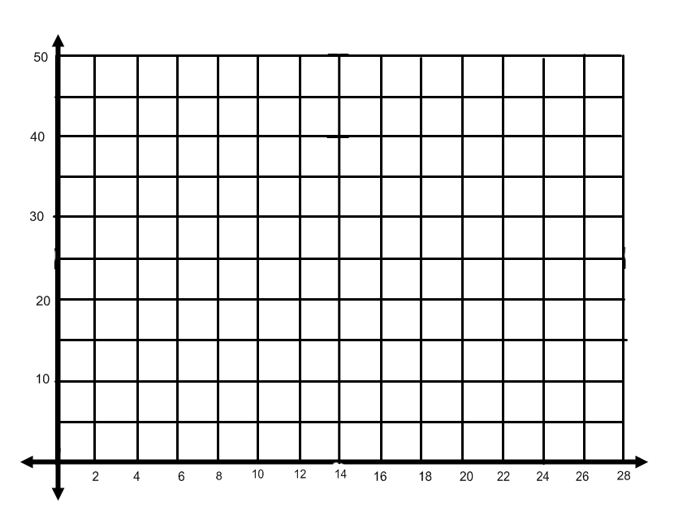

The fact that the students personally and physically participated in the simulation makes this concept much clearer.

Introduce a factual example, eg. the main contaminating material at the Chernobyl disaster in Ukraine was Caesium-30 which has a half-life of 30 years.

That means that 30 years after the disaster (which happened in 1986), half of the atoms will still be radioactive. 30 years after that, half of the remainder will still be there, and 30 years after that ... This shows that there will still be contamination there for at least the next 200 years.

**4. Understanding decay: estimating half-life**

Now I have a challenge for you. I want you to run some experiments on this idea of radioactive decay and the idea of a 'half-life'. In particular I hope you will be able to:

* estimate the 'half-life'
* estimate how many years until all atoms are 'safe'

This can be done in three stages:

* repeating the experiment physically
* using 100 dice