The Cambridge Family School Anne-Marie Scalfaro, Principal

P.S. 68 Queens Karen Gleason, Assistant Principal

“Where Learning Never Ends” Kathleen Murphy, Assistant Principal
59-09 St. Felix Avenue
Ridgewood, N.Y. 11385
Phone: 718-821-7246
Fax: 718-497-8945
www.PS 68Q.org
September 2017
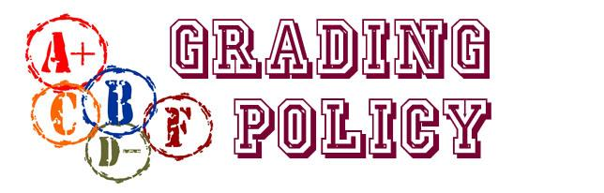

PS 68’s grading policy is uniform across the entire school.
- Report cards are distributed 3 times per year (November, March, and June)
- Grades are cumulative and show students’ progress throughout the year
- All courses are graded on a 1-4 scale except Art & Health which are graded pass (P)/ fail (F).
The school wide grading policy uses subject specific benchmark charts such as Teacher’s College benchmark reading levels and the Teacher’s College Rubrics for Narrative, Informational and Opinion Writing in order to determine these grades. Math and content area subjects will be graded based upon unit tests and/or projects.

District 24— Grading Policy

Level | Domain | Description | Pass or Fail | Report Card Equivalents
 |  |  |  |  |  | Grades 3-8 Only
4 | Exceeds | Exceeds means that a student, not only meets grade level standards but, consistently demonstrates progress towards meeting the next grade standards | Pass | E+ | A+ | 98+
 |  |  |  | E | A | 95-97
 |  |  |  | E- | A- | 93-94
3 | Meets | Meets means that a student consistently performs at grade level standards | Pass | G+ | B+ | 88-92
 |  |  |  | G | B | 85-87
 |  |  |  | G- | B- | 83-84
 |  |  |  | S+ | C+ | 78-82
 |  |  |  | S | C | 75-77
2 | Approaches | Approaching means that a student inconsistently performs at grade level standards | Pass | S- | C- | 73-74
 |  |  |  | N+ | D+ | 68-72
 |  |  |  | N | D | 65-67
1 | Below | Below means that a student consistently performs one or more levels below grade standards | Fail | N- | D- | 60-64
 |  |  |  | U | F | 0-59
“In the best classrooms, grades are only one of many types of feedback provided to students.”
- Douglas B. Reeves

Level 4: Meets Standards with Distinction – The student always demonstrates superior mastery of the content, concepts and skills for the learning standards and key ideas being assessed. For numerically graded tests, the student scores 92% or above.
Level 3: Meets Grade Level Proficiency – The student usually demonstrates mastery of the content, concepts and skills for the learning standards and key ideas being assessed. For numerically graded tests, the student scores between 75% and 91%.
Level 2: Approaching Standards – The student sometimes demonstrates mastery of the content, concepts and skills for the learning standards and key ideas being assessed. For numerically graded tests, the student scores between 65% and 74%.
Level 4: Below Standards – The student rarely demonstrates superior mastery of the content, concepts and skills for the learning standards and key ideas being assessed. For numerically graded tests, the student scores below 65%.
Pass – The student demonstrates understanding of the concepts and skills taught in a subject area and shows mastery through multiple measures of performance.
Fail - The student does not demonstrate understanding of the concepts and skills taught in a subject area. The student does not show mastery even after multiple opportunities given to measure performance.

