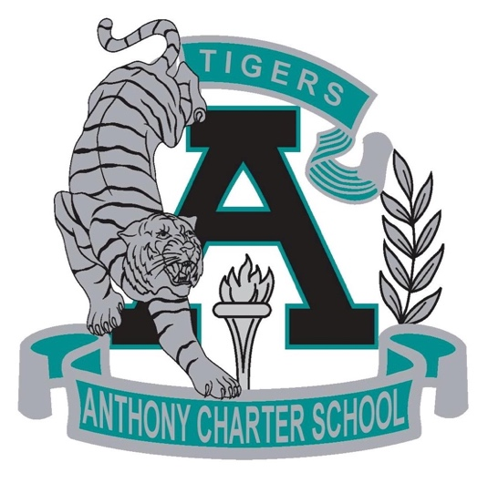

Public Notice
(Notificamiento Publico)

Anthony Charter School
Governing Council
(Junta del Cuerpo Escolar)
Monday, October 02th, 2017
(Lunes, Octobre 02, 2017)
TIME: 6:15 pm
Location:
780 Landers
Anthony NM 88021

