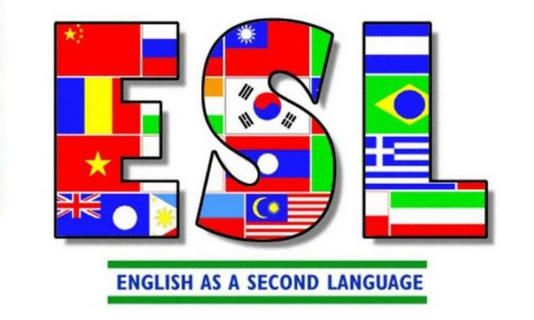
Free Adult

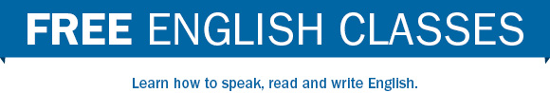

P.S. 175 will be offering free adult evening ESL classes. If you’re interested please sign up today at
P.S. 175
175 West 134th Street
New York, NY 10030
TUITION FREE CLASSES FOR
ADULTS 21 AND OLDER
NO GREEN CARD REQUIRED

Register: Wednesday, November 30, 2016
Classes will be held
Tuesday, Wednesday, Thursday
5:40 pm- 9:00 pm
For additional information please see Ms. Benjamin in room 112 or call 212.283.0426 ext. 1123

