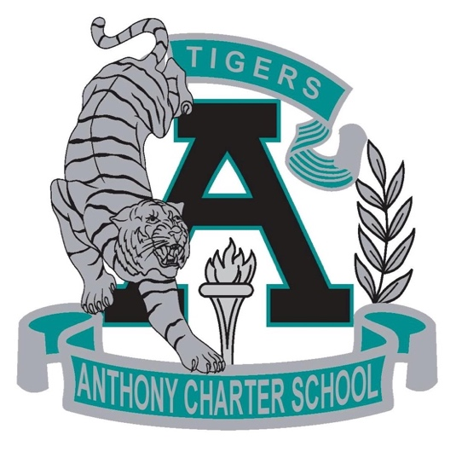

Public Notice
(Notificamiento Publico)
Regular MEETING
Anthony Charter School
Governing Council
(Junta del Cuerpo Escolar)
Sunday, January 21th, 2018
(Sunday, Enero 21, 2018)
TIME: 9:00 am
Location:
780 Landers
Anthony NM 88021

