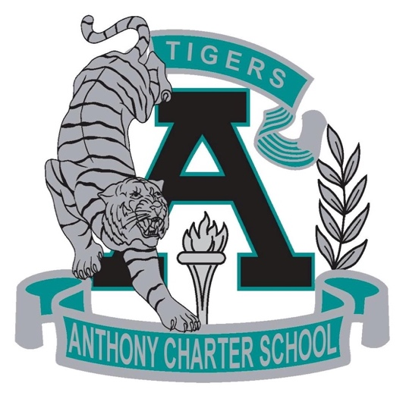

Public Notice
(Notificamiento Publico)
Regular MEETING
Anthony Charter School
Governing Council
(Junta del Cuerpo Escolar)
Monday, January 08th, 2018
(Lunes, Enero 08, 2018)
TIME: 6:15 pm
Location:
780 Landers
Anthony NM 88021

