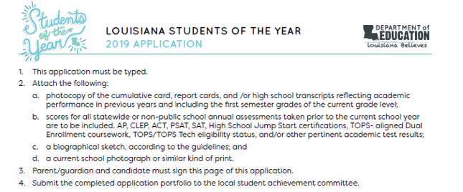
Applicant's Name; (First Middle Last) |  |  |  | Grade: (5, 8, or 12)
Home address:
City: Thibodaux |  |  | State: Louisiana |  | Zip: 70301
Parent/Guardian name(s):
Home phone: | Parent Cell: |  | Parent Work Phone:
Parent email:
School name: East Thibodaux Middle School |  |  | School phone: (985) 446-5616
Principal Name: Kenny Delcambre |  | Principal's email: kjdelcambre@mylpsd.com
School Mailing Address: 802 East 7th St. Thibodaux, LA 70301
Distric Superintendent's Name: Dr. Louis Voiron, Jr.
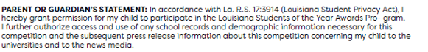
Parent/Guardian's Name Typed: | Parent/Guardian Signature: x
Date: | Applicant's Signature: x

LEADERSHIP POSITION | YEAR | ACTIVITY OR ORGANIZATION

HONOR / AWARD | YEAR | ACTIVITY / ORGANIZATION

HONOR / AWARD | YEAR | ACTIVITY / ORGANIZATION

