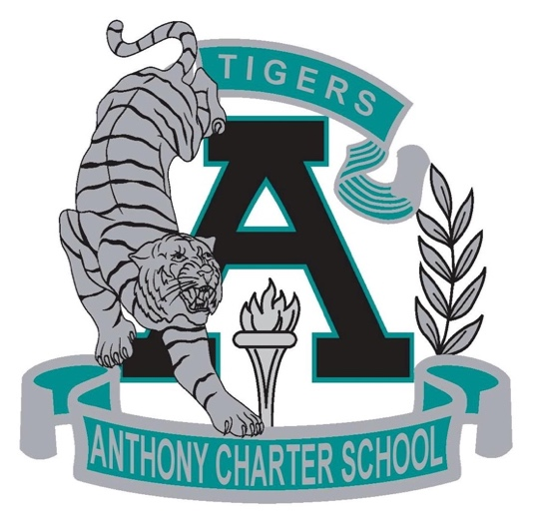

Public Notice
(Notificamiento Publico)

Anthony Charter School
Governing Council
Special Meeting
(Junta del Cuerpo Escolar)
Monday, March 20th, 2017
(Lunes, Marzo 20, 2017)
TIME: 6:00 pm
Location:
780 Landers
Anthony NM 88021

