Grade 2 September Goals

Reading
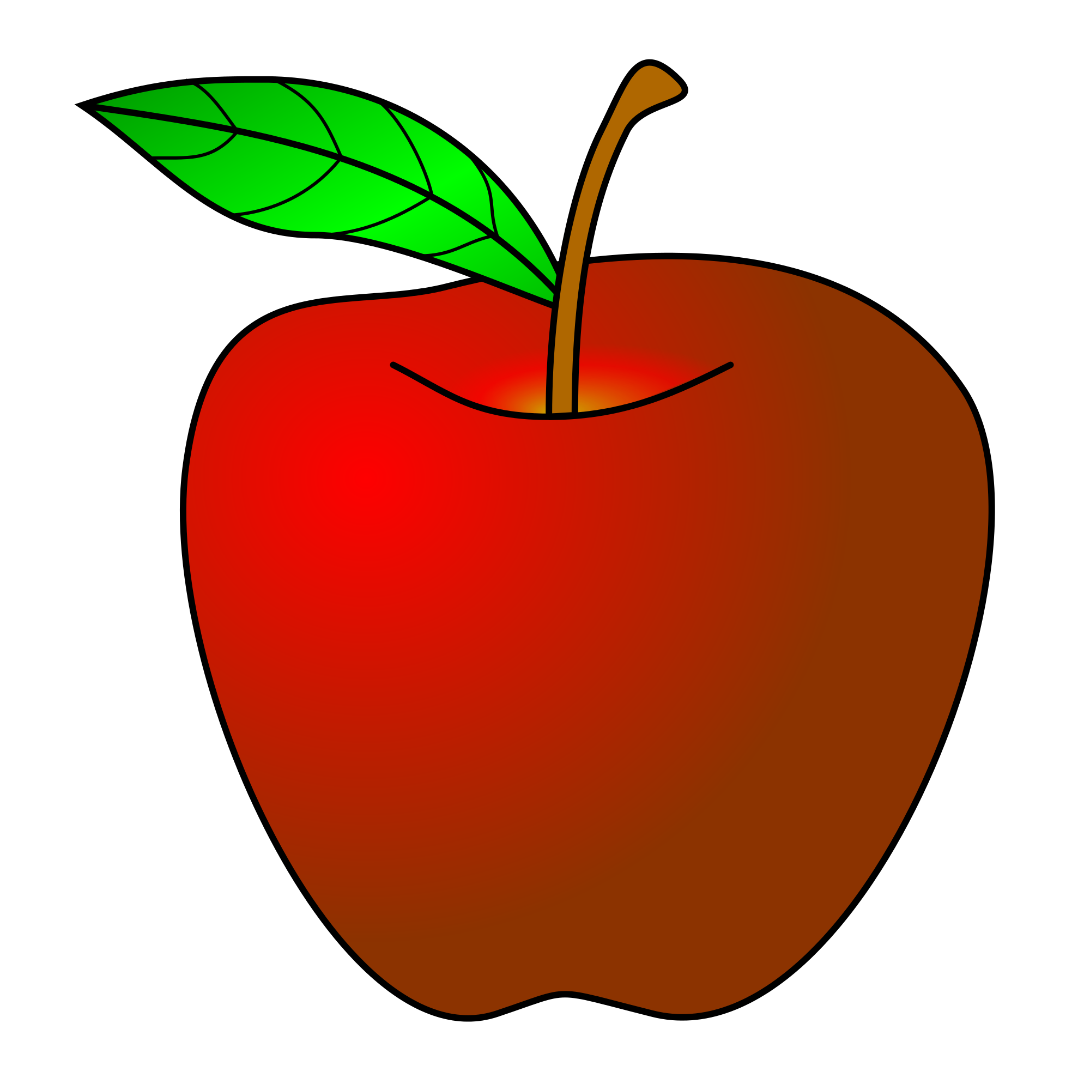
Students will think of themselves as readers by reading books that they enjoy and participate in all of the choices and decisions that readers make.
We will establish the roles and routines of reading.
Writing
We will learn to write in complete sentences using correct punctuation and capitalization. We will also learn to write in paragraph format. Students will complete an All About Me Writing piece.
Math
We will be able to recognize even and odd numbers.
We will understand different ways to represent numbers, such as using expanded form.
Science
We will learn how scientists use questions to learn about the world around them.
We will learn about the tools scientists use.
Social Studies
We will learn the location of the seven continents and main oceans.
We will also be able to locate New York City on the map.

