SWAG at PS 123 Mahalia Jackson
PS 123 Mahalia Jackson kicked off the month of November with a number of community collaboration events among students, families, faculty, partners and administration.
To expand the all school mantra for ROCK IT (Respect for All, Own It!, Care for your Community, and Keep it Safe), PS 123 has launched weekly community meetings with middle school students in order to have students express Joy, Pride and Focus. The goal is to have student voices heard and represented in the school community. Students were welcomed in the auditorium on Friday November 10, 2017 by popular hip hop instrumentals while they watched snap shots of their annual retreat to Alley Pond Park. Students were also empowered by special presentations from Principal Hernandez and Brittany Velasquez- Assistant principal of middle school. Messaging included the importance of student voice in community, and student shout outs to students who exhibited PRIDE in the present week. Also the 45 minute gathering also included staff spotlight, PS123/ Graham Windham peer mentoring program, conflict resolution strategies and a student feedback forum. A highlight to the community meeting was Principal’s Hernandez message of “See Something, Say Something.”
“Our top priority is to ensure all students feel safe. Advocacy is a tool that we are arming all our students with. All students have access to a caring adult. We do understand that there are times students may not want to talk to an adult, thinking that they would get in trouble and we want to support them in those times. Student voice matters in our school community. There are multiple ways to use it. The box is just one of the many ways we meet the needs of our students.” said Principal Hernandez
Students were introduced to the school’s Keep It Safe box, where students are invited to share any issues, concerns, or ideas to administration, in times where they may not feel comfortable having an open conversation to a caring adult.
“Students have a right to feel respected and safe. Only administrators will have access to the information in the box and we will address every situation solution based- with student identity and safety as paramount in our decision making and next steps.”
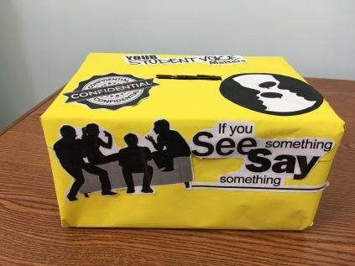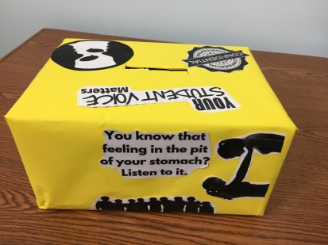

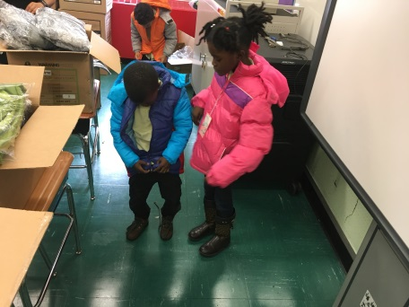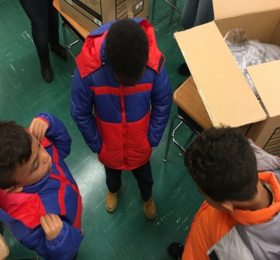
PS 123 Mahalia Jackson kicked off the cold weather season giving away warm winter coats to students and families in need. Over 80 students received warm coats as the cold season approach. Students were given the opportunity to choose their favorite color coat and were sized to ensure that they were comfortable and able to throw a great snowball.
“Thanks!” said a 4th grade student. “I love my coat. I’m going to wear it every day.”
PS 123 Mahalia Jackson recognizes the many challenges families may face while ensuring that their child (ren) make it to school on time, every day.
“We really appreciate this. That is one less thing I have to worry about.” said a parent to a 2nd grade student.
PS 123 Mahalia Jackson faculty work hard at supporting the whole need of students and families. A simple tactic is- meeting them right where they are.
“It’s just that simple- we get it. We understand the competing priorities and the obstacles our families face. Now that we know this and our families are opening up to us, how can we solve the situation together to ensure our families stay together, are safe and students continue to succeed” said Jeanine Lascelles, Graham Windham Community School Director.
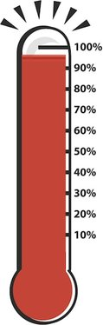The resources provided by the school and the ongoing collaboration efforts between families, faculty and partner programs such as Graham Windham Beacon and Community School programs, YMCA, Reading Rescue, etc. help attribute the schools all time high attendance of 96% on November 8th 2017.
“Intentional weekly meetings and approach, ongoing family outreach and collaboration by our attendance team, elevating student and family voice is what attribute to our success- it’s that simple.” said Principal Hernandez.

