Table of Contents
Table of Contents 1
Ms. Martinez’s Welcome Letter 3
Letters from the AP’s 4
School Policies 8
Academic Policy 9
Attendance Policy 16
Conduct Rule 17
Cell Phone Policy 19
Sexual Misconduct Policy 20
School Safety & Emergency Procedures 23
Instructional Support Student Services/Section 504 24
Map of the School 26
Faculty Directory 30
Graduation Requirements 32
DOE Calendar 33
School Events 34
Marking Period Schedule 36
Bell Schedule 37
CTE (Career Technical Education) 38
Club List 40
Sports List/PSAL Information 42
Student Guides 44
Where to go if…? 45
Student Guide to Google Classroom 47
How to read your Transcript? 50
How to read your Schedule? 51
How to Get Working Papers 52
Bus Routes 53
Advice for New Students 56
College Readiness Resources 58
Tips for College Readiness 59
How to use College Board 60
College-Accredited Courses 65
College Now Classes 65
AP Classes 66
SAT/PSAT Information 67
Ascenders 68
CLEP 68
Parent Resources 69
Tips for Parents 70
Parent Coordinator Information 71
PTA Executive Board 71
PTA Meetings 71
Lunch Forms 72

Principal’s Message

Dear Bayside Students and Families:

Welcome to Bayside High School! My primary role is to ensure rigorous instruction and a safe learning environment. I am a firm believer that curiosity is the cornerstone of learning. Through critical thinking, questions, collaborative learning opportunities, student choice and real-world connections, I encourage the community to “remain curious”. Curiosity sparks innovation and creativity, which is the leading force of our current competitive global market and Bayside’s programs.

Bayside High School offers six specialized career technical programs:

- Digital Art & Design
- Music: Performance and Production
- Environmental Engineering and Technology
- Humanities and Non-Profit Management
- Computer Programming and Web Design
- Sports Medicine and Management

Bayside is committed to ensure that in each program students engage curriculum and instruction that is driven by our belief that “What is learned, is learned by doing”. Our career technical programs engage students in project based learning and complete rigorous activities driven by their curiosity.

Additionally, we strive to meet each and every student’s social emotional needs through Whole Child Guidance. Whole Child Guidance encompasses 14 Bayside Guidance Counselors assigned by home language, smaller caseloads for more individualized attention, college advisory and targeted check-ins. Our guidance counselors remain with students throughout their entire academic years.

Finally, I realize parental involvement plays a key role in our overall success; therefore, I encourage monitoring of academic progress and attendance to ensure progressive excellence. To support the development of advocacy skills, students must reach out to their teachers to discuss any concerns or challenges. There are numerous supports and interventions available. Please note, the information available in this handbook is based on in-person instruction. Thoroughly read the policies, procedures and expectations to ensure achievement.

I look forward to working with each of you to ensure success at Bayside High School.

Respectfully,
Ms. Tracy Martinez, Principal
Letters from the AP’s
Mr. Jonathan Hirata (Room 127) - Assistant Principal of Organization
As Assistant Principal of Organization, my office oversees the school budget, staffing, and operations. This includes working with school support staff such as secretaries and school aides who work behind the scenes to make the school run smoothly. One of my roles is to support students and families in taking advantage of financial opportunities related to their education. Do you have a question regarding the St. John’s College Advantage Program, Family Income Inquiry Form (Lunch Form), or paying for an AP Exam? Please visit my office in room 127.
Mr. David Morrison (Room 128) - Assistant Principal of Student Services
Welcome to Bayside High School! The school counselor team is looking forward to the 2023 - 2024 school year and all of the opportunities ahead. As Assistant Principal of Student Services, my goal is to ensure the school counselors support all students in making successful choices that will benefit them throughout life. The school counseling team believes that it is our job to help our students and families make informed decisions, to be successful so that they can achieve their dreams when they graduate and go on to college and careers.
Our goals for this year are:
- Continue to challenge and support all students to be their best academically.
- Make positive connections with students and families and provide support when needed.
- Be available to provide social-emotional support and resources.
- Be a model for showing kindness and inclusion.
Room 128 is always open, if you need anything, please stop in. Looking forward to a wonderful school year!
Ms. Allessia Quintana (Room 119B) - IA Assistant Principal of Instructional Support Services
Welcome to the 2023-2024 school year! The goal of the Instructional Support Services department is to ensure that all students are receiving the academic and social-emotional support they need to be successful inside and outside of school. Throughout your high school career, we will work with you to foster self-advocacy and personal reflection skills to help prepare you for life after graduation. Please stop by room 119B if you need anything. I am looking forward to an amazing school year with all of you!
Ms. Melissa Haroutunian (Room 351) - Assistant Principal of School Development
Bayside High School features 6 New York State-approved CTE Programs designed to prepare students for college and careers. All Bayside High School students are enrolled in one of our CTE programs and complete a sequence of courses, have opportunities to earn college credit, take technical assessments aligned to the corresponding career cluster, and participate in work-based learning experiences. We facilitate a wide array of internships to fulfill the work-based learning requirement. Interested in an internship…please stop by to see our Work-Based Learning Team in Room 251 for more information.
Mr. Daniel Tizol (Room 216A) - Assistant Principal of Arts & World Languages
Nǐ hǎo, Hola, Kon'nichiwa, Bonjour, Annyeong! We at the Arts and World Languages Department welcome you to a wonderful community of learners. This department houses all of the digital and fine art teachers, the music and audio production teachers, and the teachers in Chinese, Japanese, Korean, French, and Spanish. We trust that you will find our teachers warm, hardworking, and forward-thinking. We believe deeply in empowering student learning through individualized learning experiences that connect you more deeply with your world. Our mission is to support your growth wherever you find yourself as a learner in any of our subject areas. Growth does not come easily, but we aim to be as painless as possible. Get outside of your comfort zone! Take advantage of our multitude of opportunities and communicate clearly and respectfully with teachers about your needs. Have a wonderful year! You’ve gotten into the best large high school in New York City. You're already starting from a good place.
Ms. Shana Tessenholtz (Room 328A) - Assistant Principal of ELA/ENL/Library
Welcome to the English Department! The English Department prepares students to become independent learners who are skilled in the four areas of the English language: reading, writing, speaking, and listening. We encourage students to become responsible for their own learning and make decisions in the classroom in order to develop skills that make connections between their reading, writing, and personal lives. The department offers a large number of college-accredited classes and advanced placement classes.
The ENL department prepares English language learners to effectively use English and academic strategies to become successful lifelong learners. Students are supported to become prepared for higher education and participate in academic study in university programs. The goal of the ENL Program is to provide resources and opportunities to English language learners in order to develop their reading, writing, listening, and speaking skills to a level appropriate for college readiness.
Ms. Madeline Belfi Galvin- Assistant Principal of Mathematics and Computer Science.
The Math and Computer Department welcomes you to Bayside. Our teachers are excited to support your mathematical Journey. Students will take Regents math classes in Algebra 1, Algebra 2, and Geometry prior to exploring college-level math classes in Precalculus, Calculus, and Statistics. Students will be engaged in hands-on learning and challenging projects as they master mathematical concepts. We encourage all students to take part in our college-accredited courses.
Students enrolled in the Computer Programming & Web Design CTE program will learn a variety of computer languages, create video games and develop Websites. Students will develop their skills through project-based learning as they work towards successful completion of the NOCTI Technical Assessment in Computer Programming.

Mr. Joseph Capuana (Room 100) - Assistant Principal of Health & Physical Education and Athletic Director
Bayside High School offers comprehensive health and physical education programs emphasizing health, fitness, and sports model education. Dance, swimming, net games, and advanced weight training are electives added to the curriculum aligned to New York State and national standards. Athletically, we offer 34 varsity and junior varsity sports teams throughout the school year. For more information, visit our Instagram @bayside.athletics or www.baysidehighschool.org/sports_teams. Students within our Sports Medicine & Management Program are prepared for careers in areas such as personal training, athletic training, exercise science, physical therapy, etc. Students earn CPR & AED certification and are prepared for an industry credential in personal training.
Dr. Shirley Labardy, DPM (Room 233) - Assistant Principal of Science
Welcome to the Science Department! We are here to support all students to be successful in their science classes. Students will take Regents science classes while at Bayside High School, in Chemistry/Fundamentals of Chemistry, Living Environment, and/or Physics, in order to complete their high school graduation requirements.
New York State mandates that students complete 1200 lab minutes to qualify for Regents exams in June. Students must attend weekly lab sessions with their regularly scheduled Science teacher. Each week has a different lab activity and the lab rooms are reset at the end of the week for the new labs. Prior labs will not be available for students to complete. Please make sure you attend lab class on the day your teacher is in the lab room.
If you are absent on your lab day, please speak with your Science teacher when you return to class, to discuss how you will complete the missed lab. If you do not complete missed labs within the term, you will receive a failing lab grade on your report card. You will not have the required lab minutes and will be barred from taking the Regents in June.
A solution we have if you know ahead of time that you will be absent during your lab session is for you to look at the posted lab schedule found outside your lab room and attend another lab session, during your scheduled lunch period. This can only occur if there is room in the lab session to welcome you and the teacher gives you permission. You will be asked to show your program to verify your lab period with the lab teacher. On your lab sheet, make sure you write the name of your regular lab teacher. Lab sheets will be given to your regular teacher, once the lab is completed.
Our Environmental Engineering & Technology CTE Program has roots within our Science & Math Departments. Students are prepared for industry-based exams and credentials including AutoCAD and NOCTI Mechatronics. Coursework is aligned with Project Lead the Way (PLTW) curriculum.
I am always available to support you in room 233.

Mr. Marc Cercone (Room 317) - Assistant Principal of Social Studies
Greetings from the Social Studies Department! Social Studies at Bayside High School guides all students through their study of history and the social sciences. The ultimate purpose of Social Studies at Bayside is to teach students how to research and analyze humanity’s triumphs and failures, ultimately evaluating the impact of these truths on modern society. Over the course of their four years here, students are required to complete:
- One (1) year of double period Global History and Geography which culminates in the NYS Global History Regents Examination
- One (1) year of U.S. History and Government which culminates in the NYS U.S. History and Government Regents Examination
- One semester (1/2 year) of Participation in Government
- One semester (1/2 year) of Economics
Social Studies also offers more Advanced Placement (A.P.) courses than any other department. Our current A.P. offerings are:
- A.P. World History
- A.P. U.S. History
- A.P. U.S. Government and Politics
- A.P. Comparative Government
- A.P. Human Geography
- A.P. Art History
- A.P. European History
- A.P. Psychology
Additionally, all Non-Profit / Humanities CTE teachers are aligned to the Social Studies Department. This unique program builds upon our department's ultimate purpose by synthesizing what we have learned about the development of modern life in order to create organizations that improve society. Simply put, it is a fantastic course of study for training the leaders of tomorrow.

School Policies
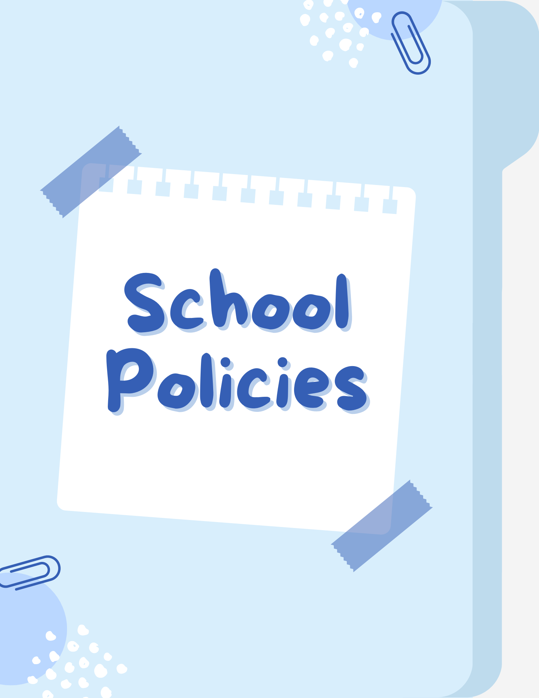

Attendance Policy
Student Attendance Policy
Due to the integral link between student attendance and success, students may not be absent from class more than 4 days in a marking period without a compelling reason, such as serious illness, death in the family, or a court appearance.
Students with more than 4 absences in a marking period are in danger of not getting a passing grade for that marking period without permission of the department supervisor.
All absences require a note of explanation; provision of such notes are to be recorded in teacher’s records. This includes Covid related absences.
Cutting: “Cutting” refers to an illegal absence from class. Students will be penalized for cutting, which is regarded as an illegal absence in our attendance policy.
Lateness: Students who enter class after the late bell will be marked LATE. Two lateness’s = 1 absence. (cut)
Good Grades and Regular Attendance
The first day of class is especially important. Teachers often explain exactly what you need to do to get top grades in that class. You may receive a course outline, long-term assignments, test schedules, learning goals, and so on. The teacher may also talk about how you’ll be tested and the factors that will determine your final grade.
Each class lays the groundwork for further learning. This is especially true of foreign language and mathematics, where the teacher presents topics step by step in logical order. Being there will help you understand topics presented in future sessions.
If you miss a class, you have to play catch-up. Speak with your teacher and ask if she/he gave out printed notes. Ask one or two of your classmates if they will share their notes with you. If you miss two or more classes, you may fall behind in your work and never recover. You can easily avoid this hardship by attending all of your classes. Learning is a much easier one step at a time.

Conduct Rule
Rules | Consequences
Attendance is required in school every single day. Medically excused absences may be accepted upon presentation of a Doctor’s Note to the Attendance Office. A note from a parent or guardian may be submitted for short absences, which did not require medical attention. Teachers will use their discretion with non-medical notes. | Absence from school will be reflected in your schoolwork and in your grades as a result of missing work and class participation. Subject failure may result. More than 4 unexcused absences in a marking period will result in failure.
Lateness: You are considered late if you are not in your seat when the bell rings. Missing all or part of a class is considered cutting. (See #3) | Repeated lateness will affect your schoolwork and result in a lowered report card grade because of missing class work and class participation. Two cuts = one absence.
Cutting any class is prohibited. Teachers will check absence reports weekly. Leaving school grounds without permission is prohibited. Leaving the school during your lunch period is prohibited. | Cutting is an illegal absence from class and will be reflected in class grades. Cutting may result in delayed promotion. Cutting may also lead to suspension from school. Parents will be informed of cutting and may be required to come to school for a conference.
Program Cards & I.D. Cards must be carried at all times in the building. They must be presented to any staff member upon request. | If you lose your Program Card, report it to the Dean’s Office and request a duplicate. If you lose your I.D. card duplicates may be obtained from the A.P. Security.
Passes: No student may be in the hall without a bathroom pass or a nurse’s pass. You must have a pass to leave ANY of the classes in your program. Bathroom passes may not be given to students during the first and last ten minutes of each period; bathrooms are locked at those times. | A student in the halls without a pass is considered cutting and may be subject to disciplinary action.
Card Playing, Smoking and Gambling anywhere in Bayside High School or on school grounds are strictly prohibited. | A student violating this rule is subject to disciplinary action (parent notification and conference) and possible suspension.
Drinking or Possession of Alcoholic Beverages or Illegal Drugs anywhere in Bayside High School or on school grounds is strictly prohibited. | Severe disciplinary action, arrest, suspension or a Superintendent’s Suspension may result in violating this rule.
Disruptive Behavior:  - Fighting is prohibited and will lead to suspension from school and possible arrest.  - Possession of any kind of a weapon, or any object that can be used as a weapon, is prohibited  - Bringing unauthorized visitors to school is prohibited.  - Engaging in activity, whether on or off school premises, which is disruptive to the safety and orderly operation of the school or the health and welfare of the students, staff and faculty of Bayside High School is strictly prohibited.  - Engaging in sexual harassment (comments, innuendo, propositions, inappropriate physical contact, etc) is prohibited.  - Engaging in physical sexual aggression is prohibited.  Please consult the discipline code for a detailed list of infractions and consequences. | - Fighting will lead to suspension and possible arrest, expulsion from the school and a notation on the permanent record.  - Possession of a weapon will lead to suspension and possible arrest, expulsion from the school and a notation on the permanent record.  - Unauthorized visitors may be arrested and any student responsible for bringing in unauthorized visitors may be suspended.  - Disruptive behavior will result in disciplinary action appropriate to the level of severity of the infraction.  - Sexual harassment may result in parental conference, restitution and/or suspension.  - Physical sexual aggression may result in referral to mental health staff, community agencies, suspension, and/or criminal charges.
School Tone:  - You are not permitted to record using cell phones and other electronic devices  - Students are not permitted to wear any gang or hate related signs or cloth. We have respect for all schools.  - No short-shorts, tank tops or bare midriffs are permitted. | - Devices will be confiscated and returned only to a parent after a Dean’s conference or meeting with the Assistant Principal of Security.  - Hate-related clothing worn in the building will be confiscated and returned only to a parent after a Dean’s conference or meeting with the Assistant Principal of Security.  - Students will be asked to change to appropriate clothing and/or parents will be required to come to school with appropriate clothing.
* The Bayside High School Code of Conduct adheres to the Citywide Standard of Discipline.
It is important for students to know that they will be banned from Senior activities such as the trip and prom in the event that they have an extensive Dean’s record. Any student who has received a Superintendent’s suspension while in high school is automatically barred from participating in senior activities.

Cell Phone Policy
Dear Students, Parents, Caregivers & Staff Members:
As required by Chancellor’s Regulation A-413, the School Leadership Team of Bayside High School has adopted a school-based cell phone policy, which took effect March 1, 2015:
SCHOOL-BASED POLICY OF 26Q495 BAYSIDE HIGH SCHOOL FOR USE OF CELL PHONES, COMPUTING DEVICES, AND PORTABLE MUSIC AND ENTERTAINMENT SYSTEMS ON SCHOOL PROPERTY
Students are permitted to bring the following electronic items to school: 1) cell phones; 2) laptops, tablets, iPads, and other similar computing devices.
Cell phones may be used as set forth below:
During the school day:
- Cell phones may not be used in areas where swimming pools are located.
- Cell phones may not be turned on or used during instructional time, except for instructional and educational purposes with the explicit approval of the teacher.
- Cell phones may be used during the following non-instructional times of the school day: during a student’s lunch period only in the student cafeteria.
- Cell phones and other electronic devices may not be used to photograph, or record (neither picture, nor sound, nor both) any student or staff member on school premises at any time. Students who use cell phones and any form of electronic technology which violate Chancellor’s Regulation A-413 will be subject to discipline set forth in the Department of Education Discipline code (e.g., unauthorized audio/video recording of altercations).
During after-school, school-sponsored programs or activities:
When all classes have been dismissed for the day, as part of a club, event, or other social gatherings
- Cell phones and other electronic devices are brought to school, either during the school day or for after-school programs or activities with the expressed acknowledgment of the owner of the carrier of the device that the school, any organization affiliated with the school, or the Department of Education have no liability whatsoever in the event that the device is lost, stolen, or misplaced.
Confiscation and return of electronic items
Students using a cell phone or other electronic device in violation of the above are subject to
- First offense: a verbal or written warning from any staff member to desist;
- Second offense: confiscation of item and return at end of the school day by the AP Student Life & Safety;
- Third offense: confiscation of item and returned to Guardian.
Your kind cooperation with this policy is most appreciated.
Tracy Martinez, Principal

Sexual Misconduct Policy
Regulation of the Chancellor
Number: A-831
Subject: STUDENT-TO-STUDENT SEXUAL HARASSMENT
Category: STUDENTS
Issued: October 7, 2021
ABSTRACT
It is the policy of the New York City Department of Education (DOE) to maintain a safe and supportive learning and educational environment that is free from sexual harassment committed by students against other students. Such harassment is prohibited in school, during school hours, during online learning, before or after school, while on school property, at school-sponsored events, or while traveling on vehicles funded by the DOE or off school property when such behavior disrupts or would foreseeably disrupt the educational process or endangers or would foreseeably endanger the health, safety, morals, or welfare of the school community. This regulation requires the designation of a Sexual Harassment Prevention liaison, as defined below, trained on this regulation and who may receive reports of student-to-student sexual harassment, and who serves as a resource on the topics covered in this regulation. This regulation sets forth reporting investigative, notification, and follow-up procedures for student-to-student sexual harassment. Students who have engaged in behavior that violates this regulation will receive interventions, supports, and disciplinary responses, as appropriate consistent with the Citywide Behavioral Expectations to Support Student Learning (Discipline Code) and Chancellor’s Regulation A-443. Victims and witnesses will receive interventions and support as appropriate. For complaints of student-to-student discrimination (including discrimination based on gender, gender identity, gender expression, and sexual orientation), harassment, intimidation, and/or bullying, please refer to Chancellor’s Regulation A-832.
- POLICY
- It is the policy of the DOE to maintain a safe and supportive learning and educational environment that is free from sexual harassment committed by students against other students. It is a violation of this regulation for a student to harass another student through unwelcome conduct or communication of a sexual nature which is sufficiently severe, pervasive, or persistent as to either:
- create a hostile, offensive, or intimidating school environment for another student by conduct that:
  - has or would have the effect of unreasonably and substantially interfering with a student’s educational performance, opportunities, or ability to participate in or benefit from an educational program (e.g., the student is not regularly attending classes; the student’s academic performance or performance in class has changed), school-sponsored activity or any other aspect of a student’s education (e.g., the student is no longer regularly attending extracurricular activities or level of participation is changed); or
  - has or would have the effect of unreasonably and substantially interfering with a student’s mental, emotional, or physical wellbeing (e.g., the student’s behavior in school is impacted; the student is withdrawn or isolating themselves; the student appears to be anxious, depressed, or distracted); or
  - reasonably causes or would reasonably be expected to cause a student to fear for their physical safety (e.g., the student and/or other students or staff have expressed concerns about the student’s safety); or
  - reasonably causes or would reasonably be expected to cause physical injury or emotional harm to a student.
OR
- otherwise adversely affects a student’s educational opportunities.
- Student-to-student sexual harassment is prohibited in school, during school hours, during online learning, before or after school, while on school property, at school-sponsored events, or while traveling on vehicles funded by the DOE or off school property when it disrupts or would foreseeably disrupt the educational process or endangers or would foreseeably endanger the health, safety, morals, or welfare of the school community.
- It is the policy of the DOE to prohibit retaliation against any student, parent, or DOE employee who in good faith reports or participates in an investigation of allegations of student-to-student sexual harassment. Any adverse action against individuals due to their participation in such protected activity is considered retaliatory. Allegations of retaliation will be investigated and subject to appropriate disciplinary action if substantiated. The term “parent” whenever used in this regulation, means the student’s parent(s) or guardian(s), or any person(s) in a parental or custodial relationship to the student, or the student, if the student is an emancipated minor or has reached 18 years of age.
- Student-to-student sexual harassment is unwelcome conduct and/or communication of a sexual nature by a student directed against another student. Such behavior can constitute sexual harassment regardless of the gender, sexual orientation, gender identity, or gender expression of any of the students involved. Sexual harassment may be a single incident or a series of related incidents.
- Student-to-student sexual harassment may take many forms. It may be verbal, nonverbal, physical, written, or electronically communicated. Electronically communicated harassment includes communications via technology including, but not limited to: internet; cell phone; email; personal digital assistant; texting; apps; wireless handheld devices; social media; chat rooms; gaming systems; and blogs.
- Examples of student-to-student sexual harassment include but are not limited to
- pressure or requests for sexual activity or favors;
- engaging in sexually violent or coercive behavior (e.g., assault, rape) or forcing a person to perform a sexual act;
- engaging in physical conduct of a sexual nature such as touching an individual’s body or clothes, patting, kissing, pinching, grabbing, or brushing up against another person;
- making sexual comments, innuendoes, remarks, insults, threats, teasing and/or jokes or asking unwelcome questions of a sexual nature;
- making graphic, verbal, or written comments about an individual’s body;
- making obscene gestures;
- stalking another person, including through the use of technology;
- leering, sexual flirtations, or propositions;
- spreading lies or rumors of a sexual nature;
- recording, posting, displaying, and/or distributing, without permission, sexually oriented or suggestive images, videos, audio recordings, pictures, or drawings; and
- threatening or engaging in physical, sexual, verbal and/or emotional abuse to harm, intimidate or control a current or former or potential dating partner (dating abuse).

School Safety & Emergency Procedures
- STUDENT ID AND METRO CARDS
ID CARDS
- Your student IDs are important and must be on your person at all times
Your ID is required for:
- Morning Entry
- End of day dismissal
- Cafeteria
- Entry into locker rooms (when gym classes change into gym uniforms)
- You will need your student ID AND your program for library entrance
METROCARDS
- Do not lose your MetroCard. Think about the money your school MetroCard saves.
- DISCIPLINE CODE
CYBERBULLYING
- Very simple - be kind and think before your post.
- You can get yourself in trouble and possibly suspended for harassment
- Police action can be taken as well.
- Maintain internet safety at all times and log out when you use school computers or any computer.
- Remember - you will be held accountable for your actions on social media. Nothing is ever permanently deleted.
- Do Not Touch - always keep your hands to yourself!
- Vaping, using profane language, being disrespectful, defying lawful authority are infractions that can lead to a dean’s file.
Again, think before you post anything on social media. If you have a problem or issue please seek the advice of your school family, such as your guidance counselor, a Dean, a teacher, safety agent or any school staff you feel comfortable with.
All of these items lead to one word - RESPECT! Let us respect one another and be considerate of each other.
- RULES AND REGULATIONS
- Bayside High School is a closed campus. No student may leave the building including during your lunch period. Furthermore, no student may have any food delivered to the school.
- Students may not bring any unauthorized person into the school building at any time. Intruders will be arrested and disciplinary action will be taken against the student who brought in the intruder.
- Students may enter the locker rooms during their scheduled gym class only.
- Gym clothes ONLY may be stored the the gym lockers. Student must use a school Master lock
- Classroom lockers will not be assigned to any student.
- Students must use the BHS official hall pass to go to the bathroom and sign the log sheet. NO passes are issued for the first and last 10 minutes of any school period.
- Students cannot use the elevator unless they have an elevator pass from the school nurse.
- Students are not allowed to sell any food or products not authorized by Bayside High School.
- Students may enter the school cafeteria during their assigned lunch period only. You must have your school ID to swipe in for lunch.
- Fighting, using force against or attempting to inflict injury upon students or staff violates the Discipline Code which will lead to disciplinary action.
- Setting off a false fire alarm or engaging in acts of arson or vandalism (e.g., graffiti) violates the discipline code.
- Engaging in theft of any sort violates school rules.
- Engaging in harassing, intimidating and/or bullying behavior, including using electronic communication violates the discipline code.
- Weapons are not permitted .
- These policies will permit our school to function in an orderly manner and will promote academic success for all of our students.
- Failure to follow school rules may lead to disciplinary action.
- HALL SWEEPS
We will be conducting random hall sweeps - what does this mean?
- If you are in the hallway after the second bell rings you are late.
- You will be asked to present your student ID to a school official.
- You must go to room 148B (Dean’s Office) for a late pass.
- Your parent/guardian will receive a phone call informing them that you were late to class.
- Treat lunch like a class - get there quickly.
- No student should be spending their lunch period in the stairwells or be in any place without adult supervision.
- Being on time for class is your responsibility.

Instructional Support Student Services/Section 504
Request for Special Education Services
If you believe your child is in need of Special Education services, you may make a request/referral to the School Based Support Team (SBST). The request/ referral is a written statement asking that the school evaluate your child to determine if they need special education services. This written statement should be addressed to the School Psychologist of the school, Yukiko Shimizu-Flores. You may submit your written request in person or via email to Ms. Flores at yshimizuflores@baysidehighschool.org as well as to your child’s guidance counselor. The request/ referral may result in a request to have your child tested to see if he or she needs special education services. The enclosed notice gives you more specific details about your child’s rights. If you have any questions about such services, ask your child’s guidance counselor.
special education parents guide.pdf
Request for a 504 Accommodation Plan
Your child may be able to receive health services and/or medical accommodations in school and DOE programs/activities under Section 504 of the Rehabilitation Act of 1973. These services help a student with health needs to participate in school on an equal basis as their peers who do not have disabilities. For example, students with a medical condition may be given medicine at school according to their health care provider’s instructions, or students who have trouble seeing or hearing may be seated close to the blackboard. The Office of School Health reviews medical accommodation requests each school year to confirm whether your child needs services and/or accommodations in school, and to let the school know about any changes to ensure your child’s needs are met.
The enclosed notice gives you more specific details about your child’s rights. If you have any questions about such services, ask your child’s guidance counselor.
Parent-letter-504-accommodations-reauthorization-(school-year-2023-2024).pdf
Section 504 Package for 2023-2024 SY.pdf

Map of the School

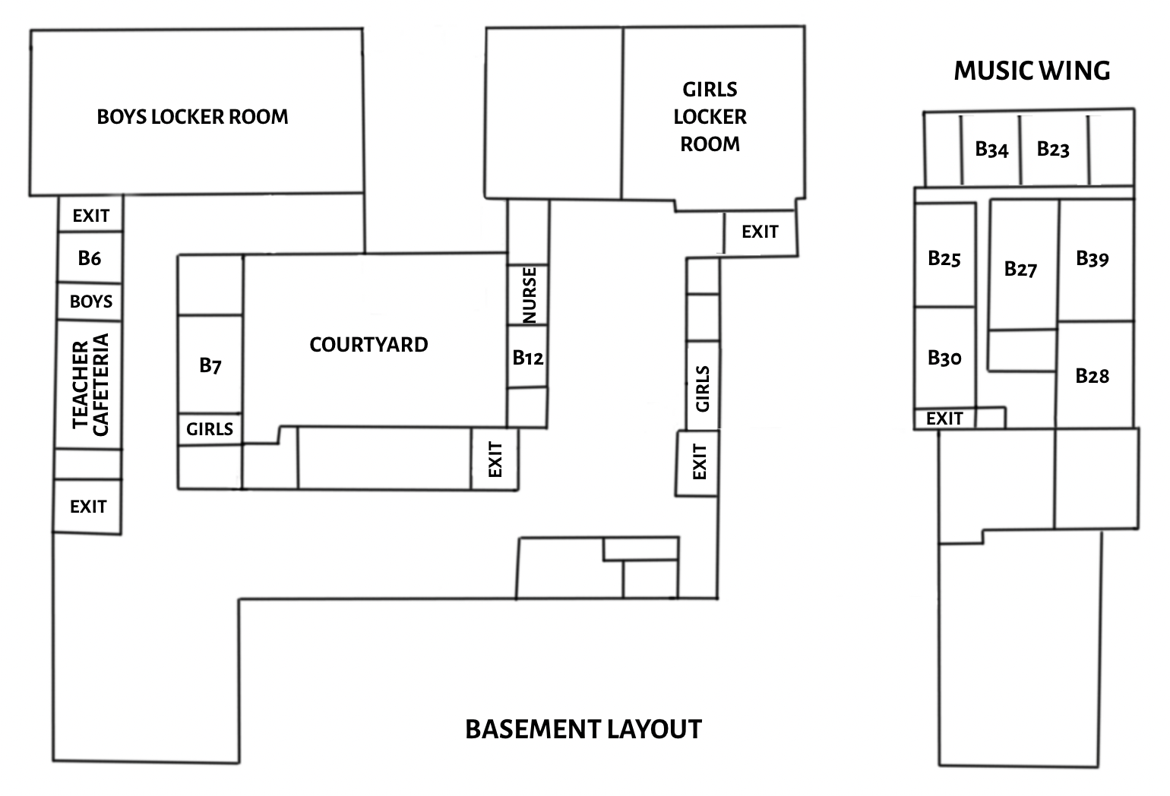
Important Rooms in the Basement
Cafeteria | Cafeteria | During your assigned lunch period, make sure to eat and talk to friends. Your lunch period is considered your free period. You cannot leave the building to eat!
Arista Tutoring | Rm. B12 | Arista students are often inside the room waiting to help students with assignments/ study skills.. If you need tutoring, check the schedule provided beginning late October.
Nurse’s Office | Rm. B21 | If you are ever feeling unwell or in need of medical attention, stop by the Nurse’s Office for assistance.
Girls Locker Room | Girls Locker Room | The staircase next to gyms 1 and 2 will take you to the locker room; make sure to bring your ID because you will be asked to swipe in.
Boys Locker Room | Boys Locker Room | The staircase next to Gym 3 will take you directly to the Boys Locker Room.
Music Wing | Rm. B25 - B39 | Most of the music classes are held in the Music Wing. To get to the Music Wing, you must take the staircase across from the Principal’s Office. If you need help getting there, you can always ask one of the deans to assist you.
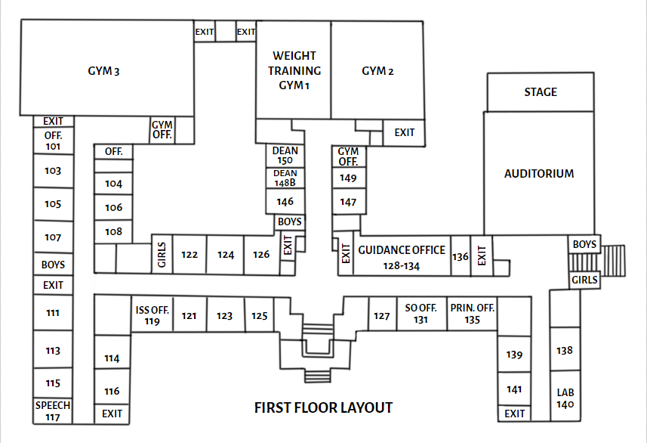
Important Rooms on the First Floor
SO Office | Rm. 131 | If you ever need help or have a question about anything related to student involvement, feel free to stop by the office. There’s always someone there who will help.
Guidance Counselor’s Office | Rm. 128 & Rm. 134 | You can get working papers here and ask your guidance counselors questions about college, programs, and more.
Dean’s Office | Rm. 148 | This is where the Lost & Found is, as well as replacement ID cards.
Office of Student Safety | Rm. 150 | If you ever need a new student MetroCard, this is where you go.
Weight Training/Gym 2 | Gym 1/Gym 2 | Every year students will be programmed into a PE class, it will either be weight training or a gym class.
Gym 3/Pool | Gym 3/Pool | Fun Fact: Gym 3 is the biggest gym in our school.
Auditorium | Auditorium | The Auditorium is used for performances and other assorted activities as directed. Students are also allowed to exit the building using the exits by the Auditorium. It was also renovated in summer 2022!
Speech Office | Rm. 117 | If you have an Individual Education Program (IEP) that calls for Speech, you go to the Speech Office for your appointments.
ISS Office | Rm. 119 | Here you will find the Instructional Support Services Department.
Principal’s Office | Rm. 135 | Here you will meet our Principal, Mrs. Martinez.
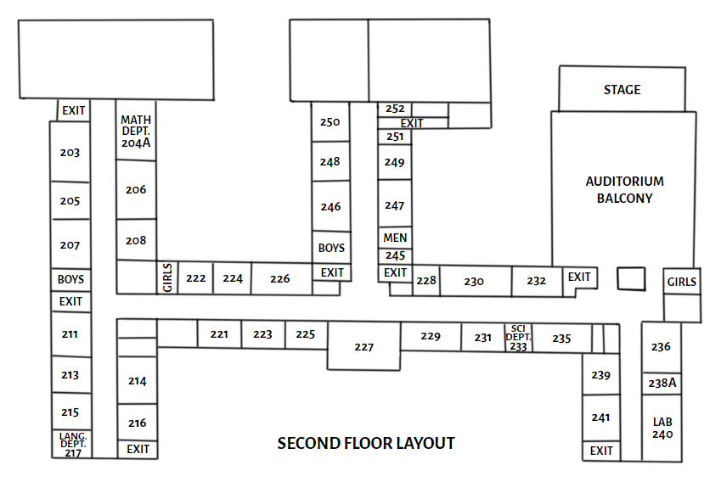
Important Rooms on the Second Floor
Math Department | Rm. 204A | Not only can you find the Math AP here, but the schedules of all the math teachers will be posted on a bulletin board outside the classroom.
Arts & World Languages Department | Rm. 217 | Bayside offers a lot of different languages such as Chinese, Korean, Japanese, Spanish, and French as well as many courses in Art & Music.
Science Department | Rm. 233 | All students must pass the Living Environment Regents and one physical science regent which can be either Chemistry or Physics.
WBL (Work-Based Learning) Office | Rm. 251 | Stop by to meet our Work-Based Learning Coordinators and learn more about internship opportunities.
Auditorium Balcony | Auditorium Balcony | The auditorium balcony is usually locked but during assemblies like Freshmen Orientation, it is opened up to allow for more seating area.

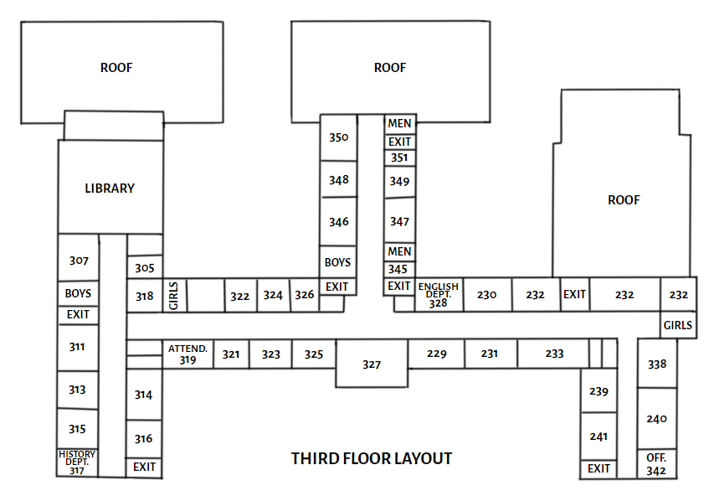
Important Rooms on the Third Floor
Library | Library  301 | Stop by the Library to borrow books, print materials out, use the laptops, or even just get away from the crowded cafeteria. To enter, you must show your schedules to make sure no one is skipping class.
Spark Office/ Ms. Jaxen’s Office | Back of the Library | Ms. Jaxen leads the Spark Program where students are able to stop by during their respective lunch periods to learn about various topics.
Social Studies Department | 317 | Most of the history classes are all located in this section of the school. Highly recommend using the staircase at the end of that hallway to get to class faster.
English Department | 328A | Besides the generall English classes, Bayside offers plenty of electives such as Journalism, Film Study, and Creative Writing.
Attendance Office | 319 | When you are absent, you must bring in a signed note either from your parent/guardian or a doctor explaining why you are absent. All your teachers must sign it before giving it to the Attendance Office.
School Development Office | 351 | Here you will meet our CTE Program Directors and AP of School Development. You can learn more information about CTE courses, college-accredited course registration, and WBL offerings.

Faculty Directory
A.P. (Assistant Principal)
Mr. Jonathan Hirata | AP of Organization | Rm 127
Mr. Don Collazo | AP of Student Life | Rm 150
Mr. David Morrison | AP of Student Service | Rm 128
Mr. Michael Oyedele | AP of Programming, Data & Testing | Rm 319
Mrs. Melissa Haroutunian | AP of School Development | Rm 351
Ms. Allessia Quintana | I.A. AP Instructional Support Services, IA | Rm 119
Mr. Daniel Tizol | AP of Arts & World Languages | Rm 216A
Mrs. Shana Tessenholtz | AP of English/ESL | Rm 328A
Mrs. Madeline Belfi-Galvin | AP of Mathematics | Rm 204A
Mr. Joseph Capuana | AP of Physical Education & Health | Rm 100
Dr. Shirley Labardy | AP of Science | Rm 233
Mr. Marc Cercone | AP of Social Studies | Rm 317

GUIDANCE COUNSELORS
Natalie Berrouet Haitian Creole nberrouet@baysidehighschool.org
Jennifer Chu Cantonese jchu@baysidehighschool.org
Nicolette Cornelius ncornelius@baysidehighschool.org
Brian Dinin bdinin@baysidehighschool.org
Viktorya Eyzengart Russian veyzengart@baysidehighschool.org
Joanna Flores Spanish jflores@baysidehighschool.org
Michelle Fiore mfiore@baysidehighschool.org
Gary Garcia Spanish ggarcia@baysidehighschool.org
Johnnette Gibson jgibson@baysidehighschool.org
Steven Jacoby sjacoby@baysidehighschool.org
Joseph Ko Korean jko@baysidehighschool.org
Alyson Meltzer ameltzer@baysidehighschool.org
Michael Paccione mpaccione@baysidehighschool.org

Stanley Tsai stsai@baysidehighschool.org
Teresa Yeh Mandarin tyeh@baysidehighschool.org
Carmen Zayas Spanish czayas@baysidehighschool.org

SCHOOL PSYCHOLOGIST
Yukiko Shimizu Flores yshimizuflores@baysidehighschool.org

SOCIAL WORKERS
Rosemary Eddelson reddelson@baysidehighschool.org
Lisa Fernandez lfernandez@baysidehighschool.org
Nadia Hamilton nhamilton@baysidehighschool.org
Mario Ynfante mynfante@baysidehighschool.org
INSTRUCTIONAL SUPPORT SERVICES
Marisol Allen ISS Secretary mallen@baysidehighschool.org

SUPPORT STAFF
Lori Badalati - Parvis Parent Coordinator lparvis@baysidehighschool.org
Diane Parrino School Aide-Records dparrino@baysidehighschool.org

2023-2024 Bayside High School Dress Code

In order to maintain a positive learning environment and to ensure safety, it is expected that Bayside High School students dress in a professional manner. We expect Bayside students to be dressed appropriately to ensure safety and to keep the focus on teaching and learning. Parents and guardians have a responsibility to remind students of these dress code protocols on campus.

Prohibited forms of dress at Bayside High School include, but are not limited to:

1) Hats or caps (with the exception of headwear worn for religious observance).
2) Clothing that contains references to drugs, alcohol, sex, violence, racism, vulgarity, or gang-affiliation.
3) Clothing that does not provide coverage of torso, undergarments, and private body parts, including shorts that expose glutes, strapless and see-through garments of any kind.
4) Sunglasses while indoors.

If a student chooses to come to school wearing clothing prohibited by the Dress Code, there will be immediate consequences. The student’s parents will be notified, the student may be subject to the interventions and disciplinary responses set forth in the Discipline Code, and the student will be expected to make appropriate adjustments to his/her clothing to conform with the Dress Code (e.g., turning shirt inside out, borrowing temporary clothing until the end of the school day, etc.).

Graduation Requirements

Minimum Regents Requirements:
Students must pass the following regents with a 65 or above in order to graduate.
 | Regents Diploma | Advanced Regents Diploma
English Language Arts (ELA) | 1 | 1
Math  (Algebra I, Geometry, or Algebra II/Trigonometry) | 1 | 3
Social Studies  (Global History or U.S. History) | 1 | 1
Science  (Living Environment, Chemistry, or Physics) | 1 | 2
World Language (LOTE) | 0 | 1
Any additional Regents exam  (Any subject) | 1 | 1
Total Regent: | 5 | 9

Bayside students usually graduate high school with 50+ credits and all the regents required to receive the Advanced Regents Diploma. Most students graduate in 4 years, but Bayside offers the option to graduate in 3.5 years (January of your senior year) or 3 years (junior year). If you are interested, please speak to your guidance counselor so they can program your classes.

Minimum Credit Requirement:
Students must have a minimum of 44 credits in total to graduate. The subject breakdown is:
 | Regents Diploma | Advanced Regents Diploma
English | 8 | 8
Social Studies  Global History  U.S. History  Government  Economics | 4  2  1  1 | 4  2  1  1
Math  At least 2 credits in advanced math (Geometry or Algebra II) | 6 | 6
Science  Life Science  (Living Environment)  Physical Science (Chemistry or Physics)  Any Life Science or Physical Science | 2  2  2 | 2  2  2
World Language (LOTE) | 2 | 6
Physical Education  Consistently throughout High School | 4 | 4
Health | 1 | 1
Art or Music | 2 | 2
Elective/CTE | 7 | 3
Total Credits: | 44 | 44

DOE Calendar
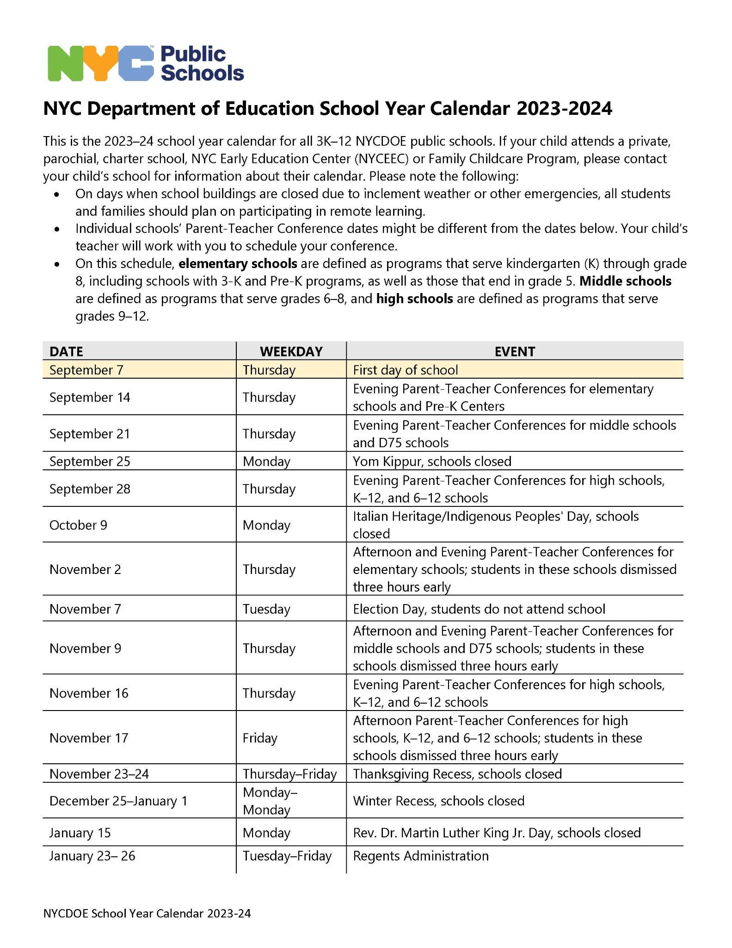

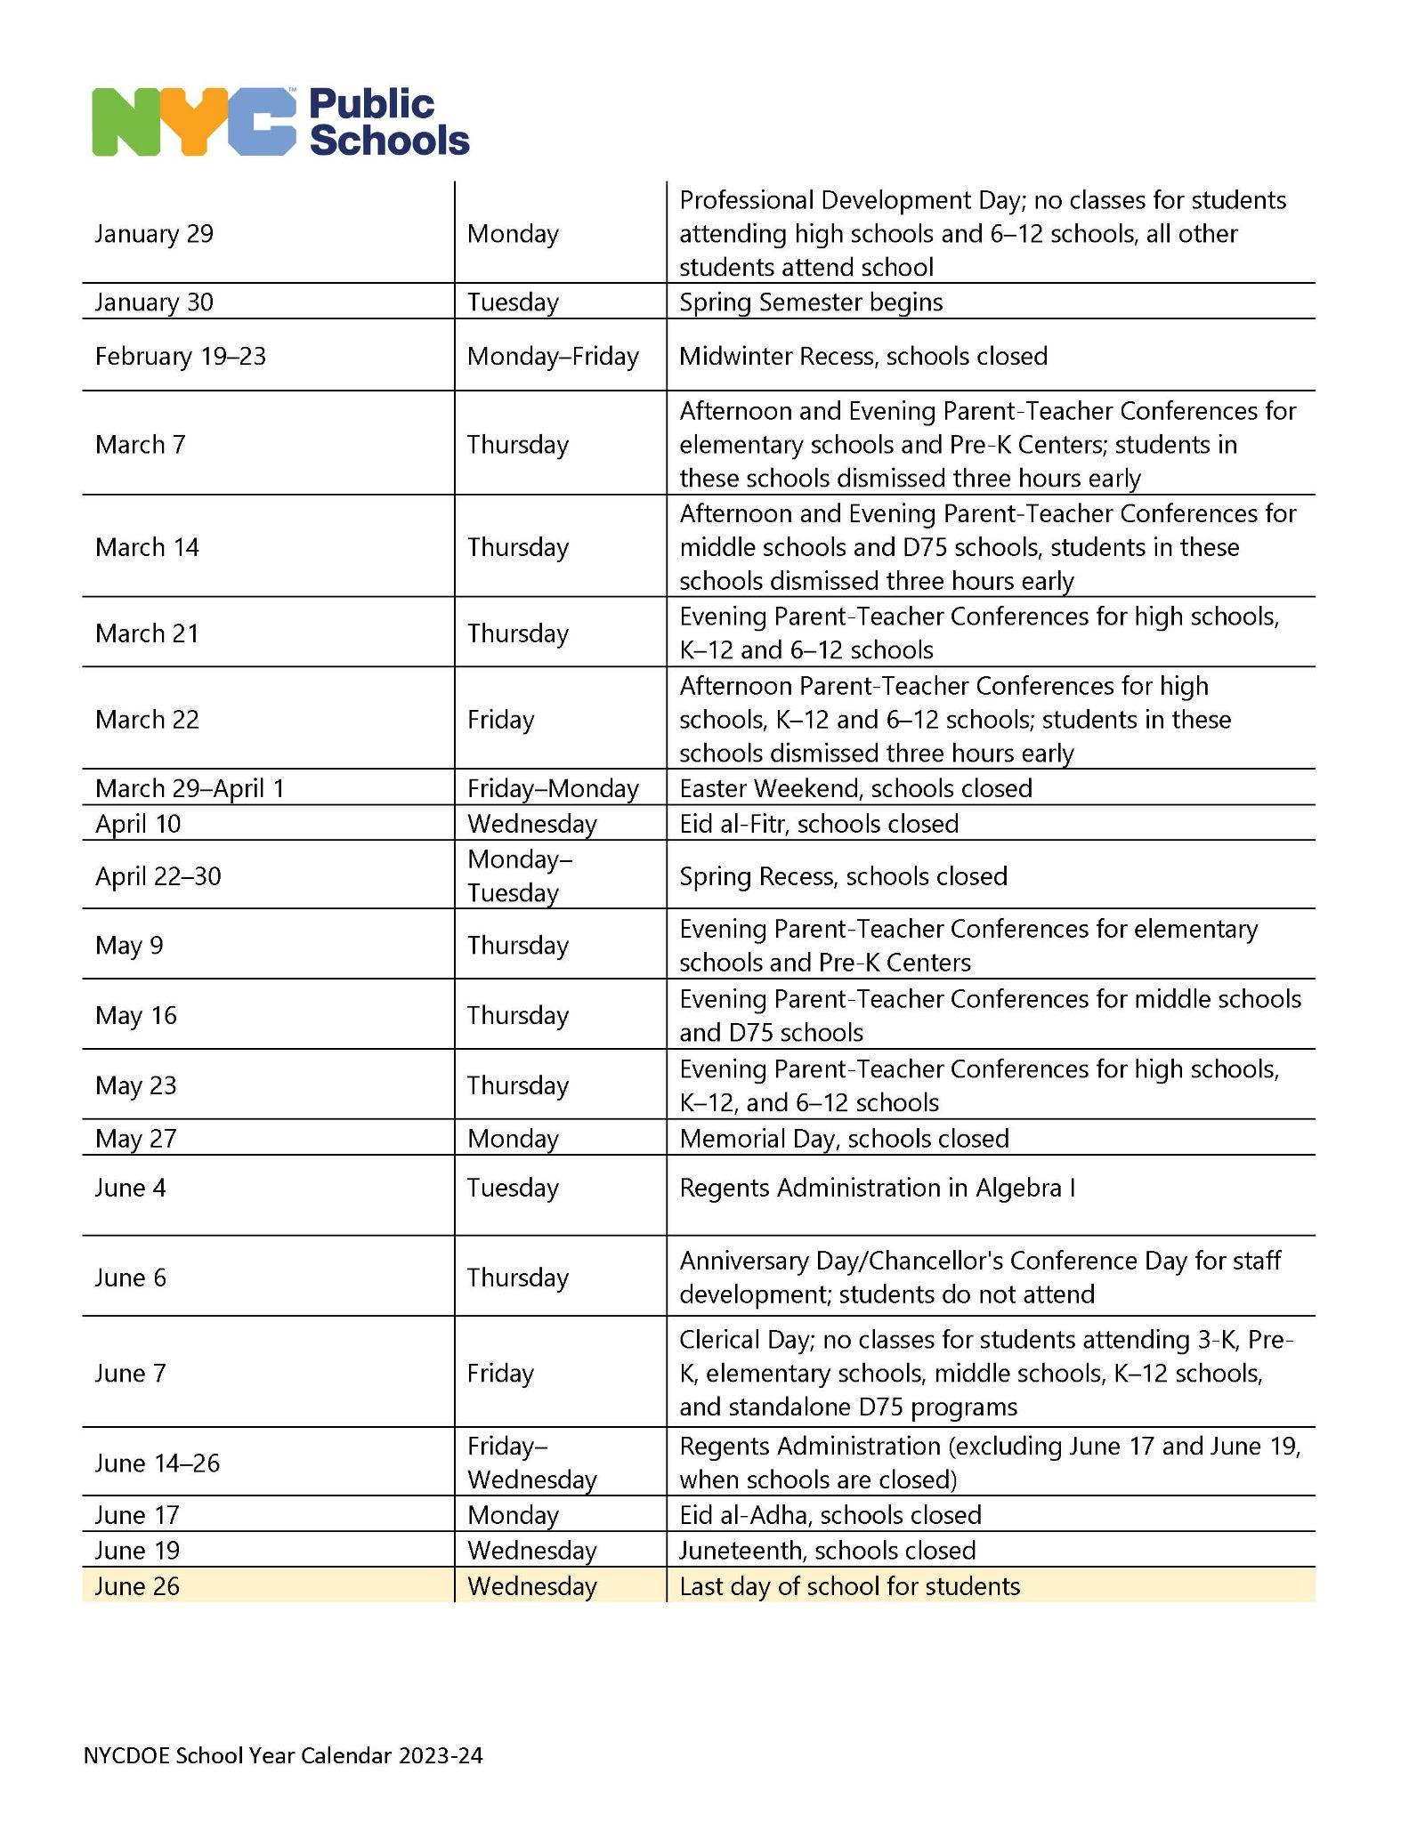
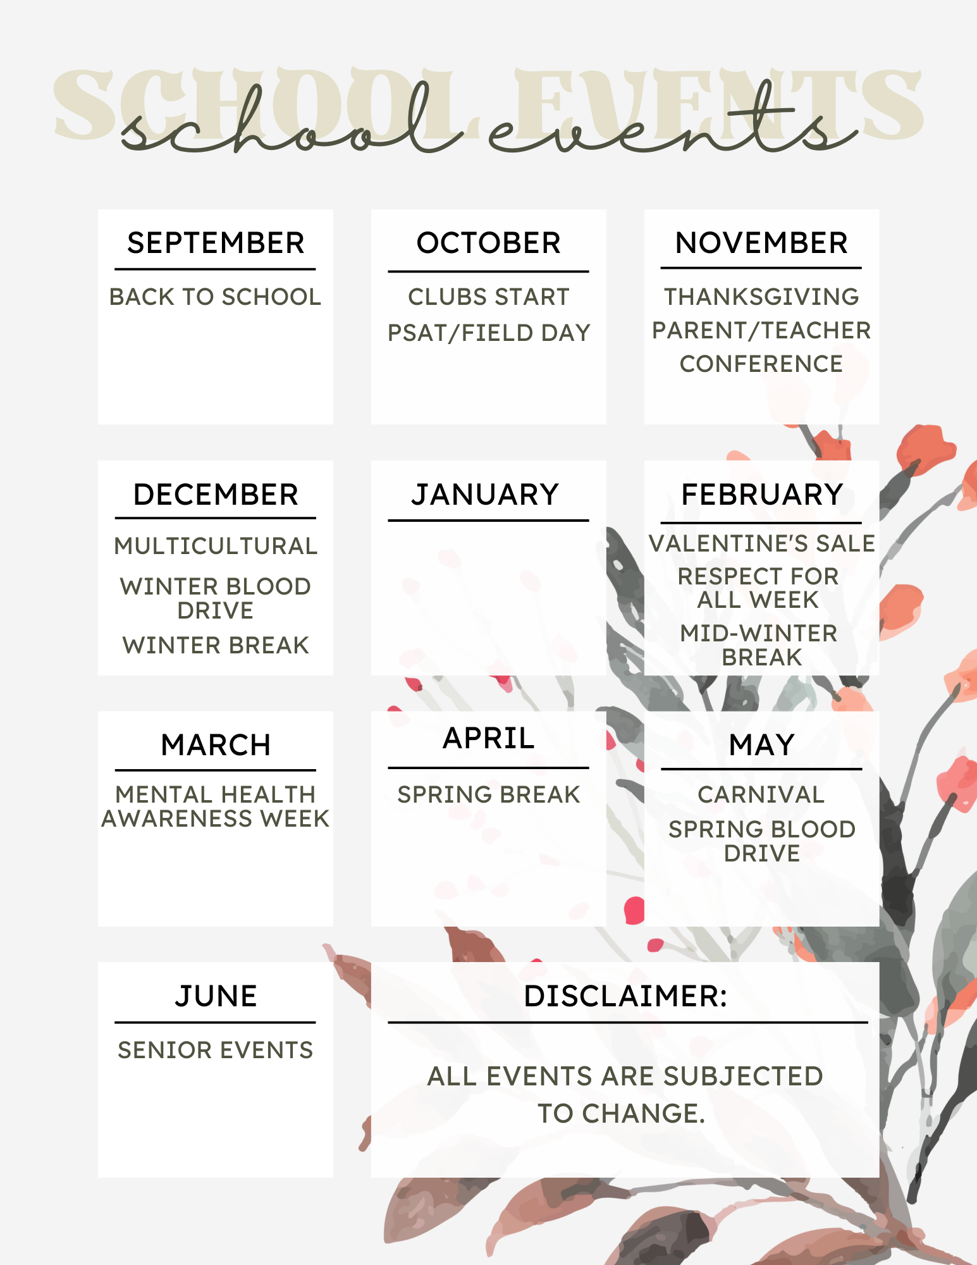

Marking Period Schedule
- Bayside has a FALL (September - January) and Spring ( February to June) semester.
- Each semester has 2 terms with 2 marking periods. This means you will receive 1 progress report( on/about 20 days into the marking period and 1 report card( on/about 40 days into the marking period) per term.
- Students are given 20 days to make up work for the marking period if they are failing. The purpose of the progress report is to motivate students to improve grades and/ seek tutoring BEFORE the end of the term..
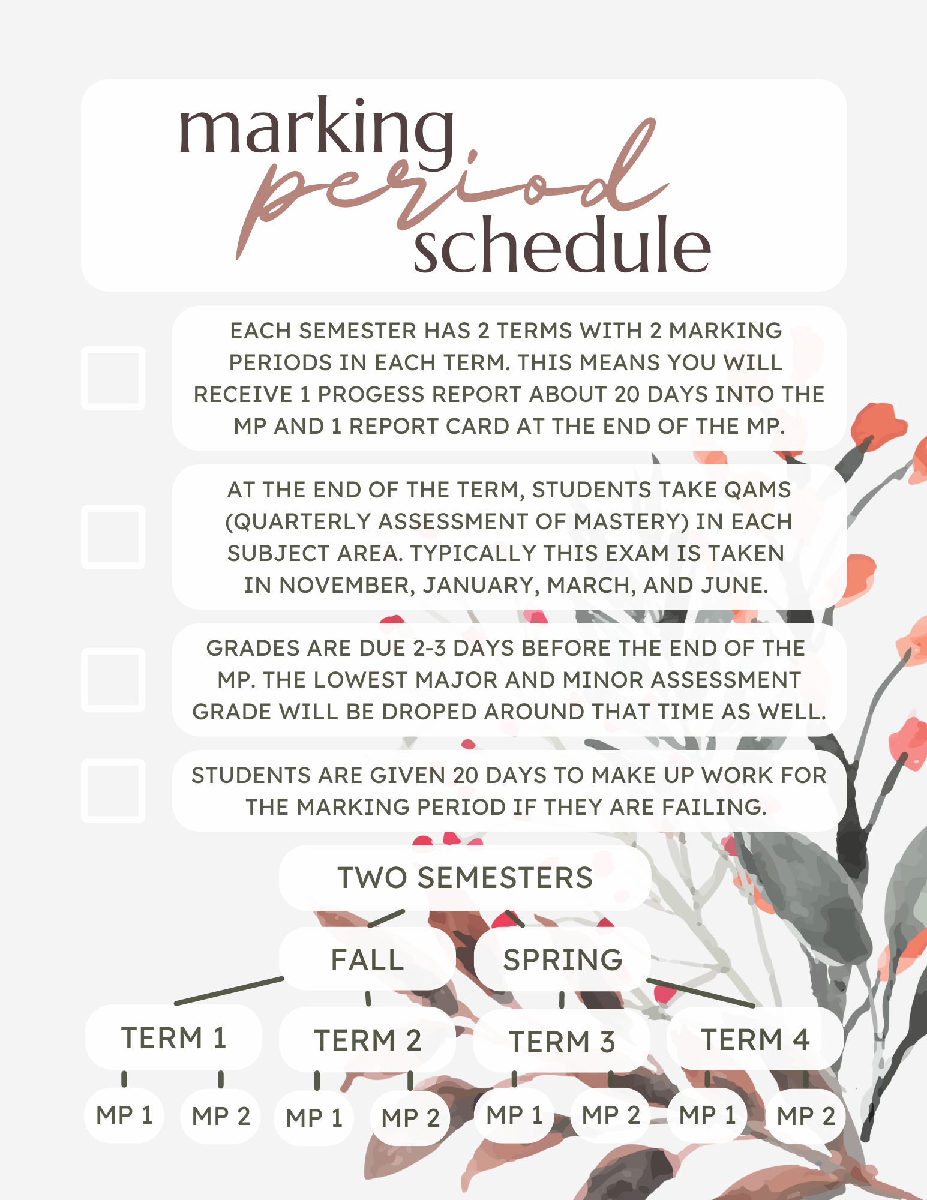
- At the end of the term, students take QAMs in each subject area. Typically this exam is taken in November, January, March, and June. This is a mastery exam in the form of either a multiple choice exam, essay, or project pending the subject area that covers material learned within the term.
- Grades are due 2-3 days before the end of the MP. The lowest grade drops around that time as well.

Bell Schedule

Period | Period Starts | BATHROOMS  OPEN | BATHROOMS  CLOSE | Period End
1 | 7:12 | 7:20 | 7:45 | 7:57
2 | 8:00 | 8:10 | 8:35 | 8:45
3 | 8:48 | 9:00 | 9:25 | 9:34
4 | 9:37 | 9:45 | 10:05 | 10:16
5 | 10:19 | 10:30 | 10:50 | 10:58
6 | 11:01 | 11:10 | 11:35 | 11:46
7 | 11:49 | 12:00 | 12:25 | 12:34
8 | 12:37 | 12:45 | 1:10 | 1:22
9 | 1:25 | 1:35 | 2:00 | 2:10
10 | 2:13 | 2:25 | 2:50 | 2:58
Hall passes will not be distributed until 10 minutes after the period starts and will no longer be distributed 10 minutes before the period ends. The bathrooms will be locked according to the schedule above. Students must have a hall pass to use the bathroom during the indicated times.
Hall sweeping occurs periodically. Deans walk around the halls to ensure that students are in their respective classes and not skipping. Any students found loitering in the halls without a pass will be told to report to room 148 for a late pass. To avoid this, please go to your class on time and don’t linger in the hallways.

CTE (Career Technical Education)
CTE Programs & Work-Based Learning Overview
Students at Bayside High School are enrolled in 1 of our 6 New York State Approved CTE Programs.
- Digital Art & Design
- Music Performance & Production
- Environmental Engineering & Technology
- Humanities & Non-Profit Management
- Computer Programming & Web Design
- Sports Medicine & Management
Each program is designed to prepare students for college and careers.
Within each CTE Program, students:
- Complete a sequence of courses
- Have opportunities for college credit
- Complete technical assessments (industry-based and supported exams for the respective career clusters)
- Complete work-based learning experiences (hands-on opportunities to apply content learned in preparation for the workforce)
Examples of Work-Based Learning experiences include: guest speakers, career days, competitions, job shadowing, work-place challenges, and internships

If you have any questions, feel free to speak to
- Your school counselor
- Assistant Principals
- CTE Program Development Directors
- Work-Based Learning Team (Room 251)

Checklist for Success in CTE Programs
- Speak to your school counselor, teachers, and school administration regarding college credit opportunities.
  - Don’t miss out on these amazing opportunities to start building a college transcript now at a reduced rate.
  - Credits are transferable to many different universities.
- Complete required coursework and pass corresponding technical assessments to be prepared to enter the workforce.
- Don’t miss out on amazing internship opportunities to prepare for your future and build your resume!!
- Speak to our WBL Team in Room 251 for more info regarding how to apply.

CTE Development Team
CTE Program | CTE Program Development Director | E-mail Address
Digital Art & Design | Ms. Kerri DeJean | kdejean@baysidehighschool.org
Music Performance & Production | Mr. Charles Wang | cwang@baysidehighschool.org
Environmental Engineering & Technology | Ms. Dorit Kleiner-Eilon | deilon@baysidehighschool.org
Humanities & Non-Profit Management | Mr. Wayne Steele | wsteele@baysidehighschool.org
Computer Programming & Web Design | Mr. Renne Castro | rcastro@baysidehighschool.org
Sports Medicine & Management | Mr. Seth Seidman | sseidman@baysidehighschool.org
Work-Based Learning Team
WBL Coordinator | E-mail Address
Mr. Jae Lee | jlee@baysidehighschool.org
Mr. Noam Bonkowski | nbonkowski@baysidehighschool.org
If you are interested in applying for an internship, please see Ms. Lori Parvis, Parent Coordinator, in Room 128 to inquire about working papers.

Club List
***This will be updated as we receive more information from clubs. ***
Bayside Club List
CLUB | Advisor (s) | Day(s) | Room | Period | Google code
Animation
Anime
Art
Astronomy
Badminton
Baysider (newspaper)
Beauty/Make-up
BHS Notes
Book Club
Bridge to Medicine
Cheerleading
Chemistry
Chess
Chinese
Chinese Yo-Yo
Coding/Lazard Academy
Drama
Debate
E-Sports
EBONY
Filipino
Film Club
Game Creation / Gaming
Habitat for Humanity
Handball
Hellenic (Greek)
Hispanic
Intl. Fashion
Japanese
Jewish Student Union
Junior Council
K. Pop
Key Club | Jacoby | Friday | Auditorium | 11
Knitting club
Korean Drumming
Muslim Student Association
Origami Social
Physics
RAFA
Robotics
Senior Council (seniors only)
Smiles for Miles
SOUL
Tae Kwon Do
Traditional Dough Figures
Underclassmen Council
Women's Empowerment

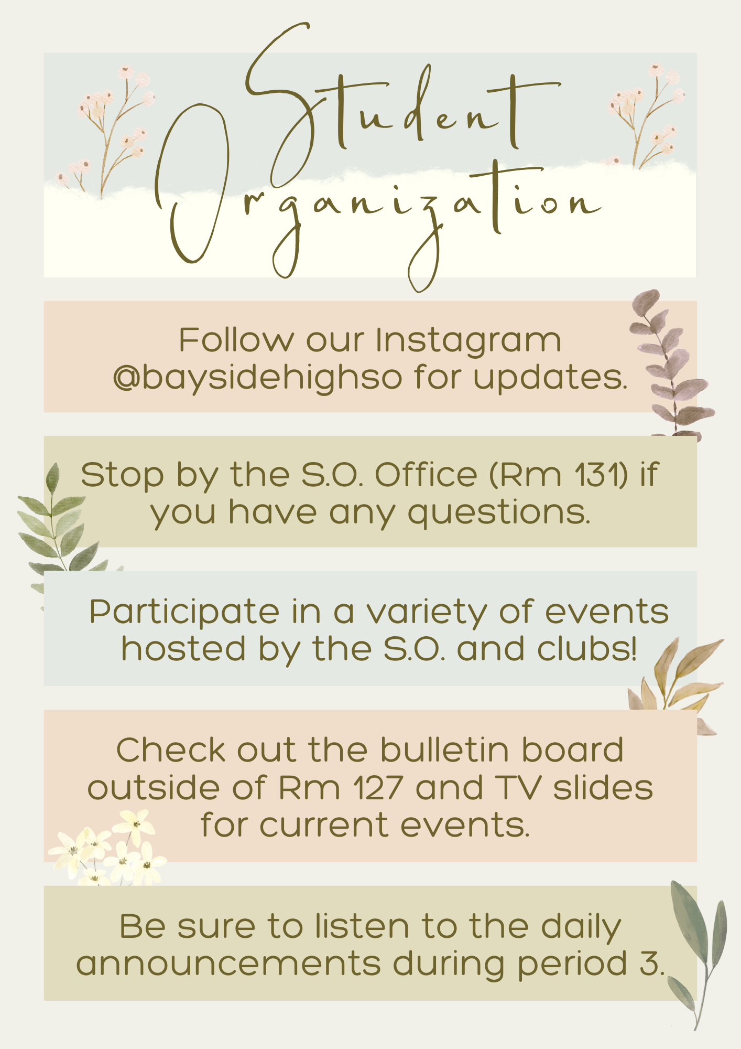

Sports List/PSAL Information
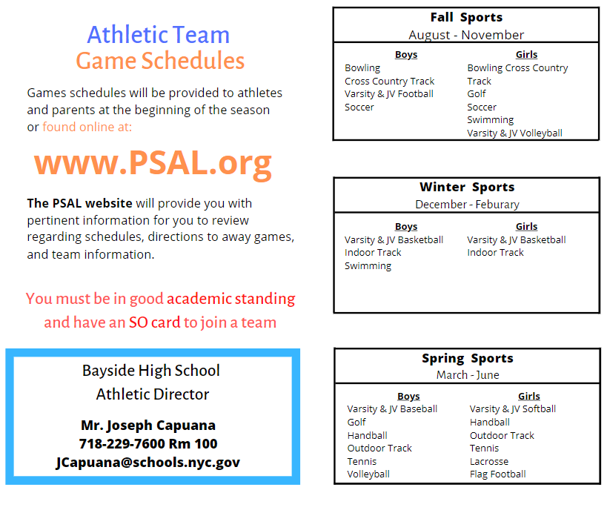

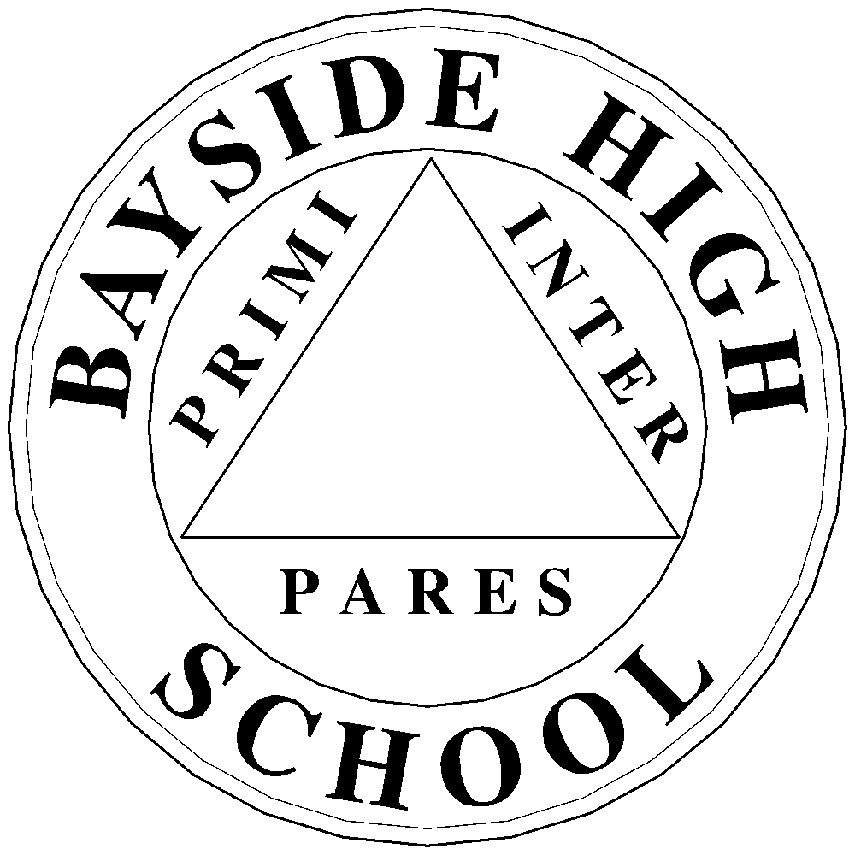
Bayside High School
32-24 Corporal Kennedy Street, Bayside, New York 11361 Telephone (718) 229-7600

Tracy Martinez, Principal Joe Capuana, AP Health & Physical Education

Health and Physical Education Department Contract

New York State Law Graduation Requirements include Eight (8) Terms of Physical Education and
One (1) Term of Health Education in Order to Graduate.

Punctuality, Preparation, Participation and Performance

- ATTENDANCE – all students are expected to attend 100% of all classes on time.

- If a student has a medical illness, he/she must bring a certified letter from a doctor specifying the reason for and the length of time the student is to be excused from Physical Education. If a student has a serious medical condition/injury, a doctor’s note is required before the student can return to active participation.

- All classes will meet on a 3/2 schedule for Physical Education.
- DRESS CODE – Regulation Bayside High School Uniform consists of a BAYSIDE T-SHIRT, shorts, and sneakers. Students can wear sweatpants as an option to shorts in all PE classes.
- The uniforms can be purchased at the S.O. Store (located in the Cafeteria) throughout the school year.

- Uniform pricing: Shorts - $5.00; Shirts - $10.00; School Locks - $10.00

- Total $25.00: Cash or money order only (made out to Bayside High School) – no checks.
Discount- Purchase all 3 items for $20.00.

- UNIFORM GRADING POLICY FOR PHYSICAL EDUCATION
Grades are based on student attendance, participation, google classroom assignments, minor and major assessments; aligned with Bayside High School's uniform grading policy.
--------------------------------------------------------------------✂------------------------------------------------------------------------

I HAVE READ AND UNDERSTAND THE ABOVE RULES AND REGULATIONS

Student Name:______________________________________________________________________
(Print)

Student’s Signature: _________________________________________________________________

Parent’s Signature: __________________________________________________________________

Phys. Ed. Teacher/Period: _____________________________________________________________
Today’s Date: _______________________________________________________________________

Student Guides
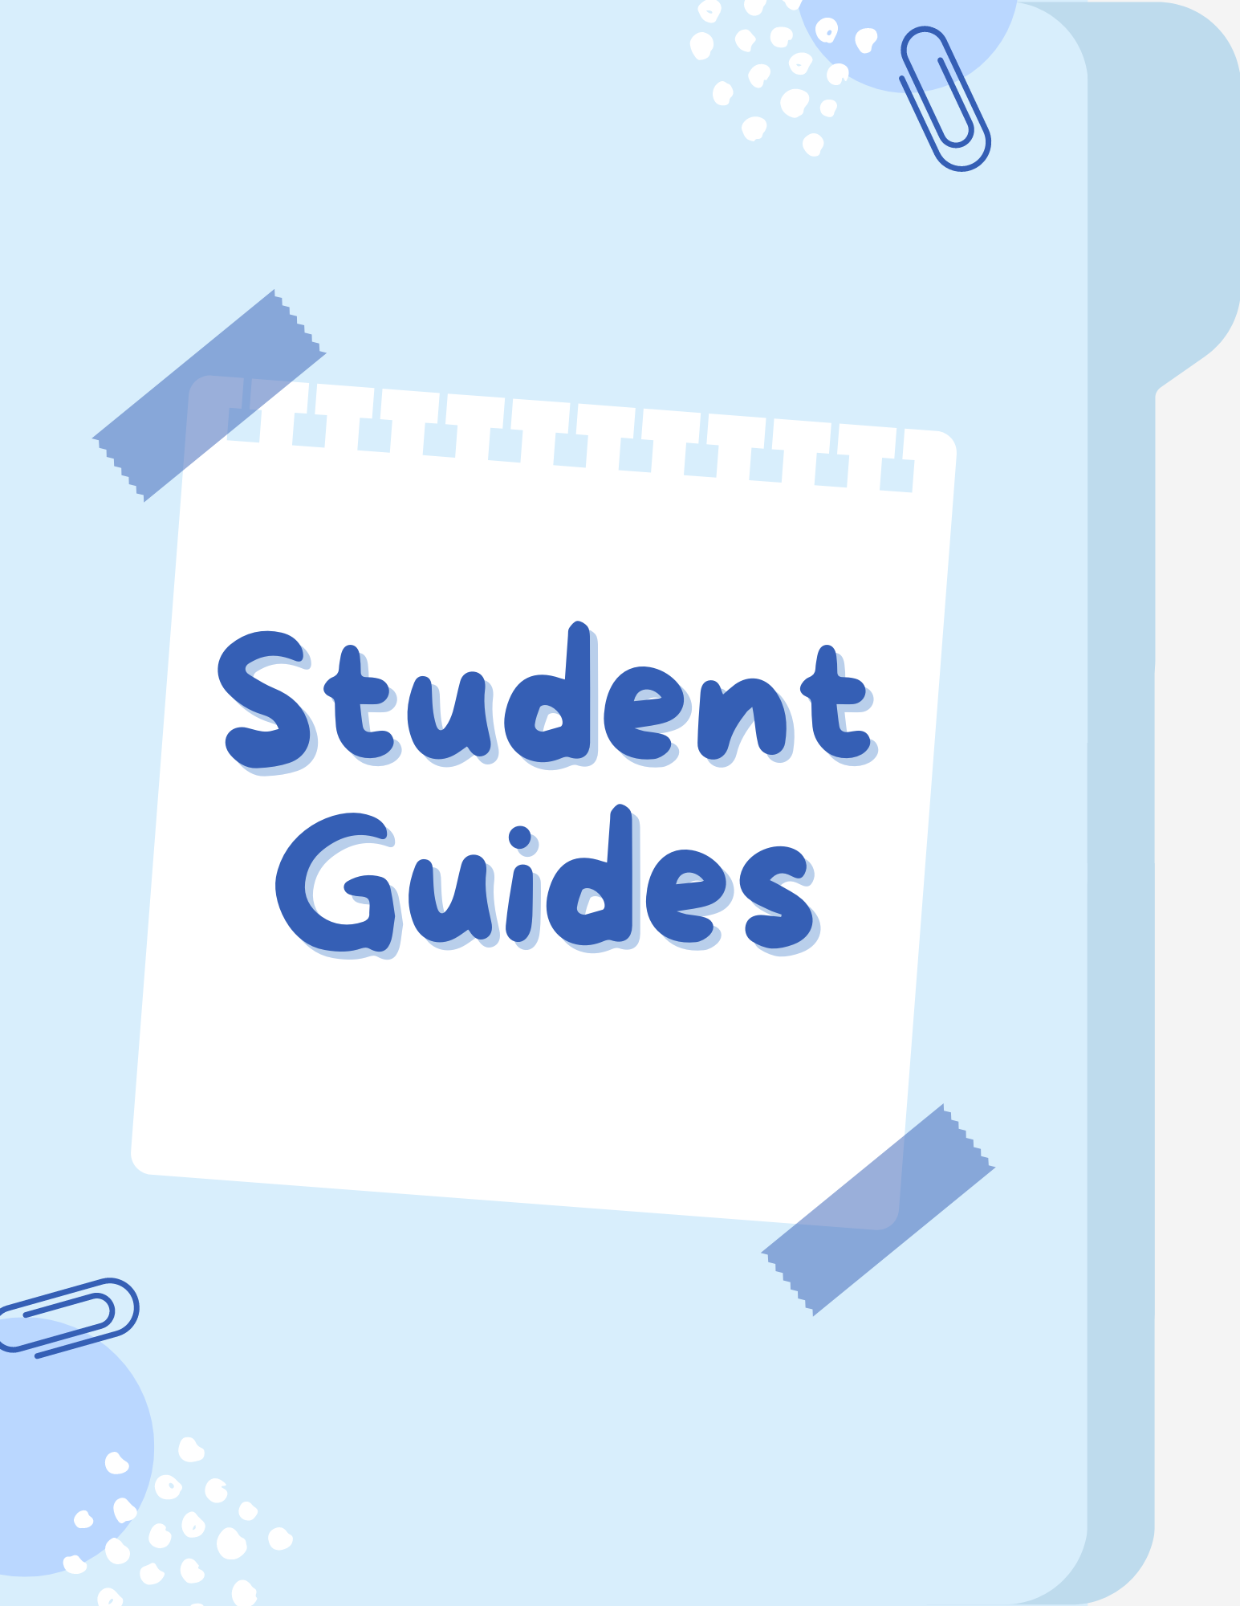

Where to go if…?

CONCERN | GO TO | ROOM
I don’t know my official class. | Your Guidance Counselor | 134
I need a copy of my transcript. | Guidance Office | 134
I am having academic problems. | Your Guidance Counselor | 134
I need working papers/job opportunities. | Guidance Office | 134
I need to correct my program. | Your Guidance Counselor | 134
I am having difficulties in my class. | Your Guidance Counselor | 134
I need help with my academics. | Free Arista Tutoring is available during your Lunch period or Free Pd) | B12
I must register for the summer for summer school. | Your Guidance Counselor | 134
I want to talk about my schedule for the following term. | Your Guidance Counselor | 134
I need information about college and scholarships. | Your Guidance Counselor | 134
I want to learn more about school events / getting involved in leadership activities. | S.O. Office | 131
I am having a problem with another student. | Dean's Office | 148B
I lost my program card/identification card. | Dean's Office | 148B
I lost something. | Dean's Office | 148B
I need a MetroCard. | Security Office | 150
I need to give in a doctor’s note. | Attendance Office | 319
I was absent and/or needed to correct my attendance status. | Attendance Office | 319
I must update my home address/phone number. | Attendance Office | 319
I need to return a textbook. | Academic Departments | English: 328A  Science: 233  Social Studies: 317  Language: 216A  Math: 204A
I need a breakfast/lunch application. | Assistant Principal – Organization | 127
I am not feeling well. | Nurse’s Office | B21
I must update my health / medical records. | Nurse’s Office | B21
I am having a problem with alcohol or drugs. | Social Worker / Spark Program/ Your Guidance Counselor | 102 / Library / 134
I am having a personal problem and need to speak to someone confidentially. | Social Worker /  Your Guidance Counselor | 102 / 134
I want to join / to know about an athletic program. | Physical Ed Office | 100
I am failing a class. | Your Guidance Counselor | 134
I need a copy of my transcript. | Guidance Office | 134
I am struggling to fill out the FAFSA. | Your Guidance Counselor | 134
I need help applying to colleges. | Guidance Office | 134
I want to learn more about senior events. | S.O. Office | 131
I want to add/drop a class. | Your Guidance Counselor | 134
I have COVID. | Your Guidance Counselor | Email them!!
I need a COVID testing kit. | Dean's Office | 148B
I am interested in finding clubs to join. | S.O. Office | 131
I want to register to take the SAT at Bayside. | Your Guidance Counselor | 134
I want to work at Bayside over the summer. | Mr. Lee | 251
I want to take College Now courses. - Guidance | Your Guidance Counselor | 134
I want to return a laptop/device. | Mr. Vasilopoulos | 305
I want to discuss my plans after college. | Your Guidance Counselor | 134
I want to learn about internship opportunities. | Mr. Lee | 251
I need a copy of my schedule. | Attendance Office | 319
I need to print something. | Library | Library

Student Guide to Google Classroom
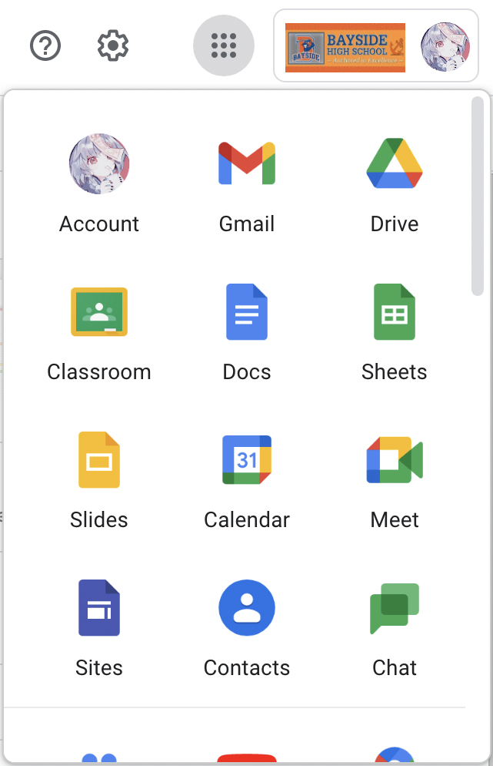

(1)
(2)
How to sign into Google Classroom:
- Go to https://classroom.google.com/ and sign in with your Bayside High School Email if you have not already.

  - Email Format: First letter of your first name, last name, last 4 digits of your OSIS followed by @baysidehighschool.org
  - Password Format: OSIS number (student ID)

- Another way to sign in to Google Classroom is by (1) clicking the Google Apps on the top right corner of the search page (it looks like 9 dots) and then (2) clicking on the Google Classroom icon.

How to join a class:
- Go to Google Classroom and click on the plus sign (+) in the upper right corner.
- Enter the class code your teacher provided you with.
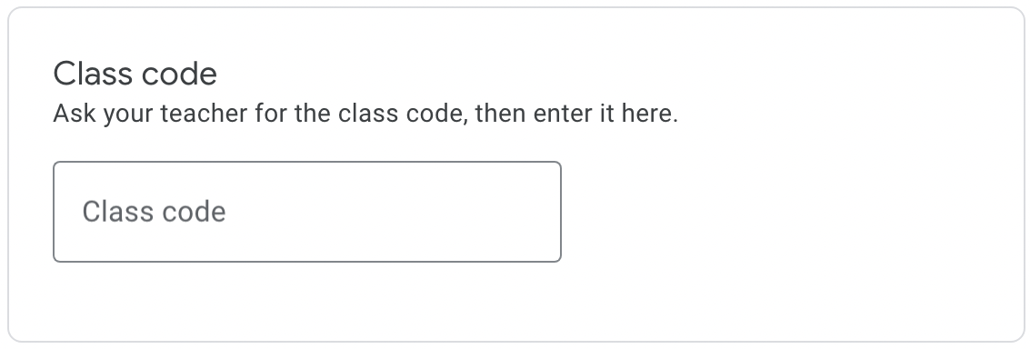
  - A class code has 5-7 letters or numbers, and no spaces or symbols.
  - Google Classroom is connected to your Google Drive. When joining a new class, a folder for the class will be created at https://drive.google.com/. Everything you upload/submit in the class will also be in the class folder.
How to read the Class Page:
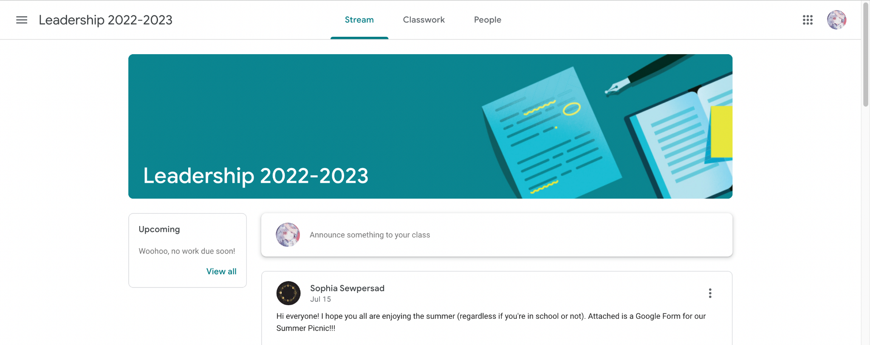

(1)
(2)
(4)
(3)

- Stream: This is where you can see all the materials the teacher posted including assignments, announcements, and resources.
- Classwork: This is where you will see all the assignments and resources that have been posted. Teachers often create topics to group similar materials together, this can be found on the left side
- People: This shows you a list of your classmates, you can contact them through email by clicking the mail icon (). You can also email your teacher(s) here.
- Upcoming Assignments: On the stream page to the left, you will see a list of all the assignments due soon. If you click View All, you will be able to see all your assignments for that class. Clicking on the assignment will bring you to a more detailed page about that assignment.
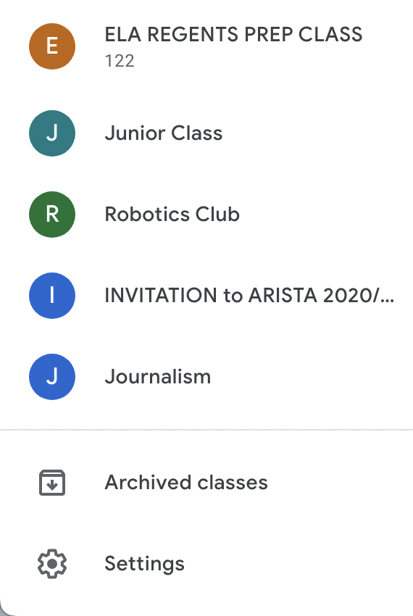
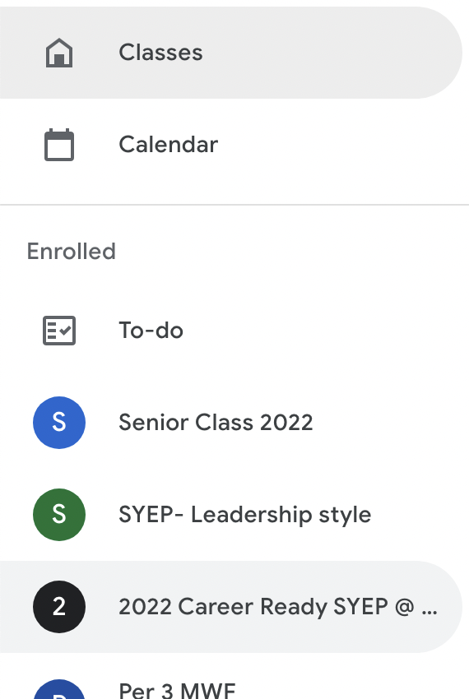

(1)
(2)
(4)
(5)
(3)
How to read the Main Menu:
- Classes: This is where you can see all the
- Calendar: You can view all your upcoming assignments in a calendar format.
- Enrolled: This is where you can see all the classes that you are enrolled in.
- To-do: This is where you can see all your upcoming assignments, the assignments that you are missing, and the finished assignments. It also shows you assignments with no due dates and if the assignments are due this week, next week, or later.
- Archived classes: Usually after the school year ends, teachers would archive old classes. You can find some of the past classes you enrolled in here.
How to submit assignments:
Open up an assignment, on the left side you will see Your Work:
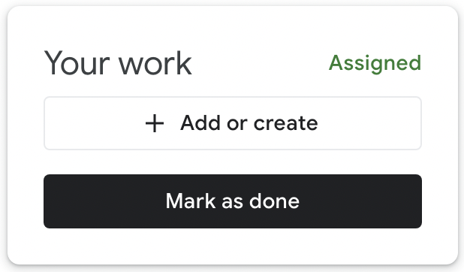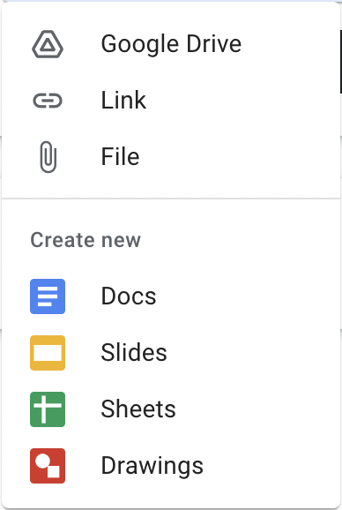

(1)
(2)
(3)
(4)
- Mark as Done: Click this to indicate that you have finished the assignment.
- Turn in: Click this to turn in the materials attached. All the materials attached will then no longer be editable and the ownership will be transferred to your teacher. Shortcuts to the materials assigned will then be added to that class’s folder in your Google drive
- Add or Create: This allows you to attach existing materials (Google Drive, Link, or Files) or create new materials (Docs, Slides, Sheets, or Drawings). Any materials created this way will be automatically added to that class’s folder in your Google Drive and shared with the teacher.
- Remove Attachment: Click the (✕) to remove any attachments you don’t want to submit.
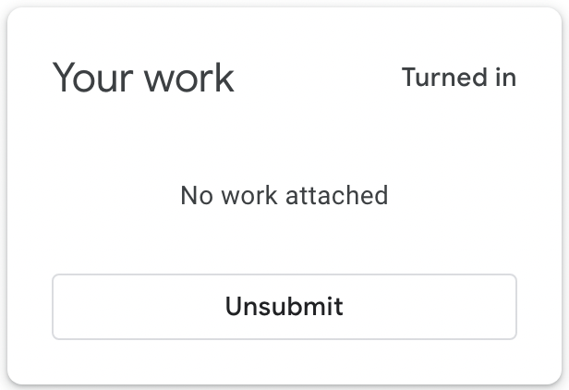

How to unsubmit assignments:
After you submit your work, you can unsubmit if you would like to change something or attach more materials. When you unsubmit, ownership will be automatically transferred back to you.

How to use comments work:
Comments posted on Stream: These comments are viewable to everyone in the class.
Private Comments: These comments are between you and your teacher, no one else will be able to see them. Oftentimes, teachers will make comments here or you can ask your teachers questions.
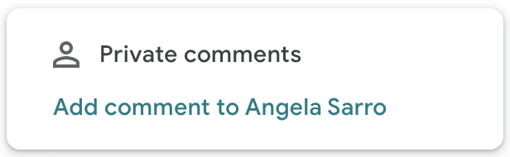

How to read your Transcript?
- This box contains basic identifying and contact information. Contact your school if any of this information is incorrect.
- This column represents the school year and term (2018/1) when the course was taken. A term is the full length of the course. Students receive final grades (actual marks) on their transcripts at the end of each term,
- This column contains the school "DBN* or "District/Borough/Number" (02M972). This describes the school where each course was taken and a grade was received. When students transfer between NYCDOE schools or take courses at other NYCDOE schools, there will be multiple DBNs on the transcript.
- This column contains the course code (EES81), which indicates what is taught and how that content is being delivered. All NYCDOE schools use the same course coding practices.
- This column contains the course title (ENGLISH 9), which describes what is actually being taught in a course. Unlike course codes, schools can choose their own course titles.
- This column contains the student's actual mark (86), or final grade in the course. Schools may choose from one or more grading scales (for example, AF and 65-100). Some marks, like NX, NL, and NS, are awarded only in rare situations. Contact your school if you have questions about any mark, or if you would like a copy of the school's grading policy.
- This column contains the name of the instructor (BENSIGN) who taught the course and assigned the final grade.
- This column contains the number of credits each course is worth (1.00). Some courses, such as Science labs and Regents prep courses are important experiences but do not count for credit. These courses appear on the transcript as worth 0.00 credits.
- This column contains the number of credits the student earned (1.00) for each course. Students only earn credits for courses they have passed. You can find a summary of the number of credits attempted compared to the number of credits awarded at the bottom of each subject area section and at the bottom of the transcript. If a student fails a course, there will be fewer credits earned in comparison to actual credits attempted. Students need 44 credits in specific courses to graduate.
- This box contains the student's Regents exam scores. Schools have the option to display all of the student's Regents exam scores or just the highest score earned for each exam.
- Contact your current school If you have questions about how they calculate the cumulative grade average.

How to read your Schedule?
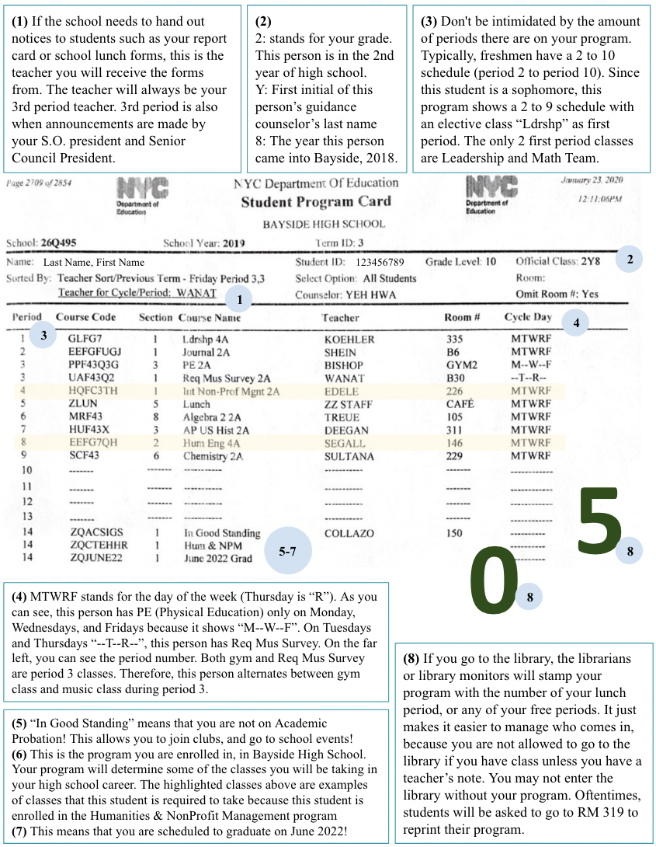

How to Get Working Papers

If you need working papers, go to room 128 to get the application. Make sure to get your working papers in advance for an internship or job.

To obtain working papers you must:
- Complete the application and make sure it is signed by your parent or guardian.
- Write on the top of your application:
  - Your guidance counselor’s name (Refer to the middle part of your schedule)
  - Your OSIS number (Refer to the middle part of your schedule)
  - Your official class # (Refer to the top right-hand corner of your schedule to find this information)
- Bring the following items:
  - Proof of birth (this can be a birth certificate, a passport, driver’s license, or state-issued ID)
  - Your social security card (original or copy)
  - A signed letter from your doctor stating that you are “fit to work”. .
  - The completed and signed application
Once you are done, bring the items listed above to 128 to be submitted for documentation. You will be asked to sign your working papers upon receiving them.

Bus Routes

Disclaimer: Routes are subject to change. Additionally, the routes shown below are only recommendations and not the only way to school.

College Point: Take the Q25 to Flushing, Main Street. Then transfer to the Q28 which will take you right to Corporal Kennedy St./ 32 AVE (Bayside High School).
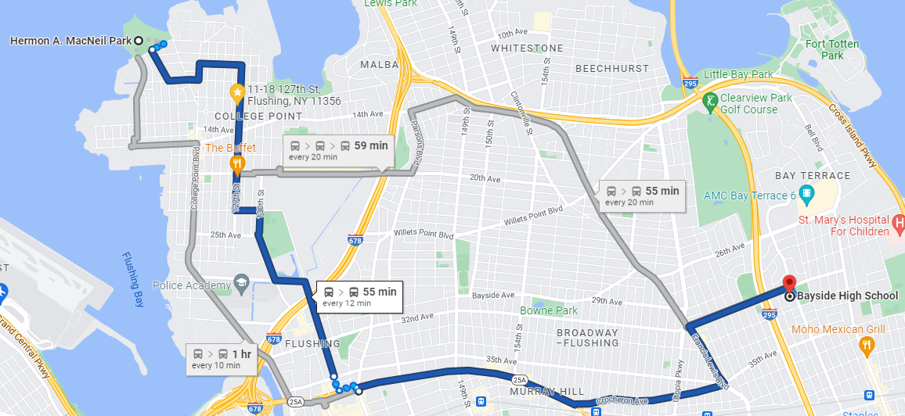

Whitestone: Take the Q76 to Francis Lewis Blvd/ 32 AVE. Then transfer to the Q28 or Q31 to Corporal Kennedy St./ 32 AVE (Bayside High School).
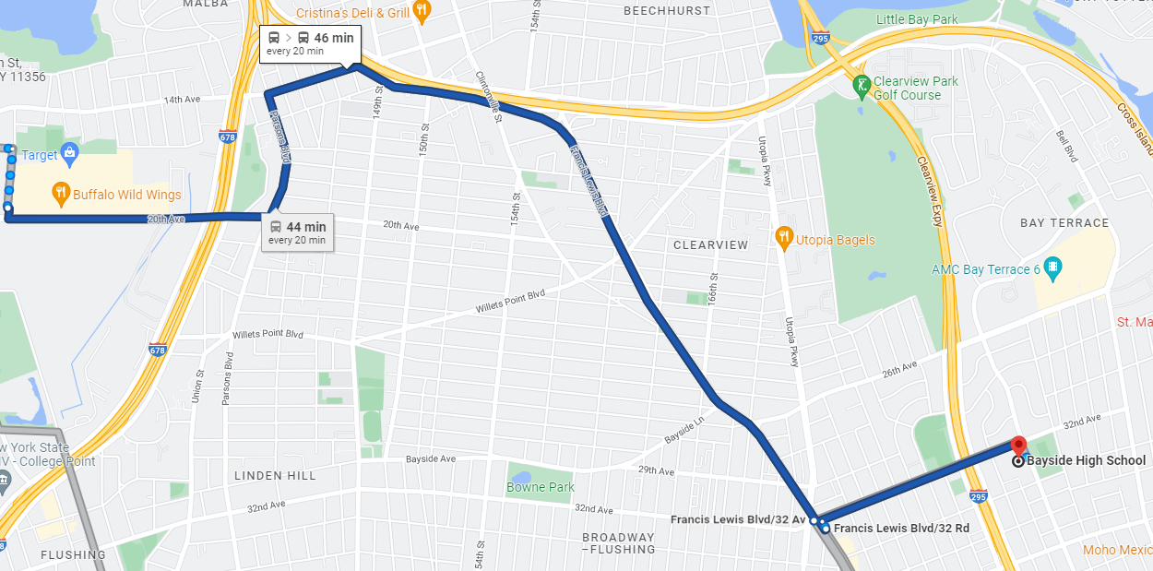
Flushing: Take the Q28 which will take you right to Corporal Kennedy St./ 32 AVE (Bayside High School).
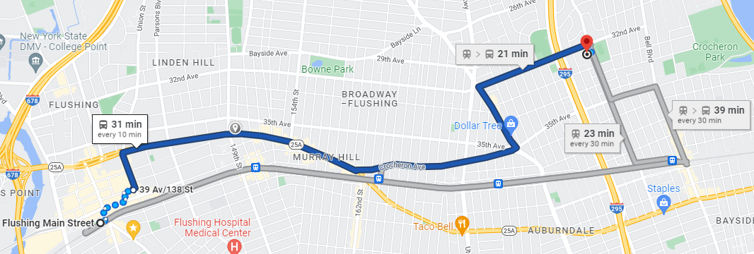

Fresh Meadows: Take the Q31 which will take you right to Corporal Kennedy St./ 32 AVE (Bayside High School).
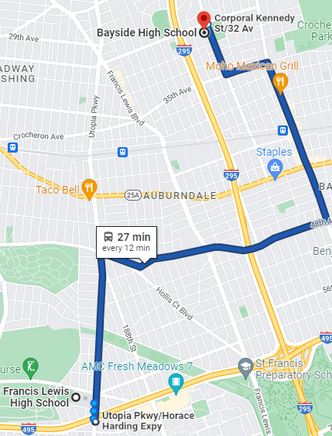
Bayside: Take the Q31 which will take you to Corporal Kennedy St./ 32 AVE (Bayside High School).
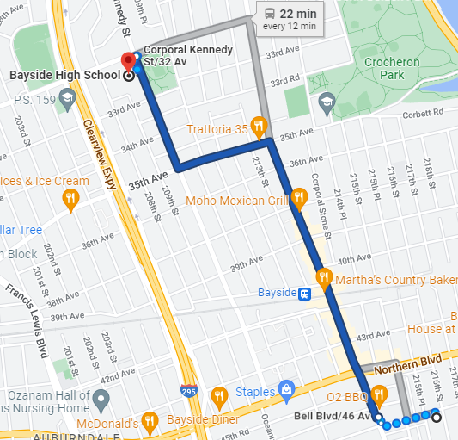

Little Neck: Take the Q12 to Northern Blvd/ Bell Blvd. Then transfer to the Q31 which will take you to Corporal Kennedy St./ 32 AVE (Bayside High School).
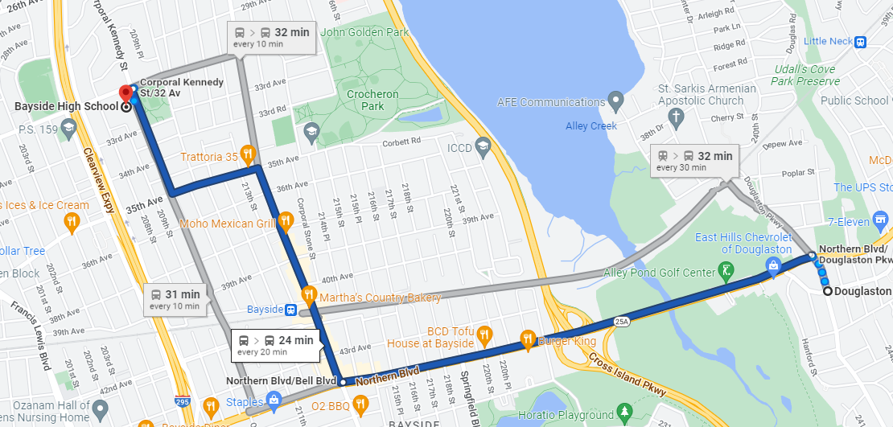

Advice for New Students
- Amir Theodile (Class of ‘24)
“Manage your time well -- become flexible with your work and learn how to spend your time and who to spend it with.”
- Annick Niyonsaba (Class of ’24)
“Communicate with teachers. Don't be afraid to ask your teachers for anything sensible.”
- Britney Bowes (Class of ‘23)
“Start joining clubs and get involved with the school community because it will seriously make your year a lot less stressful and a lot more fun. Also, take academics seriously; be nice to your teachers and classmates and start looking into the PSAT.”
- Christine Fan (Class of ‘23)
“Find a club that you are passionate about and persist in staying in that for the rest of your high school years. You will feel more involved than joining at the last minute.”
- Elyssa Chen (Class of ‘23)
“Become more sociable and branch out to other individuals. You shouldn't be afraid since everyone will likely be in the same boat as you.”
- Erica Rhee (Class of ‘23)
“Try to keep your daily tasks on track. Finish everything as quickly and efficiently as possible so you get more time to rest.”
- Isabel Catu (Class of ‘23)
“Get involved! Always stay on your toes, socialize with others, have fun, and most importantly be yourself.”
- Jovey Chen (Class of ‘24)
“Don't be scared to approach someone and talk to people! Meeting new people can be scary, but know that everyone else is most likely scared too. If you never TRY, how do you know what will happen? Try not to overthink it :)”
- Katelynne Huynh (Class of ‘22)
“Getting involved in clubs can help you become more informed about Bayside and can create relationships/connections you will use throughout your years.”
- Lia Li (Class of ‘23)
“Always form good relationships with your teachers, For example, smile and say hi and goodbye.”
- Layla El Rowmeim (Class of ‘24)
“Use resources to help you in class such as programs, websites, teachers, and peers to help keep your GPA up. Once it goes down, it's hard to raise.”
- Maliya Simpson (Class of ‘23)
“Start a conversation with the person next to you. They will probably be your best friend for the rest of your life.”
- Michelle Shi (Class of ‘22)
“Take this year to explore yourself! Get involved with all the different events that happen and next year, you can narrow down what you're really passionate about and dedicate your attention to that.”
- Myra Lin (Class of ‘23)
“Manage your time wisely, don't overwork yourself, and make sure to schedule breaks in between. Make a to-do list, make a daily or weekly schedule; it helps.”
- Queena Yue (Class of ‘22)
“Don't forsake time with friends over school to do well academically. Take advantage of whatever resources Bayside has since the school has a lot.”
- Sophia Sewpersad (Class of ‘23)
“Having friends is NOT the #1 priority; you and your mindset/comfort level come first! Make sure to set some personal goals for yourself. BE RESPECTFUL!”
- Victoria Krivitskiy (Class of ‘23)
“Try to go to a school event like Homecoming or Carnival to get into the school spirit.”
- Zuma Redzepagic (Class of ‘22)
“ALWAYS communicate with others and ask for help when you need assistance. If you don't seek help when needed, you will struggle.”

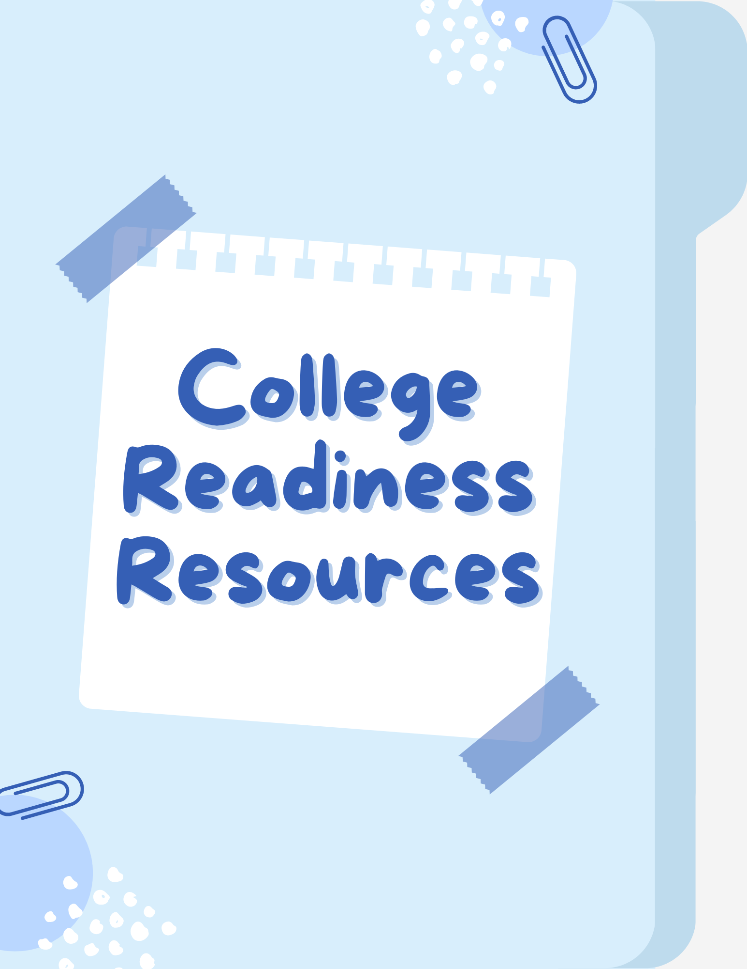
College Readiness Resources

Tips for College Readiness
Create a list: Work with your counselor to create a personalized list of colleges to apply to by December 1st. The number of colleges you put down on your list is up to you but should contain Safety, Reach and Match schools. You may qualify for CUNY and other fee waivers to help you apply for free.
  - Safety Schools are schools where the chances of you being accepted are high. It is recommended to put at least 3.
  - Reach schools are schools that you may have trouble getting into either due to personal reasons such as grades or due to strict admission rates. It is recommended to put 2-3.
  - Target schools are schools in which your current standing matches with the previously accepted freshman’s standings. It is recommended to put 3-4.
  - Look at previous admission standings to see what the average grades and test scores of the current freshman class are and compare them to your own. Research information such as their prestige in your field of study, graduation rate, financial aid, safety, overall satisfaction, and other information that you believe is important in your decision-making process.
Learn about colleges: Take advantage of their websites, virtual college tours, college fairs, and fly-in programs to learn more about the colleges and career programs on your list.
  - Make sure to take notes! You can also see if there are any teachers, friends, or adults who have or are going to a college of interest and ask them about their experience.
Keep track of deadlines: Use a calendar to manage deadlines, work on your college essay, and make sure you have letters of recommendation from teachers, employers, or others.
  - Do research on what type of college essay you’ll write: an anecdote, a list…etc. Make sure to proofread and ask if your trusted friends, counselor, or teachers could look it over.
  - Some colleges ask for additional essays and responses so make sure you allocate enough time for those as well.
  - Choose teachers that know you well so they won’t write you a generic recommendation letter. Ask them respectfully and always allow them a way to say ‘no’, and respect if they do.
  - Some colleges require an interview so make sure to study information about the school. Your application as well as common interview questions to better prepare.
Get ready to apply: Once you submit college applications, prepare to apply for financial aid. FAFSA and TAP applications open on October 1st.
  - Typically, the earlier you apply, the more aid you receive, so try to apply as early as you can. Make sure you have all your information prior to applying to make the process faster and easier.
  - You can also start looking for scholarships that you can apply to, whether essay or no essay.

How to use College Board
Registering an Account:
- Go to https://www.collegeboard.org/ and click on “Create Account”
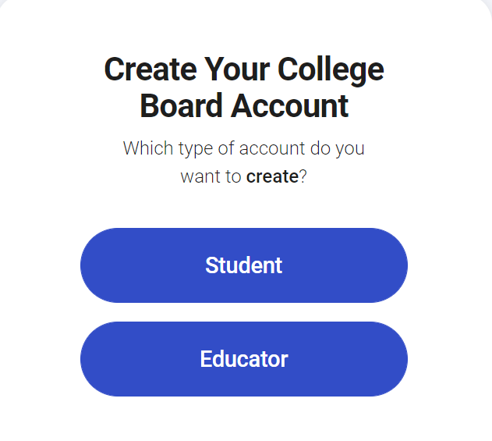
- Click on “Student”
- Fill out all the required information including
  - Full Name
  - Birthday
  - Email Address
  - High School Graduation
  - Name of the school you’re attending
  - Home Address
  - Parent Information
Double-check the information provided to make sure it is correct.
- Once you click “Next”, you will be asked to confirm your email address. Make sure to check the email used to create the account for a one-time verification code, it might take a couple of minutes. It is a 6-digit number code, if you do not see it ask for it to be resent.
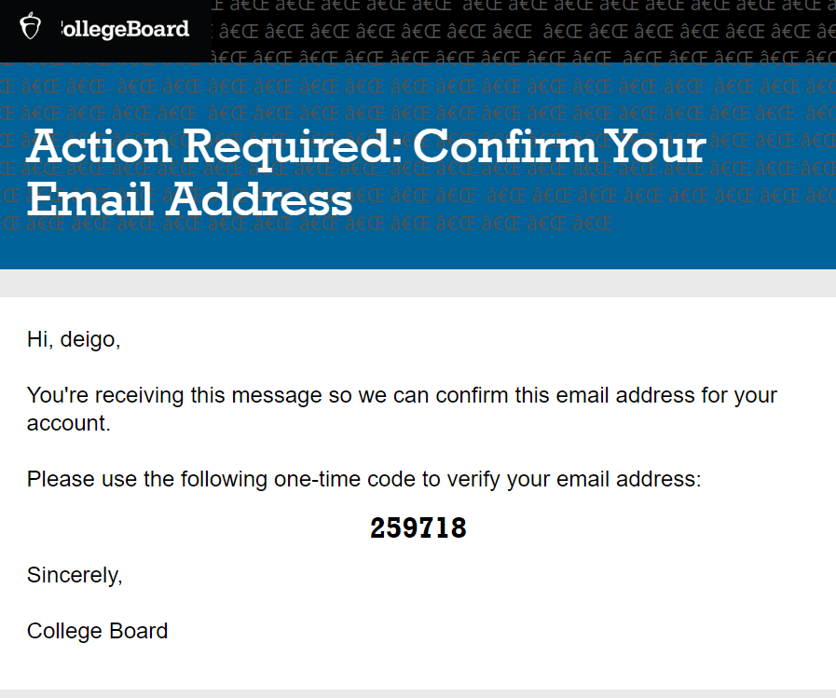
- Input the code accurately to set up your password and security phrase
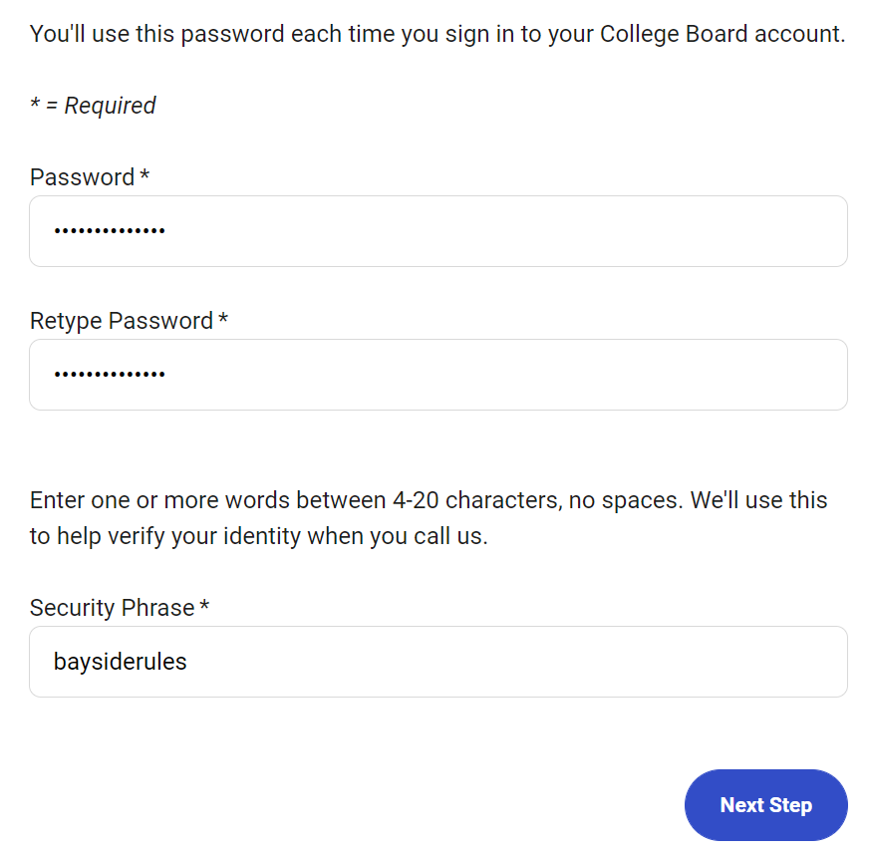
- Provide your phone number as College Board sometimes sends you reminders regarding scholarships opportunities offered.
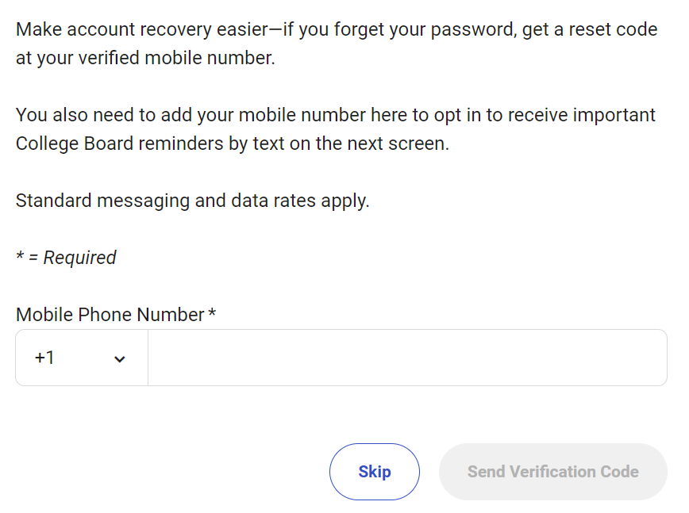
- You will need to verify your phone number as well, the process is the same as the email verification one. You will receive a text message with a 6-digit code, make sure the code is inputted correctly.
- Congrats! Make sure to save your password and security phrase. Double-check by trying to sign into your account for the first time.
Registering for SAT:
- Visit https://satsuite.collegeboard.org/sat/registration and click on “Register Now” or you can click on My SAT on the home page of College Board. It will redirect you to another page where you’ll need to click “Register for the SAT”.
- Check all the provided information and make sure it is accurate. Make sure to click confirm for the expected graduation date and your grade. Click “Continue” once you’re done.
- You will be asked to enter your demographic and academic information. This might take a while but you can save and continue later. You will only have to do this once, the information you provided the first time will be saved and next time, you can just click “Continue”.
- College Board will then ask you if you would like to opt-in on their Student Search Service. Confirm if you are interested in clicking “Continue”, you can opt-out anytime. If you would like to opt-out, click “I’ve changed my mind, please opt me out”.
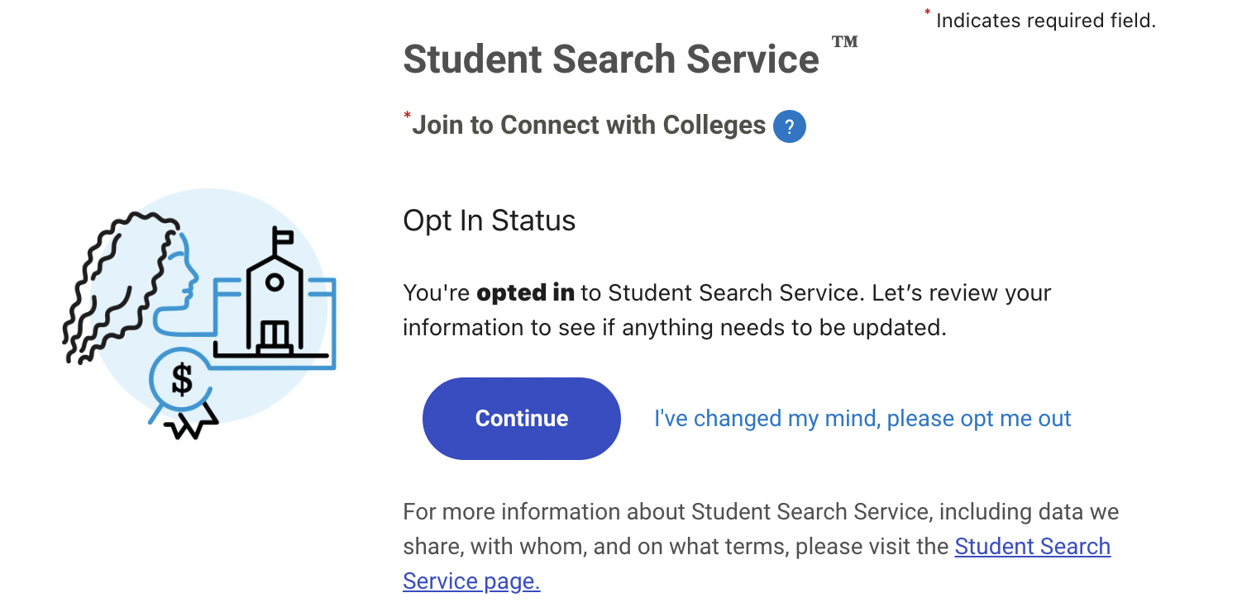
- Read through the terms and conditions, then agree to them and click “Continue”.
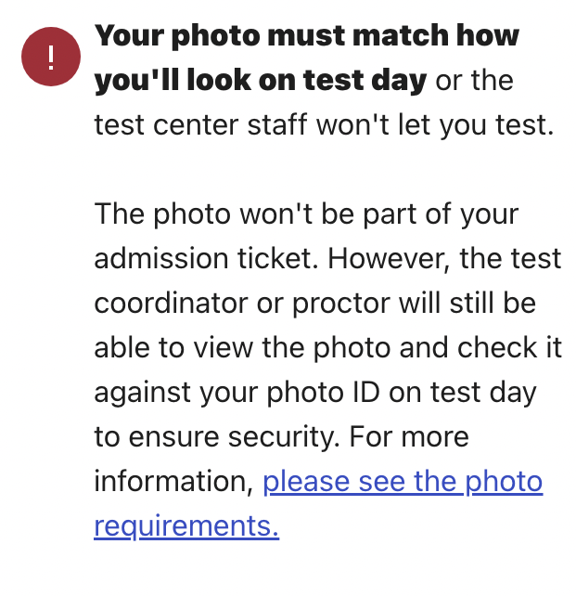
- Select which date and location you would like to take your SAT. Make sure to sign up around a month or two before your desired SAT date as spots fill up quickly. Confirm your test details and click “continue”
- Upload a photo of yourself that accurately reflects how you look. It also must meet the following requirements:
  - Shows just you with your face visible
  - Has your head and shoulders in full view
  - Lit properly and in focus

- If you would like to add the answer service to your score report, select “Yes”. This service is $16 dollars, but if you have the fee waiver, this service is free.
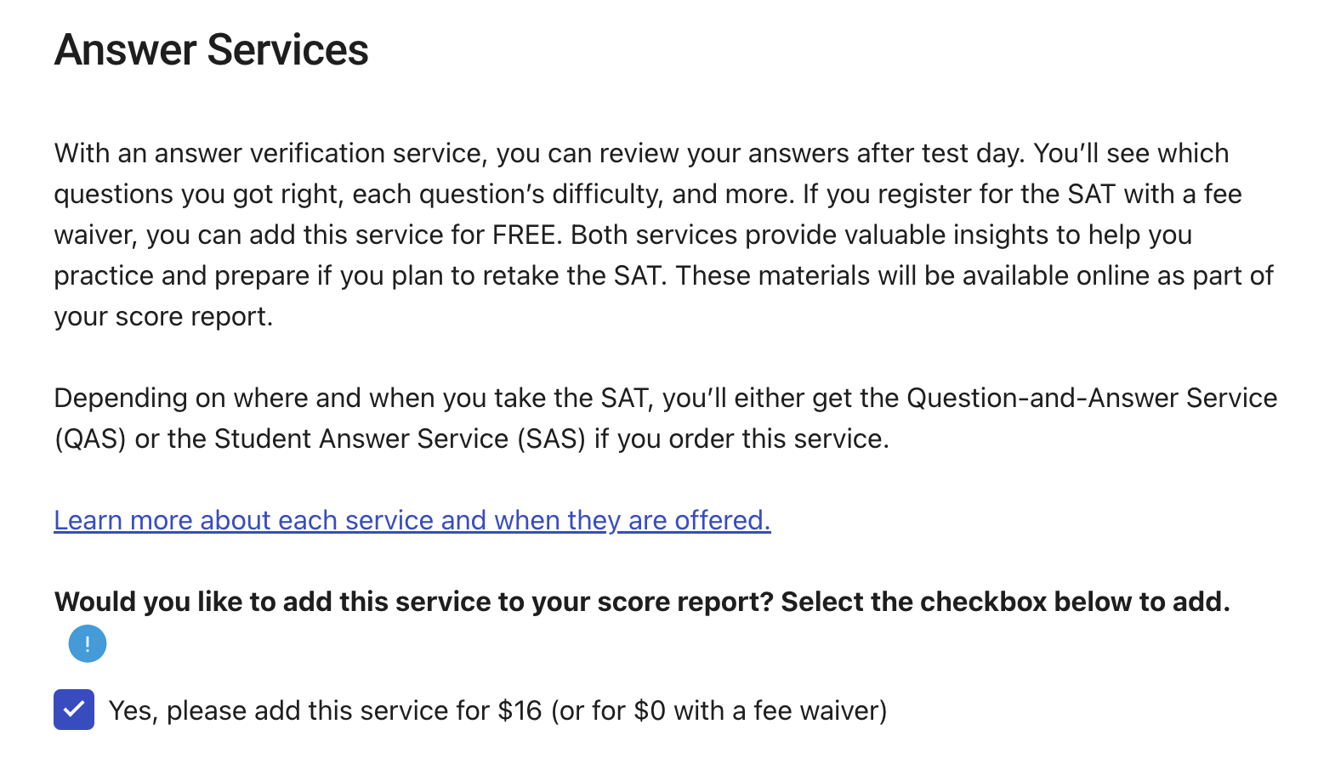
- Once you finish checking all the information, click “confirm” to finish registering for the SAT.
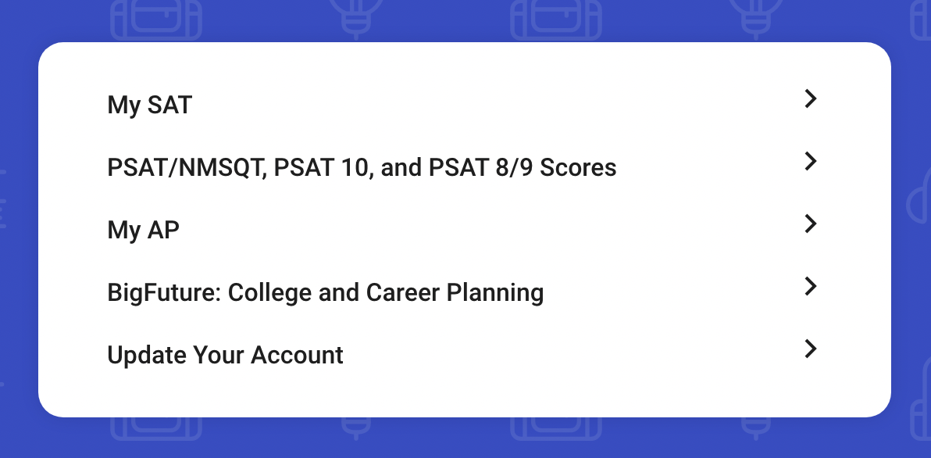

- My SAT: On this page, you will see how many fee waivers you have left and other information about the SAT. Any upcoming SATs you have registered for will show up here as well as the scores of your past SATs and PSATs.
- PSAT Scores: Even though it only mentions PSAT in the title, this page will show you all the past SAT and PSAT student score reports. By clicking on one of the SATs or PSATs, you will see the score breakdown and how many mistakes you made in each section.
- My AP: AP teachers ask students to join their class in AP Classroom. You will be provided with resources and assignments through AP Classroom.
- Big Future: Clicking on this will take you to use college resources such as How to Build Your College List, Strengthening Your College List, Practicing for the SAT, and Apply for College. Big Future provides a step-by-step guide for the college process. It also includes ways to find scholarships and how to fill out the FAFSA. Not only that, parents and educators can look here for more resources.
- Update Your Account: This will bring you to a page where you can edit your personal and school information. If you need to edit your email address, password, or security pass, this is where you go.

College-Accredited Courses
Did you know that many of your CTE courses are college accredited? This means you can graduate with as many as 30 college credits, which equals one year of college! Graduating with credits also means you will save a lot of money. We currently have college accreditation partnerships with CUNY, SUNY, Five Towns, St. John's University, Rochester Institute of Technology, and Molloy College.
Advanced Drawing
Advanced Project Management
Chinese 5A
Creative Writing
Current Issues in Health
Design, Drawing, Production
Exercise, Nutrition, & Weight Control
Film Studies
French 5A
General Biology
Graph Design
Introduction to Computer Science
Introduction to Sports Management
Journalism
Korean 5A
Music 3
Portfolio Prep
Precalculus Jr
Principles of Engineering
Recording Technologies
Required of Foundation Music
Social Entrepreneurship
Spanish 5A
Sports Marketing
Video Journalism

College Now Classes
These are college-level courses meant for high school students to start gaining college credit for free either during the morning, on weekends or after school. Unlike AP classes, as long as you pass the class, you’ll get the credits. These are highly recommended as it means you can amass credits in High School without having to pay for them in college. Most colleges accept College Now classes but research to make sure your colleges do.
College Now classes are offered during the fall and spring semester both at Bayside High School and on Saturdays. Classes offered on Saturdays can either be on campus or remote.
Make sure to keep an eye out for any College Now opportunities and apply for them as soon as you can as spots are limited. Oftentimes, your guidance counselor will email you about your interests. You can also stop by the guidance office to ask them or check out the website baysidehighschool.org for more information.

AP Classes
AP classes are college-level courses for high school students to start gaining college credit for free. Unlike College Now classes, you must pass the AP test at the end of the year held by the College Board to gain credits. You get a score from 1 to 5, each bearing its amount of credits. A score of 3 provides credits and a score of 1 or 2 provides no credits. Most colleges accept AP credits at a certain score so research to see what your college accepts.
AP classes require a lot of dedication due to their rigorous subject matter in a relatively short time and so it is highly recommended that you keep up in class by taking notes and actively participating. There are outside sources your teacher may recommend to help such as Youtube channels or websites. You can also find books, outside sources, or previous tests to help you prepare. College Board has live study sessions on Youtube so make sure to attend or watch those as they review, answer questions, and cover important topics on your AP exam. Additionally, Khan Academy is also highly recommended, teachers often post assignments and practice tests for you to do.
AP Art History
AP Biology
AP Calculus AB
AP Calculus BC
AP Chemistry
AP Chinese
AP Comparative Government
AP Computer Science
AP English Literature
AP English Language
AP Environmental Science
AP European History
AP French
AP Human Geography
AP Physics 1
AP Physics C
AP Psychology
AP Spanish Language
AP Statistics
AP Studio Art
AP US Government
AP US History
AP World History

SAT/PSAT Information

- The PSAT is the Practice SAT offered at Bayside High School for freshmen, sophomores, and juniors around October. This is excellent practice since it shows you what to expect, as well as what your initial score is and what to work on.
- Failing to take the PSAT or refusing to will lead to Academic Probation.
- The SAT is available in March, May, June, August, October, November, and December, and it is your responsibility to register for those test dates if you wish to take the test. Take advantage of any in-school SAT offered at Bayside.
- Many students often take their first SAT in their junior year since the school offers a free in-school SAT in March. All juniors are automatically registered for the in-school March SAT.
- You can take the SAT as many times as you want.
- You can take advantage of College Board books and Khan Academy to provide questions similar to the real exam. They have multiple full SATs for you to take as well as explanations for the answers.
- The SAT is not a free test, however, most people qualify for a fee waiver which includes 2 free SAT registrations, 6 free SAT Subject Test registrations, unlimited score reports to send to colleges, and waived application fees at participating colleges. Ask your counselor early on to see if you qualify for a fee waiver.
Note that some colleges offer test-optional or test-blind applications. Research your colleges to see if they require the SATs and if taking the SAT is a decision you want to take.
- Test optional means that you don’t have to submit an SAT score if you do not wish to. Some reasons why you won’t want to do this are if you were not able to take the SAT or if your score falls below the average score.
- Test-blind means the college will not accept or look at your SAT score even if you submit it, and will not use it in any admissions decision.

College Access Handbook-Bayside.pdf

CLEP
Bayside High School is excited to announce that we will offer College Board’s College-Level Examination Program (CLEP) as an opportunity for students to earn college credit for their high school coursework. The College Board’s College-Level Examination Program (CLEP) has been the most widely trusted credit-by-examination program for over 50 years, accepted by 2,900 colleges and universities and administered in more than 1,800 test centers (Good News: Bayside High School is a CLEP Test Center). This rigorous program allows students from a wide range of ages and backgrounds to demonstrate their mastery of introductory college-level material and earn college credit. Students can earn credit for what they already know by getting qualifying scores on any of the 34 examinations.

Click here to learn about CLEP

Parent Resources

Tips for Parents

Below are 10 simple tips parents may do to get involved with their kids:
- Talk to your child daily about school activities and experiences.
- Talk with teachers regularly - even when no problems exist,
- Broaden your child’s understanding of the world by visiting malls, museums, parks, zoos, universities, sports stadiums, theaters, transportation facilities, farms, and local landmarks.
- Set goals and milestones that are challenging but attainable.
- Find or create a quiet place for your child to study.
- Meet with their teachers.
- Listen to your child and pay attention to their problems.
- Visit the school regularly and become involved in school activities as often as possible.
- Designate a specific time and place for homework.
- Become family with your child’s curriculum and its required skills and goals.

Parent Coordinator Information
Lori Badalati - Parvis | (718) 229-7600 x1284 | lparvis@baysidehighschool.org | Rm 128

PTA Executive Board
President : Dr. Alan Queen
Treasurer: Mr. Jared Rosoff
Recording Secretary: Ms. Nalini Sahedo-Persaud
Corresponding Secretary Mrs. Zaxshil Ramos

PTA Meetings
PTA meetings are generally held on a Thursday at 7:15 PM. Parents will be made aware of PTA meetings through phone calls or voicemails from the school, so be on the lookout if you’re interested. The zoom link will also be posted on our website baysidehighschool.org.

September 28, 2023
October 19, 2023
November 9, 2023
December 14, 2023
January 18, 2024

February 15, 2024
March 21, 2024
April 18, 2024
May 16, 2024
June 13,2024

Lunch Forms
You can fill out the lunch form online at https://www.myschoolapps.com/.
The lunch forms will be available as of September either online or on paper. Students who have not filled it out will receive a copy to bring home. Every family should fill out the lunch forms as you can save up to $1200. Lunch forms aren’t just for free or reduced lunch, they can provide many free services for your children such as SAT waivers and college application fee waivers.
SAT Test (2 times × $43= $86)
SAT Additional Score Reports (8 schools × $9.50 = $76)
SAT Test Score Analyzer Q&A ($28.00 × 2 = $56)
AP Tests: (4 tests × $85.00 = $340)
SAT Waiver Colleges Apps (4 schools × $50 = $200)
SUNY 4 campus Apps (4 schools × $60 = $240)
SUNY College Credits reduced to $90
NCAA Clearinghouse App: $50.00

