Saint Anselm Catholic Academy

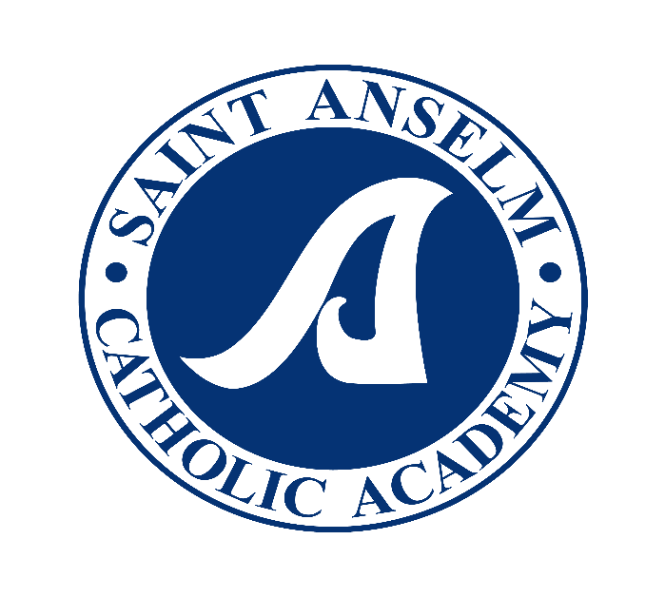
STRATEGIC PLAN-Spring 2017

Abridged Format (the original 43 page document is available for review in the Main Office)

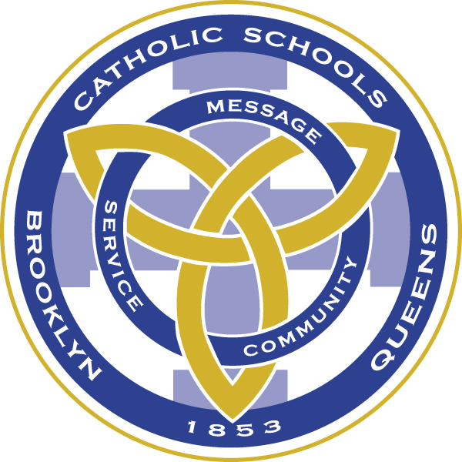
Office of the Superintendent • Catholic School Support Services
Roman Catholic Diocese of Brooklyn
310 Prospect Park West Brooklyn, New York 11215 718-965-7300 fax: 718-965-7353

21 April 2017
Mr. James McKeon, Principal
Saint Anselm Catholic Academy
365 83rd Street
Brooklyn, NY 11209-4404

Dear Mr. McKeon,
On behalf of the Strategic Planning Review Team, I wish to congratulate you, your staff, the Board of Directors and parent community for successfully completing the Strategic Plan for Saint Anselm Catholic Academy 2017-2020. The plan reflects both the foundational structure and operational vitality for a quality Catholic academy as outlined in the National Standards and Benchmarks for Effective Catholic Elementary and Secondary Schools.
The planning team created necessary and sufficient goals, objectives and strategies for each of the five domains to meet and exceed the challenges of the future. As a result of your visionary planning based upon the mission of the academy, the Strategic Planning Review Team is pleased to approve the plan and commend you for the quality and scope of your thoughtful deliberations.
Please be advised that at the conclusion of the 2017-2018 academic year an evaluation of the progress of the strategic plan will be necessary. A document for this purpose is attached.
Thank you for your dedication and determination to secure a bright future for the present and future students and families of Saint Anselm Catholic Academy.
Sincerely,
Brother Ralph Darmento, F.S.C.
Deputy Superintendent of Schools
STRATEGIC PLAN-Spring 2017
MISSION STATEMENT AND OVERVIEW OF DOMAIN TASK FORCE RESULTS
This section of the report includes the mission statement and presents a summary of the key elements that constitute each of the five domains and provides an overview of the goals included in the plan. It is important to remember that the following goals are intended to be implemented over the next three years. A complete set of domain task force goals, objectives, and action steps is included in the Appendix of this report.

ST. ANSELM CATHOLIC ACADEMY MISSION STATEMENT
The mission of St. Anselm Catholic Academy is:
The MISSION of Saint Anselm Catholic Academy is to educate students in the IMAGE AND VALUES OF OUR LORD by providing a path for Catholic growth, physical safety, character development, personal responsibility, academic rigor and educational opportunities for all students with an emphasis on English Language Arts (ELA), MATH, STEM and the Arts and a commitment to our school, parish and local communities.
CATHOLIC IDENTITY
The religious mission of a Catholic school, its Catholic identity and faith formation, is the soul of the school’s program and activities. Religious mission is the factor that distinguishes Catholic schools from other educational options. In order to maintain success in these changing times, there must be a strong collaborative effort among all levels of St. Anselm Catholic Academy to maintain and enhance the school’s Catholic Identity.
Catholic Identity Goals:
- To have staff and volunteers evangelize students, parents and families in order to strengthen Catholic identity and faith
- To put our faith in action through charitable works of mercy and service
- To teach Catholic faith, history and culture
ACADEMIC EXCELLENCE
The academic program provides the scope and structure that nurtures the spiritual, intellectual, and developmental needs of students. The strength and vitality of the academic program, inclusive of all curricular offerings, extra-curricular offerings, and educational and developmental support services, forms the basis upon which schools are compared and rated by society at large.
1
The instructional program must include effective supervision and evaluation of teacher performance, a common set of learning standards, student achievement measures, and adequate educational resources to meet student learning needs and enable each to reach his or her full potential. A strong academic program is a compelling incentive that can attract new students and retain current students.
Academic Excellence Goals
- To utilize an enhanced curriculum which promotes active learning in each classroom and increases student engagement •
- To challenge students to meet or exceed grade appropriate standards to maximize academic, spiritual, social and emotional development
- To actively engage students in an educational environment where technological literacy and a STEM focus are an integral part of a balanced Catholic school education
- To foster an environment where professional development opportunities are integral and ongoing
ENROLLMENT AND MARKETING
A comprehensive and updated enrollment program and admissions process is vital to building enrollment in the schools. The admissions process must be welcoming and professional. Strong educational programs along with a variety of extra-curricular before and after school programs are essential for enrollment stability. Enrollment stability and growth are essential to the vitality of the academy. In today’s competitive environment, utilizing an effective marketing program is essential to the continued development and growth of the institution. A value proposition and proprietary strengths that distinguish Catholic schools from other educational options are necessary to sustain current enrollment and attract new students. This message must be communicated not only to Catholic parents, but to all parents, and to the broader community of alumni, parishioners, civic and political leaders, and the community at large.
Enrollment and Marketing Goals:
- To build a more comprehensive marketing program
- To increase enrollment yearly over the next three years
- To establish an Alumni Association
GOVERNANCE AND LEADERSHIP
The success of Catholic schools depends on the key components of effective governance and leadership. Catholic school governance and leadership can be seen as a ministry that promotes and protects the responsibilities and rights of the school community. Governance and leadership based on the principles and practices of excellence are essential to insuring the Catholic identity, academic excellence, and operational vitality of the school.
2
Governance and Leadership Goals:
- To achieve greater integration between SACA and the St. Anselm Parish as a whole
- To increase leadership opportunities for faculty and Board
- To create a more systematic approach to the recruitment of Board members
- To increase knowledge of the Board’s workings among parents, faculty, parish and alumni
FINANCE AND DEVELOPMENT
In any organization, finances are the bedrock upon which all facets of the organization are built. Enrollment, the efficacy of the academic program, acquiring and retaining highly qualified personnel, the structural integrity of the buildings, etc. are all driven by the financial health and vitality of the school.
Finance and Development Goals:
- To ensure the Board of Directors maintain financial accountability and sustainability of the Academy
- To establish an annual fund
- To coordinate all Academy fund-raising projects

The work of the Strategic Planning Committee reflects the best thinking of many people who believe in the value of Catholic education and want those benefits for all students at St. Anselm Catholic Academy.
The strategic directions set forth in this plan provide a clear pathway for St. Anselm Catholic Academy for the next three years. To realize the full benefit of the plan, it will require sustained leadership from the Board of Directors and the ongoing involvement of stakeholders. The Board of Directors will need to establish sub-committees that align with specific directions to guide plan implementation and monitor progress.
The work accomplished through the strategic planning process has resulted in a well-defined foundation to build upon the traditions of the past and create a unified direction to sustain and revitalize Catholic school education at St. Anselm Catholic Academy.

3

