|  |
| --- |
| **Subject: Geometry Unit: Four** |
| **Unit Topic and Length:**  **SIMILAR TRIANGLES**  **(Three weeks)** |
| **Big Ideas/Enduring Understandings:**  Ratios and proportions can be used to decide whether two polygons are similar and to find unknown side lengths of similar figures. |
| **Essential Questions:**  How does comparing similar polygons describe the relationship between them?  How do geometric relationships involving similarity help to solve problems and/or make sense of phenomena? |
| **Common Core Learning Standards:**  **G-SRT.1** Verify experimentally the properties of dilations given by a center and a scale factor:  a. A dilation takes a line not passing through the center of the dilation to a parallel line, and leaves a line passing through the center unchanged.  b. The dilation of a line segment is longer or shorter in the ratio given by the scale factor.  **G-SRT.2** Given two figures, use the definition of similarity in terms of similarity transformations to decide if they are similar; explain using similarity transformations the meaning of similarity for triangles as the equality of all corresponding pairs of angles and the proportionality of all corresponding pairs of sides.  **G-SRT.3** Use the properties of similarity transformations to establish the AA criterion for two triangles to be similar.  **Prove theorems involving similarity**  **G-CO.10** Prove theorems about triangles. *Theorems include: measures of interior angles of a triangle sum to 180°; base angles of isosceles triangles are congruent; the segment joining midpoints of two sides of a triangle is parallel to the third side and half the length; the medians of a triangle meet at a point.*  **G-SRT.4** Prove35 theorems about triangles. *Theorems include: a line parallel to one side of a triangle divides the other two proportionally, and conversely; the Pythagorean Theorem proved using triangle similarity*.  **G-SRT.5** Use congruence and similarity criteria for triangles to solve problems and to prove relationships in geometric figures. |

|  |  |  |
| --- | --- | --- |
| **Content:**  **Similarity Preserved for Transformations**  **Minimum Requirements to Determine if Triangles are Similar**  **Similarity for Right Triangles**  **Mid-segments of triangles**  **Finding side lengths of triangles by setting proportions based on similar figures.**  **The internal angles of Regular Polygons** | **Skills:**  Understanding the difference between congruency and similarity. How these properties are effected by transformations.  Understanding when triangles are similar.  Discovering the theorems for similarity.  AA, SAS and SSS.  Proving triangles are similar.  Understanding that corresponding parts of similar triangles are similar.  The mid-segment theorem for triangles.  Applying the mid-segment theorem to real life situations to solve problems involving inaccessible distances.  Applying the knowledge of similar triangles to real life problems. Using diagrams to model situations involving similarity with triangles and other polygons.  Deriving the formula for the sum of the internal angles of regular polygons. | **Days:**  **2**  **2**  **2**  **1**  **2**  **2**  **3**  **2** |
| **Assessment Evidence and Activities:**  Pre and Post Tests (formative assessment and assessments for evidence of growth)  Problem Solving Tasks and Activities  Quizzes  Questioning and Observations  Do Nows and Exit Slips  Class work and Homework | | |
| **Possible Support Strategies:**  Use of manipulatives  Word Walls and Individual Glossaries  Journals | | |
| **Formative Assessment:**  The assessments listed above will be used to identify students’ strengths and weaknesses.  There will be constant adjustments and fine tuning of the curriculum delivery based on this analysis. Sharing student work, sharing best practice and planning next steps will be an integral part of common planning meetings. | | |
| **Final Performance Based Task: See Attached**  A number of tasks and student activities will be completed during this unit.  These tasks are attached and included in this unit plan below. | | |
| **Extension:**  Differentiated column sheets for solving similar triangles.  Most of the attached tasks are differentiated or open ended to cater for individual differences. | | |
| **Learning Plan & Activities:**  The learning plan will incorporate work shop style lessons which will allow for student centered learning. Group work will be incorporated into various concepts with a focus on students learning collaboratively. There will be an emphasis on technique to enable students to solve skills based questions. This will be supported with problem solving exercises for all content to give students a conceptual understanding of the material. | | |
| **Resources:**  Text book : Meaningful Math Algebra I Prentice Hall Mathematics Algebra I  Graphing calculators  Geometric Manipulatives, Sketchpad  Smart Board Demonstrations  Problem solving materials created by teachers | | |

**Geometry Pre–Test SIMILAR TRIANGLES**

Name : ___________________________________ Date : _____________

1.) State whether  and  are congruent. (Questions 1 – 3 G.G.44)



[A] yes, by either SSS or SAS

[B] yes, by SSS only

[C] yes, by SAS only

[D] No; there is not enough information to conclude that the triangles are

congruent.

2.) Based on the given information, what can you conclude, and why?

**Given:** H  L and HJ  JL



[A] HIJLKJ by ASA [B] HIJJLK by AAS

[C] HIJJLK by SAS [D] HIJLKJ by SAS

3.) Name the theorem or postulate that lets you immediately conclude





[A] SAS [B] ASA [C] AAS [D]none of these

(Questions 4 – 6 G.G.45)

4.) A lamppost is 6 feet high and casts an 8-foot shadow. At the same time of day,

a flagpole directly behind the lamppost casts a 28-foot shadow.



Which proportion can be used to find the height, *H*, of the flagpole?

[A] *= * [B] * = * [C] * = * [D] * = *

5.) Two ladders are leaning against a wall at the same angle as shown. How far up the wall does the shorter ladder reach?



[A] 8 ft [B] 10 ft [C] 6 ft [D] 20 ft

6.) Use similar triangles to find *x*.



[A] 1.5 ft [B] 2.67 ft [C] 1.25 ft [D] 6 ft

(Questions 7 – 9 G.G.46)

7.) Use the Side-Splitter Theorem to find *x,* given that .



[A] 12 [B] 6 [C] 20 [D] 24

8.) Given , solve for *x*.The diagram is not drawn to scale.



[A]  [B]  [C]  [D] 

9.) In the figure shown, *BC* || *DE* , *AB* = 2 yards, *BC* = 9 yards, *AE* = 36 yards, and

*DE* = 36 yards. Find *BD*.



[A] 9 yd [B] 8 yd [C] 6 yd [D] 27 yd

(Questions 10 – 12 G.G.47)

10.) The accompanying diagram shows part of the architectural plans for a structural support of a building. *PLAN* is a rectangle and *AS* *LN*. Which equation can be used to find the length of *AS* ?



[A]** = ** [B] *=*

[C] *=*  [D] *=*

11.) Use the diagram below to solve for *a* and for *b.*



[A] ** [B] **

[C] ** [D] **

12.) Use the diagram below to solve for *a* and for *b.*



[A]  [B] 

[C]  [D] 

Name : ___________________________________________ Date : ___________________

A surveyor is given the task of measuring the distance across a lake from A to B. She set up he surveying equipment at point C and shoots

in two lines to points E and D. She then records the following measurements. CA = 42 meters, CD = 70 meters, CB = 60 meters and CE = 100 meters.

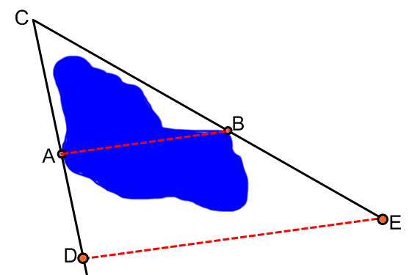

She found the length of DE to be 120 meters. How far across the lake is it? Explain the mathematics that you used to solve this problem.

Is it alright to assume that triangle ABC and triangle CDE are similar?

_____________________________________________________

_____________________________________________________

_____________________________________________________

_____________________________________________________

_____________________________________________________

_____________________________________________________

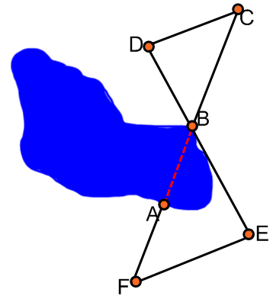

A surveyor is given the Task of measuring the distance across a lake (AB). She decides to stake out the following similar triangles. Her surveying equipment allows her to determine that DC and FE are parallel. How does this information help her?

_____________________________________________________

_____________________________________________________

_____________________________________________________

_____________________________________________________

She can measure the distances: DC = 48 meters, FE = 72 meters,

BC = 60 meters and FA = 40 meters, how is the surveyor going to use these measurements to help her find out the distance across the lake?

_____________________________________________________

_____________________________________________________

_____________________________________________________

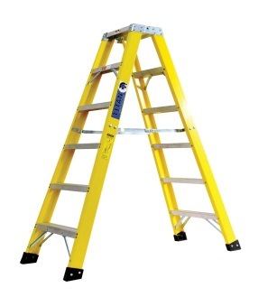 

It is a bright sunny day and I decide I need to know the height of a large tree in my backyard that I want to have trimmed. I took my ladder out to measure the height of the tree but realized that it was not going to be tall enough to do the job. I was about to give up when my neighbor’s daughter who is studying high school geometry yelled over the fence that she could help me out. She measured the length of the tree’s shadow, which was 42 meters. Then she positioned the ladder, which is 2.4 meters high, and measured its shadow. The ladder’s shadow was exactly 3 meters.

Where did she position the ladder and how did this model help her to find the length of the tree? Finally what was the tree’s length?

__________________________________________________________________________

__________________________________________________________________________

__________________________________________________________________________

__________________________________________________________________________

__________________________________________________________________________

__________________________________________________________________________

__________________________________________________________________________

A surveyor is given the task of measuring the distance across a lake from A to B. She set up he surveying equipment at point C and shoots

in two lines to points E and D. She then records the following measurements. CA = 44 meters, AD = 48 meters, CB = 55 meters.



She found the length of DE to be 84 meters. In order for us to be able to easily solve this problem what must the distance be from B to E? Explain how we are able to use mathematics to help us with this situation. How far across the lake is it?

__________________________________________________________________________

__________________________________________________________________________

__________________________________________________________________________

__________________________________________________________________________

__________________________________________________________________________

__________________________________________________________________________

__________________________________________________________________________

__________________________________________________________________________

__________________________________________________________________________

__________________________________________________________________________

I need to measure the distance across the river. I am on one side and my co-worker is on the other side of the river. We want to place some stakes in the ground set up some triangles that will help us solve the problem. How do we set up our stakes and what measurements do we need to take?

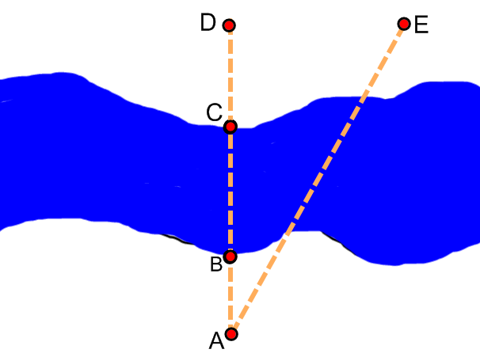

Make a problem up with the barest bit of information for your teacher to solve and find the distance across the river.

__________________________________________________________________________

__________________________________________________________________________

__________________________________________________________________________

__________________________________________________________________________

__________________________________________________________________________

__________________________________________________________________________

__________________________________________________________________________

Name: ___________________ Date : ______________

Aim : To be able to use our knowledge of mid-segments to solve real world problems.

Do Now

In the figure below AC = 8cm. and AE = 16cm. Also B, is the midpoint of AD. What special name does BC have? If DE = 12 cm, what is the length of BC?

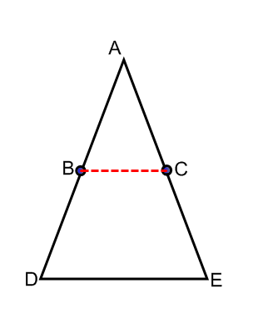

Any mid-segment joins the midpoints of two adjacent sides of a triangle. This forms a segment which is parallel and half the length of the third side of the triangle. What knowledge of parallel lines and transversals can we use to prove that ABE is congruent to ADE?

_____________________________________________________

_____________________________________________________

River Technique #2. Another technique involves trying to lay out a square with one side being the distance to be measured, d, and another side along the accessible shore. The square is laid out by a person walking from point A along the shore at right angles to the width of the river until the angle over to the inaccessible point, B, is estimated to be 45 degrees. The two sides of the square have the same length and, since you know how many paces is the side along the shore, you know that the distance across the river is the same length.

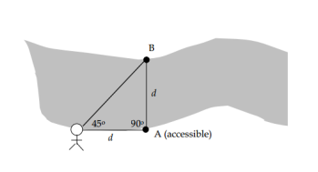

1. Surveyors are brought in to find the length of a swimming race across part of a lake from A to B. They set up a tripod at point C. They also located the midpoints of AC and BC. When they connected these two points they found the distance to be 48 meters. What other distances are needed to find the length of the swim across the water?

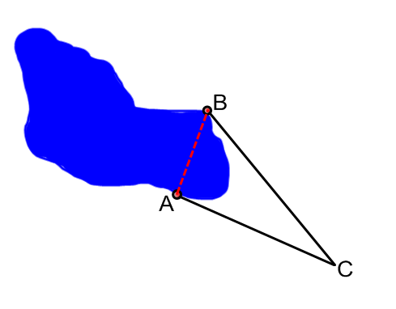

2) The isosceles triangle below is a diagram of the wall on the main building of the Rock and Roll Hall of Fame. The base is 229 feet 6 inches. Each side of the triangle is broken up into four congruent parts buy the diagonal struts. What is the length of the grey horizontal beam AB?

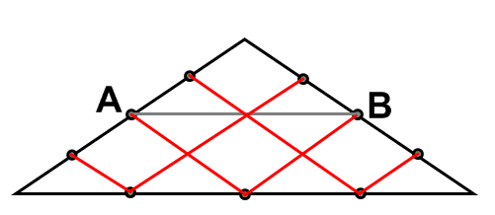

_____________________________________________________

_____________________________________________________

3) There is a kayak race across the lake below from point A to point B. Surveyors are brought in to find out if the length of the race is long enough to qualify for a record. They set up a tripod at point C. Complete this diagram and word problem with just enough information for your fellow student to work out the distance of the race.

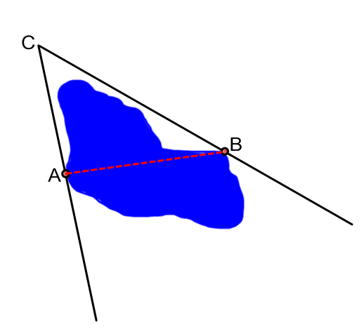

***Exit Slip***

Describe the mid-segment of a triangle.

AC is 42 cm. and BC is 38 cm. If D and E are the midpoints of AC and AB respectively, what is the length of DC?

What is the length of the mid-segment?

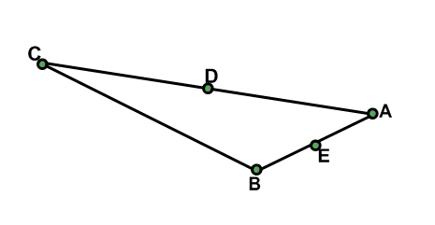

*Congruent and Similar Triangles*

Name: ___________________________ Date : _____________

PART I

I need to measure the distance across a river, but I cannot stretch my tape measure across the water. I am using my knowledge of similar figures to help me solve this problem.

There are two trees on the bank of the river on the opposite side. I rowed my boat across and measured the distance between these two trees. Now I set up three stakes in the ground which form a triangle. When I stand at point A, the line of sight from me to each tree passes directly over both stake C and stake B. Now I am measuring two sides of the triangle formed by the stakes.

How can I use this information to find the distance across the river?

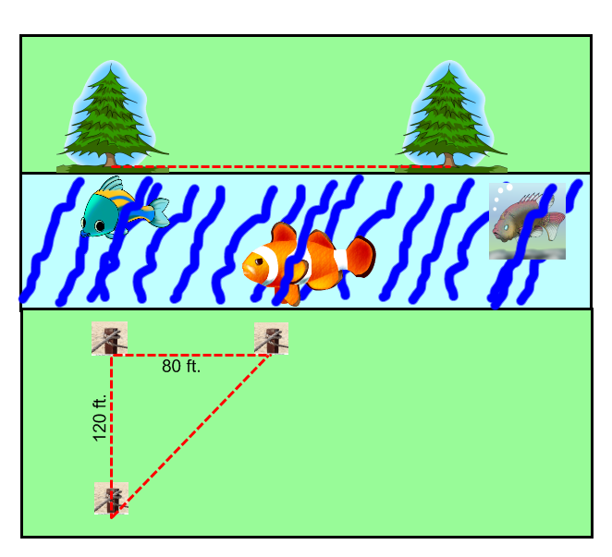

PART II

**The South Bronx**

Look at the map of an area in the South Bronx. All of the streets which run from East to West are parallel to each other and are exactly 50 yards apart if I am walking along any of the following avenues:

Alexander Ave., Willis Ave., Brook Ave. or St. Anns Ave

These avenues all make angles of 70o with each of the streets.

Alexander Ave., Willis Ave., Brook Ave. and St. Anns Ave. all run from North to South and they are also parallel to each other and they are exactly 396 yards apart.

Third Ave. and Fourth Ave. as you can see on the map is not parallel to the avenues mentioned above but they are parallel to each other. Third and Fourth Avenues make angles of 50o with each of the streets.

1) What angle does Third Ave. make with Willis Ave. ?

_____________________________________________________

_____________________________________________________

_____________________________________________________

2) If I walk west to east along any of the streets what is the distance

from Third Avenue to Fourth Avenue ?

_____________________________________________________

_____________________________________________________

3) Can you name at least three pairs of congruent triangle ? You must

draw the triangles below and label the streets/avenues and tell how

you know they are congruent.

4) What is the distance between Third Ave. and Willis Ave. if I am

walking on 138th Street ?

_____________________________________________________

_____________________________________________________

_____________________________________________________

5) I am racing my friend from Third Ave. to Willis Ave. I am

running on 145th Street and my friend is running on 144th Street ?

Who has to run further and how much further is it?

_____________________________________________________

_____________________________________________________

6) What is the distance between Third Ave. and alexander Ave. if I am

walking on 140th Street ?

_____________________________________________________

_____________________________________________________

7) What is the ratio of the areas of the land surrounded by Brook

Ave., St Anns Ave., 147th St. and 148th St. compared to the land

surrounded by Alexander Ave., St. Anns Ave., 139th St.

and 143rd St. ?

_____________________________________________________

_____________________________________________________

