Grade 5 September 2019 Goals

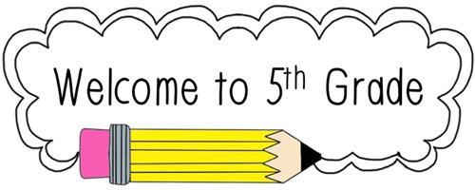

Reading: Students will access complex texts through applying close reading strategies, use text evidence to answer questions, and acquire domain-specific vocabulary in reference to the text.

Writing: Students will write personal narratives to develop real life experiences, using effective technique, use of sensory descriptive details, and clear event sequences.
Math: Students will use place value understanding of whole numbers and place value of decimals.

Science: Students will investigate patterns of earth and sky and determine why we see different stars at different times.
Social Studies: Students will pre-assess themselves on geography and early societies of the Western Hemisphere before learning about Pangaea and the Continental Drift.

