The New York City Department of Education

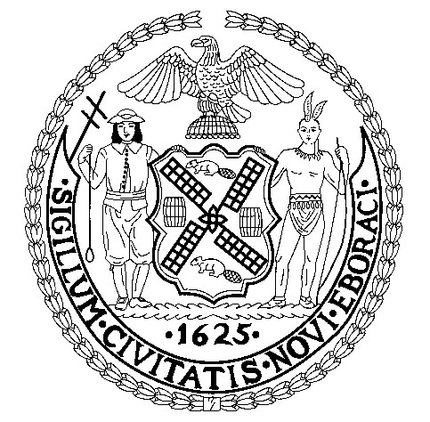
Cobble Hill School of American Studies
347 Baltic Street
Brooklyn, New York 11201
Principal: Anna Maria Mulé

  - P.T.A MEETINGS

- September 28th 5:30 p.m.-6:30 p.m. Virtual Meeting
- October 26th 10:00 a.m.-11:00 a.m. Virtual Meeting
- November 10th 5:30 p.m.-6:30 p.m. In Person Meeting
- December 21 3:00 p.m.-5:00 p.m. In Person Meeting
- January 25th 10:00 a.m.11:00 a.m. Virtual Meeting
- February 15th 5:30 p.m.-6:30 p.m. Virtual Meeting
- March 18th: 12:30 p.m.-1:30 p.m. In person Meeting
- April 26th: 5:30 p.m.-6:30 p.m. Virtual Meeting
- May 24th: 10:00 a.m.-11:00 a.m. Virtual Meeting
- June 14th: 10:00 a.m.-11:0O a.m. Virtual Meeting

2021-2022 S.L.T Meeting

- October 26th 1:30 p.m. -2:30 p.m. Virtual Meeting
- November 10th 2:30 p.m. – 3:30 p.m. In person Meeting
- December 21st 2:00 p.m. – 3:00 p.m. In Person Meeting
- January 25th 2:00 p.m. – 3:00 p.m. Virtual Meeting
- February 15th 2:30 p.m. - 3:30 p.m. Virtual Meeting
- March 18th 2:30 p.m. - 3:30 p.m. In person Meeting
- April 26th 2:30 p.m. - 3:30 p.m. Virtual Meeting
- May 24th 2:30 p.m. – 3:30 p.m. Virtual Meeting
- June 14th 2:30 p.m. - 3:30 p.m. Virtual Meeting

