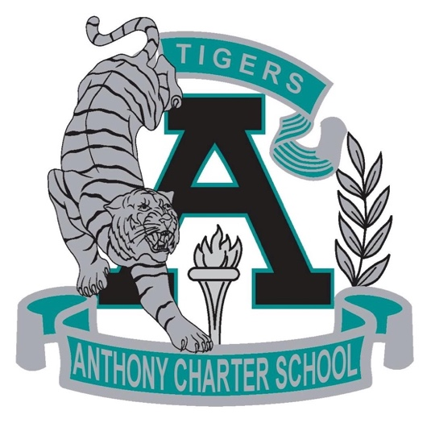

Public Notice
(Notificamiento Publico)
SPECIAL MEETING
Anthony Charter School
Governing Council
(Junta del Cuerpo Escolar)
Friday, December 22th, 2017
(Viernes, Diciembre 22, 2017)
TIME: 9:00 am
Location:
780 Landers
Anthony NM 88021

