|  |  |
| --- | --- |
| Subject: Algebra II Unit: Ten | |
| **Unit Topic and Length:**  **TRIGONOMETRIC FUNCTIONS**  **(Three weeks)** | |
| **Common Core Learning Standards:**  **G-SRT.6** Understand that by similarity, side ratios in right triangles are properties of the angles in the triangle, leading to definitions of trigonometric ratios for acute angles.  **F-TF.1** Understand radian measure of an angle as the length of the arc on the unit circle subtended by the angle.  **F-TF.2** Explain how the unit circle in the coordinate plane enables the extension of trigonometric functions to all real numbers, interpreted as radian measures of angles traversed counterclockwise around the unit circle.  **G-SRT.7** Explain and use the relationship between the sine and cosine of complementary angles.  **F-BF.3** Identify the effect on the graph of replacing f(x) by f(x) + k, k f(x), f(kx), and f(x + k) for specific values of k (both positive and negative); find the value of k given the graphs. Experiment with cases and illustrate an explanation of the effects on the graph using technology. Include recognizing even and odd functions from their graphs and algebraic expressions for them.  **F-TF.8** Prove the Pythagorean identity sin2(Θ) + cos2(Θ) = 1 and use it to find sin(Θ), cos(Θ), or tan(Θ) given sin(Θ), cos(Θ), or tan(Θ) and the quadrant of the angle.  **F-TF.9** (+) Prove the addition and subtraction formulas for sine, cosine, and tangent and use them to solve problems.  **F-TF.5** Choose trigonometric functions to model periodic phenomena with specified amplitude, frequency, and midline. | |
| **Big Ideas/Enduring Understandings:**  Proving identities requires the use of the rules of arithmetic and algebra to produce equivalent expressions.  Evaluating trigonometric functions requires the use of arithmetic and algebraic rules and geometric analysis to understand degree and radian measure.  Relationships between trigonometric quantities can be represented symbolically, numerically, graphically and verbally in the exploration of real world situations  Trigonometric functions and features such as amplitude, frequency, and midline can be used to model periodic phenomena.  Trigonometric relationships can be described and generalizations made for mathematical situations that have numbers or objects that repeat in predictable ways. | **Essential Questions:**  When and how is trigonometry used in solving real world problems?  How do I determine trigonometric characteristics of problems that would determine how to model the situation and develop a problem solving strategy?  How is periodic phenomena used to define a trigonometric model?  When and why is it necessary to follow set rules/procedures/properties when manipulating trigonometric expressions?  How are algebraic rules used to verify trigonometric identities?  How are key features of a graph used to interpret trigonometric functions and models? |

|  |  |  |
| --- | --- | --- |
| **Content:**  **Define trigonometric ratios and solve problems involving right triangles**  **Extend the domain of trigonometric functions using the unit circle**  **Build new functions from existing functions**  **GRAPH trigonometric functions**  **Model periodic phenomena with trigonometric functions**  **Solve trigonometric equations** | **SKILLS**  Sketch the unit circle and represent angles in standard position.  Express and apply the six trig functions as ratios of the sides of a right triangle. **A2.A55**  Know the exact and approximate values of the sine, cosine, and tangent of 0°, 30°, 45°, 60°, 90°,  180°, and 270° angles. **A2.A56**  Sketch and use the reference angle for angles in standard position (for the unit circle). **A2.A57**  Define radian measure.  Convert between radian and degree measures. **A2.M2**  Find the value of trig functions, if given a point on the terminal side of angle J (as located on the unit circle). **A2.A62 Unit Circle**  Use inverse functions to find the measure of an angle, given its sine, cosine, or tangent **A2.A64**  Know and apply the co-functions and  reciprocal relationships between trig ratios. **A2.A58**  Use the reciprocal and co- function relationships to find the value of the secant, cosecant, and cotangent of 0°, 30°, 45°, 60°, 90°, 180°, and 270° angles. **A2.A59**  Find the value of trig functions, if given a point on the terminal side of angle θ.  Use inverse functions to find the measure of an angle, given its sine, cosine, or tangent **A2.A64**  Determine the length of an arc of a circle,  given its radius and the measure of its central angle. **A2.A60, A2.A61**  Sketch and recognize one cycle of a function of the form: y = A sin Bx or y = A cos Bx.  Write the trig function that is represented by a given periodic graph.  Restrict the domain of the sine, cosine, and tangent functions to ensure the existence of an inverse function.  **A2.A63**  Sketch the graph of the inverses of the sine, cosine, and tangent functions. **A2.A65**  Determine the trig. Functions of any angle using tech.  Determine amplitude, period, frequency, and phase shift, given the graph or equation of a periodic function **A2.A69**  Sketch and recognize one cycle of a function of the form : Asin(bx), Acos(bx) **A2.A70**  Sketch and recognize the graphs of the functions y = sec(x), y = csc(x), y = tan(x),y = cot(x). **A2.A71**  Write the trigonometric function that is represented by a given periodic graph **A2.A72**  Justify the Pythagorean identities.  Apply the angle sum and difference formulas for trigonometric functions **A2.A76**  Apply the double-angle and half-angle formulas for  trigonometric functions **A2.A77**  Use inverse functions to find the measure of an angle, given its sine, cosine, or tangent.  Solve trig equations for all values of the variable from 0° to 360° **A2.A68**  Solve for an unknown side or angle, using the Law of Sines or the Law of Cosines **A2.A73**  Determine the area of a triangle or a parallelogram, given the measure of two sides and the included angle  **A2.A74**  Determine the solution(s) from the SSA situation (ambiguous case) **A2.A75** | **Days:**  **1**  **2**  **1**  **1**  **1**  **1**  **1**  **2**  **2**  **1**  **1**  **1**  **2**  **2**  **1**  **2**  **1**  **2**  **2**  **2**  **2**  **2**  **1**  **1**  **1** |
| **Assessment Evidence and Activities:**  Pre and Post Tests (formative assessment and assessments for evidence of growth)  Problem Solving Tasks and Activities  Quizzes  Questioning and Observations  Do Nows and Exit Slips  Class work and Homework | | |
| **Possible Support Strategies:**  Use of manipulatives  Word Walls and Individual Glossaries  Journals  Back Tracking Technique demonstrated for solving equations | | |
| **Formative Assessment:**  The assessments listed above will be used to identify students’ strengths and weaknesses.  There will be constant adjustments and fine tuning of the curriculum delivery based on this analysis. Sharing student work, sharing best practice and planning next steps will be an integral part of common planning meetings. | | |
| **Final Performance Based Task: See Attached** | | |
| **Extension:**  Differentiated column sheets for evaluating trigonometric expressions and for solving trigonometric equations.  The performance tasks will also have extension challenges. | | |
| **Learning Plan & Activities:**  The learning plan will incorporate work shop style lessons which will allow for student centered learning. Group work will be incorporated into various concepts with a focus on students learning collaboratively. There will be an emphasis on technique to enable students to solve skills based questions. This will be supported with problem solving exercises for all content to give students a conceptual understanding of the material. | | |
| **Resources:**  Text book : Meaningful Math Algebra I Prentice Hall Mathematics Algebra I  Graphing calculators  Geometric Manipulatives, Sketchpad  Smart Board Demonstrations  Problem solving materials created by teachers | | |

**Unit Test for Trigonometry**

**Name: ________________________________ Date : __________________**

|  |  |
| --- | --- |
| **1.**  Expressed in radian measure, 235º is  [1]                [2]                   [3]                  [4] | |
| **2.**  What is the value of  sin(-240º) ? | |
| [1]                      [2]                    [3]                    [4] | |
| **3.** The value of  is | |
| [1]                       [2]                    [3]                    [4] | |
| **4.**  If the tangent of an angle is negative and its secant is positive, in which  quadrant does the angle terminate? | |
| [1]  I                        [2]  II                    [3]  III                    [4]  IV | |
| **5.** In the unit circle shown at the right, what are the coordinates of *B*? | |
| [1]       [2]       [3]        [4] |  |
| |  | | --- | | **6.** What is the value of     ?       [1]                      [2]                   [3]                [4] | | |
| **7.** What is the value of    ? | |
| [1]   1                [2]                         [3]             [4] | |
| **8.**  Which expression is *not* equivalent to sin 150º ? | |
| [1]  sin 30º             [2]  - sin 210º          [3]  cos 60º        [4]  - cos 60º | |
| **9.** A flower bed is planted in the shape of an arc along the edge of a circular  walkway.  If the circle has a radius of 5 yards and the angle subtended by  the arc measures 1.5 radians, what is the length, in yards, of the border? | |
| [1]  0.5          [2]   2         [3]  5     [4]  7.5 | |
| **10.**  If  sin (*x* + 20º) = cos *x* , the value of  *x*  is | |
| [1]  35º                       [2]  45º                 [3]  55º                [4]  70º | |
| **11.** The expression    is equivalent to | |
| [1]                [2]           [3]                 [4] | |
| **12.** The expression  (1 + cos *x*)(1 - cos *x*) is equivalent to | |
| [1]  1                         [2]              [3]               [4] | |
|  | |
| **13.**  The expression  cos 80º cos 70º  +  sin 80º sin 70º   is equivalent to         [1] cos 10º            [2]  cos 150º         [3]  sin 10º       [4]  sin 150º | |
| **14.**  If       and    ,  then  sin (*a - b*)  equals         [1]                  [2]                [3]               [4] | |
| **15.** The expression  sin2*A* - 2sin*A*  is equivalent to | |
| [1] (sin*A*)(sin*A* - 2)     [2] (2sin*A*)(sin*A* - 1)  [3] (sin*A*)(2cos*A* - 1)    [4]  (2sin*A*)(cos*A* - 1) | |
| **16.**  What value of *x* in the interval  0º < *x* < 180º satisfies the equation :  ? | |
| [1]  -30º              [2] 30º               [3]  60º              [4]  150º | |
| **17.**  What is the amplitude of the graph of the equation   ? | |
| [1]  1/2                 [2]  2                [3]  *π*                 [4] 2*π* | |
| |  | | --- | | **18.**  A sound wave is modeled by the curve  *y* = 3sin4*x*.  What is the period of this curve?    [1]  *π*                [2]  *π*/2           [3]  3   [4]  4 | | |
| **19.** The graph of the function   *y* = 3sin(2*x* +  π)   will display a  horizontal shift of : | |
| [1]  *π* units to the right  [2]  *π* units to the left       [3]  *π*/2 units to the right    [4]  *π*/2 units to the left | |
|  | |
| **20.**  A radio transmitter sends a radio wave from the top of a 50-foot tower.  The wave is represented by the graph shown at the right.  What is the equation of this radio wave?   [1]  *y* = sin *x*         [2]  *y* = 1.5 sin *x* [3] *y* = sin 1.5*x* [4]  *y =* 2sin*x* |  |
| **21.** Which graph represents the function *f* (*x*) = -sin*x*  in the  interval  -*π* < *x* < *π* ? | |
| [1]                             [2]                [3]                     [4] | |
|  | |
| **22.**  Which value of *x* is *not* in the domain of the function defined  by *y* = tan*x* ?      [1]  *π*            [2]   *π* / 2          [3] *π* / 3             [4]  2*π* / 3 | |
|  | |
| **23.**  In ∆*ABC*, *m<A* = 120, *b* = 10", and *c* = 18".  What is the area of ∆*ABC* to the *nearest square inch*?    [1]  52           [2]  78                [3] 90                 [4]  156 | |
|  | |
| **24.**  In ∆*ABC*, *m<A* = 45, *m<B* = 30, and *a* = 10.  What is the length of side *b*?       [1]           [2]              [3]            [4] | |
|  | |
| **25.**  You must cut a triangle out of a sheet of paper.  The only  requirements you must follow are that one of the angles must  be 60º, the side opposite the 60º angle must be 40 centimeters,  and one of the other sides must be 15 centimeters.  How many different triangle can you make?    [1]  1               [2]  2                 [3] 3                  [4]  0 | |
|  | |
| **26.**   In ∆*ABC*, sin*A* = 0.5, *m<B* = 45, and *b* = 20.  What is the length of side *a*?    [1]            [2]  10              [3]            [4] | |
|  | |
| **27.**  In triangle *ABC, a* = 2, *b* = 4 and *c =* .  Find the *largest* angle of the triangle.    [1]  60º                [2] 120º              [3] 150º              [4]  30º | |
|  | |
| **28.**  Al is standing 50 yards from a maple tree and 30 yards from an oak tree in the park.  His position is shown in the diagram at the right.  If he is looking at the maple tree, he needs to turn his head 120º to look at the oak tree.  How many yards apart are the two trees? |  |
|  | |
| [1]  58.3        [2]  65.2         [3] 70         [4]  75  **29.**  Find the *exact value* of  sec 60º + cot 45º + csc 30º .       [1]  1                 [2]  2             [3]           [4]  5 | |
|  | |
| **30.**  Assuming an angle lies in Quadrant I, evaluate   as a fraction in lowest terms.       [1]  5/12             [2]  5/13          [3] 12/5           [4]  13/5 | |

Name: _________________________ Date : _____________

**Ferris Wheel**

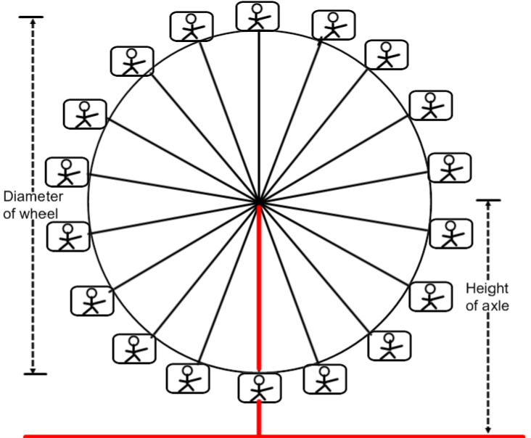

A Ferris Wheel is 70 meters in diameter and rotates once every three minutes. The center axle of the Ferris Wheel is 50 meters from the ground.

|  |  |  |  |  |  |  |  |
| --- | --- | --- | --- | --- | --- | --- | --- |
| **Time**  **(minutes - seconds)** | **0min 0sec** |  |  |  |  |  |  |
| **Height of Passenger above ground (m)** | **15** |  |  |  |  |  |  |

|  |  |  |  |  |  |  |  |
| --- | --- | --- | --- | --- | --- | --- | --- |
| **Time**  **(minutes)** |  |  |  |  |  |  |  |
| **Height of Passenger above ground (m)** |  |  |  |  |  |  |  |

|  |  |  |  |  |  |
| --- | --- | --- | --- | --- | --- |
| **Time**  **(minutes)** |  |  |  |  |  |
| **Height of Passenger above ground (m)** |  |  |  |  |  |

1. Using the axes below, sketch a graph to show how the height of a

passenger will vary with time. Assume that the wheel starts rotating when the passenger is at the bottom. Because there are 18 carriages, this means that to get to each new position it will take :

(3 x 60)/18 seconds or ten seconds which equates to ****min.

Also angle A would be 360/18 or 20 degrees. Thus the height above the ground would now be (35 – 35Cos 20o) + 15.

This = (35 – 35 x .9397) + 15 = (35 – 32.8892) + 15  17.11

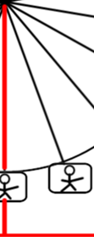

A**minmin**

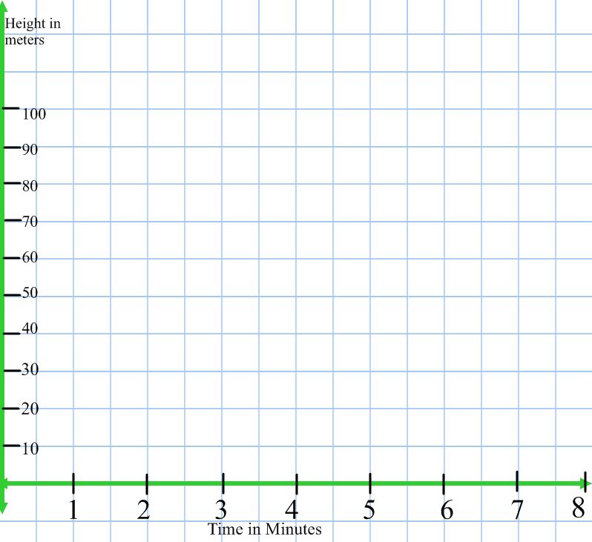

A mathematical model for this motion is given by the formula:

h = a - bcos(ct) where h = the height of the car in meters

t = the time that has elapsed in minutes

a, b, c are constants. Find values for a, b and c that will model this situation.

_____________________________________________________________

______________________________________________________________

______________________________________________________________

______________________________________________________________

______________________________________________________________

______________________________________________________________

_____________________________________________________________

______________________________________________________________

______________________________________________________________

______________________________________________________________

______________________________________________________________

______________________________________________________________

_____________________________________________________________

______________________________________________________________

______________________________________________________________

______________________________________________________________

______________________________________________________________

______________________________________________________________

Look at the cards on the next three pages and match them in to six sets of three.

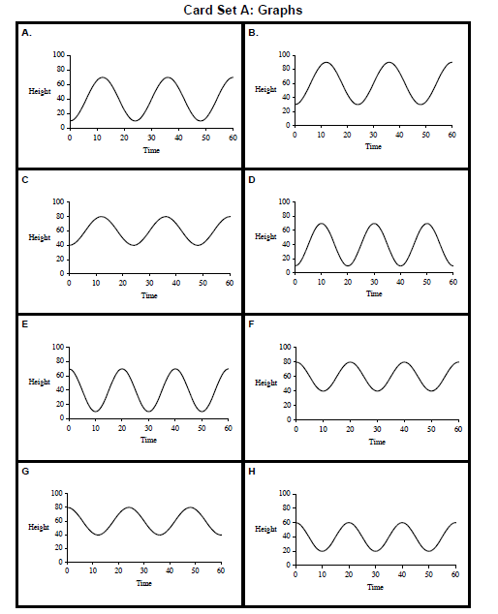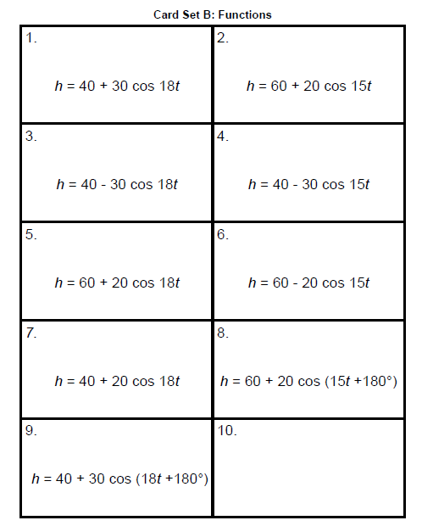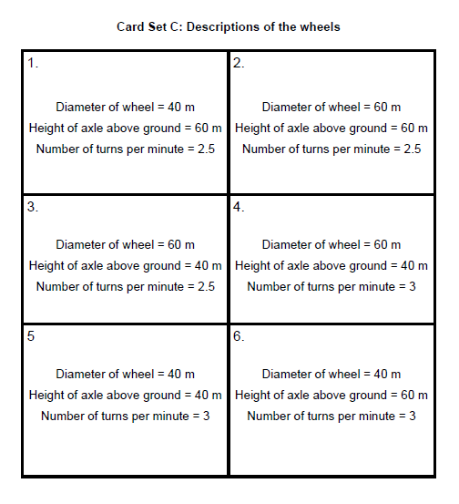

One revolution in 3 minutes means that one cycle of the cosine graph taked 3 minutes. There is a period of 3. Thus  = 3 or *n* = .

Also at time = zero, we know that the height above the ground is 15 meters.

This is the very bottom postion of the ferris wheel.

Name : __________________________ Date : ____________

**Common Core State Standards MCC9‐12.F.IF.7e**

***Graph trigonometric functions, showing intercepts and end behavior, and showing period, midline, and amplitude.***

Mathematical Goals •

Collect data and represent with a graph

Determine if a relationship represents a function Identify characteristics of a graph.

The hands of a clock on a wall move in a predictable way. As time passes, the distance between the ceiling and the tip of the hour hand changes. We want to investigate how this distance has changed over a twelve hour period.

Let’s simulate the situation using a clock and the diagram below.

The hour hand in this case goes all the way to the rim of the clock and is 40 cm long. You need to calculate the distance between the tip of the hour hand and a line representing the ceiling every hour on the hour.

Directions: Work in pairs. You will need a ruler, graph paper, the sheet with the clock and the ceiling. Record your distances in a table and graph your results explaining what type of relationship you have found.

|  |  |  |  |  |  |  |  |  |  |  |  |  |  |
| --- | --- | --- | --- | --- | --- | --- | --- | --- | --- | --- | --- | --- | --- |
| **Time** | **12 PM** | **1** | **2** | **3** | **4** | **5** | **6** | **7** | **8** | **9** | **10** | **11** | **12** |
| **Distance from the ceiling (cm)** |  |  |  |  |  |  |  |  |  |  |  |  |  |

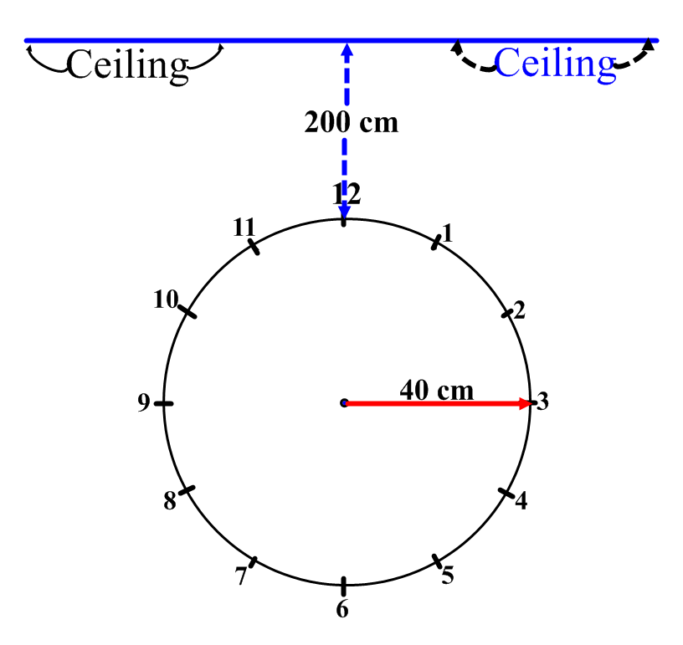

Y = (40-40cos(x)) + 200